Do Negative Income Shocks Last Longer, and Do They Hurt the Poor More? Evidence from Rural Indonesia.

David Newhouse*
Department of Economics
Cornell University

Abstract

This paper estimates the persistence of transient income shocks to farm households in rural Indonesia. Persistence is defined as the elasticity of households’ 1997 per capita income with respect to its 1993 per capita income, controlling for time-invariant household characteristics. Local rainfall levels are employed as an exogenous indicator of transitory income shocks. On average, thirty percent of income shocks remain after four years. Negative shocks persist no longer than positive shocks, and neither negative nor positive shocks disproportionately affect poor households. These findings cast doubt on arguments advocating public intervention to stabilize or redistribute income.

JEL classifications: D31, I32, C31, O53
Keywords: Income dynamics, Income Shocks, Indonesia
How much do transient income shocks affect households’ future income? Do negative income shocks persist longer than positive shocks? Do either negative or positive shocks exhibit disproportionate persistence for poor households? How sensitive are empirical estimates of the persistence of shocks to measurement error in initial income and unobserved household characteristics? This study addresses these four questions for a sample of rural Indonesian farm households. Currently, little is known about the persistence of income shocks in the developing world, due to the lack of large scale panel surveys from developing countries.

The efficacy of policies that seek to promote economic well being by stabilizing or redistributing income, however, depends on how long negative and positive shocks persist. Assuming risk aversion, the greater the persistence, the greater the benefit from policies that reduce income volatility. The case for public intervention is stronger, however, if negative shocks persist longer than positive income shocks. In that case, a mean-preserving reduction in the variance of household income increases households’ lifetime expected income.

If negative shocks are particularly persistent for the poor and if policymakers give particular attention to the poor, then the case for intervention is stronger still. Furthermore, if poor households are able to put income windfalls towards purchasing assets that substantially increase their expected future income, then redistribution from rich to poor households can help families escape poverty. The hope that positive income shocks persist for the poor may partly explain the design of the Indonesian Left Behind Villages (IDT) program, a $564 million anti-poverty initiative undertaken by the Soeharto administration in 1994. In addition to upgrading infrastructure in poor villages, this program earmarked funds to be disbursed as grants to needy households in poor villages. The persistence of positive income shocks for poor households affects the optimal mix between investment in village infrastructure and direct grants to poor households as policy instruments to fight poverty.

Although understanding income persistence is important for formulating anti-poverty policy, labor and development economists tend to view this issue from different perspectives. Development economics has been influenced by models in which household income or well-being has at least one unstable equilibrium (e.g., Dasgupta and Ray, 1986, Bannerjee and Newman, 1991). In these models, income shocks can persist and build on themselves, as household incomes adjust to a new equilibrium. These models are thought to be especially germane to developing countries, which are characterized by a large number of household businesses, imperfect credit and insurance markets, a lack of public safety nets, and widespread malnutrition.

Some empirical evidence from developing countries is consistent with models of multiple equilibria: In rural China, data with relatively little measurement error indicate that one third of the mean poverty gap is due to year-to-year fluctuations in consumption (Jalan and Ravallion, 1998). High levels of transient poverty would be predicted by models in which transient income shocks lead households into and out of a low-consumption equilibrium. In addition, the poorest rural Chinese households are least able to insure consumption against negative income shocks (Jalan and Ravallion, 1999); perhaps they are least able to insure future income as well. Furthermore, in Ethiopia, the livestock holdings of pastoralists appear to be subject to two equilibria in herd sizes (Lybbert, et al, 2001). These empirical findings, the popularity of theoretical models of multiple equilibria in household well-being, and underlying conditions in developing countries, all suggest to development economists that household income shocks persist far into the future.

Labor economists, on the other hand, have been profoundly influenced by the canonical model of permanent income, which assumes that transient income or earnings shocks are serially independent and therefore exhibit no persistence (Friedman, 1957). Empirical tests of this model typically allow for an autoregressive component of unobserved earnings, using estimated covariances from standard earnings equations. These empirical studies, using data from developed countries, reject the permanent income model’s strong assumption of no serial dependence, but autocorrelation between earnings and its lag tends to be low or even negative (See, for example, Lillard and Weiss, 1980, Bourguignon and Morrisson, 1983, Abowd and Card,1989, Burkhauser et al, 1997). Given these empirical findings as well as the popularity of the permanent income framework, labor economists tend to believe that both positive and negative shocks wear off quickly, as household incomes regress to their mean levels.

This study contributes empirical evidence to this debate by analyzing the persistence of household income shocks among rural farm households in Indonesia. Persistence is defined as the elasticity of 1997 per capita income with respect to 1993 per capita income, controlling for time-invariant household characteristics. The empirical estimates of persistence, obtained by using local rainfall as an exogenous determinant of lagged transient income, yield four main conclusions. First, income shocks do persist; on average, approximately thirty percent of the income shock remains after four years. Second, the persistence of negative income shocks is roughly equal to the persistence of positive shocks. Third, the persistence of both negative and positive income shocks for poor households is low or moderate. Finally, unobserved heterogeneity and especially measurement error are significant sources of bias, and depending on the specification, can alter estimates of persistence by up to forty percentage points.

This paper consists of seven sections: Section two reviews the empirical methods that have been used to estimate the persistence of earnings or income. Section three discusses the data used in this study. Section four presents a theoretical model that illustrates how income shocks can persist, and how persistence could depend on the household’s wealth and the direction of the shock. Section five considers three different econometric methods, as well as their underlying assumptions, that are used to estimate persistence. Section six presents the empirical results, and section seven concludes.

Previous Literature

Existing studies use four different econometric approaches to obtain estimates of income persistence. The most basic of these involves estimating persistence by regressing the logarithm of current per capita income on its lag, in the presence of other time-invariant characteristics (Grootaert and Kanbur, 1997). Using this method, Fields et al (2001) estimate that in Indonesia, 50% of income shocks persist four years later.

These OLS estimates of persistence, however, are biased by measurement error in income and unobserved household heterogeneity. If true persistence is positive, classical measurement error in lagged income leads its coefficient, which is estimated persistence, to be biased downward. On the other hand, OLS estimates of persistence are upwardly biased in the presence of unobserved household heterogeneity. Failure to control for unobserved fixed attributes, such as managerial ability or soil quality, leads estimates of the persistence of shocks to include the systematic effect of these unobserved characteristics on income.

Fields et al (2001) correct for the presence of measurement error in lagged income by employing household consumption and asset holdings as instruments for initial income. The estimated persistence of income in Indonesia using this method is 75%. Although these instruments are uncorrelated with classical measurement error, they are almost surely positively correlated with unobserved characteristics of the household such as ability. Therefore, in the presence of unobserved household heterogeneity, this method gives upwardly biased and inconsistent estimates of income persistence.

Two other econometric methods, both of which are inapplicable in this study due to data limitations, have been used to obtain consistent estimates of income or earnings persistence in the presence of unobserved heterogeneity. The first follows the large literature that has estimated the effect of lagged earnings shocks, along with the variance of unobserved heterogeneity, using the variance and covariance terms of the residuals from standard earnings regressions. (Abowd and Card, 1989, Atkinson, Bourguignon, and Morrisson, 1992, Moffit and Gottschalk, 1995). However, this method requires many periods of earnings or income data in order to identify the variance and autoregressive parameters of interest convincingly. Currently, only two years of panel data from Indonesia are publicly available.

An alternative method controls for unobserved heterogeneity using household specific intercepts, or fixed effects (Arrellano and Bond, 1991). This procedure typically involves first-differencing income and instrumenting for the lagged difference. The resulting estimates of persistence may not be consistent, since this method ignores the persistence (or lack thereof) due to serially independent shocks, which are uncorrelated with the lagged incomes used as instruments. Beyond that concern, however, this method is also inapplicable to data from Indonesia because it requires at least three observations per household. A two period panel contains only one observation per household of the effect of lagged income on current income, meaning that income persistence is not identified in the presence of household-specific intercepts.

Two recent papers (Jalan and Ravallion 2001, Lokshin and Ravallion 2001) relax the assumption made in the earlier literature that income persistence is identical for all households. Using data from three countries, Hungary, Russia, and China, they find that shocks persist slightly longer for poorer households. None of the countries shows evidence that shocks lead household incomes to adjust to a new equilibrium.

This study extends these most recent two papers by distinguishing two factors that could affect persistence: The direction of the income shock and the longer-term economic status of the household. Ascertaining the effect of these two factors on persistence answers two of the questions posed in the introduction: Do negative shocks to income persist longer than positive shocks, and do negative or positive shocks persist especially long for poor and middle class farm households?

The Data

The data are taken from the first and second rounds of the Indonesian Family Life Survey (IFLS), a panel survey of households and communities conducted jointly by RAND and the Demographic Institute at the University of Indonesia. The survey sampled 320 villages in 13 of Indonesia’s 27 provinces and is representative of 83% of the national population of roughly two hundred million. The first round of the survey interviewed approximately 7,200 households, nearly half of which lived in rural villages in 1993. Of these rural households, about two thirds (2,249 households) are farm households, defined as households who reported owning both a farm business and at least one farm asset in 1992. Of the rural farm households interviewed in 1993, 94.8% (2,132) furnished enough information in the resurvey to estimate household income in 1997.

Household incomes were constructed from various sections of the questionnaire that asked respondents about their income. Additional data on rainfall levels were taken from monthly reports published by the Indonesian Weather Service, which listed the amount of rainfall measured at 35 to 45 rain stations (Badan Meteorologi dan Geofisika, 1992-1997). These local levels of rainfall, measured in standardized deviations from station-specific means, are used as an instrument for transient income shocks, following Paxson (1992), Jacoby and Skoufias (1998), Jensen (2000), and others reviewed in Rosenzweig and Wolpin’s (2000). These measures of household income and local rainfall are described in further detail in Appendix A.

This paper estimates the persistence of log per capita income, which is henceforth used interchangeably with household income. The problem of proper adjustment for household size has inspired a lengthy literature and remains unresolved; in the absence of consensus in the literature, I use the simplest and most popular adjustment, per capita income, which is consistent with the poverty lines and incidences calculated by Indonesia’s Central Bureau of Statistics (BPS). All estimates of income persistence in this paper, however, are conditioned on household size, so that variation in household size has no effect on estimated persistence. The natural log of per capita income is used, to capture the widely accepted notion that utility functions are concave, and also to produce estimates of income persistence that can be interpreted as elasticities. Income is measured in thousands of rupiah, and households are given a minimum per capita income of one thousand rupiah (about 50 cents) a month, in order to prevent the undue influence of small income gains to very poor households.

Indonesia’s economy enjoyed broad-based growth from 1993 to 1997. This growth is reflected in Figure 1, which presents the distribution of income in both years. The first two rounds of the IFLS encompass the final five years of a period of real GDP growth and relatively stable economic management that characterized much of the 30-year Soeharto regime; between 1993 and 1997, real GDP grew about 7% per year. The stunning collapse of the rupiah that led to massive economic dislocation and political chaos began in September 1997 and climaxed in January 1998. The IFLS, however, was mostly conducted from August to November of 1997, largely before the adverse effects of the financial crisis were apparent.

Theoretical framework

A variety of theories have been advanced in the literature to explain why income shocks may persist, and why persistence could depend on the direction of the shock and the initial wealth of the households. Household production functions may be lumpy in certain inputs; for example, negative income shocks may force farm households to choose not to raise livestock that they cannot afford to feed (Dercon, 1998). Similarly, negative income shocks may cause farm households to use agricultural inputs or methods that are less risky, but give a lower expected return (Rosenzweig and Binswanger, 1993). A negative income shock may rob poor households of the collateral required to obtain a loan at the equilibrium interest rate (Stiglitz and Weiss, 1981). If social capital is positively correlated with wealth, richer households may be able to draw on stronger social insurance networks, which could help them weather negative income shocks. Finally, poor households, in the wake of a negative income shock, may not be able to maintain their level of health or nutrition, which in turn reduces productivity (Strauss and Thomas, 1998). In the model presented by Dasgupta and Ray (1986), those unlucky enough to be rationed out of a job in the first period languish in an undernourished, under-productive state – “no longer through bad luck but through cumulative causation.” Each of these five mechanisms -- activity choice, risk, access to credit, human or social capital, or health and nutrition -- can cause both negative and positive income shocks to persist, in different ways for different households.

The following general theoretical framework encompasses these and other mechanisms that could cause income shocks to persist. In this model, income shocks persist because consumption decisions taken by the household this period affect next period’s level of both market and non-market assets, which in turn affects future income. In year t, households are assumed to observe their full income FI_{t}, which is the amount of income the household would earn if all its members consumed no leisure. That full income is a function of a vector of household assets owned at the end of the previous year (A_{t-1}), predetermined characteristics of the household (Z), and transient income shocks in year t (S1_{t}).

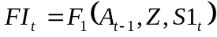 (1)

Households divide their full income between non-durable consumption goods X_{t}, which includes leisure, and the purchase and sale of assets A_{t}. Let V(A_{t}) equal the present value of the expected stream of utility accruing to a household with assets A_{t,} S2 represent stochastic shocks to these assets, and 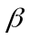 equal the discount rate. Conditional on full income FI_{t}, households choose their consumption of non-durables to solve the following recursive maximization problem:

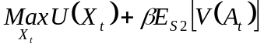 (2)

Assets (A) consist of two types: Market assets (such as farmland, livestock, and housing, denoted A1) and non-market assets (like social networks, claims on non-coresident family members, or non-farm employment opportunities, denoted A2). Stocks of both types of assets persist over time; next year’s assets are modeled as a function of the previous year's assets, as well as the non-durable goods purchased that year by the household. Market assets can be sold to increase consumption, but the value of these assets are constrained to remain above a household-specific credit limit, which is a function of the household’s predetermined characteristics and the previous year’s assets. Allow P_{A1} and P_{X} to represent price vectors for market assets and non-durable goods, respectively, which are assumed exogenous and constant across the sample. The budget constraint for market assets can then be written as:

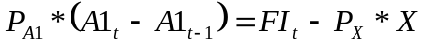 (3)

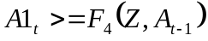. (4)

where F₄ determines the credit limit. Non-market assets at the end of year t are a function of lagged non-market assets, non-durable goods purchased in the market, household characteristics, and stochastic shocks to asset levels.

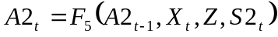. (5)

For example, the non-farm job opportunity available to the household in year t is a function of its own lagged value (an element of A2_{t-1}), the consumption of leisure in time t (X_{t}), and luck (S2_{t}).

If U is quasi-concave in X_{t}, there exists a unique set of demand functions F₆ and a value function V such that:

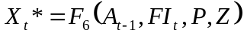, (6)

and V(A_{t}, Z) gives the present value of the stream of expected utility that will accrue to a household with assets A_{t} and pre-determined characteristics Z. Full income FI is unobserved. Subtracting and substituting in for the optimal value of leisure consumption gives observed income Y_{t} as a function of household characteristics, assets remaining at the end of the previous period, the vector of prices, and income shocks:

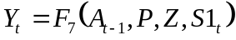. (7)

Assets owned by the households at the end of the previous period, A_{t-1}, are determined by endogenous household decisions that are influenced in part by the amount of income earned by the household last period. Substituting equations (3), (5), and (6) in for lagged assets in (7) gives the law of motion for observed income Y_{t}.

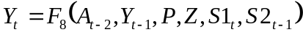. (8)

Equation (8), after using (3), (5) and (6) to substitute recursively for lagged assets and income through 1993, can be rewritten as:

. (9)

Empirical estimation of equation (9) gives an approximation of income persistence, which is defined as the partial derivative of F with respect to household income in 1993 Y₁₉₉₃, controlling for time-invariant characteristics Z, initial assets A₁₉₉₂, and subsequent income shocks S₁₉₉₄ through S₁₉₉₇.

In conclusion, the model above presents a general framework that encompasses a wide variety of mechanisms proposed in the literature to explain income persistence. These mechanisms suggest that the persistence of income could depend on both the direction of the shock and/or the household’s initial level of wealth. In the end, though, the importance of these mechanisms for persistence depends on the form of the structural functions contained in the model, and economic theory is unable to distinguish between the various functional forms that would lead to different patterns of income persistence. Therefore, I now turn to the task of empirically estimating the persistence of income.

Econometric model

I first stratify the sample into four groups, on the basis of households' economic class and the direction of their income shocks in 1993, in order to test the possibility that these two factors affect the persistence of shocks. Households’ economic class is determined by whether their predicted permanent income is above or below the sample median, while the direction of the household’s 1993 income shock is determined by the sign of the households’ predicted 1993 transient income. Predictions of permanent income and transient income in 1993 are obtained by estimating the following regression using OLS:

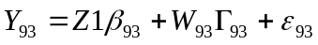. (10)

Y₉₃ is the vector of observed 1993 per capita incomes. Z1 represents a matrix of the observed, predetermined characteristics, including age, education, 1992 sector of the head, household assets held in 1992, and village-level irrigation facilities and soil quality. W₉₃ represents a matrix of proxies for 1993 transient income shocks. Measures of transient income consist of quarterly average rainfall from the nearest rainfall station, measured in standardized deviations from the station-specific mean, the net value of farmland purchases in the past year and its square, and the net value of livestock purchases in the past year. ε₉₃ is a vector of classical error terms drawn from a distribution with zero mean and variance 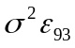.

Based on the results of this regression, the vector of 1993 incomes is decomposed into three parts: predicted permanent incomes, equal to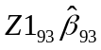, predicted transient 1993 incomes, equal to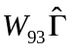, and a residual representing incomes due to unobserved household characteristics, measurement error, model misspecification, and sampling error. The interaction of the household’s economic class with the sign of predicted 1993 transient income creates four groups. Income persistence can then be estimated separately for the four group subpopulations of farm households.

After dividing the sample into four groups based on households' economic class and the direction of their 1993 income shocks, it is possible to define a population parameter to represent the income persistence of each group. A group’s income persistence is that group’s average elasticity of true 1997 income, Y*₉₇, with respect to true 1993 income, Y*₉₃, controlling for predetermined characteristics Z and rainfall levels W₉₄₋₉₇.
Income persistence, for either the entire population, or for a particular group subpopulation, corresponds to 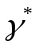 in the second equation of the following system:

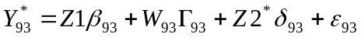. (11)

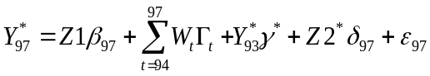. (12)

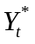 is a vector containing the unobserved true log per capita incomes in year t. Z1 is a matrix containing the set of observed time-invariant household characteristics that affect household income. 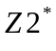 is a matrix containing the set of unobserved time-invariant household characteristics that affect household income. W_{t} is a matrix containing the measures of transient income in year t, which consists of four quarters of rainfall and their squares, as well as the previous year’s net purchases of farmland and livestock when t=1993. 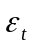 is a vector of classical error terms drawn from a distribution with zero mean and variance 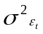.

In the sample, however, both true household income 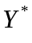, and some household characteristics that systematically affect income , are unobserved. Controlling for these latent variables is the main econometric challenge in estimating the persistence of income, 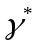 in equation (12). Following the classical model of measurement error, the vector of observed incomes Y is assumed equal to true incomes plus a vector of mean zero stochastic measurement error component, denoted zeta, which is uncorrelated with everything:

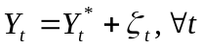, (13)

where measurement error 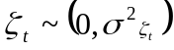, and is assumed to be orthogonal to all other variables.

The characteristics of a household that are unobserved and therefore omitted from the regression, Z2*, appear, along with measurement error, in the stochastic error term.

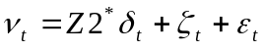, (14)
where specification error 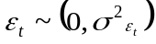, and is assumed to be orthogonal to all other variables.

The analogues of equations (11) and (12), based on observed data, can therefore be written:

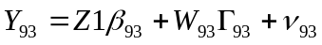 (15)

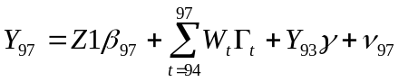 (16)

Because Y* and Z2* are unobserved, estimating in equation (16) using standard methods may lead to inconsistent estimates of income persistence , as defined in equation (12). The next section discusses three sets of additional assumptions that can be imposed in order to obtain consistent estimates of income persistence with the data at hand.

Method A: OLS

A first approach to consistently estimating income persistence is to assume both that 1993 income is measured without error, and that unobserved household characteristics have no systematic effect on 1997 income.

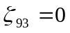. (17.A)
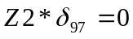. (18.A)

Substituting (17.A) and (18.A) into (16) gives:

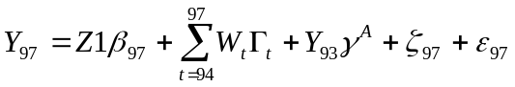. (19.A)

Under these two assumptions, the OLS estimates 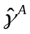obtained from (19.A) are unbiased and consistent estimates of as defined in equation (12). If assumption (18.A) is incorrect and δ₉₃ and δ₉₇ are of the same sign, however, the OLS estimates are subject to upward bias, because the estimated coefficient includes the systematic effect of unobserved fixed household characteristics on income. In addition, assuming that true persistence is positive (as the results strongly suggest), any measurement error in initial income will cause attenuation bias which will bias the OLS estimates of persistence downward.

Methods B and C: Instrumental Variables

Instrumental variables estimation can be used to obtain consistent estimates of a regression coefficient when an independent variable is correlated with the error term. In this case, 1993 income is a function of unobserved household characteristics, Z2*, which also appear in the error term of the 1997 income equation. In addition, two stage least squares estimates are consistent in the presence of random-noise measurement error in the endogenous variable, observed income in 1993.

The identifying instruments must satisfy two criteria. First, the instruments must be uncorrelated with the disturbance term in the equation for 1997 income, 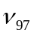 in equation (16), which includes omitted characteristics Z2*. Second, the instruments must be reasonably well correlated with 1993 log per capita income Y₉₃, which can be tested using results from the first stage regression. As usual, the main challenge is discovering instruments that satisfy these two criteria.

Method B: Endogenous Instruments

The second identification strategy assumes that unobserved characteristics of the household has no systematic effect on all households’ income in either 1993 or 1997.

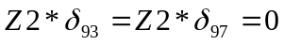. (17.B)

Equations (14)-(16) and (17.B) imply that any characteristic of the household that is correlated with 1993 income is a valid instrument, since measurement error and specification error are uncorrelated with all household characteristics by assumption. Under assumption (17.B), 1993 consumption and 1993 household assets can be used as instruments to obtain consistent estimates of income persistence, even if 1993 income is measured with random-noise measurement error. The main advantage of this method is that household consumption and asset levels are readily available instruments. The main drawback is assumption (17.B.); unobservable characteristics of the household, consumption and assets are, in all likelihood, affect income and are positively correlated with the instruments, since farm households with high unobserved "ability" are likely to enjoy above-average levels of consumption and wealth. These instruments are therefore almost certainly endogenous, that is, positively correlated with the error term, resulting in 2SLS estimates of persistence that are upwardly biased and inconsistent.

Method C: Exogenous Instruments

To overcome the problem of upwardly inconsistent estimates of persistence due to unobserved heterogeneity, this paper relies on variation in 1993 income due to observed indicators of transient income shocks to consistently estimate the persistence of income. The consistency of the estimates rests on the assumption that these instruments (W₉₃) are orthogonal to the income due to unobserved characteristics of the household Z2*, conditional on observed characteristics of the household Z1:

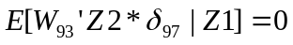. (17.C)

The instruments contained in W₉₃ are: local rainfall and its square for the four quarters prior to the 1993 interview, measured in standardized deviations from station-specific means, and the purchase and sale of farmland and livestock in 1992-1993 (conditional on the amount of these and other assets owned in 1992) in the twelve months prior to the interview. Net asset purchases in the last year, conditional on asset levels owned in 1992 and other pre-determined household characteristics, are assumed to reflect unanticipated transitory income shocks, but not household characteristics that determine future income. This assumption may seem problematic in theory, especially if unobserved characteristics strongly affects a household's propensity to buy or sell assets, but empirically this concern proves unimportant, as shown in the results below. These variables appear to satisfy assumption (17.C), and can therefore be treated as exogenous.

Two-stage least squares estimates are consistent, if assumption (17.C) holds, but remain biased in finite samples. The bias is approximately equal to the original OLS bias divided by the F statistic from a test of the null hypothesis that the coefficients on the instruments in the first stage regression are jointly zero (Bound, Jaeger, and Baker, 1995). The empirical results presented in the next section indicate that estimates obtained using these "exogenous instruments" are almost always higher than the OLS estimates for each group. These two stage least squares estimates are therefore biased downward somewhat, and can be interpreted as a lower bound estimate of income persistence.

In conclusion, I consider three estimation strategies that can be used to estimate income persistence with two periods of data. Each strategy produces consistent estimates of persistence if additional assumptions are satisfied. Method A is OLS, which produces consistent estimates under the untenable assumptions that 1993 household income was measured without error and that all relevant time-invariant household characteristics are included as controls. Method B is "endogenous 2SLS", which uses convenient instruments such as 1993 household assets and consumption to instrument for 1993 income. However, this method is liable to produce estimates that are upwardly biased and inconsistent, since the instruments used are positively correlated with omitted characteristics of the households that systematically affect income. Therefore, the estimates of persistence obtained using this method can be interpreted as an upper bound. Finally, method C is "exogenous 2SLS", which produces consistent estimates of persistence under the relatively reasonable assumption that the instruments -- local rainfall and 1993 asset sales and purchases, conditional on 1992 assets -- are uncorrelated with the unobserved characteristics of the household that affect income in both periods. For some specifications and subgroups, these instruments are only weakly correlated with 1993 income. In these cases, estimates of persistence obtained using this method are likely to be biased downward. Nonetheless, these exogenous 2SLS estimates are consistent and should be interpreted as the most accurate measures of persistence presented.

Results

Table 1 presents results from the regression corresponding to equation (10), in which 1993 log per capita income is regressed onto correlates of permanent income Z1 and transient income shocks W₉₃. The results from this regression are used to classify households into four groups based on their predicted permanent and transient income. In general, the signs and magnitudes of the estimated coefficients are reasonable. Households with greater number of people have lower per capita income on average, and the marginal cost of adding a member declines. The per capita income of households rises with the education of both the household head and other household members. Households with heads employed in the formal and government sectors enjoy higher incomes on average than households headed by agricultural or informal sector workers, who in turn are better off than households headed by an inactive or family worker. Assets have a significant and positive effect on per capita income, as do rough indicators of village soil quality and irrigation facilities. Net purchases of farmland and livestock assets are positively correlated with income, within the range of the data. Finally, the R² of 0.38 indicates that the independent variables explain a fairly high proportion of the variation in income. The standard errors of certain variables, such as age and education, may be artificially low due to the imputation of missing income data based on these characteristics. In general, though, the intuitive results displayed in Table 1 strongly suggest that the income data are reasonably accurate indicators of households’ economic well-being in 1993.

The estimated coefficients on local rainfall levels are less easily interpreted. In the fourth quarter of 1992, and the second and third quarters of 1993, both above and below average local rainfall is positively correlated with income, ceteris-paribus. Figure 4 displays the cumulative density functions of households’ per capita income, conditional on permanent income correlates, stratified by rainfall groups. In the fourth quarter of 1992, high and low rainfall households have virtually identical density functions, while in the first quarter of 1993, the income of high rainfall households is stochastically dominated by households that experienced average and low rainfall levels. These unexpected results could be partially explained by household’s ex-post responses to low rainfall; Rose (forthcoming) finds that Indian villagers that experienced negative rainfall shocks were more likely to participate in the labor market. Also, households surveyed in the first round of the IFLS reported that adding additional jobs or obtaining loans or grants from relatives, which would both be included as part of household income, were the two most common responses to economic shocks. Regardless, however, variation in local rainfall remains an exogenous determinant of 1993 income in the data, and can therefore be used as an instrument to consistently estimate income persistence.

The regression results given in table 1 are used to predict permanent income and transient income in 1993. The sample distribution of both of these variables is plotted in figures five and six. Figure five demonstrates that predicted permanent incomes vary substantially in the sample of farm households in rural Indonesia. Figure 6 indicates that, although the estimated effect of observed transient income shocks was positive for most households, significant variation also exists in the strength and direction of estimated transient income shocks.

How persistent are income shocks in general? The persistence of the average shock, for the average household, can be obtained by estimating equation (14) for the entire sample. Table 2 shows the estimated persistence using all three methods outlined in the previous section. The first column gives the estimated persistence using the exogenous instruments of rainfall and net asset sales, which are largely free of bias due to measurement error and unobserved heterogeneity. Roughly 28% of the 1993 income shocks experienced by households persisted into 1997, which corresponds to an annual persistence rate of approximately 73%. The first stage F statistic on the exogenous instruments, which appear to the right of the persistence coefficient and its standard error, is 3.7. Taken together with the OLS results reported in the third column, this result indicates that the downward finite sample bias is small and amounts to approximately three percentage points. Overall, a substantial amount, roughly 30%, of household income shocks persist four years later.

How sensitive are these estimates of average persistence to changes in the empirical specification? The first robustness check, reported in the second column of table 3, drops sales of farmland and livestock from the set of instruments. If purchases of these asset are partly based on expectations of above-average future income shocks, or unobserved characteristics that increase income, inclusion of asset sales in the instrument set will produce upwardly inconsistent estimates of persistence. However, excluding the asset sale instruments reduces estimated persistence by only seven percentage points, which is well within the standard deviation of estimated persistence. Therefore, any endogenaity in the asset sale instruments appears to be relatively unimportant empirically.

Table 3 also explores how estimates of persistence vary when rainfall levels between 1994 and 1997 are omitted from the specification. In the theoretical framework described above, these intermediate rainfall levels are exogenous determinants of 1997 income, and including them controls for potential serial correlation in rainfall while increasing the efficiency of estimated persistence. However, the sixteen additional rainfall variables (quarterly rainfall levels over four years), like the 1993 rainfall instruments, vary only across rain stations. When estimating persistence in the subpopulation groups defined by economic class and shock direction, the full set of 1994-1997 rainfall levels are perfectly collinear with one or more of the rainfall instruments. Therefore, when estimating persistence for separate subpopulations in results reported below, rainfall levels from 1994 through 1996 are omitted from the model. Omitting these three years of rainfall causes estimated persistence for the entire sample to rise from 0.28 to 0.51, a one standard deviation increase. This increase is sufficiently small to justify the omission of these intermediate rainfall variables when estimating persistence for the group subpopulations, on the grounds of maintaining full rank among the set of instruments.

Are negative shocks more persistent than positive shocks, and do either negative or positive shocks persist particularly long for poor households? Table 4 displays the results from a regression that estimates persistence separately for each of the four group subpopulations. The left-most column, again, lists the estimates obtained using the exogenous instruments. The lack of persistence among poor households that experienced a negative shock is striking; only 4% of the shock remains four years later. Meanwhile, positive income shocks for the poorer half of households persist moderately long (24% remains after four years), as do negative shocks for the richest half of households (32%). Positive shocks for the richest half of households persist longer (77%). The null hypothesis that the persistence of income shocks is equal across all groups cannot be rejected. If anything, positive shocks last longer than negative shocks, and the persistence of both positive and negative shocks is low to moderate for poor households.

How much are estimates of persistence affected by the presence of unobserved characteristics of the households and measurement error in measured income? These are important sources of bias, judging from a comparison of the estimates given by the three empirical methods. Since the null hypothesis of equal persistence across all four groups was not rejected, I focus on the different estimates of average persistence given in table 2. Using the endogenous instruments, which corrects for attenuation bias due to measurement error in the OLS estimates, raises estimated persistence from 0.19 to 0.64. Persistence estimated with the exogenous instruments, which corrects the upward bias due to individual heterogeneity, lowers the 0.67 value to 0.28. Therefore, the amount of negative bias from measurement error appears to be slightly greater than the amount of positive bias due to unobserved household characteristics. The IFLS is a particularly rich data source, and the positive bias from unobserved heterogeneity could be much greater if fewer time-invariant household characteristics were included in the regression. Overall, I conclude that estimates of persistence can be substantially biased by measurement errors in income and unobserved characteristics of the household, and that these two issues are worthy of careful treatment when trying to measure the persistence of income.

Are these conclusions robust? Appendix B reviews results from three additional robustness checks that were performed on the data, none of which contradicted the main conclusions. First, the sample was split into three economic classes based on the tercile of their predicted permanent income, in case income persistence was significantly higher for the poorest third than the poorest half. Second, the sample was divided into three groups based on their income shocks, to see if large positive or negative shocks exhibited greater persistence than small shocks. Finally, non-parametric regressions were performed that smoothed 1997 household income, conditional on pre-determined characteristics, onto predicted 1993 income. In all three cases, the main conclusions stand; in particular, there is no evidence that negative shocks last longer than positive shocks or that either negative or positive shocks last disproportionately long for poor households.

Four main conclusions emerge from the results. First, compared to earnings persistence in the US, income shocks to farm households in rural Indonesia persist a great deal; approximately thirty percent of a household’s 1993 transient income shocks remain in 1997. Second, if anything, positive shocks are more persistent than negative shocks. Third, neither positive nor negative shocks persist particularly longer for poor households. Finally, both measurement error in income and unobserved characteristics of the household are important empirically; measurement error biases OLS estimates of average persistence by almost 50 percentage points, while unobserved heterogeneity, even after controlling for many observed time-invariant characteristics, biases the estimates by 35 percentage points. These four conclusions are robust to a variety of different empirical specifications.

Conclusion

This study analyzed the persistence of income shocks among rural farm households in Indonesia during the four years of macroeconomic growth that preceded the 1998 financial crisis. The persistence of income shocks is defined as the average elasticity of 1997 per capita income with respect to 1993 per capita income, holding time-invariant characteristics of the household constant. This study answered three substantive questions. Did income shocks persist? Yes. On average, roughly thirty percent of the 1993 income shock remains four years later. Did negative income shocks last longer? No. If anything, positive shocks exhibit greater persistence. Were either negative or positive shocks disproportionately persistent for poor households? No, estimated persistence was greatest for rich households that experienced positive shocks. The similarity in the persistence of positive and negative shocks is inconsistent with a variant of the multiple equilibria models put forth in the development economics literature, in which either positive or negative income shocks can put households on a path towards a new equilibrium. However, the substantial persistence of household income shocks found in this study far exceeds the low levels of earnings persistence reported for developed countries in the labor economics literature.

Anti-poverty policy in developing countries is influenced by beliefs regarding income persistence. In particular, proponents of aggressive government intervention to moderate the effect of income shocks sometimes argue that negative shocks persist longer than positive shocks. In addition, advocates of direct government grants to households in poor rural areas sometimes argue that financial support will enable poor households to enjoy a virtuous cycle of increasing income. The results of this study, however, indicate that positive and negative transient income shocks persist equally long for both poor and middle class households, casting doubt on these rationales for policy interventions to stabilize or redistribute income. The results suggest that rural poverty in Indonesia is not attributable to recent negative income shocks, but rather to more permanent characteristics of the household or village. If these results are confirmed, anti-poverty efforts in Indonesia should focus on these more permanent households characteristics, following the lead of programs that promote family planning, education, and improvements to village infrastructure.

The results of this study, however, should not be misinterpreted as evidence that poor households are unaffected by income shocks. Poor households in Indonesia may be particularly well-positioned to recover from household income shocks, given the relative efficiency of labor markets in places with high population density, and the strong ties among extended family members in Indonesia. Moreover, even in Indonesia the effect of income or other shocks on other important household outcomes besides future income, such as household wealth or children’s schooling, may depend critically on the economic position of the household and the type of shock the household experiences. Also, the symmetric persistence of incomes found in this study, as well as the similar persistence across economic classes, may be a result of the macroeconomic growth that occurred during the time of this survey.

Future work on this topic in Indonesia will benefit immensely from the public release of the third mini-round and fourth full round of the Indonesian Family Life Survey, which were fielded in 1998 and 2000, respectively. The later rounds of the survey will allow researchers to examine the extent to which poorer households were able to rebound from income shocks after the severe economic downturn in 1998. With all four rounds of the survey, it will also be possible to examine the medium-term effect of asset sales, school withdrawals, and other coping mechanisms employed by households in the wake of the crisis. Although Indonesia clearly has more insight to offer with respect to these issues, households in other countries and regions in the developing world may exhibit different patterns of income dynamics. The increasing availability of comprehensive longitudinal surveys from developing countries augurs well for researchers and policy-makers interested in issues relating to income and wealth dynamics in the developing world.
Appendix A
Constructing household income and local rainfall levels

Total household income was constructed from a variety of questions asked in the survey. Household labor earnings consist of the cash and in-kind earnings or profits reported by individual respondents for up to two jobs, summed over all household members. When possible, reported income for the past year was used; when missing, reported income in the past month was multiplied by twelve. When individual income estimates were unavailable, estimates of labor earnings provided by the head’s spouse were used. The Non-labor income of the household is the sum of estimates given by the head’s spouse of the value of various other sources of income, including pensions, scholarships, insurance claims, winnings, and the like. In addition, income reported from the rental of household assets was included as non-labor income. The rental value of housing consumed by the household was not included in income; this could be a concern in theory, but in practice only seven, or 0.3%, of the rural farm households in the survey reported income from housing rentals that exceeded 10% of total household income. Remittance income includes the value of all reported transfers in the last year from non-co-resident parents, siblings, and children of both the spouse and the husband of the household, including inheritances from deceased parents and gifts from non-family members. Finally, self-consumed income was calculated by multiplying the reported value of self-produced food consumed in the past week by 52. Income from all sources except self-produced income was imputed when missing. Incomes were deflated and expressed in thousands of 1993 Jakarta rupiah using a price index calculated separately for the rural and urban regions of each province; since the Central Bureau of Statistics only collects price data in urban areas, income in rural areas were deflated using a price index of agricultural inputs in that province. The income data were cleaned based on alternative indicators of household economic well-being such as consumption, housing floor, and asset levels. Nonetheless, measurement error in incomes is inevitable and warrants careful attention when empirically estimating income persistence.

Rainfall data were obtained from monthly reports published by the Indonesian Weather Service (Badan Meteorologi dan Geofisika, 1992-1997). For each month, these reports list the average rainfall for that month as measured at 35 to 45 weather stations in Indonesia, as well as that station’s mean and standard deviation rainfall for that month, taken over the last 50-100 years. The rainfall variable used is the standardized deviation from mean rainfall for a particular month. Each subdistrict (kecematan) in the survey was matched to the geographically closest rain station that provided rainfall data that month. Standardized rainfall was then averaged over three months to create four quarterly rainfall variables per year.

Appendix B
Robustness checks

How robust are the four main conclusions, especially the finding that the persistence of shocks is equal for negative and positive shocks? This appendix reviews four different robustness checks. First, the classification of the bottom half of the sample as poor may mask disproportionately high persistence among the poorest households. To test this, I divided the sample into three economic classes, based on the tercile of predicted income, and estimated the income persistence of each group. The results, which are reported in table 5, indicate that the poorest households have the lowest estimated persistence, while the richest households have the highest. This reinforces the conclusion that, if anything, persistence is higher for rich than poor households.

Similarly, classifying transient income shocks into only two categories, based on the sign of predicted transient income, may be misleading, if households are able to recover from small negative shocks but larger negative shocks persist longer. To test this, I split households into three groups, based on the their predicted transient income in 1993. Of the households with negative income shocks, the two thirds with the most negative predicted transient income are classified as households that suffered "large negative shocks". Meanwhile, the remaining third, whose estimated transient income was negative but closest to zero, are combined with their slightly more fortunate counterparts -- the third of the lucky households with the smallest positive transient income -- to form a group that experienced "small shocks". The remaining households are classified as having experienced "large positive shocks". Table 6 reports results from a regression that estimates persistence separately for these three different groups of shocks. Again, the column reports estimated persistence using the exogenous instruments, which is 44% for large negative shocks, 36% for small shocks, and 54% for large positive shocks. The differences across these two groups are not close to statistically significant at the 95% level. As an additional check on the sensitivity of estimated persistence to small shocks, table six reports estimates of persistence for all four groups, omitting households that experienced small shocks. The results are consistent with the full sample; again, persistence is lowest among poor households that experienced negative shocks, and moderate (27%) for poor households that experience positive shocks.

Figures 7 and 8 give a final check on the robustness of the conclusions that negative and positive shocks persist equally long. In figure 7, 1997 income, conditional on pre-determined variables Z1 and rainfall from 1994 to 1997, is smoothed on predicted transient income. The results show the extent to which household incomes in 1997 recovered from observed shocks in 1993. The fairly flat slope of the smoothed 1997 income line shows that 1997 income was relatively insensitive to 1993 income shocks, and certainly there is pattern that indicates that on average, households that experienced negative shocks in 1993 find themselves destitute in 1997.

Figure 8 shows the smoothed relationship between 1997 income, conditional on pre-determined household characteristics and 1994 to 1997 rainfall, on predicted 1993 transient income. For the richest households, the line’s positive slope near the right hand side of the graph suggests that positive shocks persist longer for rich households than for middle class and poor households. Similarly, the steep negative slope of the middle class in the range of negative shocks suggests that middle class households are better able to recover from negative income shocks than poor or richer households, although non-parametric plots must be interpreted with some caution near the bounds of the data. Meanwhile, the relatively flat slope of the line for poor households indicates that neither positive nor negative shocks are particularly persistent for the poorest households. Overall, both figure 6 and 7 support the conclusions drawn from tables 2, 3, and 4. There is no evidence that negative shocks persist longer than positive shocks, or that either negative or positive shocks are especially persistent for the poor.
REFERENCES
Abowd, John M. and David Card, 1989, “On the Covariance Structure of Earnings and Hours”, Econometrica, vol. 57, no. 2.
Arrellano, Manuel, and Stephen Bond, 1991, “Some Tests of Specification for Panel Data: Monte Carlo Evidence and an Application to Employment Equations”, Review of Economic Studies, vol. 58, no. 5.
Atkinson, Anthony B, F. Bourguignon, and Christian Morrisson, 1992, “Empirical Studies of Earnings Mobility”, Fundamentals of Pure and Applied Economics 52, Harwood Academic Publishers.
Badan Meteorologi dan Geofisika, 1992-1997, “Laporan Meteorologi dan Geofisika”, Jakarta : Departement Perhubungan, Badan Meteorologi dan Geofisika.
Bannerjee, Abhijit and Andrew Newman, 1991, “Risk-Bearing and the Theory of Income Distribution”, Review of Economic Studies, vol. 58, no. 2.
Bound, John, David Jaeger, and Regina Baker, 1995, “Problems with Instrumental Variables Estimation When the Correlation Between the Instruments and the Endogenous Explanatory Variable is Weak”, Journal of the American Statistical Association, vol. 50 no. 430.
Bourguignon, Francois and Christian Morrisson, “Earnings Mobility Over the Life Cycle: A 30-year Sample of French Cadres”, in “Panel Data on Incomes”, edited by Anthony B. Atkinson and Frank Cowell.
Burkhauser, Richard, Douglas Holtz-Eakin, and Stephen E. Rhody, 1997, “Labor Earnings Mobility and Inequality in the United States and Germany During the Growth Years of the 1980’s”, NBER working paper 5988.
Dasgupta, Partha and Debraj Ray, 1986, “Inequality as a Determinant of Malnutrition and Unemployment: Theory”, Economic Journal, Vol. 96 no. 384.
Dercon, Stefan, 1998, “Wealth, risk and activity choice: cattle in Western Tanzania”, Journal of Development Economics, Vol. 55, no. 2.
Duan, Naihua, 1983. “Smearing estimate: A nonparametric retransformation method”, Journal of the American Statistical Association, Vol. 78, no. 383.
Fields, Gary S., Paul L. Cichello, Samuel Freije, Marta Menendez, and David Newhouse, 2001, “For Richer or for Poorer: Did Household Incomes Converge or Diverge in the 1990s?”, Cornell University.

Frankenberg, Elizabeth, V.A. Beard, and M. Saputra. 1999. “The Kindred Spirit: Ties between Indonesian Children and their Parents.” The Southeast Asian Journal of Social Sciences 27(2): 65-86.
Frankenberg, Elizabeth and Duncan Thomas, 2000, “The Indonesia Family Life Survey (IFLS): Study Design and Results from Waves 1 and 2.” DRU-2238/1-NIA/NICHD.
Friedman, Milton, 1957, “A Theory of the Consumption Function”, Princeton University Press.
Grootaert, Christiaan, Ravi Kanbur, and Gi Taik Oh, 1997, “The Dynamics of Welfare Gains and Losses: An African Case Study,” Journal of Development Studies, vol. 33, no. 5.
Jacoby, Hanan and Emannuel Skoufias, 1998, “Testing Theories of Consumption Behavior Using Information on Aggregate Shocks: Income Seasonality and Rainfall in Rural India” American Journal of Agricultural Economics, vol. 81 no. 1.
Jalan, Jyotsna and Martin Ravallion, 1998, “Transient Poverty in Postreform Rural China”, Journal of Comparative Economics, vol. 26, no. 2.
Jalan, Jyotsna and Martin Ravallion, 1999, “Are the Poor Less Well Insured? Evidence from Vulnerability to Income Risk in Rural China”, Journal of Development Economics vol. 58, no. 1.
Jalan, Jyotsna and Martin Ravallion, 2001, “Household Income Dynamics in Rural China”, World Bank Working Paper.
Jensen, Robert, 2000, “Agricultural Volatility and Investments in Children”, American Economic Review, vol. 90 no. 2.
Lillard, Lee and Yoram Weiss, 1979, “Components of Variation in Panel Earnings Data: American Scientists 1960-1970”, Econometrica 47, no. 2.
Lokshin, Micheal and Martin Ravallion, 2001, “Household Income Dynamics in Two Transition Economies”, World Bank Working Paper.
Lybbert, Travis, Christopher Barrett, Solomon Desta and D. Layne Coppock, 2001, “Pastoral Risk and Wealth-differentiated Herd Accumulation in Southern Ethiopia”, Cornell University.
Moffitt, Robert and Peter Gottschalk, 1995, "Trends in the Autocovariance Structure of Earnings in the US: 1969-1987", Brown University, mimeo.
Paxson, Christina H., 1992, “Using Weather Variability to Estimate the Response to Savings to Transitory Income in Thailand”, American Economic Review, vol. 81 no. 1.
Rose, Elaina, "Ex Ante and Ex Post Labor Supply Responses to Risk in a Low Income Area", forthcoming in Journal of Development Economics.
Rosenzweig, Mark, and Hans Binswanger, 1993, “Wealth, Weather Risk, and the Composition and Profitability of Agricultural Investments”, The Economic Journal, v. 103 p. 56-78.
Rosenzweig, Mark, and Ken Wolpin, 2000, “Natural “Natural Experiments” In Economics”, Journal of Economic Literature v. 38 p. 827-874.
Stiglitz, Joseph and Andrew Weiss, 1981, “Credit Rationing in Markets with Imperfect Information”, American Economic Review v. 71, no. 3.
Strauss, John, and Duncan Thomas, 1998, "Health, Nutrition, and Economic Development", Journal of Economic Literature, June 1998, v. 36 no. 2.
Thomas, Duncan, Elizabeth Frankenberg and James P. Smith, 2001, “Lost but Not Forgotten: Attrition in the Indonesian Family Life Survey”, Journal of Human Resources, Vol. 36 no. 3.
Thomas, Duncan, Kathleen Beegle, Elizabeth Frankenberg, Bondan Sikoki, John Strauss, and Graciela Teruel, 2001, “Education in a crisis”, unpublished manuscript, available at http://chaka.sscnet.ucla.edu/IFLS/ppr/educris.pdf.

Table 1
Regression used to predict permanent and 1993 transient income

 | Log Per Capita Income, 1993
Correlates of Permanent Income
'93 Household Size |  | -0.334
 |  | (0.046)**
'93 Household Size Squared |  | 0.013
 |  | (0.004)**
Illiterate Adults |  | 0.032
 |  | (0.043)
Primary schooled Adults |  | 0.135
 |  | (0.027)**
Jr High-Schooled (or above) Adults |  | 0.180
 |  | (0.036)**
'93 Age of head |  | 0.042
 |  | (0.011)**
'93 Age of Head Squared |  | -0.0005
 |  | (0.0001)**
Head Illiterate |  | Omitted
Head Incomplete Primary |  | 0.037
 |  | (0.082)
Head Completed Primary |  | 0.160
 |  | (0.088)
Head Jr. High |  | 0.173
 |  | (0.101)
Head High school |  | 0.387
 |  | (0.118)**
Head University |  | 0.382
 |  | (0.166)*
Head Inactive |  | Omitted
Head Public Sector |  | 1.055
 |  | (0.150)**
Head Agriculture Sector |  | 0.220
 |  | (0.106)*
Head Informal Sector |  | 0.277
 |  | (0.123)*
Head Formal Sector |  | 0.641
 |  | (0.122)**
Head Family Worker |  | 0.050
 |  | (0.272)
Head Unknown Sector |  | 0.457
 |  | (0.126)**
Log '92 Value of Farmland |  | -0.097
 |  | (0.025)**
Log '92 Value of Farmland Squared |  | 0.014
 |  | (0.003)**
Log '92 Value of Livestock |  | 0.023
 |  | (0.011)*
Log '92 Value of Non-business Assets |  | 0.039
 |  | (0.009)**
Log '92 Value of Business Assets |  | 0.074
 |  | (0.011)**
Poor Soil Quality in Village |  | -0.169
 |  | (0.067)*
No Irrigation in Village |  | Omitted
Technical Irrigation in Village |  | 0.282
 |  | (0.085)**
Semi-Technical Irrigation in Village |  | 0.145
 |  | (0.089)
Rainwater Irrigation in Village |  | 0.129
 |  | (0.089)
Correlates of 1993 Transient Income
Change in log Value of Farmland '92-'93 |  | 0.348
 |  | (0.109)**
Change in log Value of Farmland Squared '92-'93 |  | -0.037
 |  | (0.014)**
Change in Value of Livestock '92-'93 |  | 0.041
 |  | (0.020)*
Local Rainfall Q4 1992 |  | 0.030
 |  | (0.053)
Local Rainfall Q4 1992 Squared |  | 0.195
 |  | (0.077)*
Local Rainfall Q1 1993 |  | -0.217
 |  | (0.056)**
Local Rainfall Q1 1993 Squared |  | -0.137
 |  | (0.043)**
Local Rainfall Q2 1993 |  | -0.040
 |  | (0.084)
Local Rainfall Q2 1993 Squared |  | 0.111
 |  | (0.117)
Local Rainfall Q3 1993 |  | 0.257
 |  | (0.162)
Local Rainfall Q3 1993 Squared |  | 0.569
 |  | (0.299)
Constant |  | 1.935
 |  | (0.289)**
Observations |  | 2133
R-squared |  | 0.37
Standard errors in parentheses
* significant at 5%; ** significant at 1%

Table 2
Estimates of the average persistence of income shocks, 1993-1997

 | Obs | 2SLS with Exogenous Instruments |  |  | 2SLS with Endogenous Instruments |  |  | OLS
 |  | Coef | S.E. | F | Coef | S.E. | F | Coef | S.E.
Average Persistence | 2133 | 0.28 | 0.24 | 3.7 | 0.64 | 0.08 | 17.3 | 0.19 | 0.03

Table 3
Sensitivity of the average persistence of income shocks, 1993-1997, to different specifications.

 | 2SLS with Exogenous Instruments |  | 2SLS with Rainfall only Instruments |  | 2SLS with Endogenous Instruments |  | OLS
 | Coef | S.E. | Coef | S.E. | Coef | S.E. | Coef | S.E.
1994-1997 Rainfall Controls | 0.28 | 0.24 | 0.21 | 0.32 | 0.64 | 0.08 | 0.19 | 0.03
1996-1997 Rainfall Controls | 0.32 | 0.23 | 0.29 | 0.29 | 0.64 | 0.09 | 0.19 | 0.03
1997 Rainfall Controls | 0.51 | 0.23 | 0.62 | 0.30 | 0.66 | 0.09 | 0.19 | 0.03
No Rainfall Controls | 0.76 | 0.16 | 0.89 | 0.18 | 0.69 | 0.08 | 0.20 | 0.03

Persistence is defined as the elasticity of 1997 per capita household income with respect to 1993 per capita income, conditional on pre-determined characteristics of the household. “Exogenous instruments” include quarterly rainfall between 1992 and 1993, their squares, and 1992-1993 sales of farmland and livestock; these instruments give estimates of persistence that are largely free of bias due to unobserved heterogeneity and measurement error. F columns report the results of a joint F test on the instruments in the first stage regression.
Table 4
Estimates of the persistence of income shocks, 1993-1997,
by economic class and direction of shock.

Economic Class | 1993  Income Shock | Obs | 2SLS with Exogenous Instruments |  |  | 2SLS with Endogenous Instruments |  |  | OLS
 |  |  | Coef | S.E. | F | Coef | S.E. | F | Coef | S.E.
Poor | - | 193 | 0.04 | 0.13 | 196 | 0.43 | 0.22 | 4.3 | -0.03 | 0.09
 | + | 874 | 0.24 | 0.22 | 3.8 | 0.55 | 0.10 | 18.8 | 0.15 | 0.03
Rich | - | 157 | 0.32 | 0.27 | 35.9 | 0.68 | 0.21 | 4.7 | 0.29 | 0.05
 | + | 909 | 0.77 | 0.32 | 3.0 | 0.67 | 0.15 | 18.1 | 0.24 | 0.05
 |  |  | F | P-value |  | F | P-value |  | F | P-value
Test of equality |  | F(3,119) | 1.44 | 0.23 |  | 0.35 | 0.78 |  | 4.7 | 0.00

Table 5
Estimates of the persistence of income shocks, 1993-1997,
by economic class.

1993  Income Shock | Obs | 2SLS with Exogenous Instruments |  |  | 2SLS with Endogenous Instruments |  |  | OLS
 |  | Coef | S.E. | F | Coef | S.E. | F | Coef | S.E.
Lower Class | 711 | 0.11 | 0.22 | 2.7 | 0.57 | 0.11 | 18.2 | 0.11 | 0.04
Middle Class | 711 | 0.33 | 0.25 | 3.5 | 0.68 | 0.17 | 5.5 | 0.22 | 0.06
Upper Class | 711 | 0.81 | 0.34 | 1.1 | 0.72 | 0.13 | 9.3 | 0.41 | 0.04
 |  | F | P-value |  | F | P-value |  | F | P-value
Test of equality |  | 1.45 | 0.24 |  | 0.40 | 0.67 |  | 1.45 | 0.24

Households are classified as poor or rich based on whether their predicted permanent per capita income in 1993 is above or below the sample median, and as lower, middle, or upper class according to the tercile of predicted permanent income. Households are classified as experiencing negative or positive shocks based on the sign of their predicted 1993 transient income. To avoid perfect multicolinearity with the rainfall estimates, 1994-1996 rainfall controls were omitted from these and all subsequent regressions.
Table 6
Estimates of the persistence of income shocks, 1993-1997,
by shock direction.

1993  Income Shock | Obs | 2SLS with Exogenous Instruments |  |  | 2SLS with Endogenous Instruments |  |  | OLS
 |  | Coef | S.E. | F | Coef | S.E. | F | Coef | S.E.
Large Negative Shock | 234 | 0.44 | 0.17 | 30.1 | 0.22 | 0.15 | 13.7 | 0.15 | 0.06
Small Shock | 774 | 0.36 | 0.32 | 0.9 | 0.63 | 0.11 | 12.3 | 0.20 | 0.04
Large Positive Shock | 1125 | 0.54 | 0.25 | 4.6 | 0.65 | 0.12 | 11.0 | 0.18 | 0.04
 |  | F | P-value |  | F | P-value |  | F | P-value
Test of equality |  | 0.11 | 0.90 |  | 3.21 | 0.04 |  | 0.26 | 0.77

Table 7
Estimates of income persistence
by economic class and direction of shock
(excluding small shocks)

Economic Class | 1993  Income Shock | Obs | 2SLS with Exogenous Instruments |  |  | 2SLS with Endogenous Instruments |  |  | OLS
 |  |  | Coef | S.E. | F | Coef | S.E. | F | Coef | S.E.
Poor | - | 187 | -0.01 | 0.64 | 8.1 | 0.50 | 0.37 | 3.5 | -0.35 | 0.10
 | + | 806 | 0.27 | 0.20 | 4.7 | 0.53 | 0.09 | 15.0 | 0.15 | 0.03
Rich | - | 147 | 0.28 | 0.26 | 15.7 | 0.64 | 0.20 | 6.4 | 0.32 | 0.05
 | + | 842 | 0.59 | 0.29 | 3.4 | 0.69 | 0.16 | 13.9 | 0.19 | 0.05
 |  |  | F | P-value |  | F | P-value |  | F | P-value
Test of equality |  |  | 0.49 | 0.69 |  | 0.31 | 0.82 |  | 4.8 | 0.00

Small shocks are defined as a household’s predicted transient income falling between –0.05 and 0.05 log points. As above, exogenous IV’s include rainfall and asset sales variables, while “endogenous IV’s” include consumption and asset instruments likely correlated to household unobservables. These results are also obtained from regressions that omit 1994-1996 rainfall levels due to colinearity concerns.
Figure 1
Distribution of Household Monthly Per Capita Income,
1993 and 1997.

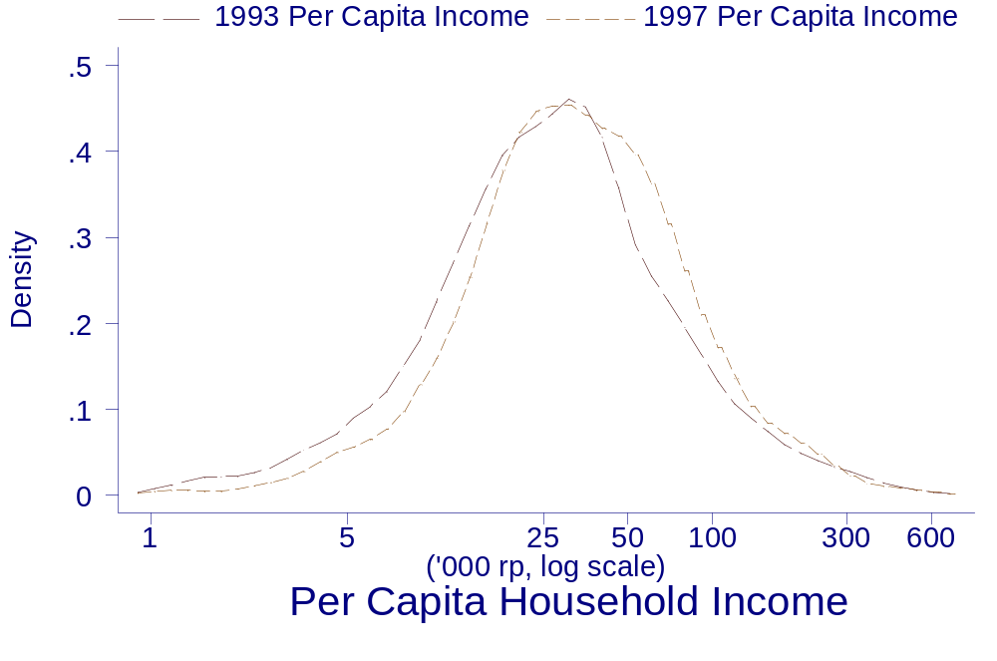
Figure 2
Distribution of Local Rainfall, 1992-1993

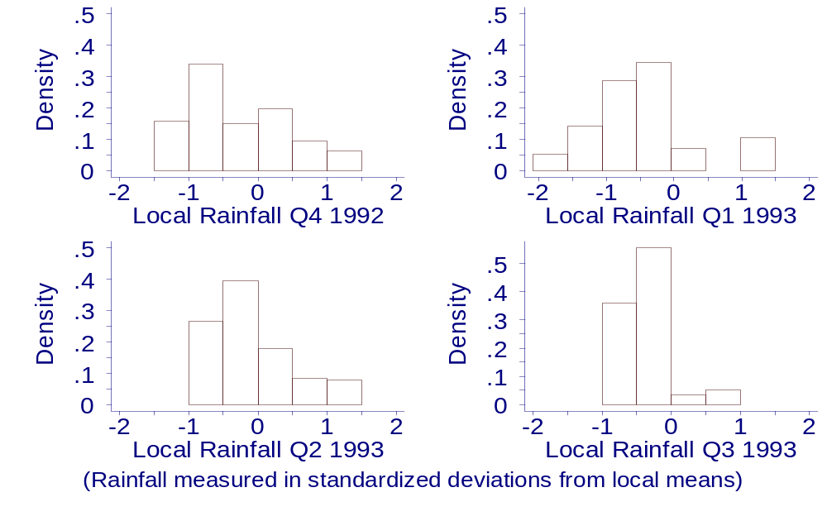

Figure 3
Distribution of Net Assets Purchased, 1992-1993
(Of those with non-zero purchases)
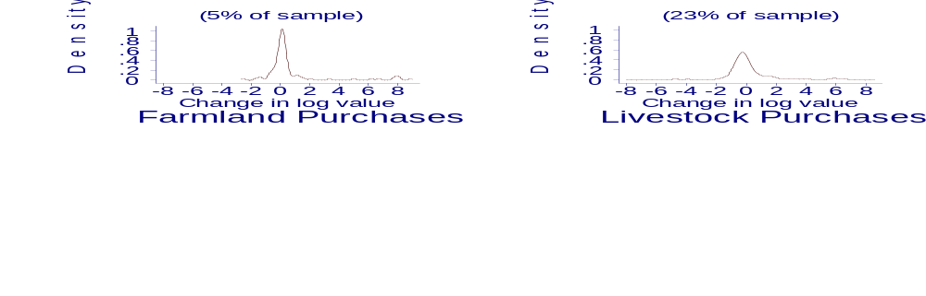

Figure 4
Cumulative Density of Log Per Capita Income, Conditional on
Pre-determined Household Characteristrics, by Rainfall Group.

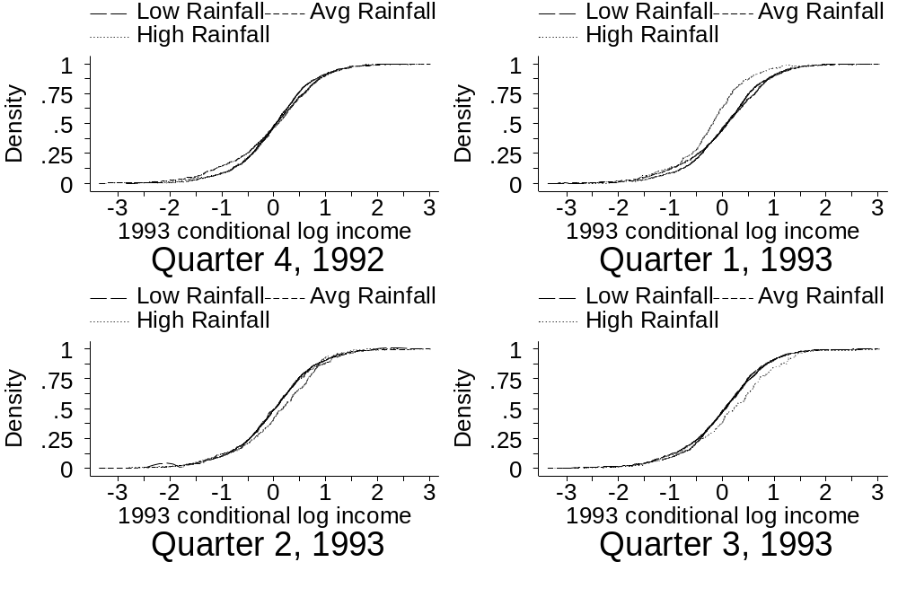
Average
High
High
High

Average rainfall indicates that the average of the standardized monthly rainfall levels reported from the nearest station, taken over the indicated quarter, is between –0.5 and 0.5. High and low rainfall households’ standardized rainfall averaged above 0.5 or below –0.5, respectively, over the indicated quarter.

Figure 5
Distribution of Predicted Permanent Income

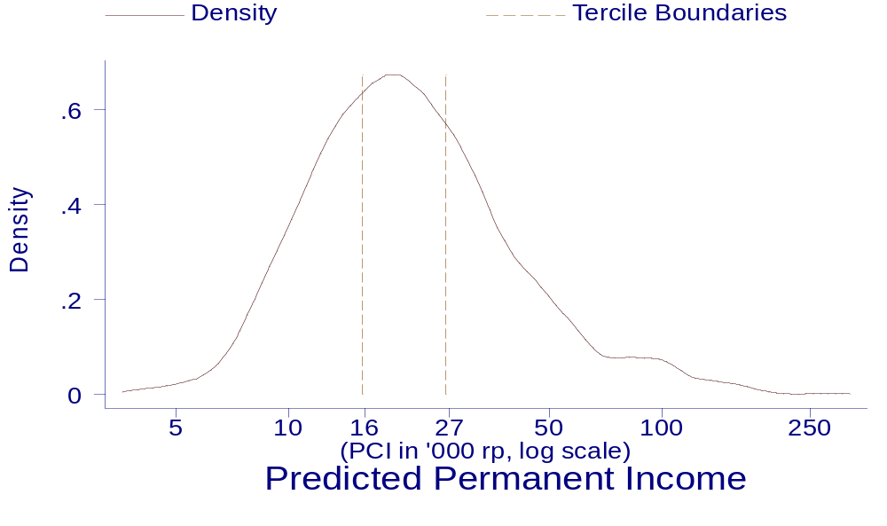

Figure 6
Distribution of Predicted 1993 Transient Income

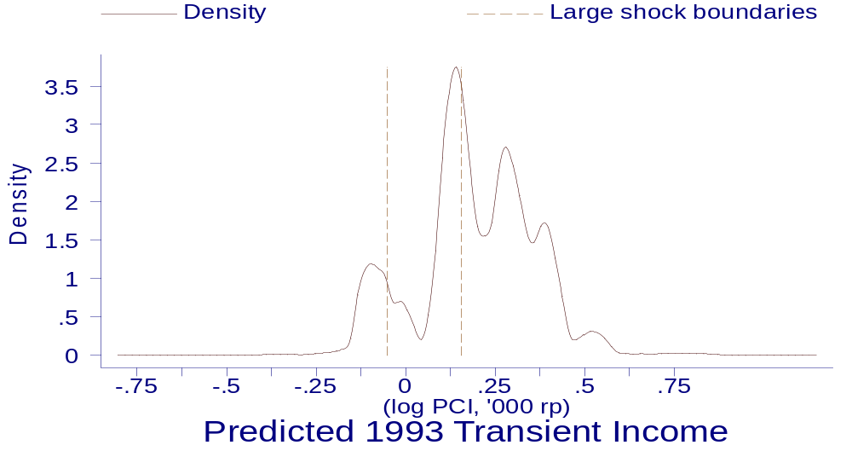
Figure 7
1997 income, conditional on pre-determined characteristics, smoothed against predicted 1993 transient income.

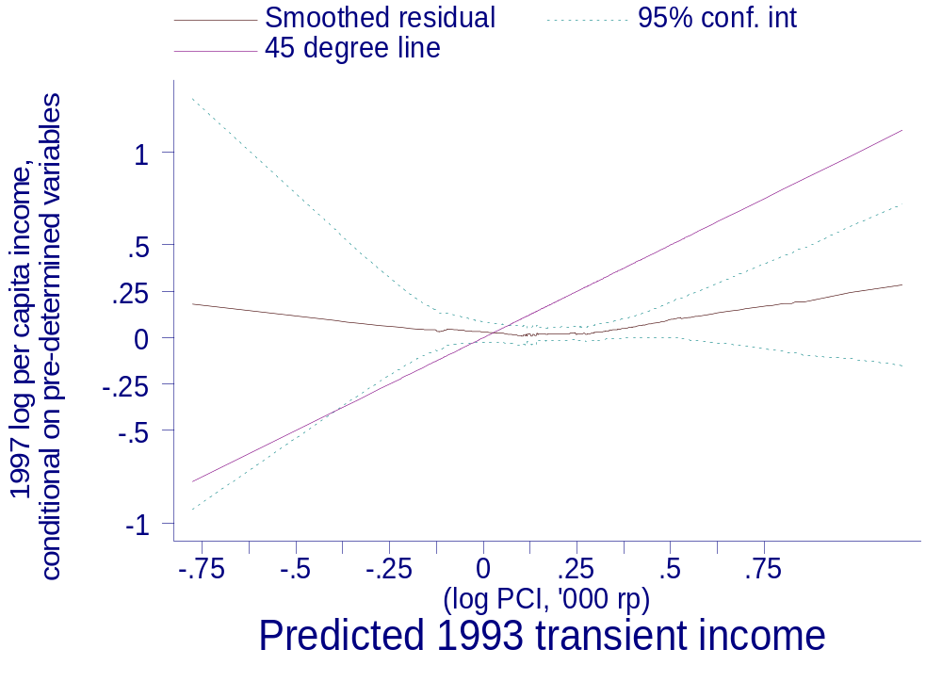
Figure 8
1997 income, conditional on pre-determined characteristics, smoothed against predicted 1993 transient income, by household's economic class.

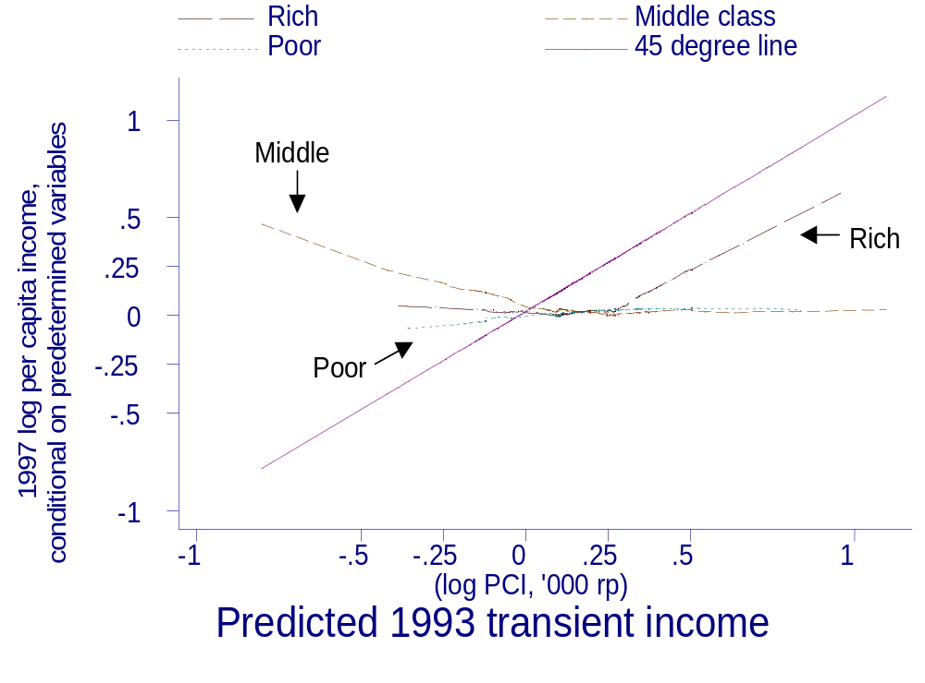

* Corresponding author: Department of Economics, Cornell University, Ithaca, NY 14850. Tel.: +1-607-277 -7008. Email: dln10@cornell.edu. I thank John Abowd, Christopher Barrett, Gary Fields, George Jakubson, Ravi Kanbur, and Joseph Newhouse for their helpful comments.
Both Grootaert and Kanbur, and Fields et al, actually regress income change on a set of control variables, which includes lagged income. The persistence reported above equals the estimated coefficients on initial income plus one, which is equivalent to the coefficient on lagged income from a regression of current income on lagged income and the same set of control variables.
Patterns of attrition in the IFLS is described in more detail in Thomas, et al (2001).
Under the assumption that household size enters the household income equation additively.
There are two other reasons why these data do not reflect the effects of the economic crisis. First, households were asked to report income obtained during the previous twelve months. Second, initial evidence shows that nominal wages stayed relatively constant during the start of the crisis. Although the government’s inflation numbers jump in November and December, that jump is still a small factor in the 1997 price index that was used to deflate incomes in this study.
Throughout this section, the F functions correspond to their equation number.
Prices are assumed constant across households. Relaxing this assumption complicates the model but does not change the empirical specification.
The head of the household is defined as the top prime-age earner, where prime age is between 18 and 50. If there is no prime-age earner, the head is defined as the top earner. If nobody in the household works, the head is defined as the reported household head.
A qualification: Additional income obtained through labor supply coping mechanisms may persist longer than the persistence of income obtained through a one-time rainfall shock. In this case, estimated persistence may be an overstatement of the persistence of one-time income shocks like rainfall, even though the persistence parameter defined in equation (12) is still estimated consistently.
See Frankenberg, et al, 1999, for evidence on the important role of income transfers from non-coresident children in Indonesia.
Evidence from Cote d’Ivoire indicates that rainfall shocks affect investments in children’s schooling (Jenson, 2000), while Indonesian data indicate that the poorest households made the greatest cutbacks in schooling investments during the economic crisis (Thomas, et al, 2001)
In the 1993 survey, the survey did not interview all adults individually and for adults not separately interviewed, earnings estimates provided by the head’s spouse were used. In the 1997 survey, data from the labor earnings module was not publicly available as of November 2002, and therefore earnings estimates given by the head’s spouse were used for all household members.
This measure of self-consumed income may overstate the value of income as it does not account for inflation (Paxson, 1993); on the other hand, it may understate the value of home consumption by valuing self-produced food at the selling price rather than the buying price.
The log of missing income components were predicted using related household characteristics, and subsequently transformed into currency units using a smearing transformation (Duan, 1983)
Figures 6 and 7 were created using a running line smoother, which smoothes points against its nearest neighbors non-parametrically. An algorithm selects, for each point, the optimal number of nearest neighbors to smooth against in order to minimize mean squared error. This procedure is similar to local weighted regression (lowess); the difference is the lack of a kernel weighting function.

