The Dynamics of

Global Urban Expansion

Shlomo Angel, Stephen C. Sheppard and Daniel L. Civco

With

Robert Buckley, Anna Chabaeva, Lucy Gitlin,
Alison Kraley, Jason Parent, and Micah Perlin

Transport and Urban Development Department
The World Bank

Washington D.C., September 2005

© 2005 Department of Transport and Urban Development, The World Bank

Disclaimer: The opinions and the information presented in this report are the sole responsibility of the authors of the report, and in no way reflect the policies of the World Bank. Care has been taken to avoid mistakes, and the remaining mistakes are also the sole responsibility of the authors of the report.
Cover images:
Background⎯Digital Globe Quickbird image of London, 28 July 2002.
Inset⎯28 May 1989 (red) and 19 June 2000 (yellow) built-p pixels of London superimposed on Landsat data.
An electronic version of this report is available at http://www.williams.edu/Economics/UrbanGrowth/DataEntry.htm.
Please address all inquiries to Dr. Shlomo Angel at solly.ny@verizon.net, Dr. Stephen C. Sheppard at stephen.c.sheppard@williams.edu; or to Dr. Daniel L. Civco at dcivco@canr.uconn.edu.

ABSTRACT

This study examined the dynamics of global urban expansion by defining a new universe of 3,943 cities with population in excess of 100,000 and drawing a stratified global sample of 120 cities from this universe. Population data and satellite images for two time periods⎯a decade apart⎯were obtained and analyzed, and several measures of urban extent and expansion⎯among them the built-up area of cities and the average density of the built-up area⎯were calculated. Data for 90 cities out of the global sample of 120 is presented and analyzed in this report. Weighted averages of the built-up area and the average density, as well as compactness and contiguity measures⎯and their change over time⎯are presented for nine regions, four income groups and four city size groups covering the entire globe. Densities in developing-country cities were found to be some three times higher than densities in cities in industrialized countries, and densities in all regions were found to be decreasing over time. If average densities continue to decline at the annual rate of 1.7%⎯as they have during the past decade⎯the built-up area of developing-country cities will increase from 200,000 km² in 2000 to more than 600,000 km² by 2030, while their population doubles. Ten econometric models that sought to explain the variation in urban extent and expansion in the universe of cities were constructed, and several hypotheses postulated by neoclassical theories of urban spatial structure were tested. All tests yielded R² values in excess of 0.80. The policy implications of the analysis are presented and discussed. The Central message of this study is quite clear: Developing country cities should be making realistic⎯yet minimal⎯plans for urban expansion, designating adequate areas for accommodating the projected expansion, investing wisely in basic trunk infrastructure to serve this expansion, and protecting sensitive land from incursion by new urban development.

TABLE OF CONTENTS

I BACKGROUND AND OBJECTIVES 1

- The magnitude of global urban expansion 1
- The implications of urban expansion 2
- Concerns about urban expansion 4
- The form of urban expansion 5
5. The consequences of urban expansion 6
6. The forces shaping urban expansion 8
7. Measuring urban expansion 9
8. Urban expansion policies 11

II THE RESEARCH DESIGN AND THE SAMPLE OF`CITIES 14

- Introduction 14
- The rationale for sampling 15
- The initial universe of cities 16
- Metropolitan areas as individual data units 17
- Sample size 17
- Sample stratification 18
- Sample selection 21
- The new universe of cities 22
- The provisional sample of 90 cities and the assignment of weights 23

III THE Classification OF Urban Land Cover
USING Remote Sensing 31
- Overview and Rationale 31
- Landsat 33
- The Remote Sensing Process 34
- The Thematic Extraction Algorithm 36
- Selection of Landsat Imagery 40
- Image Classification Protocol 40
- Accuracy Assessment 45
8. Results and Discussion 47

IV MEASURING URBAN EXTENT AND EXPANSION 49
  - Overview and rationale 49
2. Acquiring and processing city district boundaries 52
3. Calculating the built-up area of cities 53
4. Estimating the population and built areas for cut-off districts 54
- Estimating basic measures of urban extent and expansion
in regions, income groups and city size categories 55
- Acquiring elevation and deriving slope 59
- The incorporation of slope and water data into
the land use classifications 61
8. The Consolidated Built-up Area and the Buildable Perimeter 63
9. The Contiguity Index as a measure of urban spatial structure 64
- The Compactness Index as a measure of the extent
to which a city is fully-built 68
11. The Openness Index 71

V MODELING URBAN EXTENT AND EXPANSION 74
- The role for analytic models of urban extent and expansion 74
- Theory and hypotheses explaining urban expansion 76
- The collection of data for the analysis of urban expansion 79
- Models of urban extent and urban expansion 82
- Models of urban compactness and contiguity 87
- Conclusions and directions for further research 89
VI THE POLICY IMPLICATIONS OF THE CURRENT FINDINGS 91
- Anticipating the scale of change 91
2. The anticipated impact of Compact City policies 93
3. Urban expansion policies 95
4. Regulating urban expansion 97
5. The active management of urban expansion in developing countries 99
6. The costs of failure 101

VII CITY DATA SHEETS 103

REFERENCES 194

ACKNOWLEDGEMENTS 200
I BACKGROUND AND OBJECTIVES

1. The magnitude of global urban expansion
The population in developing-country cities is expected to double in the next thirty years: from some 2 billion in 2000 to almost 4 billion in 2030. According to our own preliminary estimates, cities with populations in excess of 100,000 contained 1.7 billion people in 2000, and their total built-up area ⎯at average densities of some 8,000 persons per square kilometer⎯was of the order of 200,000 square kilometers at that time. If average densities continue to decline at the annual rate of 1.7%⎯as they have during the past decade⎯the built-up area of developing-country cities will increase to more than 600,000 square kilometers by 2030. In other words, by 2030 these cities can be expected to triple their land area, with every new resident converting, on average, some 160 square meters of non-urban to urban land during the coming years.
In parallel, the urban population of industrialized countries is now expected to grow by 11% in the next thirty years: from some 0.9 billion to 1 billion. According to our own provisional estimates, cities with population in excess of 100,000 contained some 600 million people in 2000, and their total built-up area ⎯at average densities of almost 3,000 persons per square kilometer⎯was of the order of 200,000 square kilometers at that time. If average densities continue to decline at the annual rate of 2.2%⎯as they have during the past decade⎯the built-up area of industrialized-country cities will increase to some 500,000 square kilometers by 2030. In other words, by 2030 these cities can be expected to increase their populations by 20% and their land areas by 2.5 times, with every new resident converting, on average, some 500 square meters of non-urban to urban land.
In total, urban built-up areas in the world consumed some 400,000 square kilometers in 2000, or 0.3% of the total land area of countries, estimated at some 130 million square kilometers. The land taken up by cities amounted to some 3% of arable land, estimated at 14 million square kilometers in 2000. Cities are now expected to grow 2.5 times in area by 2030, consuming some 1 million square kilometers, or 1.1% of the total land area of countries. They may possibly consume as much as 5−7% of total arable land, depending on the future rate of expansion of arable land, which is currently 2% per annum.

2. The implications of urban expansion
What are the implications of the accelerated rate of global urban expansion and what can or should be done about it?
The basic dimensions of the policy debate on the expansion of cities are certainly not new. The age-old question underlying this debate is still whether expansion should be resisted, accepted, or welcomed. At one extreme, there have been those who fought to limit the growth of cities by any and all means. At the other, there were those who welcomed it and actively prepared cities for absorbing the oncoming waves of new migrants. Two historical examples⎯one from London and one from New York⎯can serve to frame this debate.
In 1580, under pressure from the influential guilds, which were fearful of competition from recently arrived craftsmen, Queen Elisabeth issued a proclamation restricting development near and within the city. Enacted by Parliament in 1592, her decree had three major provisions: to prohibit “any new building of any house or tenement within three miles of any of the gates of the said city of London; to restrict the construction of habitations ‘where no former house has been known to have been’; and to forbid in any house “any more families than one only to be placed”…. [B]etween 1602 and 1630, no fewer than fourteen such proclamations were enacted in attempts to limit London’s growth.
In contrast, in 1811, when New York City had only 100,000 people crowded into the southern tip of the island of Manhattan, three Commissioners⎯Morris, de Witt Clinton and Rutherford⎯ drafted a plan to expand its street grid so as to prepare for more than a tenfold increase in the city’s population. In presenting their now-famous plan, the Commissioners remarked:
To some it may be a matter of surprise that the whole island has not been laid out as a city. To others it may be a subject of merriment that the commissioners have provided space for any population that is collected at any spot on this side of China.
Four hundred years have passed since the Queen’s proclamation and two hundred years since the Commissioners’ plan. Still, the fundamental question of whether urban expansion should be resisted, accepted or welcomed is still with us today and is still largely unresolved. While many will readily agree that urban expansion is an issue of serious concern, there is no consensus among scholars, policy makers or urban residents themselves about whether further development should be restricted or encouraged. In the US, for example, respondents to a survey in 2000 by the Pew Center for Civic Journalism “were almost evenly split between those wanting local government to limit further development to the infilling of already built-up areas and those wanting local government to also plan for and encourage new development on previously undeveloped areas”.
In industrialized countries, where rural-urban migration is now minimal and where most population movements are now inter-urban or intra-urban, there have been recent attempts to provide answers to this question that are particularly relevant to their present level of urbanization and development. Concerns for unwieldy urban expansion⎯ typically castigated as “sprawl”⎯have recaptured the attention of both policy makers, academics and, more recently, voters during the last decade. In contrast, we note, virtually no attention has been paid to this issue in developing countries, where levels of urbanization and development are typically lower, where rural-urban migration has by no means ebbed, and where most urban population growth is about to take place.
The central objective of the Urban Growth Management Initiative is to examine the available policy options for confronting the projected urban expansion in the cities of developing countries. In other words, it seeks an answer to the question of what can and should be done about it. This demands gaining a better understanding of the key dimensions of this expansion as well as of the forces that are driving it globally, regionally and locally, so as to be able to consider carefully the kinds of policies that are likely to be effective, efficient, equitable and sustainable, while keeping in mind that such policies may be quite different from those available or of interest in industrialized-country cities.
Why should we concern ourselves with the projected spatial expansion of developing-country cities? Does urban expansion take place in substantially different forms, or it is essentially identical everywhere? Does it really matter in what form it takes place? What are the forces that are now shaping urban expansion? How can we measure urban expansion in meaningful ways that address our concerns? What are the key policy areas that have a bearing on shaping urban expansion? At this early stage, the Urban Growth Management Initiative seeks to begin to provide meaningful answers to these questions and to lay the foundations for fruitful research on and effective action to manage urban expansion in developing-country cities.

3. Concerns about urban expansion
Why should we concern ourselves with the projected spatial expansion of developing-country cities, and why now?
Considering that research and policy interests are often subject to fashion and that such fashions originate in the metropolitan centers of industrialized countries, we should suspect that the recent concerns with “sprawl” would be diffused globally, and sooner rather than later. These concerns have now become paramount, especially in the United States:
In 1998, New Jersey voters approved a plan to buy one million acres of undeveloped land (20% of the state’s total land area) using state funding, to ensure that this land is never developed. Between 1998 and 2002, another 620 ballot measures allocating $25 billion in public funds for land conservation measures were approved by voters across the United States. Sprawl, and urban land development more generally, have become central topics in election campaigns, the main concerns of some of the most prominent environmental groups, and a constant subject of media attention. In fact, sprawl and land development tied with crime and violence as the most important local issue for Americans in a recent survey by the Pew Center for civic Journalism.
Given the attention to “sprawl” in the centers of opinion-making, and given that most data on “sprawl”⎯on both its causes and its consequences⎯is only available in industrialized countries, there is a danger that our understanding of urban expansion and the actions chosen to confront it will be unduly influenced by established concerns or by tested policies that are largely irrelevant to developing-country cities. In these cities, public and private resources, development priorities, and modes of governance⎯to name a few⎯are quite different from those prevailing in the industrialized countries and, as such, merit different analyses and different policy responses. This study seeks to generate new data for the dimensions of urban expansion in developing-country cities and the forces shaping it, so that they can be compared to those in industrialized-country cities, and so that the commonalities and differences between them can be better understood.

4. The form of urban expansion
Does urban expansion take place in substantially different forms, or is it essentially identical everywhere?
Urban expansion takes places in substantially different forms. In any given city, new urban expansion can take place with the same densities (persons per square kilometer) as those prevailing in existing built-up areas, with increased densities, or with reduced densities. It can take place through the redevelopment of built-up areas at higher densities, through infill of the remaining open spaces in already built-up areas, or through new “greenfield” development in areas previously in non-urban use. New greenfield development can either be contiguous with existing built-up areas or can “leapfrog” away from them, leaving swaths of undeveloped land that separate it from existing built-up areas. It can encroach upon wetlands, watersheds, forests, and other sensitive environments that need to be protected, as well as upon farms, fields, and orchards surrounding the city. And it can thus reduce, maintain or increase open space in and around the city.
New expansion can contain a higher, equal, or lower percentage of residential areas vis-à-vis employment opportunities. New employment opportunities, as well as new residences, can be centralized in a small number of locations or spread out over entire newly urbanized areas. Expansion may take place along corridors, resulting in a star-shaped or elongated city, or in areas closest to the city center, resulting in a more-or-less circular city. It can be orderly⎯properly laid out in simple geometric forms⎯and it can be disorderly. It may leave adequate rights-of-way for roads and other necessary infrastructure, or it may leave too little or too much land for roads. The infrastructure accompanying urban expansion may be of varying quality, reflecting very different levels of investment, maintenance and repair. New land development can be largely legally sanctioned, conforming to strict zoning for separate land uses or to mixed zoning for mixed land uses. It can also be largely illegal, entailing either squatter invasions, informal land subdivisions, non-compliance with zoning and building codes, or construction both on steep slopes and in flood plains, which can be subject to mudslides and inundation, respectively.
One of the aims of the study is to examine the different forms that urban expansion takes by looking at the size and shape of built-up areas in a global sample of 120 cities and associating them with their populations. This is done, as we shall detail in the next chapter, by first classifying satellite images of these cities in two time periods⎯approximately a decade apart⎯into built-up and non-built-up areas; by then associating these built-up areas with the populations residing in them in the two time periods, using available census data for the appropriate administrative districts comprising the urban area; and finally by deriving, for each city in the sample, a number of metrics associated with urban extent and expansion.
These metrics make it possible to examine the extent to which different cities fall into different urban expansion “regimes” or cohorts. Comparative research on economic growth and convergence among different countries, for example, has found such division of countries into groups, based on initial conditions, to be important in understanding why economic growth proceeds at persistently different rates in different countries. Using similar techniques, we identify the variables that distinguish groups of cities that display a similar within-group structure of urban expansion. This provides a useful scientific insight into the structure of urban expansion and its sensitivity to initial conditions, as well as a superior foundation for policy recommendations tailored to the individual characteristics of each metropolitan area.

5. The consequences of urban expansion
Does it really matter in what form urban expansion takes?
The available evidence⎯although spotty, controversial, and not necessarily applicable to developing-country cities ⎯suggests that the above-mentioned differences in the growth and expansion of cities are associated with both positive and adverse outcomes that affect the welfare and wellbeing of their citizens. Some outcomes associated with urban expansion⎯e.g. the increased production of greenhouse gases associated with increased car travel in low-density cities⎯may even transcend urban boundaries.
In most cases, however, it is difficult to speak of the “consequences” of different forms of urban expansion, because the cause-and-effect relationships between different phenomena are all too often hard to ascertain. To take one example, say lower-density cities are found to be associated with higher level of car use. Does that imply that lower-density cities require higher levels of car use or that the ready availability of cars makes lower-density cities possible? Or, to take another example, say lower-density cities are associated with lower house prices and hence with larger houses. Can we conclude that larger houses are the consequence of lower urban densities or are the preferences for larger houses driving densities down?
Leaving aside the issue of causality for the moment, the available literature is rife with blame for inappropriate⎯and therefore unnecessarily costly⎯urban expansion. Most blame is directed at expansive, leapfrogging “greenfield” development. It is claimed that such development reduces both access and view of open space; it encroaches on sensitive environments and on prized farmland; it requires longer journeys to work; it leads to higher levels of car use and therefore to higher levels of air pollution, energy use, and the production of greenhouse gases; it increases dependence on cars; it is careless about the carless; it makes public transport less attractive and less efficient; it requires longer and more costly extensions of public infrastructure networks; it imposes additional costs (externalities) on sitting residents; it diverts construction away from central areas that need to be redeveloped; it reduces social interaction and makes for a less exciting urban lifestyle; and it increases alienation, social fragmentation, and both economic and racial segregation.
Some of these claims are disputed: despite massive urban expansion, the amount of land in farm use, in the US for example, has not been reduced; journeys to work are found to be shorter when jobs decentralize together with residences; leapfrogging is temporary and the open spaces left by leapfrogging are soon filled with new development; segregation is, in fact, reduced in low-density cities; lower densities reflect the preferences of homeowners and businesses for bigger homes and low-rise living and working environments, respectively; and it is cheaper transport technology⎯affordable private cars, for the most part⎯that has driven low-density urban expansion, and not the other way around.
Some of the claims of the critics of “sprawl” are not disputed, but it is argued that its adverse effects can be remedied without changing its basic character: air pollution, excessive energy use, and the production of greenhouse gases can be and are being ameliorated with the adoption of new automobile technology; congestion can be effectively reduced with appropriate road pricing; sensitive environments and open space can be protected by public acquisition of development rights through conservancies; externalities associated with new development can be internalized by imposing appropriate taxes; and, at least in some cities, central areas can and are being revitalized as suburban residents return to the city seeking a more fulfilling urban lifestyle.
Finally, there are claims that low-density “sprawl” may in fact lead to more efficient and more rapid economic development; to more rapid job creation; to more affordable and thus larger housing, and to lower levels of shelter deprivation; to higher rates of home ownership; to cheaper and better public services; to satisfactory levels of social interaction; and to a better and higher quality of life.
One of the principal aims of this study is to shed light on some of the more important associations between different measures of urban expansion and different aspects of welfare, particularly as they pertain to developing-country cities. At this stage of the study, however, it will not be possible to examine many of the claims outlined here in a rigorous manner. Some—but certainly not all—of this work is left to the second stage of the study, already under way, when local consultants in each city will collect more detailed data on the ground.

6. The forces shaping urban expansion
What are the forces that are currently shaping urban expansion?
Again, leaving aside issues of determining actual causality⎯endogeneity issues, as they are referred to in statistical analyses⎯a number of hypotheses have been advanced to explain the volume, the characteristics, and the dynamics of urban expansion. Some of these hypotheses have, in fact, been tested using large bodies of data from industrialized-country cities. Differences in the form of urban expansion have been attributed to six different types of effects: the effects of the natural environment; the effects of demographics; the effects of the economy; the effects of the transport system; the effects of consumer preferences for proximity; and the effects of governance.
More specifically, aspects of the natural environment that may affect urban expansion include those of climate, slope, insurmountable barriers, and the existence of drillable water aquifers. Demographic effects may include rural-migration and natural population growth in the city, the level of urbanization in the country, and the rank of the city in the country’s urban hierarchy. Aspects of the economy that can affect urban expansion include the level of economic development, differences in household incomes, exposure to globalization, the level of foreign direct investment, the degree of employment decentralization, the level of development of real estate finance markets, the level and effectiveness of property taxation, and the presence of cycles of high inflation.
Aspects of the transport system that affect urban expansion may include the introduction of new transport technologies and most notably the private automobile, transportation costs vis-à-vis household incomes, the level of government investment in roads, the existence of city centers that were already developed before the advent of the automobile, and the existence of a viable public transport system. Consumer preferences that may affect the form of urban expansion include: preferences for proximity to open space, for single-family dwellings, or for home ownership; preferences for urbanism as a way of life, for proximity to other people and to urban amenities, or for proximity to one’s place of work; and preferences for “flight from blight” or its converse, the appeal of gentrified neighborhoods in the inner city.
Variations in the form of governance that may affect the form of urban expansion may include the country’s legal origin as well as its more recent totalitarian as against democratic past; the number of independent municipal governments in the metropolitan area; the share of the metropolitan area not incorporated into towns; the share of land in the metropolitan area in public ownership; the existence of an effective metropolitan planning agency; and the type, strictness, and quality of enforcement of various urban development controls.
One of the cardinal objectives of this study is to test these hypotheses as they pertain to a global sample of 120 cities. In the first stage of the study, now complete, we focus on testing a number of these hypotheses using the urban expansion data generated by the study and the available data on causal factors that does not necessitate data collection in each individual city. In the second stage of the study, now already under way, an additional number of hypotheses will be tested using data collected on the ground by local consultants in each city in the sample.

7. Measuring urban expansion
How can we measure urban expansion in meaningful ways that address our concerns?
Clearly, it will not be possible to test any hypotheses regarding the form and shape of urban expansion unless they can be properly measured. Until recently, however, when it came to measuring urban expansion in a rigorous comparative framework, there were no reliable data available for deriving even the simplest of measures.
The average density of population in the city, for example, could provide a ready and robust measure of whether a city were more compact and less sprawling than another city. But if the average urban density could only be derived by dividing the population of the metropolitan area by the administrative area contained within its official boundaries, it would be a highly unreliable measure, simply because it would vary with the definition of the metropolitan boundaries. The absence of good data on the built–up areas of cities has lead some analysts to reject average urban density altogether, as an imprecise—and therefore a less–than–useful—measure, even though the change in that measure is arguably the most robust measure of urban expansion.
One of the aims of this study is to resurrect the use of the average density by using the actual built-up area of the city (rather than its administrative area) in the denominator, so that average density measures the population per square kilometer of built-up area in the city. Conversely, we can measure its reciprocal: the average number of square meters of land consumed by every resident in the city. Both average density and average built-up area per person have now been derived using the classification of built-up and non-built up areas in Landsat images for two time periods⎯approximately a decade apart⎯and combined with district-level population data for a global sample of 120 cities.
Still, while average built-up area density and land consumption per person do provide two meaningful measures of urban expansion, they may still fall short of describing “sprawl”, for example, in a meaningful way that corresponds to our intuitive perception of sprawl. The leapfrogging aspect of urban sprawl, for example, cannot be picked up by these measures. Thus, if the built-up pixels in an urban district are found to be all contiguously aggregated in one single location or spread out thinly throughout the district, the average density of such a district as measured in this study will be the same in both cases. Similarly, if the built-up area of the city is a fully-built compact circle or a star-shaped form with arms extending in several directions, the average built-up area density of the city in both cases will be the same.
Burchfield, Overman, Puga and Turner make the following observation about US cities:
We find that only 0.3% of the 1992 residential development is more than one kilometer away from other residential development. On the other hand, if we consider a finer spatial scale, we find that 43% of the square kilometer surrounding an average residential development is undeveloped. Thus while there is no large-scale leapfrogging, residential development is not particularly compact.
The authors suggest that “a natural city-level measure of sprawl is the average percentage of undeveloped land within one kilometer of new residential development in each metropolitan area.” They use this measure to compare levels of sprawl in UN cities as well as to explain variations in these levels among cities. This measure is particularly sensitive to micro levels of leapfrogging. It is an important dimension of urban sprawl because, as noted earlier, this type of leapfrogging may remove more peripheral land than necessary from rural uses, and because it may extend urban infrastructure networks further than the minimum necessary at present to connect new urban areas to existing ones. Conversely, it is an important measure of openness⎯the access and visibility of open space⎯that people seek when they leave the inner city in favor of the urban periphery. In this study, we adopt a similar procedure to that proposed by Burchfield et al. to construct an Openness Index that measures the average percentage of non-built up area in a 1-km.-diameter circle surrounding each built-up pixel in the city.
Although both average built-up area density and the Openness Index discussed above are meaningful measures of the form of urban expansion, they leave important aspects of this form unexplored. Some authors have attempted to measure the compactness of cities as the extent to which the footprint of the urban area corresponds to a circular disk. Several such measures have been discussed in the literature, mostly in association with the compactness of election districts in the United States. In this study we explore a Compactness Index that measures the extent to which the built-up area of the city resembles a circular disk.
If access or proximity to open space at the urban periphery is an important amenity, then urban residents will have an incentive to build at the periphery. This may give rise to market failure because new construction will not internalize the loss of the value of open space to sitting residents. In some circumstances, this external cost can be reduced by developing peripheral land in “fingers” that extend out, reducing its compactness and thus increasing the total perimeter of the urban area and making available a larger number of residential sites with access or proximity to open space. These considerations suggest that there are several complementary measures of urban expansion, each one of them meaningful in its own way.
One of the principal aims of this study is to test different measures of urban extent and expansion, to develop new measures, to compare these measures in a global sample of cities, and to explain variations in these measures among cities using a variety of econometric models. The better we understand the how and why of urban expansion, the more effective our employment will be of any policies designed to modify and shape it to our liking, and the more intelligently we can deliberate on those aspects of urban expansion that need to be managed and those aspects that need to be left alone. In this phase of the study, we report on a number of key measures and proceed to describe several new measures that are presently being tested before applying them to the sample as a whole.

8. Urban expansion policies
What are the key policy areas that have a bearing on the shape of urban expansion?
There are three groups of policy areas that have a bearing on shaping urban expansion:
- Policies that affect or seek to affect rural−urban (or international) migration, both directly and indirectly;
- Policies that affect or seek to affect the distribution of urban populations among cities; and
- Policies that affect or seek to affect the process of urban development in individual cities and metropolitan areas.
The motivations for pursuing policies of the first type are many⎯from concerns that cities are already too big and bursting at their seams, to the romantic longings for a wholesome village lifestyle, and to the need to focus development on rural areas, where the majority of poor people live and work. Policy prescriptions have ranged from increasing agricultural productivity and improving rural education to restricting the movement to cities by requiring residence permits. All in all, even though many governments have attempted to control rural−urban migration flows, most, if not all, of these have ended in utter failure⎯not only in democratic countries that guarantee freedom of movement, but also in non-democratic countries such as the former USSR. In China, one of the very few places where people are still required to have residence permits (Hukou) to live in cities, a floating population of some 80−120 million resided in cities illegally in 2000.
Davis and Henderson, for example, conclude that alternative policy regimes have little impact on the rate of urbanization. They do find, however, that public sector investment policies and political structures have significant impact on the second set of policies defined above, that is, on the system of cities that develops, and on the extent to which the urban population is concentrated in a smaller or larger number of urban places. They also find that urban concentration or “primacy” can have significant implications for the rate of economic growth. Still, effective population distribution policies of both types defined above are few and far between, and while most governments have attempted to employ them in form or another in the past, very few of them can claim success. Again, the former USSR may be a case in point: the repeated attempts to limit the size of Moscow to two million and to redirect the urban population to development regions has failed miserably as Moscow has grown to four times its planned size.
For the most part, the growth of population of a typical city is predicated on its own natural birth and death rates and on its attractiveness to those who see opportunity and promise there. Successful cities, where economic growth is robust, employment is plentiful, urban services are adequate, and the quality of life is high attract people. These cities naturally grow faster than other cities in the country where economic opportunities are few and the promise of a better life is less than convincing. It is hard to imagine, therefore, that the residents or the policy makers of a successful city will agree to curtail its economic growth or to reduce either its level of urban services or its quality of life so as to prevent people or firms from moving in.
The central focus of this study is therefore on the third set of policies mentioned above⎯those that aim at managing the urban development process in individual cities and metropolitan areas in one form or another.
This study seeks to explore the effects of various policy regimes on various measures of urban expansion. It seeks to determine whether, other things being equal, urban expansion in cities pursuing different policy regimes take different shapes and forms. This cannot be determined without seeking information on the policy regime guiding urban development in each individual city in our sample. Collecting such information is one of the key objectives of the second stage of this study, supported by a grant from the US National Science foundation (NSF). In this second phase of the study, now already under way, local consultants are collecting data in municipal offices and in real estate agencies on the policy regimes guiding the urban development process. Once the data is obtained and analyzed, key dimensions of the policy regime governing urban expansion will be quantified and entered into the econometric models seeking to explain variations in different measures of urban expansion in our global sample of 120 cities.
* * *
II THE RESEARCH DESIGN AND THE SAMPLE OF`CITIES

1. Introduction
In the broader context of the study of urbanization, this study focuses on the spatial consequences of urbanization, rather than on the demographic dimensions of the growth of urban populations. It seeks to describe, measure and explain the patterns and dynamics of the urban use of land, and it seeks to do so in a global comparative framework by focusing on a sample of cities of different sizes in all world regions.
The first phase of the study⎯and the one that is reported on here⎯makes four important contributions to the present study of urbanization and urban expansion:
- The global sample of cities: The study introduces a new and improved list of 3,943 cities and metropolitan areas with populations in excess of 100,000⎯the universe of cities⎯ and identifies a global, stratified sample of 120 cities from this universe of cities. This sample is of sufficient size, so as to derive global estimates and global norms, as well as to engage in rigorous econometric modeling than can explain variations⎯as well as change over time⎯ in the urban extent of cities;
- The rigorous classification of remote-sensing data: The study uses an innovative and cost-effective methodology for classifying built-up and non-built up pixels in Landsat satellite images of all the cities in the global sample⎯approximately a decade apart⎯that permits the accurate and detailed measurement of the built-up area of cities and its change over time;
- The construction of metrics: The study defines, constructs and tests a number of descriptive metrics of urban extent and expansion that correspond to our intuitive grasp of these phenomena, making it possible⎯for the first time⎯to estimate urban extent and expansion for the universe of cities by geographic regions, income classes and city size groups;
- The derivation of explanatory models: The study introduces a number of hypotheses and tests a number of econometric models associated with these hypotheses that explain the variation in urban extent and expansion in the sample of cities, using available geographic, demographic and economic data.
The second phase of the study⎯now already under way, supported by a grant from the US National Science Foundation (NSF)⎯improves on the first phase by making two additional contributions:
- Improving the classification of remote-sensing data: Engaging local consultants in each city in the sample to provide ground-truth checks in selected locations, so as to test and improve the initial classification of images;
- Improving the explanatory models: Using data from census and municipal offices, real estate agencies, and visits to informal settlements to improve the explanations of variations in urban extent and expansion among cities, as well as to test several hypotheses regarding the effects of urban extent and expansion on quality of life and on key dimensions of poverty in the sample of cities.
The third phase of the study⎯now already under way as well and supported by the Japanese Trust Fund to the World Bank⎯examines the alternatives available to cities in making effective preparations for absorbing their future population growth in the coming decades. The study will focus on three cities soon to be chosen⎯one in China, one in India and one in Sub-Saharan Africa⎯engaging a consulting firm to collect data, exploring alternatives with groups of local stakeholders, and preparing policy prescriptions for managing urban expansion in these cities in the years to come. The consultants will prepare handbooks so that other cities will also be able to prepare for urban expansion.
The following sections in this chapter will provide greater detail on the universe of cities and sample of cities developed for the study. Subsequent chapters will focus on the classification of Landsat images in the sampled cities into built-up and non-built-up areas; on the development of metrics for measuring urban extent and expansion; and on the development and testing of econometric models that explain urban extent and expansion.

2. The rationale for sampling
Our most recent investigation found a total of 3,943 distinct metropolitan areas that had populations in excess of 100,000 in the year 2000. These metropolitan areas had an estimated population of 2.1 billion, and they constitute the ‘universe’ of cities for the purpose of this study. The actual number of cities in this category may be of the order of 3,500−4,500, and it is indeed both a surprise and a pity that a complete and reliable list of metropolitan areas (with their corresponding latitude/longitude location) does not exist at the present time.
The few global comparative studies of cities undertaken in the past have had to rely on haphazard collections of cities for which data were available, usually in different and non-compatible forms. Needless to say, these were generally either cities in developed countries, or large capital cities in developing countries that are already part of the global network of world cities⎯Buenos Aires, Mexico City, Shanghai, Seoul, or Bangkok to take typical examples. Smaller and lesser-known cities are rarely, if ever, included in global comparative studies. Possible biases are only to be expected in drawing conclusions about the universe of cities from such non-random collections of cities. Even basic questions such as whether, on the whole, cities are becoming more or less compact over time can still not be answered without referring to a properly drawn sample of cities while using identical definitions and procedures for collecting and aggregating data.
This chapter describes how our universe of cities was originally obtained at the outset of the study, how the original⎯as well as the final⎯sample of 120 cities was selected, and how the final sample of cities corresponds to the new universe of cities that emerged from our investigation.

3. The initial universe of cities
Two universes of cities were identified at the time of our initial sample selection in 2003. The first was the matrix of city data prepared by Vernon Henderson at Brown University, as part of a World Bank research project entitled “Successful cities: Determinants of City Growth Rates.” This matrix provided information on the urban population in the period 1950–2000 for 2,719 metropolitan areas that had populations in excess of 100,000 in the year 2000. The second was a list of 4,574 metropolitan areas prepared by the United Nations Human Settlements Programme (UN Habitat). This second list also focused on cities that had populations in excess of 100,000 in the year 2000. Both lists provided exact latitude/longitude locations for most cities.
The difference between the two lists was largely due to: the inclusion in the UN Habitat list of a larger number of smaller-size cities; a more complete listing of Chinese cities; the inclusion of more countries; and more double-counting. Most large cities were included in both lists: the average size of the cities in the UN list not included in Henderson’s list was 250,000 and the median was 150,000. Of the cities not included that were larger than 500,000 almost half were in China. The UN Habitat list also incorporated some countries⎯ e.g. Algeria, Libya and North Korea⎯not included in Henderson’s list. And finally, the UN Habitat list included more cities that were part of larger metropolitan areas⎯e.g. Giza, which is part of greater Cairo; Quezon City, which is part of Metro Manila; and St. Paul, which is part of the metropolitan area of Minneapolis−St. Paul.
The research team created a new universe of cities in mid-2005 by combining the UN Habitat list of 4,574 cities with an updated list of 2,884 cities provided by Henderson into a new, comprehensive list of 3,943 cities. In this new list, most double counting was eliminated, cities for which an exact location could not be found were eliminated, and cities that were estimated to be part of larger metropolitan areas were eliminated as well. An explanation of the procedure used to derive this new universe of cities appears in Section 7 of this chapter.

4. Metropolitan areas as individual data units
It is important to note at the outset that the focus of this study is on metropolitan areas rather than on city administrative jurisdictions, and that the satellite images, the population data, and the derived measures of urban extent and expansion all pertain to metropolitan areas. Indeed, both the Henderson and the UN Habitat lists sought to focus on metropolitan areas, rather than on individual city jurisdictions, so as to avoid double-counting of cities that were part of larger metropolitan agglomerations. This is by no means a simple and well-defined task. It is often difficult to determine how far a metropolitan area extends or⎯in the cases of the U.S. Eastern Seaboard or Japan’s Kanto plain, for example⎯where one ends and another begins. In other cases⎯say, in Yulin, China, for example⎯it is difficult to tell where the city ends and the rural area begins as they gradually dissolve into each other. In addition, given the paucity of travel data, one cannot rely on commuting patterns to determine the outer limits of functional metropolitan areas. The lists of metropolitan areas, therefore, can only be taken as provisional lists of loosely defined but unique urban places, where initial attempts have been made to agglomerate all contiguous urban jurisdictions into single metropolitan areas. The lists themselves are thus to be considered work in progress, as we shall see more clearly in Section 7 below.

5. Sample size
UN Habitat selected a sample of 355 cities from its universe of 4,574 cities, drawing approximately 40 cities in each of nine world regions. In addition, it selected a small sub-sample of 35 cities from this larger sample. The method of sampling used by UN Habitat involved selecting approximately 40 cities at random in each region of the universe of cities, so that the probability of being selected was proportional to the population in each city. Larger cities therefore had much higher probabilities of being selected than smaller ones. Considering that future funding for collecting global city data on a regular and sustained basis is likely to be rather limited, the study team decided to use the two UN Habitat samples as the basis for creating a new sample. This should increase the probability that, in the coming years, the data collected for the present study could be supplemented and updated by panel data to be collected by UN Habitat in its larger sample.
The study team considered the size of the sample necessary to derive global norms and estimates as well as to model global urban extent and expansion. While there was no rigorous analytical procedure employed in deciding on the exact sample size of 120, it was determined at the outset that 35 cities would be too few and 355 would be too many. It was also determined that a sample of 120 cities would be adequate for deriving statistically-significant results for the universe of cities as a whole, provided it was a stratified sample. In a stratified sample, each city in the sample represents a group of cities in the universe and is given a weight that is proportional to the share of the population of this group in the total population of the universe. The weight given to each city in the sample is then used in calculating global measures of urban extent and expansion, as well as in the statistical modeling of these measures.

6. Sample stratification
Three important characteristics were used to define the strata in our stratified sample of 120 cities: (a) the world region in which the city is located; (b) city size; and (c) the level of economic development of the country in which the city is located, measured by Gross National Income (GNI) per capita. The universe of cities was divided into nine regions, into four size categories, and into four per–capita income groups:
Table II-1: Comparison of the Study Sample with the Universe of Cities, by Region
 | Urban Pop. | Cities | Sample Population |  | Sample Cities
Region | in 2000 | in 2000 | Population | % | Number | %
East Asia & the Pacific | 410,903,331 | 550 | 57,194,979 | 13.9% | 16 | 2.9%
Europe | 319,222,933 | 764 | 45,147,989 | 14.1% | 16 | 2.1%
Latin America & the Caribbean | 288,937,443 | 547 | 70,402,342 | 24.4% | 16 | 2.9%
Northern Africa | 53,744,935 | 125 | 22,517,636 | 41.9% | 8 | 6.4%
Other Developed Countries | 367,040,756 | 534 | 77,841,364 | 21.2% | 16 | 3.0%
South & Central Asia | 332,207,361 | 641 | 70,900,333 | 21.3% | 16 | 2.5%
Southeast Asia | 110,279,412 | 260 | 36,507,583 | 33.1% | 12 | 4.6%
Sub-Saharan Africa | 145,840,985 | 335 | 16,733,386 | 11.5% | 12 | 3.6%
Western Asia | 92,142,320 | 187 | 18,360,012 | 19.9% | 8 | 4.3%
Total | 2,120,319,475 | 3,943 | 415,605,624 | 19.6% | 120 | 3.0%

a. Geographic regions: UN Habitat used a breakdown of countries into nine regions to draw its sample of 355 cities, and it is this regional classification that was used for constructing our study sample. The nine regions are: (1) Europe—including both Western and Eastern Europe, as well as the Russian Federation; (2) East Asia and the Pacific—comprising China, the two Koreas, Mongolia and the Pacific islands; (3) Latin America and the Caribbean; (4) Northern Africa; (5) Other Developed Countries—comprising the United States, Canada, Japan, Australia and New Zealand; (6) South and Central Asia, including Iran; (7) Southeast Asia; (8) Sub–Saharan Africa; and (9) Western Asia, including Turkey. A minimum of eight cities was selected from each of these nine regions. Five of these nine regions have approximately 15−20% each of the global urban population. Sixteen cities were selected from each of these five regions. Two of the regions have 5–8% each of the global urban population, and twelve cities were selected from each one of them. A comparison of the universe of cities and the sample of cities appears in table II-1.
b. City size categories: The smaller universe of cities provided by Henderson was used to divide cities into four size strata. This universe was divided into four classes so that the total urban population in each size class was approximately equal. The total population in the Henderson universe of 2,719 metropolitan areas was 1.815 billion. This population was divided into 4, so that each size category contained approximately 454 million people. This resulted in the following size categories:
- Size class 1: cities with populations between 100,000 and 528,000 (1,982 cities);
- Size class 2: cities with populations between 528,000 and 1,490,000 (498 cities);
- Size class 3: cities with populations between 1,490,000 and 4,180,000 (190 cities); and
- Size class 4: cities with populations in excess of 4,180,000 million (49 cities).
To the extent possible, the cities in each of the nine regions were sampled so that there was to be an equal number of cities in each size category. For example, in Latin America and the Caribbean, a total of sixteen cities were selected for the sample, four cities in each size category. The sample of 120 cities therefore contained approximately 30 cities in each size category. As a result, although the resulting final sample contains only 120 cities (3% of the total number of cities), it contains 415 million people (20% of the world’s urban population). Because urban land consumption is closely related to the urban population, the share of the built-up area examined and analyzed in the sample cities amount to approximately one–fifth of the built–up area in urban use in the global universe of cities.
Table II-2 compares the final universe of cities and the sample in terms of population size categories. Three characteristics of the table merit special attention: first, the size categories in the universe are no longer equal in the new universe of cities because so many small cities were added to the original Henderson universe. Second, in some regions there were not enough cities in the largest size category, and so cities in the second-largest size category were selected instead. Third, while the number of cities in each size category in the sample is still approximately the same, only 1.3% of the population and 0.9% of the cities in the smallest size category are in the sample, compared to 57% of the population and 48% of the cities in the largest size category. This necessarily means that in the assignment of weights to the cities in the sample, the smaller cities will be assigned much heavier weights than the larger ones.
Table. II-2: Comparison of the Study Sample with the Universe of Cities, by Size Class
 | Urban Pop. | Cities | Sample Population |  | Sample Cities
City Size Category | in 2000 | in 2000 | Population | % | Number | %
100,000 – 528,000 | 650,874,692 | 3,131 | 8,308,191 | 1.3% | 29 | 0.9%
528,000 - 1,490,000 | 496,583,987 | 560 | 30,400,467 | 6.1% | 31 | 5.5%
1,490,000 – 4,180,000 | 468,804,459 | 197 | 87,925,743 | 18.8% | 33 | 16.8%
More than 4,180,000 | 504,056,338 | 55 | 288,971,224 | 57.3% | 27 | 48.2%
Total | 2,120,319,475 | 3,943 | 415,605,624 | 19.6% | 120 | 3.0%

c. Per capita income categories: The World Bank’s World Development Report provides a regular breakdown of countries into four annual Gross National Income (GNI) per capita categories. The 2003 World Development Report was initially used to obtain the classification of the universe of cities into four 2001 per–capita income groupings. This initial classification was later changed to reflect annual Gross National Product (GNP) per capita in Purchasing Power Parities (PPP), using World Bank data for 1995. This resulted in the following annual GNP per–capita categories:
- GNP per–capita category 1: cities in countries with annual GNP per–capita measured in PPP of less than $3,000;
- GNP per–capita category 2: cities in countries with annual GNP per–capita measured in PPP between $3,000 and $5,200;
- GNP per–capita category 3: cities in countries with annual GNP per–capita measured in PPP between $5,200 and $17,000; and
- GNP per–capita category 4: cities in countries with annual GNP per–capita measured in PPP of $17,000 or higher.

Table II-3 compares the final universe of cities and the sample in terms of annual GNP per capita categories. As can be seen from the table, the share of cities in each category in the sample is of the order of 3% of the cities in the universe in all GNP per capita categories.

Table II-3: Comparison of the Study Sample with the Universe of Cities, by GNP per Capita Class
 | Urban Pop. | Cities | Sample Population |  | Sample Cities
1995 GNP Per Capita in PPP | in 2000 | in 2000 | Population | % | Number | %
Less than $3,000 | 537,574,166 | 1,075 | 92,568,021 | 17.2% | 32 | 3.0%
$3,000 - $5,200 | 518,840,787 | 855 | 85,044,633 | 16.4% | 25 | 2.9%
$5,200 - $17,000 | 516,674,573 | 1,082 | 124,057,217 | 24.0% | 35 | 3.2%
More than $17,000 | 547,229,950 | 931 | 113,935,753 | 20.8% | 28 | 3.0%
Total | 2,120,319,475 | 3,943 | 415,605,624 | 19.6% | 120 | 3.0%

7. Sample selection
It must be noted here that the research team did not have access to the UN Habitat universe of 4,574 cities when constructing the global sample of 120 cities, but rather only to the sample of 355 cities drawn by UN Habitat from this universe. The only available universe of cities was that prepared by Henderson. As noted earlier, this universe of 2,761 cities was stratified into the nine geographical regions, then further stratified into the four size categories, and then further stratified into the four income categories. This stratification resulted in a total of 144 cells, of which 60 cells were found to be non–empty. The cities in the UN Habitat sample of 355 were then allocated among these 60 cells. After ensuring that as many cities in the UN Habitat sub–sample of 35 cities were included in our initial sample selection, other cities from the UN sample of 355 were selected at random from each non-empty cell.
This procedure resulted in an initial sample of 120 cities. There then followed a prolonged period of replacing individual cities by other cities from the UN Habitat sample in case essential data were not found. To be included in the final sample, three conditions had to be met:
- The country in which the city was located had to have conducted and published two population censuses during the years 1985−2002;
- Statistical information on the country in which the city was located had to be collected by the World Bank’s World Development Indicators (WDI); and
- Cloud-free Landsat images of the city had to be available for two time periods, each one within not more than three years of the time of each national census.
The first constraint eliminated cities in some 20 countries. Most countries were in the midst of political strife: Afghanistan, Angola, the Congo Democratic Republic, Burma, Cambodia, Lebanon, the Palestinian Territories, Colombia and Haiti. Eliminating these countries introduces a bias in the sample: it is largely restricted to cities in peaceful countries and says little or nothing about urban expansion in the midst of civil or international conflict, or in failed states. The only large country for which census data were not available was Pakistan. The second constraint eliminated all small countries and most small island countries, as the World Bank does not regularly collect demographic or economic information about them. It also eliminated Cuba, Libya and North Korea, three countries that are presently not members of the Bank. Eliminating these countries introduces another bias in the sample: it eliminates cities in the remaining centrally-planned economies. The third constraint eliminated more than about a dozen cities from the original sample, and there is some bias introduced by this constraint too. The Landsat acquisition plan favors the United States, and there is less frequent coverage of some parts of the world. Also, there is a bias against those parts of the world commonly in cloud cover (equatorial, tropical, and sub-tropical areas) for which there are fewer cloud-free scenes available. These latter biases were largely overcome by insisting on picking the required number of cities in all the nine regions.
The final sample that emerged from this procedure is shown in table 4 below. 117 cities in this sample are from the UN Habitat sample of 355 cities, and 22 are from its sub-sample of 35 cities. Three cities that were not in the UN Habitat sample were added to our sample⎯Fukuoka, San Salvador and Moscow⎯because no appropriate replacement cities for their particular cells were found in the UN Habitat sample. Figure II.2 graphically depicts the locations of the 120 cities, by UN Habitat Region, categorized by population and incomes classes.

8. The new universe of cities
As mentioned earlier in this chapter, a new universe of cities was created in mid-2005 by combining the original UN Habitat list of 4,578 cities with an updated list of 2,884 cities provided by Henderson into a new, common list of 3,943 cities.
The two lists were first compared to identify metropolitan areas that appeared in both lists. The two lists used different naming conventions, sometimes citing the name in the local language and sometimes the international name (e.g. München as against Munich, Germany), and sometimes spelling the same name differently. Cities appeared more than once in the same list with different spellings or different names. The latitudes and longitudes of all cities were then compared to check where cities were, in fact, identical. Many missing latitudes and longitudes were then obtained from other lists of cities that have now become available:
- The NASA World Wind (worldwind.arc.nasa.gov) has a Place Finder that, given a city name, finds all places with that name and their latitudes and longitudes;
- The Tageo website (www.tageo.com) has a list of some 3,850 cities with populations of 100,000 or more (no date given), their population and their latitudes and longitudes; and
- The Maxmind GeoIP City Database (www.maxmind.com) has a list of 2,760 cities with population in excess of 100,000.
After identifying as many latitudes and longitudes for the cities in the Henderson and UN Habitat lists, some 70 cities for which no location was found or for which multiple locations were found were eliminated from the new universe.
As it turned out, there were serious discrepancies between the two lists regarding cities in the U.S. and the U.K. The UN Habitat list had 339 metropolitan areas in the U.S. and 219 in the U.K., while the Henderson list had 208 in the U.S. and 50 in the U.K. According to the latest censuses in the two countries, there were 260 metropolitan areas in the U.S. and 73 in the U.K. with populations in excess of 100,000 in the year 2000. In the new universe of cities, the lists of metropolitan areas from the recent censuses in both countries replaced the U.S. and U.K. cities in the Henderson and UN Habitat lists.
Finally, an attempt was made to try to rid the new universe of cities from cities that were parts of larger metropolitan areas. The procedure that was adopted was by no means perfectly accurate. For every city, the geographical distance to twenty nearest neighbors was computed. Cities that were within the orbit of larger cities were then eliminated. The radii of the orbits of cities were computed as a function of their population: 30 kms for cities of 10 million or more; 20 kms for cities of 4.7 million or more; 10 kms for cities of 1.2 million or more; 5 kms for cities of 300,000 or more; and 3 kms for cities of 100,000 or more. This procedure made it possible to eliminate several hundred cities from the combined UN and Henderson list that were either in the orbit of larger cities or were identical cities with different names.
Applying all these procedures resulted in a new universe of 3,943 cities. This universe is by no means complete. It does require more work, but it appears to be a considerable improvement on the other available universes of cities at the present time.

9. The provisional sample of 90 cities and the assignment of weights
The global sample of cities assembled for this study contains 120 cities. Satellite images and population data were obtained for all 120 cities for two time periods approximately a decade apart, and all these images were classified into built-up and non built-up pixels. The classification is now complete, as are the corresponding population estimates. However, for this draft report it was only possible to obtain summary measures⎯e.g. built-up area totals, densities, and annual changes in built-up areas and densities⎯for 90 cities in the sample.
As mentioned earlier, the new universe of cities contained 3,943 cities, some 50% more than those found in the Henderson sample from which the original sample was drawn. In the new universe, there are altogether 90 non-empty strata out of a total of 144 strata (9 regions x 4 income classes x 4 city size categories = 144). The 90-city sample contained cities in 50 strata out of these 90 strata. In order to use the 90-city sample data in modeling and calculations, strata for which there was no representative city in the sample had to be combined with strata that did have such representatives. This resulted in 50 merged strata that now contained all non-empty cells in the new universe of cities. The merged strata are shown in figure II-1.

Table II-4: The Global Sample of 120 Cities
 | City |  |  |  | Country
 |  | Population | Size |  |  | GNP/cap. | Income
No. | Name | in 2000 | Class | Rank | Name | in PPP ($) | Class
 | Eastern Asia
1 | Shanghai | 12,900,000 | 4 | 1 | China | 3,547 | 2
2 | Beijing | 10,800,000 | 4 | 2 | China | 3,547 | 2
3 | Seoul | 9,887,779 | 4 | 1 | Republic of Korea | 13,958 | 3
4 | Hong Kong | 6,927,000 | 4 | 4 | China | 3,547 | 2
5 | Guangzhou | 3,893,000 | 3 | 9 | China | 3,547 | 2
6 | Pusan | 3,830,000 | 3 | 2 | Republic of Korea | 13,958 | 3
7 | Zhengzhou | 2,070,000 | 3 | 23 | China | 3,547 | 2
8 | Yulin | 1,558,000 | 3 | 46 | China | 3,547 | 2
9 | Yiyang | 1,343,000 | 2 | 67 | China | 3,547 | 2
10 | Leshan | 1,137,000 | 2 | 88 | China | 3,547 | 2
11 | Ulan Bator | 738,000 | 2 | 1 | Mongolia | 1,491 | 1
12 | Changzhi | 593,500 | 2 | 185 | China | 3,547 | 2
13 | Anqing | 566,100 | 2 | 196 | China | 3,547 | 2
14 | Ansan | 549,900 | 2 | 15 | Republic of Korea | 13,958 | 3
15 | Chinju | 287,100 | 1 | 24 | China | 13,958 | 3
16 | Chonan | 114,600 | 1 | 47 | Republic of Korea | 13,958 | 3
 | Europe
1 | Paris | 9,624,000 | 4 | 1 | France | 23,225 | 4
2 | Moscow | 9,321,000 | 4 | 1 | Russian Fed. | 6,644 | 3
3 | London | 8,219,226 | 4 | 1 | United Kingdom | 22,652 | 4
4 | Milan | 4,251,000 | 4 | 1 | Italy | 22,875 | 4
5 | Madrid | 4,072,000 | 3 | 1 | Spain | 18,314 | 4
6 | Warsaw | 2,269,000 | 3 | 1 | Poland | 9,114 | 3
7 | Vienna | 2,070,000 | 3 | 1 | Austria | 25,694 | 4
8 | Budapest | 1,825,000 | 3 | 1 | Hungary | 11,301 | 3
9 | Thessaloniki | 789,000 | 2 | 2 | Greece | 15,280 | 3
10 | Palermo | 684,300 | 2 | 7 | Italy | 22,875 | 4
11 | Sheffield | 640,048 | 2 | 9 | United Kingdom | 22,652 | 4
12 | Astrakhan | 486,100 | 1 | 36 | Russian Fed. | 6,644 | 3
13 | Leipzig | 446,491 | 1 | 19 | Germany | 23,913 | 4
14 | Le Mans | 194,825 | 1 | 34 | France | 23,225 | 4
15 | Castellon | 144,500 | 1 | 40 | Spain | 18,314 | 4
16 | Oktyabrsky | 111,500 | 1 | 147 | Russian Fed. | 6,644 | 3
 | Latin America and the Caribbean
1 | Mexico City | 18,100,000 | 4 | 1 | Mexico | 8,182 | 3
2 | Sao Paolo | 17,800,000 | 4 | 1 | Brazil | 6,781 | 3
3 | Buenos Aires | 12,600,000 | 4 | 1 | Argentina | 11,131 | 3
4 | Santiago | 5,538,000 | 4 | 1 | Chile | 8,412 | 3
5 | Guadalajara | 3,908,000 | 3 | 2 | Mexico | 8,182 | 3
Table II-4: The Global Sample of 120 Cities (continued)
 | City |  |  |  | Country
 |  | Population | Size |  |  | GNP/cap. | Income
No. | Name | in 2000 | Class | Rank | Name | in PPP ($) | Class
 | Latin America and the Caribbean (continued)
6 | Guatemala City | 3,242,000 | 3 | 1 | Guatemala | 3,633 | 2
7 | Caracas | 3,153,000 | 3 | 1 | Venezuela | 5,174 | 2
8 | San Salvador | 1,408,000 | 2 | 1 | El Salvador | 4,307 | 2
9 | Montevideo | 1,236,000 | 2 | 1 | Uruguay | 8,130 | 3
10 | Tijuana | 1,167,000 | 2 | 7 | Mexico | 8,182 | 3
11 | Kingston | 912,500 | 2 | 1 | Jamaica | 3,370 | 2
12 | Ribeirão Preto | 502,333 | 2 | 23 | Brazil | 6,781 | 3
13 | Valledupar | 274,300 | 1 | 16 | Colombia | 5,618 | 3
14 | Guarujá | 269,104 | 1 | 70 | Brazil | 6,781 | 3
15 | Ilhéus | 161,898 | 1 | 85 | Brazil | 6,781 | 3
16 | Jequié | 130,207 | 1 | 102 | Brazil | 6,781 | 3
 | Northern Africa
1 | Cairo | 10,600,000 | 4 | 1 | Egypt | 3,253 | 2
2 | Alexandria | 4,113,000 | 3 | 2 | Egypt | 3,253 | 2
3 | Casablanca | 3,541,000 | 3 | 1 | Morocco | 3,195 | 2
4 | Algiers | 2,760,740 | 3 | 1 | Algeria | 4,979 | 2
5 | Marrakech | 736,500 | 2 | 4 | Morocco | 3,195 | 2
6 | Port Sudan | 384,100 | 4 | 2 | Sudan | 1,512 | 1
7 | Aswan | 219,017 | 4 | 15 | Egypt | 3,253 | 2
8 | Tébessa | 163,279 | 4 | 13 | Algeria | 4,979 | 2
 | Other Developed Countries
1 | Tokyo | 26,400,000 | 4 | 1 | Japan | 23,828 | 4
2 | Los Angeles | 16,373,645 | 4 | 2 | United States | 31,338 | 4
3 | Chicago | 9,157,540 | 4 | 3 | United States | 31,338 | 4
4 | Philadelphia | 6,188,463 | 4 | 6 | United States | 31,338 | 4
5 | Houston | 4,669,571 | 4 | 10 | United States | 31,338 | 4
6 | Sydney | 3,664,000 | 3 | 1 | Australia | 24,013 | 4
7 | Minneapolis | 2,968,806 | 3 | 14 | United States | 31,338 | 4
8 | Pittsburgh | 2,358,695 | 3 | 21 | United States | 31,338 | 4
9 | Cincinnati | 1,979,202 | 3 | 23 | United States | 31,338 | 4
10 | Fukuoka | 1,341,470 | 2 | 10 | Japan | 23,828 | 4
11 | Tacoma | 700,820 | 2 | 62 | United States | 31,338 | 4
12 | Springfield | 591,932 | 2 | 72 | United States | 31,338 | 4
13 | Modesto | 446,997 | 1 | 94 | United States | 31,338 | 4
14 | St. Catharine’s | 389,600 | 1 | 14 | Canada | 25,456 | 4
15 | Victoria | 317,506 | 1 | 16 | Canada | 25,456 | 4
16 | Akashi | 293,117 | 1 | 60 | Japan | 23,828 | 4

Table II-4: The Global Sample of 120 Cities (continued)
 | City |  |  |  | Country
 |  | Population | Size |  |  | GNP/cap. | Income
No. | Name | in 2000 | Class | Rank | Name | in PPP ($) | Class
 | South and Central Asia
1 | Mumbai | 18,100,000 | 4 | 1 | India | 2,220 | 1
2 | Kolkota | 12,900,000 | 4 | 2 | India | 2,220 | 1
3 | Dhaka | 12,300,000 | 4 | 1 | Bangladesh | 1,427 | 1
4 | Teheran | 7,225,000 | 4 | 1 | Iran | 5,460 | 3
5 | Hyderabad | 6,842,000 | 4 | 4 | India | 2,220 | 1
6 | Pune | 3,489,000 | 3 | 9 | India | 2,220 | 1
7 | Kanpur | 2,450,000 | 3 | 11 | India | 2,220 | 1
8 | Jaipur | 2,145,000 | 3 | 13 | India | 2,220 | 1
9 | Coimbatore | 1,292,000 | 2 | 23 | India | 2,220 | 1
10 | Vijayawada | 1,237,000 | 2 | 28 | India | 2,220 | 1
11 | Rajshahi | 1,016,000 | 2 | 4 | Bangladesh | 1,427 | 1
12 | Ahvaz | 997,000 | 2 | 7 | Iran | 5,460 | 3
13 | Shimkent | 360,100 | 1 | 4 | Kazakhstan | 4,215 | 2
14 | Jalna | 244,523 | 1 | 158 | India | 2,220 | 1
15 | Gorgan | 188,710 | 1 | 33 | Iran | 5,460 | 3
16 | Saidpur | 114,000 | 1 | 25 | Bangladesh | 1,427 | 1
 | Southeast Asia
1 | Metro Manila | 10,900,000 | 4 | 1 | Philippines | 3,668 | 2
2 | Bangkok | 7,281,000 | 4 | 1 | Thailand | 5,846 | 3
3 | Ho Chi Minh City | 4,615,000 | 4 | 1 | Vietnam | 1,854 | 1
4 | Singapore | 3,567,000 | 3 | 1 | Singapore | 21,832 | 4
5 | Bandung | 3,409,000 | 3 | 2 | Indonesia | 2,807 | 1
6 | Medan | 1,879,000 | 3 | 4 | Indonesia | 2,807 | 1
7 | Palembang | 1,422,000 | 2 | 5 | Indonesia | 2,807 | 1
8 | Kuala Lumpur | 1,378,000 | 2 | 5 | Malaysia | 8,217 | 3
9 | Cebu | 718,821 | 2 | 10 | Philippines | 3,668 | 2
10 | Ipoh | 566,211 | 2 | 2 | Malaysia | 8,217 | 3
11 | Bacolod | 429,076 | 1 | 7 | Philippines | 3,668 | 2
12 | Songkhla | 342,475 | 1 | 2 | Thailand | 5,846 | 3
 | Sub-Saharan Africa
1 | Addis Ababa | 2,639,000 | 3 | 1 | Ethiopia | 648 | 1
2 | Johannesburg | 2,335,000 | 3 | 2 | South Africa | 8,667 | 3
3 | Accra | 1,976,000 | 3 | 1 | Ghana | 1,804 | 1
4 | Harare | 1,752,000 | 3 | 1 | Zimbabwe | 2,372 | 1
5 | Ibadan | 1,731,000 | 3 | 3 | Nigeria | 808 | 1
6 | Pretoria | 1,508,000 | 3 | 4 | South Africa | 8,667 | 3
7 | Kampala | 1,212,000 | 2 | 1 | Uganda | 1,164 | 1
8 | Bamako | 1,131,000 | 2 | 1 | Mali | 683 | 1
9 | Ouagadougou | 1,130,000 | 2 | 1 | Burkina Faso | 931 | 1

Table II-4: The Global Sample of 120 Cities (continued)
 | City |  |  |  | Country
 |  | Population | Size |  |  | GNP/cap. | Income
No. | Name | in 2000 | Class | Rank | Name | in PPP ($) | Class
 | Sub-Saharan Africa (continued)
10 | Ndola | 568,600 | 2 | 3 | Zambia | 715 | 1
11 | Banjul | 399,386 | 1 | 1 | Gambia | 1,542 | 1
12 | Kigali | 351,400 | 1 | 1 | Rwanda | 1,019 | 1
 | Western Asia
1 | Istanbul | 9,451,000 | 4 | 1 | Turkey | 5,731 | 3
2 | Tel Aviv-Jaffa | 2,181,000 | 3 | 1 | Israel | 18,895 | 4
3 | Baku | 1,936,000 | 3 | 1 | Azerbaijan | 2,358 | 1
4 | Sana'a | 1,653,300 | 3 | 1 | Yemen | 760 | 1
5 | Yerevan | 1,406,765 | 2 | 1 | Armenia | 2,222 | 1
6 | Kuwait City | 1,190,000 | 2 | 1 | Kuwait | 14,471 | 3
7 | Malatya | 437,000 | 1 | 14 | Turkey | 5,731 | 3
8 | Zugdidi | 104,947 | 1 | 6 | Georgia | 1,722 | 1
 | Total | 415,605,624

1 | 1 | 2 | 3 | 4 |  | 2 | 1 | 2 | 3 | 4 |  | 3 | 1 | 2 | 3 | 4
1 | 0 | 1 | 0 |  |  | 1 | 0 | 0 |  |  |  | 1 | 0 | 0 | 0
2 | 0 | 4 | 1 | 0 |  | 2 | 0 | 0 | 0 |  |  | 2 | 0 | 1 | 1 | 0
3 | 1 | 0 | 1 | 0 |  | 3 | 2 | 0 | 2 | 1 |  | 3 | 5 | 1 | 1 | 1
4 |  |  |  |  |  | 4 | 3 | 2 | 2 | 3 |  | 4
4 | 1 | 2 | 3 | 4 |  | 5 | 1 | 2 | 3 | 4 |  | 6 | 1 | 2 | 3 | 4
1 | 1 |  | 0 |  |  | 1 |  |  |  |  |  | 1 | 2 | 3 | 3 | 3
2 | 2 | 1 | 3 | 1 |  | 2 |  |  |  |  |  | 2 | 1 | 0
3 | 0 | 0 | 0 |  |  | 3 |  |  |  |  |  | 3 | 1 | 1 | 0 | 1
4 |  |  |  |  |  | 4 | 4 | 2 | 3 | 2 |  | 4
7 | 1 | 2 | 3 | 4 |  | 8 | 1 | 2 | 3 | 4 |  | 9 | 1 | 2 | 3 | 4
1 | 0 | 0 | 1 | 0 |  | 1 | 2 | 3 | 4 | 0 |  | 1 | 1 | 1 | 2 | 0
2 | 1 | 1 |  | 1 |  | 2 |  |  |  |  |  | 2 | 0 | 0 | 0
3 | 1 | 2 |  | 0 |  | 3 | 0 | 0 | 0 |  |  | 3 | 1 | 1 | 0 | 0
4 |  |  | 0 |  |  | 4 |  |  |  |  |  | 4 | 0 | 0 | 1
Figure II-1: Merged Strata in the Universe of Cities

Each one of the nine yellow boxes in figure II-1 represents a region, with the vertical dimension representing income classes and the horizontal dimension representing city size classes. Empty boxes represent strata in which there was no city in the new universe of cities. Those marked with 0 represent strata that had cities in the universe, but no cities in the 90-city sample. Non-zero values represent the number of cities in the 90-city sample in that stratum. The outlines represent merged strata. If we represent each box with a 3-digit number (region, income group, size group), then the upper left square in figure II-2 indicates that one representative city in the 90-city sample represents three strata⎯111, 112, and 113; 4 cities represented strata 121 and 122, and so on.
Representative cities in both merged and non-merged boxes were assigned weights for each stratum they represented. For example, the city representing strata 111, 112, and 113 was assigned a weight corresponding to each stratum it represented⎯the weight being equal to the total population in the cities in the universe belonging to that stratum, divided by the population of the city representing the stratum. Similarly, if more than one city represented a stratum, each representative city was assigned the same weight⎯the weight being equal to the total population in the cities in the universe belonging to that stratum, divided by the total population of the cities in the 90-city sample representing the stratum.
The assignment of weights to each city in the 90-city sample made possible the calculation of several measures⎯both totals and averages⎯of urban extent and expansion that will be discussed in Chapter 4. They also made possible the construction of more accurate econometric models that explain the variation in urban extent and expansion in our universe of cities. Those will be presented and discussed in detail in Chapter V.
* * *
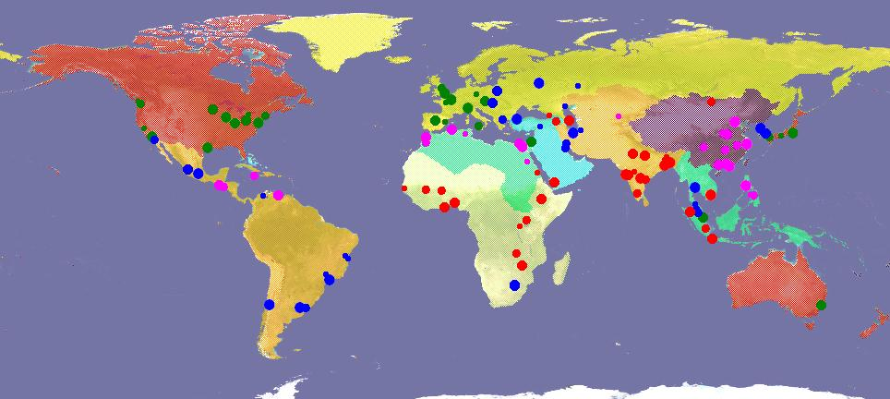
Figure II-2. The Global Sample of 120 Cities, by Regions, Population Size, and Income Classes
 | Regions | Population | Size Class | Income (annual per | Class  capita GNP)
 | East Asia & the Pacific  Europe  Latin America & the Caribbean  Northern Africa  Other Developed Countries  South & Central Asia  Southeast Asia  Sub-Saharan Africa  Western Asia |  | 100,000 to 528,000  528,000 to 1,490,000  1,490,000 and 4,180,000  > 4,180,001 |  | < $3,000  $3,000 - $5,200  $5,200 - $17,000  > $17,000

III THE Classification OF Urban Land Cover
USING Remote Sensing

1. Overview and Rationale
The systematic study of global urban expansion requires good data that until now has not been available. At the minimum, it requires high quality, internationally comparable data of the urban land cover in a global sample of cities for two time periods, as well as corresponding population data for these two periods. As a result of the absence of comparative data, important debates on urban policies continue to take place with little or no data to support one position or another. Introducing the debate on the merits of compact city policies for developing countries, for example, Burgess acknowledges that :
The lack of empirical data on existing density levels and trends, and a lack of clarity on what are the most appropriate indicators to measure them, pose a problem for the assessment of densification policies for cities in developing countries.
What empirical data on urban land cover, or on density levels and trends, are available at the present time?
Moderate resolution land cover data are available for much of the globe for circa 1990 and 2000, in the form of EarthSat’s GeoCover LC (Land Cover) product. However, the EarthSat coverage is not complete and land cover data for several cities in our global sample, for example, were not available. Furthermore, an inspection of a sample of cities which are covered by EarthSat’s GeoCover LC revealed that⎯while perhaps appropriate for general urban land cover mapping⎯they were not accurate enough or detailed enough for this study (see, for example, figure III-1 below). An additional difficulty with this data set is that the identification of urban land cover in individual metropolitan areas does not correspond to population data for these areas, and this makes it impossible to calculate density levels and trends, for example.
A second important global data set that focuses on urban land cover was developed and completed by the Socioeconomic Data and Applications Center (SEDAC) of Columbia University using nightlights data from the late 1990s. Urban land cover in this data set was also found to be insufficiently accurate (see, for example, fig. III-2 Below). SEDAC did, however, meticulously collect data on the administrative districts of countries and cities and on the population in these districts for the two census periods circa 1990 and 2000, and these proved essential for this study, as we shall see below.

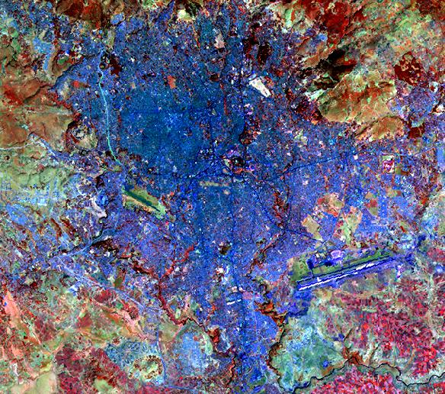  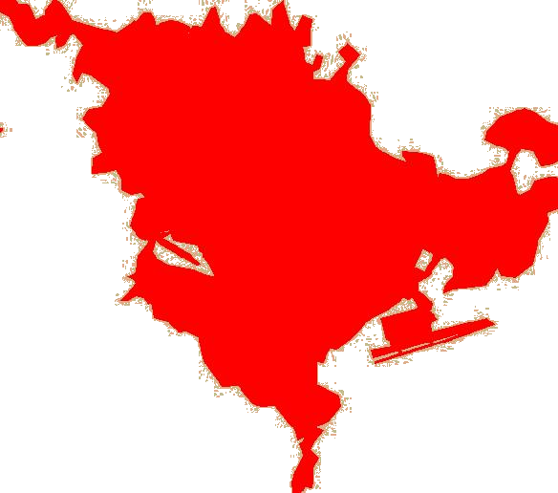 | 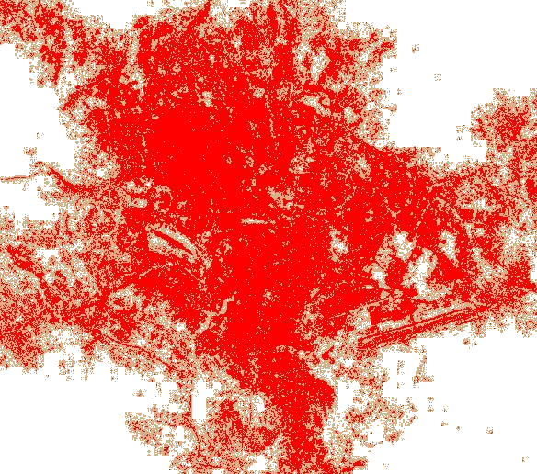
Addis Ababa, Ethiopia | 5 January 2000
Figure III-1a. Urban land cover as portrayed in EarthSat’s GeoCover LandCover product. | Figure III-1b. Urban land cover as derived in this project through computer-assisted processing of Landsat data.

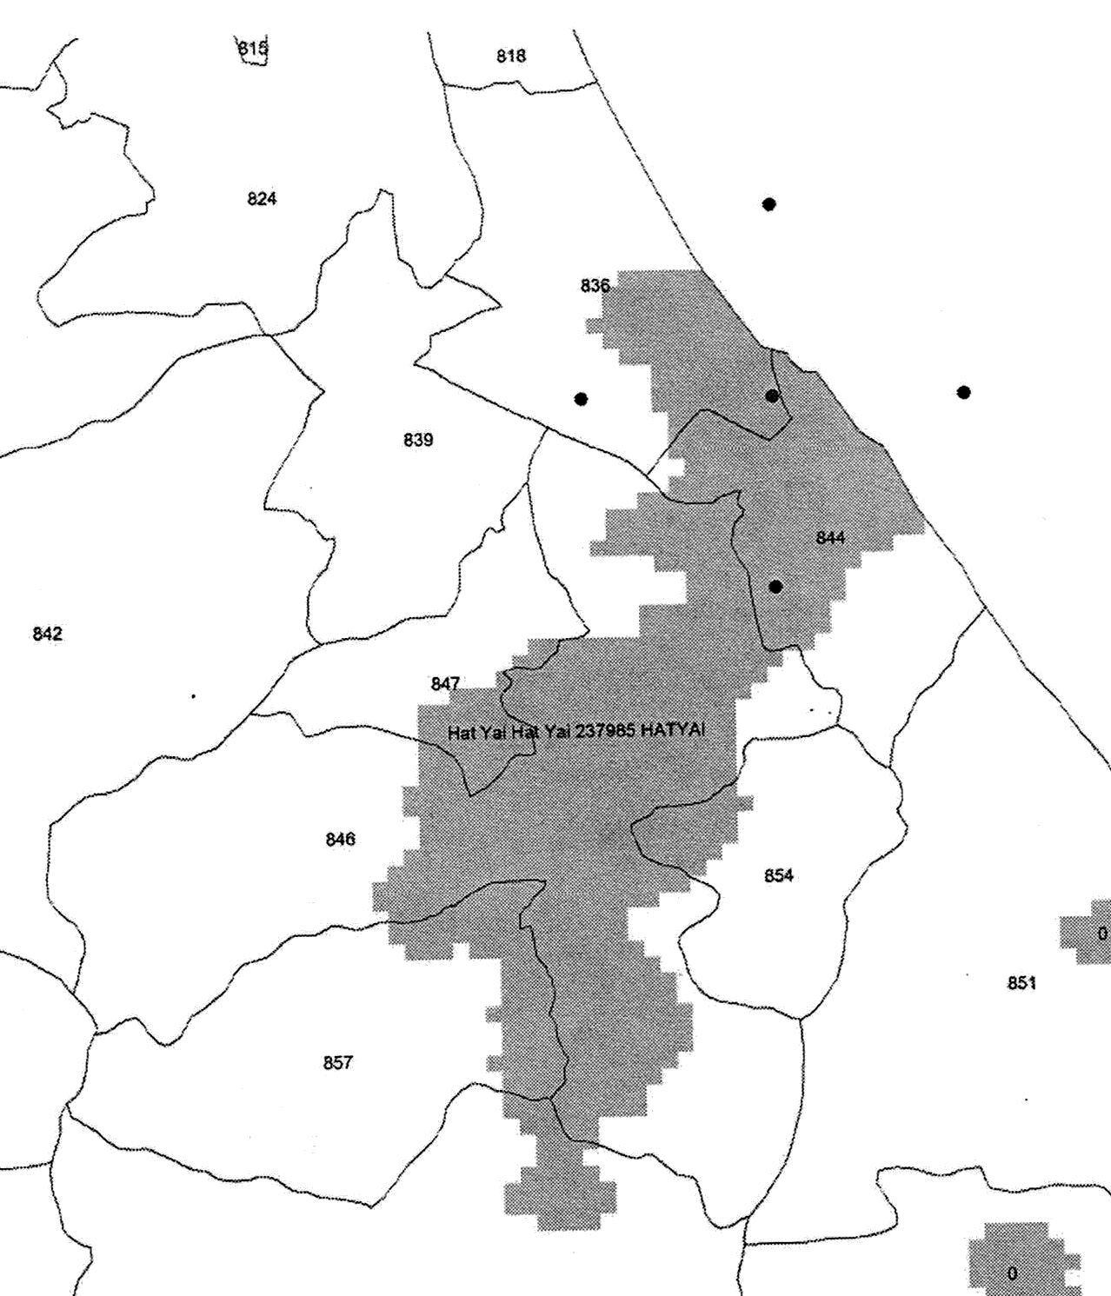 | 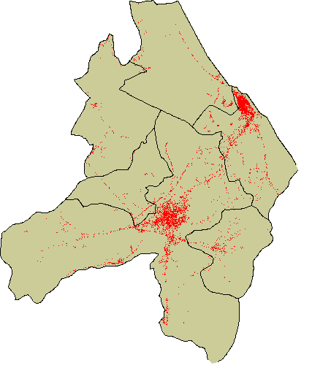
Songkhla, Thailand | circa 2000
Figure III-2a. Urban land cover as portrayed in SEDAC’s nightlight classification. | Figure III-2b. Urban land cover as derived in this project through computer assisted processing of Landsat data.

As noted earlier, one of the central objectives of this study was to generate an empirical data set on existing density levels and trends in a global sample of 120 cities, and this chapter describes how that objective was accomplished. This required identifying at the outset an inclusive set of administrative districts from SEDAC files that fully-contained each one of the metropolitan areas in the sample. Given the set of relevant districts for each city in the sample, the task of the research team was to develop detailed classifications of developed or built-up land for each district in each of the 120 sample cities for two periods circa 1990 and 2000, referred to as T₁ and T₂, respectively.
Computer-assisted processing of satellite remote sensing data was judged as the most cost-effective means by which to extract this information, and the Landsat Thematic Mapper (TM) and Enhanced Thematic Mapper+ (ETM) were deemed the optimal sensors for this purpose. This chapter describes the procedure employed by the research team to obtain these classifications in the global sample of cities.

2. Landsat
The Landsat earth observational satellites have been in operation since 1972, with the launch of ERTS-1, later named Landsat, and with the launch of the second satellite in the series in 1975. The first Landsats carried an imaging multispectral scanner (MSS), with four spectral bands and a nominal 80-meter ground resolution. Landsats 4 and 5, launched in 1982 and 1984, respectively, carried both the 80 meter MSS, as well as an improved sensor, the Thematic Mapper (TM), possessing six, rather than four, reflective bands and one thermal band, as well as a higher spatial resolution (30 meters for the reflective bands, and 120 meters for the thermal band). Landsat 7, launched in 1999, carries the Enhanced Thematic Mapper+ (ETM), spectrally nearly equivalent to Landsat 4 and 5 TM. Notable differences were the inclusion of a 15 meter panchromatic band, and the improved spatial resolution (60 meters) for the thermal band. Table III-1 summarizes the properties of both the Landsat 4/5 TM and Landsat 7 ETM+.
Table III-1. Landsat Thematic Mapper (TM) and Enhanced Thematic
Mapper (ETM) Spectral and Spatial Properties

 | Landsat 4/5 | TM | Landsat 7 | ETM
Band | Spectral (m) | Spatial (m) | Spectral (m) | Spatial (m)
1 Blue | 0.45-0.52 | 30 | 0.45-0.52 | 30
2 Green | 0.52-0.60 | 30 | 0.52-0.60 | 30
3 Red | 0.63-0.69 | 30 | 0.63-0.69 | 30
4 Near Infrared | 0.76-0.90 | 30 | 0.76-0.90 | 30
5 Middle Infrared 1 | 1.55-1.75 | 30 | 1.55-1.75 | 30
6 Thermal Infrared | 10.40-12.50 | 120 | 10.40-12.50 | 60
7 Middle Infrared 2 | 2.08-2.35 | 30 | 2.08-2.35 | 30
Panchromatic | n/a | n/a | 0.50-0.90 | 15

3. The Remote Sensing Process
Remote sensing can be defined as
the art and science involving the detection, identification, classification, delineation, and analysis of earth surface features and phenomena using imagery acquired from terrestrial, aircraft and satellite platforms equipped with photographic and non-photographic sensors using visual and computer-assisted interpretation techniques.
The process of remote sensing is illustrated in figure III-3 (after CCRS) and consists of the following elements:
1. Energy Source or Illumination (A) - the first requirement for remote sensing is to have an energy source which illuminates or radiates electromagnetic energy to the target of interest.
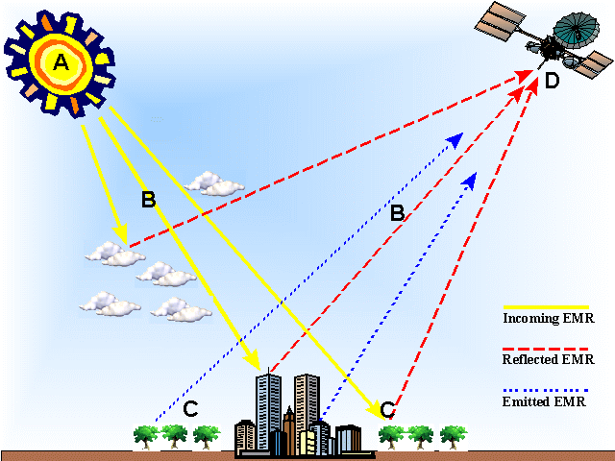
Figure III-3. The process of remote sensing
2. Radiation and the Atmosphere (B) - as the energy radiating from the travels to the target, it will come in contact with, and interact with the atmosphere, as it passes through it. This interaction may take place a second time as the energy travels from the target to the sensor.
3. Interaction with the Target (C) - once the energy makes its way to the target through the atmosphere, it interacts with the target depending on the properties of both the target and the radiation.
4. Recording of Energy by the Sensor (D) - after the energy has been scattered by⎯or emitted from⎯the target, we require a sensor (remote - not in contact with the target) to collect and record the electromagnetic radiation from the target.
5. Transmission, Reception, and Processing - the energy recorded by the sensor has to be transmitted, often in electronic form, to a receiving and processing station where the data are processed into an image (hardcopy and/or digital).
6. Interpretation and Analysis - the processed image is interpreted, visually and/or digitally or electronically, to extract information about the target.
7. Use of Information - the final element of the remote sensing process involves the use of the information⎯often in combination with other data⎯ to obtain a better understanding of the target, to compare characteristics and summary measures of different targets, or to explain variations in target characteristics and measures.
Remote sensing images have four different types of resolutions: spectral, spatial, radiometric, and temporal. Spectral resolution characterizes the range of sensitivity of sensors to different wavelengths of electromagnetic radiation, as well as the width and placement of those bands. Spatial resolution characterizes with the fineness of detail afforded by the sensor optics and platform altitude. Radiometric resolution refers to the number of unique quantization (brightness) levels in the data. And temporal resolution characterizes the frequency of revisits by a remote sensing platform. The Landsat sensors used in this project possess six reflective multispectral bands with 30- meter spatial resolution (see Table III-1). Each of these bands renders reflectance in 256 grey or brightness levels, and the nominal time between revisits of the Landsat satellites is 16 days.
Remote sensing is based on the differentiation of land cover based on variations in their spectral reflectances. Ideally each land cover type of interest should exhibit a unique set of energy-matter (i.e., reflectance) interactions. In reality, however, it is quite common to find that different earth surface features have similar reflectance characteristics; and that objects from what is perceived as a uniform cover type have different reflectance characteristics.. This presents a conundrum for the accurate classification of land use and land cover types.
In addition to spectral reflectance (i.e., color or tone), a human analyst will employ other criteria in the visual-cognitive process of interpreting remote sensing imagery: texture, pattern, size, shape, shadow, and context, among other visual cues. In contrast, however, most methods for computer-assisted classification of digital remote sensing data that do not involve a human observer utilize a “per-pixel, spectral data-alone” approach. Figure III-4 presents the spectral reflectance properties of several land cover types.
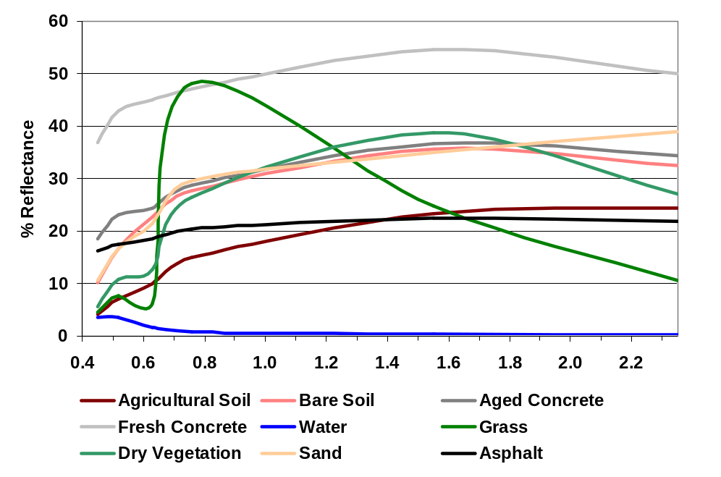
Figure III-4. Spectra of Sample Cover Types and Landsat TM/ETM Bands

It is important to note that there is a spectral similarity among distinct land cover classes. For instance, bare soil, sand, and aged concrete have similar reflectance in several of the Landsat bands. So, too, do asphalt and agricultural soil. Though not shown in figure III-2, shadows cast by steep slopes in a rural setting or by tall structures in an urban setting can appear similar to water. These spectral similarities between natural covers and anthropogenic land uses are problematic for “per pixel, spectral data alone” classification techniques.

4. The Thematic Extraction Algorithm
The rationale underlying the traditional approaches to computer-assisted land cover classification using digital remote sensing data is that pixels from within the same land cover class tend to group together⎯or cluster⎯in multispectral feature space, and that groups of pixels from different cover classes tend to be separate from one another in multispectral feature space. This simple realization is illustrated in figure III-5. The tendency for pixels from within the same land cover class to form spectrally distinct clusters is the foundation of the algorithm employed in this project for thematic feature extraction and classification.
Computer-assisted classification of digital multispectral remote-sensing data can be partitioned into two general approaches: supervised and unsupervised. In the former, an analyst selects “training areas” that are spectrally representative of the land cover classes of interest. From these training areas, univariate and multivariate statistics, such as mean vector, standard deviation, variance and covariance, are first calculated and then used to classify each independent pixel of the entire image being examined. Decision rules can be non-parametric, such as minimum Euclidean distance to means, or parametric, such as Gaussian maximum likelihood. Supervised training area selection and classification requires a priori decisions on the part of the analyst before resorting to computer-assisted classification.

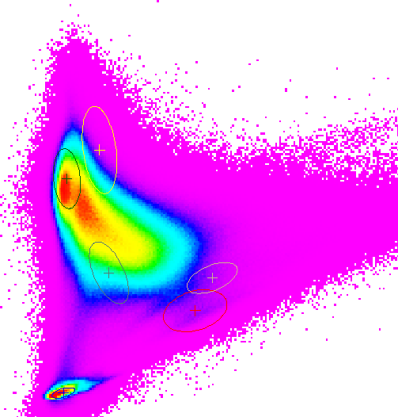
Dark Urban
Grassland
Forest
Wetland
Water
Bright Urban
Bare Soil
Band

3

Band 4

Figure III-5. Pixel brightness values in ETM Bands 3 and 4
showing mean vector and standard deviation ellipse for
several cover types.

In unsupervised classification, often referred to simply as cluster analysis, a computer algorithm first partitions a multispectral image into self-defining spectral clusters. After the classification is completed, the analyst then employs a posteriori knowledge in labeling the spectral classes into information classes. An unsupervised approach was utilized in this project, specifically the Iterative Self-Organizing Data Analysis (ISODATA) algorithm. This algorithm was used as implemented in the Leica Geosystems ERDAS Imagine 8.7 image processing and pattern recognition software suite. The following discussion is taken largely from the ERDAS Imagine Field Guide:
ISODATA is iterative in that it repeatedly performs an entire classification (outputting a thematic raster layer) and recalculates statistics. Self-Organizing refers to the way in which it locates clusters with minimum user input. The ISODATA method uses minimum spectral distance to assign a cluster for each candidate pixel. The process begins with a specified number of arbitrary cluster means or the means of existing signatures, and then it processes repetitively, so that those means shift to the means of the clusters in the data.

To perform ISODATA clustering, an analyst must specify three parameters:
- N - the maximum number of clusters to be considered. Since each cluster is the basis for a class, this number becomes the maximum number of classes to be formed. The ISODATA process begins by determining N arbitrary cluster means. Some clusters with too few pixels can be eliminated, leaving less than N clusters.
- T - a convergence threshold, which is the maximum percentage of pixels whose class values are allowed to be unchanged between iterations.
M - the maximum number of iterations to be performed. On the first iteration of the ISODATA algorithm, the means of N clusters can be arbitrarily determined. After each iteration, a new mean for each cluster is calculated based on the actual spectral locations of the pixels in the cluster. Then, these new means are used for defining clusters in the next iteration. The process continues until there is little change between iterations.
The initial cluster means are distributed in feature space along a vector that runs between the point at spectral coordinates (μ₁-σ₁, μ₂-σ₂, μ₃-s₃, ... μ_{n}-σ_{n}) and the coordinates (μ₁+σ₁, μ₂+σ₂, μ₃+s₃, ... μ_{n}+σ_{n}) where μ is the mean and σ is the standard deviation. Such a vector in two dimensions is illustrated in figure III-6a. The initial cluster means are evenly distributed between (μ_{A}-σ_{A}, μ_{B}-σ_{B}) and (μ_{A}+σ_{A}, μ_{B}+σ_{B}).
Pixels are analyzed beginning with the upper left corner of the image and proceeds left to right and top to bottom, block by block. The spectral distance between the candidate pixel and each cluster mean is calculated. The pixel is assigned to the cluster whose mean is the closest. The ISODATA function creates an output image file with a thematic raster layer as a result of the clustering. At the end of each iteration an image file that shows the assignments of the pixels to the clusters is created and stored. Considering the regular, arbitrary assignment of the initial cluster means, the first iteration of the ISODATA algorithm always gives results similar to those in figure III-6b. For the second iteration, the means of all clusters are recalculated, causing them to shift in multispectral feature space. The entire process is repeated—each candidate pixel is compared to the new cluster means and assigned to the closest cluster mean.
After each iteration, the normalized percentage of pixels whose assignments are unchanged since the last iteration is displayed in a dialog window. When this number reaches T (the convergence threshold), the program terminates. It is possible for the percentage of unchanged pixels to never converge or reach T (the convergence threshold). Therefore, it is usually necessary to monitor the percentage, or to specify a reasonable maximum number of iterations, M, so that the program does not run indefinitely.

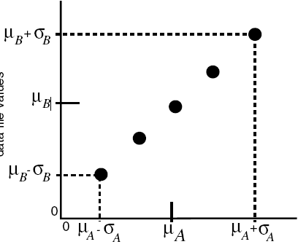 | 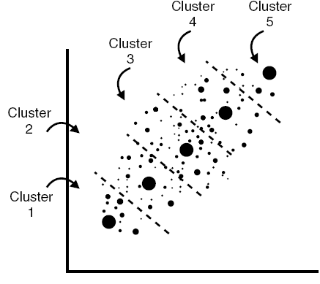 | 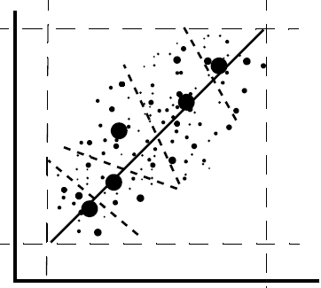
Figure III-6a. Initial centroids  Source: ERDAS Field Guide | Figure III-6b. Results after first iteration | Figure III-6c. Decision regions after clustering completed

Once the cluster formation has been completed, the entire image is subjected to a minimum Euclidean distance to means classifier, using the spectral cluster centroids (i.e., the mean vectors). Each pixel is classified into the spectral cluster of nearest neighbors in n-dimensional spectral space (figure III-6c). The resulting classification map must then be post-processed by the analyst, whose role is to assign a meaningful land cover class label to each spectral cluster. This is typically accomplished by referring to either the source imagery, to an independent map, or to field observations). This is the a posteriori part of the classification process, and it demands careful scrutiny and labeling of classes by the analyst.

5. Selection of Landsat Imagery
The Landsat Thematic Mapper (TM) and Enhanced Thematic Mapper-Plus (ETM)data were selected as the basis for image analysis and land cover classification. Landsat scenes available through EarthSat’s GeoCover Ortho Landsat TM database were identified and previewed via the Earth Observing System Data Gateway. If the scenes in the GeoCover-Ortho Stock Scenes archive were both cloud-free, especially within the area of interest surrounding the cities, and were acquired on a date within two years of the respective country’s population census, they were selected as appropriate for analysis and purchased from EarthSat. For those cities for which either there was excessive cloud cover or were more than two years from the census date, a search of other Landsat 4/5 and 7 data was conducted with the USGS Global Visualization Viewer (GLOVIS). These additional scenes were purchased from USGS EROS Data Center (EDC) through EarthSat, which produced a GeoCover-Ortho Custom Projection product conforming to the specifications of the original NASA contract for the GeoCover Ortho Landsat TM product. In several instances, suitable Landsat data for one or both dates for several cities was not available, requiring a modification of the original sample of 120 cities. Later in the project, if additional Landsat data were needed, they were obtained from the Global Land Cover Facility (GLCF) at the University of Maryland.
All Landsat data were orthographically corrected to remove geometric distortions and displacements. Each scene was geo-referenced to the Universal Transverse Mercator (UTM) projection and the WGS-84 datum. Image pixels were re-sampled to 28.5 meters.

6. Image Classification Protocol
Administrative district boundary map files were superimposed on each full-scene Landsat image, and only those parts of the image that were in the subset of districts containing the metropolitan area were selected for classification. Each full-scene Landsat was subset to just the area required to cover each city. This was done for two reasons: (1) to facilitate data management, processing, and storage, as well as to reduce the overall area to be classified to the minimum coverage required, thereby allowing the analyst(s) to focus on the urban features, and (2) to derive urban land use statistics defining the cities and for which population data were available. These district boundaries were derived from the Socioeconomic Data and Applications Center (SEDAC), part of Columbia University’s Center for International Earth Science Information Network (CIESIN).
An unsupervised classification approach was chosen for the classification of T₁ and T₂ Landsat imagery (figure III-7). The ISODATA clustering algorithm was used to partition the T₁ subset scenes into 50 spectrally separable classes. Using the Landsat data themselves, along with independent reference data when available, each of the 50 clusters was placed into one of seven pre-defined cover classes: water, urban, vegetation, barren (including bare soil agriculture), clouds/ shadow, snow/ice, and “undetermined”. The latter class was one reserved for those pixels for which a clear determination could not be made on the first clustering. Only those pixels for which the land cover class was certain were labeled. The “undetermined” class typically consisted of pixels confused between urban and barren. Those pixels labeled as such were extracted from the T₁ and submitted to a second clustering in an attempt to maximize the separability among those spectrally similar classes. The clusters from this second iteration were labeled into one of the six informational classes.
Because per-pixel, spectral data-alone classification methods often encounter difficulty in discriminating between urban and barren cover types (see, for example, Figure II-2), confusion still remained after this second pass. The classification maps were carefully scrutinized to detect obvious misclassifications by comparing results with the source image, through a careful, section-by-section examination of the Landsat imagery. On-screen editing of regions of pixels obviously misclassified was performed through heads-up digitizing. This analyst intervention and application of his or her expert knowledge increased both the thematic and spatial accuracies of the classifications. It is this analyst post-processing of the ISODATA-generated classifications that makes the derived land cover superior to nearly any land cover dataset available at a global scale (see, for example, figure III-8).
The resulting land cover classifications were recoded into two classes: non-urban and urban. Because emphasis had been placed on optimizing the classification of urban (built up) pixels, and because water often was displaced during the manual, on-screen editing process, and since water is a constraint to urban growth, this class was extracted again from the source Landsat data. A “water index” was calculated for each Landsat scene:
Water Index = (Band 1 + Band 2 + Band 3) / (Band 4 + Band 5 + Band 7)
The image produced by the water index is essentially a ratio of visible spectrum bands to reflected infrared bands. Water demonstrates moderately low reflectance in the visible spectrum, and very low to almost negligible reflectance over infrared wavelengths. Figure III-8 illustrates the process of augmenting the urban / non-urban land cover classification with the water category.

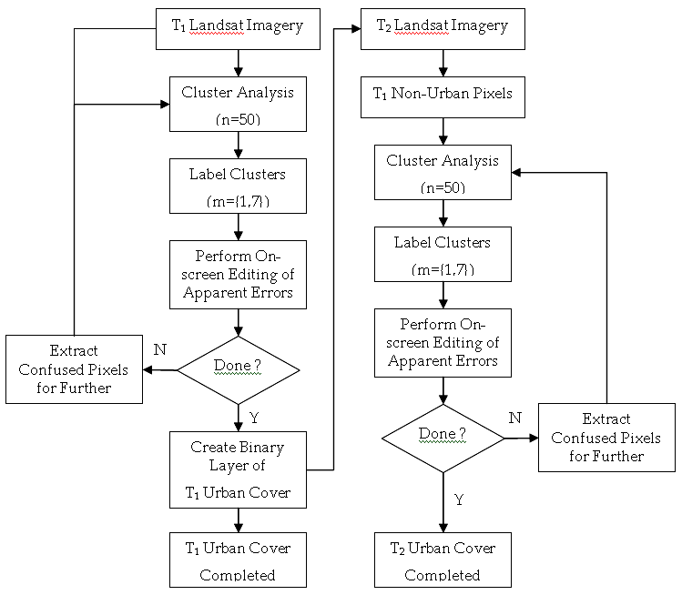
Figure III-7. Protocol for T₁ and T₂ urban land cover classification

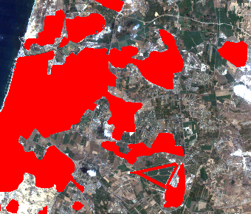 | 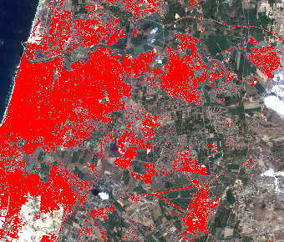
EarthSat GeoCover, 1986 | Project-derived classification, 1986
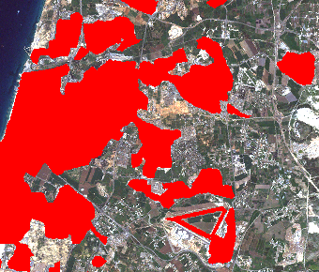 | 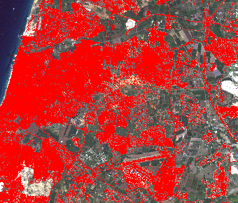
EarthSat GeoCover, 2000 | Project-derived classification, 2000

Figure III-8. Urban land cover for the Greater Tel Aviv region

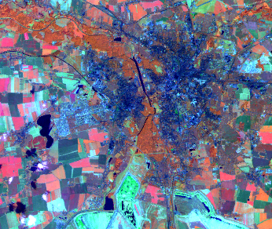 | Landsat data are processed with a water index algorithm:  (Band 1 + Band 2 + Band 3) / (Band 4 + Band 5 + Band 7)
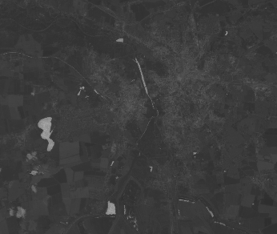 | This generates a continuous value image representing “degree of wetness”.
 | Analyst interactively examines “wetness” image and original Landsat data to determine a threshold (cutoff) for water and non-water.
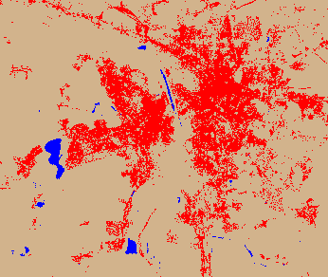 | Water class is extracted from water index image and overlain with urban / non-urban classification.
Figure III-9. Illustration of the development of a water class

7. Accuracy Assessment
Qualitatively, the classifications derived in this project appear highly accurate, both spatially and thematically, owing to the level of expert-driven, post-classification editing of the results derived from clustering. Yet, there is a need for a quantitative expression of just how good the classifications really are. This is typically accomplished by comparing a sample of pixels’ classification with some form of reference data -- or ground. Preferably, when available, these reference data should (a) be of a higher spatial resolution than that of the classifications being assessed, (b) be contemporaneous with the dates of the classifications’ source remote sensing imagery, (c) possess a known (and acceptably high) classification accuracy themselves.
Samples for which accuracy is to be assessed can be in the form of either regions or individual groups of pixels. Further, these samples can be selected using several different strategies: random, stratified random, systematic, equalized, among others. In this project, an equal number of urban and non-urban pixels were randomly selected from a set of representative set of city classifications.
Accuracy assessment was performed independently for the T₁ and T₂ land cover classification for the two categories of urban and non-urban. For each land cover map, an equalized, random set of test points was selected, using the T₁ land cover as the basis. The test points within a sample were further randomized to avoid bias in the reference labeling of those pixels. Additionally, the pixel located at a randomly generated easting and northing was used, rather than the ‘majority’ option offered by some algorithms. This set of points was exported into an ASCII file and used as the same set of test points to assess the accuracy of the T₂ classification. As noted earlier, ideally, it would be desirable to use an independent source of reference data of higher precision and known accuracy for validating the classifications, however, such data were, and are, not generally available. Therefore, the source Landsat imagery was used as the basis for assigning reference labels to each classified test pixel. Standard measures of producer’s accuracy, consumer’s accuracy, overall accuracy, and kappa were generated (Congalton and Green, 1999).
Producer’s accuracy is an expression of errors of omission, or false dismissals (for example, from the perspective of the urban category, labeling a pixel classified as non-urban when in fact it is urban). Consumer’s accuracy is an expression of errors of commission, or false alarms (for example, again from the perspective of the urban category, labeling a pixel as urban when in fact it is not). Overall accuracy is a measure of the number of sample pixels correctly classified. And the kappa coefficient is a measure of how different the classification results are from those expected by chance alone.

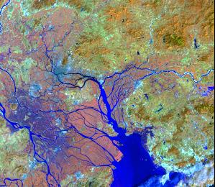 | 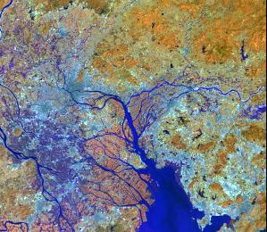 | 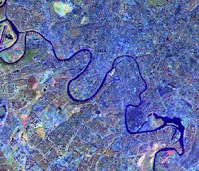 | 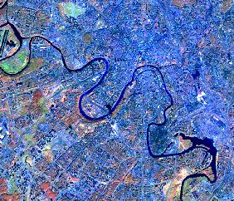
Fig. III-9a. Landsat TM Image, 13-Oct-90 | Fig. III-9b. Landsat TM Image, 14-Sep-00 | Fig. III-10a. Landsat TM Image, 08-Oct-91 | Fig. III-10b. Landsat TM Image, 14-Oct-02
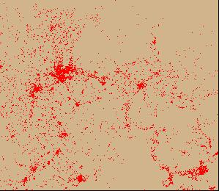 | 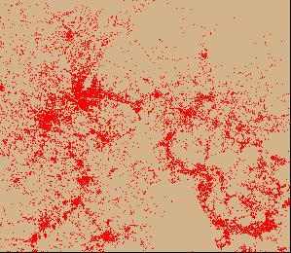 | 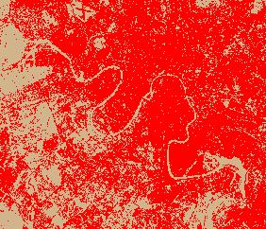 | 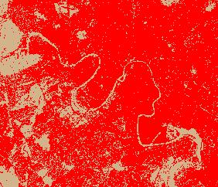
Fig. III-9c. T₁ Urban land cover classification  Producer’s Accuracy: 86.7%  Consumer’s Accuracy: 86.7% | Fig. III-9d. T₂ Urban land cover classification.  Producer’s Accuracy: 88.24%  Consumer’s Accuracy: 93.75% | Fig. III-10c. T₁ Urban land cover classification  Producer’s Accuracy: 92.31%  Consumer’s Accuracy: 80.00% | Fig. III-10d. T₂ Urban land cover classification  Producer’s Accuracy: 92.86%  Consumer’s Accuracy: 86.7%
Figure III-9. Guanzhou, China |  | Figure III-10. Moscow, Russia
8. Results and Discussion
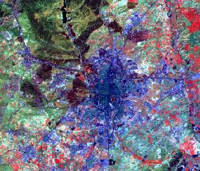 | 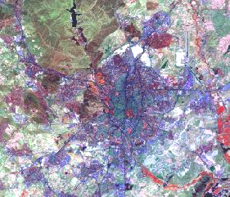
Fig. III-11a. Landsat TM Image, 25-May-89 | Fig. III-11b. Landsat TM Image, 22-Aug-00
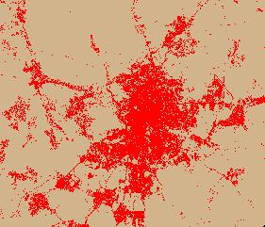 | 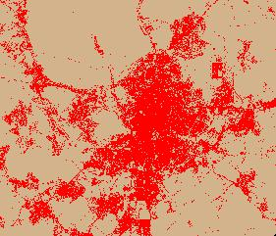
Fig. III-11c. T₁ Urban land cover classification  Producer’s Accuracy: 93.75%  Consumer’s Accuracy: 100.00% | Fig. III-11d. T₂ Urban land cover classification  Producer’s Accuracy: 100.00%  Consumer’s Accuracy: 81.25%
Figure III-11. Madrid, Spain
The classification: The classification protocol overviewed previously generally performed well in extracting land cover information. The identification of the clearly, spectrally separable classes of vegetation, water, clouds/ shadow, and snow/ice was quite efficient. However, problems were encountered with the spectrally similar classes of urban, barren, and bare-soil agriculture. These confusions were resolved by way of either a second-pass clustering of the “undetermined” class, or, and perhaps more useful, through on-screen editing of apparent errors (i.e., heads-up digitizing). Most, but obviously not all, conflicts among these spectrally related classes were eliminated. Figures III-9, III-10 and III-11 are examples of classification results and the parent Landsat images for Guanzhou, Moscow, and Madrid, respectively.

Urban Land Cover Accuracy: Table III-2 presents summary accuracy assessment measures based on a sample of twelve completed cities. Data reported include Producer’s Accuracy (related to errors of omission), Consumer’s Accuracy (related to errors of commission), and Overall Kappa (related to chance agreement). Since the urban class is of principal interest, accuracy assessment was conducted on the binary urban/non-urban classification maps.
The poorest urban (built land) classification accuracies in this sample for T₁ were for both Bamako and Jaipur, at 84.6% and 73.3% for producer’s and consumer’s accuracy, respectively.
Highest T₁ producer’s accuracy for the urban class was for Addis Ababa at 100%, and highest consumer’s accuracy was found for Madrid, also at 100%.
For T₂, lowest producer’s accuracy for the urban class was for both Chicago (USA) and Sao Paulo at 85.7% and lowest and consumer’s accuracy for Jaipur at 73.3%.
Highest T₂ producer’s accuracy was 100% for Madrid, Cincinnati, and Caracas, and consumer’s accuracy was highest for Buenos Aires also at 100%.
Overall mapping accuracy (OMA) for these twelve sample cities was 89.2 percent for both for T₁ and T₂, a highly acceptable and well-balanced level to meet the needs of this project. Cohen’s kappa coefficient was 0.828, indicating an accuracy significantly different from that due to chance alone.
Derived from the early to mid-1990s Landsat Thematic Mapper satellite data, the National Land Cover Dataset (NLCD), developed by the Multi-Resolution Land Characteristics Consortium (MRLC), is a 21-class land cover classification scheme applied consistently over the United States. The second phase of NLCD for the circa 2001 time period is underway. Per-pixel accuracy assessments for grouped urban-related classes for the eastern United States (EPA Regions 1, 2, 3, and 4) range from 69 to 93 percent producer’s accuracy and approximately 72 to 87 percent consumer’s accuracy. Overall mapping accuracy for Level I classes ranges from 74 to 83 percent.
The accuracy derived from the focused nature of the classification conducted in this project clearly surpasses that of a broader, more general land cover mapping program such as the National Land Cover Dataset.

Table II-2. Summary accuracy metrics for twelve sample cities
T₁ | Class | Reference | Classified | Number | Producers | Consumers
 |  | Totals | Totals | Correct | Accuracy | Accuracy
 | Non-urban | 193 | 180 | 167 | 86.5% | 92.8%
 | Urban | 167 | 180 | 154 | 92.2% | 85.6%
 | Totals | 360 | 360 | 321 | 89.2% | OMA
 | Overall Kappa | 0.8417
T₂ | Class | Reference | Classified | Number | Producers | Consumers
 |  | Totals | Totals | Correct | Accuracy | Accuracy
 | Non-urban | 189 | 174 | 162 | 85.7% | 90.7%
 | Urban | 171 | 186 | 159 | 93.0% | 87.6%
 | Totals | 360 | 360 | 321 | 89.2% | OMA
 | Overall Kappa | 0.8160

* * *

IV MEASURING URBAN EXTENT AND EXPANSION

1. Overview and rationale
In this chapter, several basic measures of urban extent and expansion will be defined and the way they were obtained in this study will be described in detail; provisional tables summarizing these measures for the universe of cities⎯categorized by regions, income groups and city-size categories⎯will be introduced, based on data for 90 cities out of 120 cities in our global sample; and new measures that will be the subject of further research will be explored.
The principal objective of measuring urban extent and expansion is to provide concise information to interested stakeholders that will ground the study, the debate, and the decisions concerning these issues in empirical facts. To quote William Thomson (Lord Kelvin):
When you measure what you are speaking about and express it in numbers, you know something about it, but if you cannot express it in numbers your knowledge about it is of a meager and unsatisfactory kind.
The classification of the Landsat images of our global sample of 120 cities into built-up and non-built up areas in two time periods has resulted in the creation of abstracted and highly-simplified visual images of these cities as they are seen from space (see chapter VII). Examining these images, even cursorily, one can see that each city has a different signature: One can see that some cities are more compact while in others there is more open space between built-up areas. Some cities appear to be more circular, and some more linear or star-shaped. Some appear as largely monocentric⎯comprising one solid area⎯while others appear more polycentric, made of several distinct areas that are separate from each other. In some cities the boundary between the built-up area and the rural area is rather sharp, while in other cities the urban and the rural dissolve into each other. One can also see that the signature of each city changes between the two time periods in different ways. One can see new expansion into rural areas, expansion that can be adjacent to already built areas or that leapfrogs across open spaces. One can also see the infill of the open spaces between already built-up areas that results in their consolidation. One can see cities becoming more monocentric or more polycentric over time. Surely, one can grasp these patterns intuitively. They inform us about the shape and form of cities, but they fall short of providing solid evidence for debating and deciding upon the future of our cities.
To describe these different patterns intelligently, to understand how they change over time, to compare cities with each other, or to explain the variations among these patterns statistically, we need to select quantitative measures that summarize one or another of their properties. Since any such measure will, of necessity, involve the loss of much detail, we need to ask ourselves: of the many aspects of these patterns that can be measured, which ones should we measure? Horn, Hampton and Vandenberg suggest one important criterion for judging which measure is ‘best’:
The de facto arbiter of what measure is best is intuition: which one most ‘fully encompasses our intuitive notion’, or which one best results in a ‘correspondence between visual and quantitative expression’…. Analytical philosophers have a term that applies to visual intuition in the case of compactness. They say that this term constitutes the reportive definition of compactness, the one most people have in mind when they use this word. Reportive definitions contrast with stipulative definitions in which one simply, and arbitrarily, stipulates that a given term will have such-and-such a meaning⎯regardless of whether that meaning is the one in the minds of most people.
Most factual questions about the form and shape of cities that are intuitively quite simple to grasp do not lend themselves to straightforward answers that have a high degree of precision: Where does the city end and the rural area begin? What is the population of the city? What is the built-up area of the city? What is the average density in the city? What is the degree of openness or sprawl in the city? How compact or dispersed is the city? What is the urbanized area of the city, the area that the city occupies including the non-built up spaces that are largely contained within the built-up areas? How much of new development is infill of these spaces and how much is new greenfield development? How much new urbanized land would the city need if its population doubled or if its income doubled? These questions cannot be easily answered simply because there are no well-defined stipulative definitions of these concepts that correspond to our reportive definitions.
To begin with, it is not at all clear where the limits of the city are⎯where the city ends and the rural area begins. While it may have been quite simple to determine the population and the area of a medieval walled city in an unambiguous way, it is quite another matter to determine the population or the area of a large modern metropolis that extends in all directions, absorbing towns and villages into its midst, leaving areas undeveloped, and gradually dissolving into the surrounding rural area.
Population data in the great majority of countries are collected in national censuses every decade in very similar ways, and it is generally of good quality. The census typically counts the population in small census tracts, and the population is then aggregated to larger and larger administrative districts, eventually producing population totals for provinces or states and for the country as a whole.
Cities have administrative boundaries associated with them in the sense that city governments have jurisdiction over certain well-defined administrative areas. But the area contained within the jurisdictional boundaries of cities has little to do with the metropolitan area of these cities. In some cases, this area is very small in comparison with the size of the metropolitan area: the Los Angeles metropolitan area, for example, contains 35 independent municipalities. In other cases, say in Beijing, the jurisdictional boundaries of the municipality contain an area that is much larger than the built-up area of the city. The official area of the municipality is therefore not a very precise measure, neither of the built-up area of the city nor of what we intuitively grasp to be the city. The population of this area is precisely reported in the census, but if the average density of the city, for example, were to be calculated by dividing this population by the municipal area the result would be dependent on the administrative decisions regarding municipal boundaries and would change if these boundaries changed by administrative fiat. If is for that reason that Malpezzi, for example, advises against using the average density calculated in this manner as a measure of ‘sprawl’.
In this study, the population of every city in the sample in two recent census periods was calculated by adding the census populations of all the administrative districts that fully-contained what appeared to the research team to be the metropolitan area of the city at the time the census was taken. In this sense, this definition of the city population was inclusive, as it included the non-urban population in these districts as well. Determining whether a particular district should or should not be included in the calculation was an iterative process that will be described in greater detail in the following section.
Given the list of districts that contained the metropolitan area, Landsat images of these districts (taken as close as possible to the year the census was taken) were obtained, and each pixel in the image was classified into three categories: built-up, non-built-up and water. This made it possible to measure the built-up area of every city in the sample and to use this measure to obtain the average density of the built-up area as well as the amount of built-up area per person. For the latter measures to be consistent, the calculation of the total built up area of each city in the sample included all the built-up pixels in the administrative districts that fully-contained the metropolitan area of the city at the time the census was taken. These basic measures⎯as well as preliminary estimates of continuity and compactness, to be introduced below⎯were calculated for 90 cities in the sample, and⎯based on these calculations⎯preliminary estimates for the universe of cities were obtained.
The remainder of this chapter is divided into three parts: (a) a detailed description of the procedures used to calculate the basic population and built-up area measures; (b) summary tables and discussion of the key measures of urban extent and expansion in the global sample of cities; and (c) a preliminary discussion of additional measures of urban extent and expansion that will be calculated and reported upon in future phases of this study.

2. Acquiring and processing city district boundaries
Administrative districts provide the spatial framework for measuring the population of the cities in our sample, using available census data for dates close to 1990 and 2000. ESRI shapefiles containing sets of district boundaries were acquired for each city from the Socioeconomic Data and Applications Center (SEDAC), a research unit within Columbia University’s Center for International Earth Science Information Network (CIESIN). For some cities, the district boundary data contained obvious errors in alignment or shape. All sets of district boundaries were checked against Landsat imagery in order to detect any noticeable errors. Whenever errors were observed, the district boundaries were edited in order to improve their alignment with natural features, such as coastlines or major rivers, or to correct their shape so they more closely followed natural topographic features.
The T₁ and T₂ dates of the Landsat data were usually different from the dates of the decennial census dates. In some cases the dates of the only available Landsat images were up to four years earlier or later from the corresponding census date. Therefore, it was necessary to interpolate the census data, so that the population figures corresponded to the T₁ and T₂ dates of the Landsat images. City population growth was assumed to be exponential, and the annual growth rate, g, was calculated using the following equation:
P₀₀ = P₉₀ x (1+g)¹⁰, (1)
where P₉₀ = population in 1990 and P₀₀ = population in 2000. Given the annual population growth rate, d, the population in the two dates for which satellite images were available, T₁ and T₂, were calculated using the following equations:
P₁ = P₉₀ x (1+g)^{T1-1990}, and (2)
P₂ = P₉₀ x (1+g)^{T2-1990}, (3)
where P₁ = population in T₁ and P₂ = population in T₂.
Initially, the administrative districts that contained a particular city were unknown. Consequently, the sets of districts selected at the outset often contained an excessive number of districts that did not contain any of the built-up areas of the sample cities. The set of districts containing the city needed to be identified before proceeding with the analysis. Districts to be contained in this set were defined to be districts any part of which intersected a 1-km buffer around the main built-up area of the city, and the main built-up area was assumed to be larger than 1 km².
The classified land cover images contained three separate classes: urban, non-urban, and water. Urban pixels were extracted from each land cover image in order to identify the main built-up area and also to assist in later steps in the analysis. Each image was then reclassified to create a grid file containing only the built-up pixels. This urban grid file was created for each city for T₁ and T₂, although only the T₂ grid was used for identifying the main built-up area at this early stage in the analysis. Furthermore, to facilitate the identification of the main built-up area of a city, a smoothing algorithm was applied to the T₂ urban grid data. A grouping function was then applied to the smoothed grid, which assigned contiguous pixels to clusters. Clusters larger than 1 km² (1231 pixels) were identified. These selected clusters were then converted to a shapefile. The largest polygon(s) were then manually selected to constitute the main built up area of the city. A selection-by-location tool was then used to select administrative districts that intersected a 1-km buffer around the selected polygons. The selected districts were then exported to a new shapefile since they were determined to be set of districts containing the city. This procedure is illustrated in figure IV-1 below for the city of Accra.

3. Calculating the built-up area of cities
The classification of landcover in the Landsat images containing the cities in the sample typically extended beyond the set of districts containing these cities. To calculate the built-up area for every district in this set, the urban grid for every city in the sample needed to be clipped using the city districts shapefile. Clipping the urban grid was done by using the ArcMap’s Raster Calculator with the city districts shapefile set as an analysis mask.
The zonal statistics tool was used to count the number of built-up pixels in each city district and organize the results into a table. Each urban pixel has an area of approximately 812 m² since the grid cells (pixels) measure 28.5 m x 28.5 m. The total urban area, for each district, was then calculated by multiplying the number of urban pixels by the area of each pixel. The total built up area of the city was calculated by summing the built-up areas for the set of districts containing the city.
Figure IV-1. Illustration of the progression of steps involved
in creating a district shapefile for the city Accra
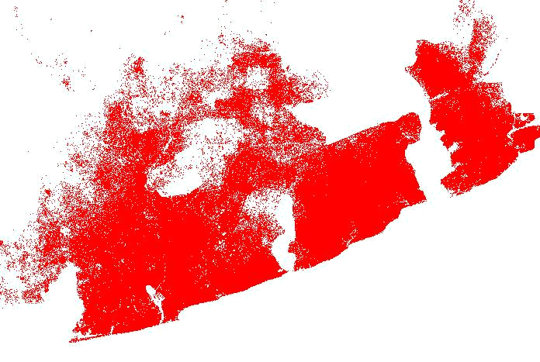 | 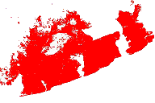 | 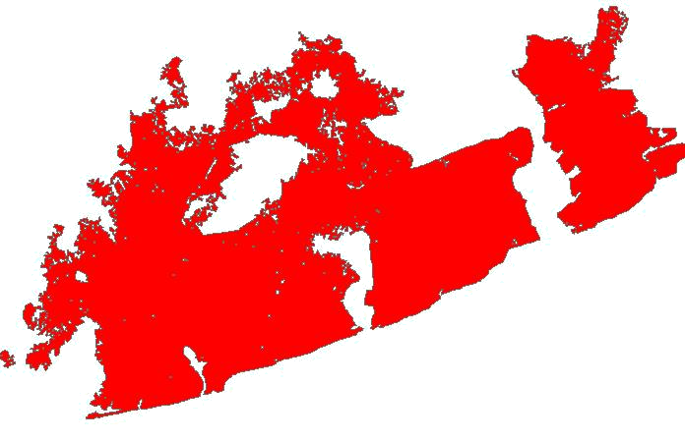
(a) Extracted urban grid | (b) Smoothed urban grid | (c) Urban areas > 1 km²
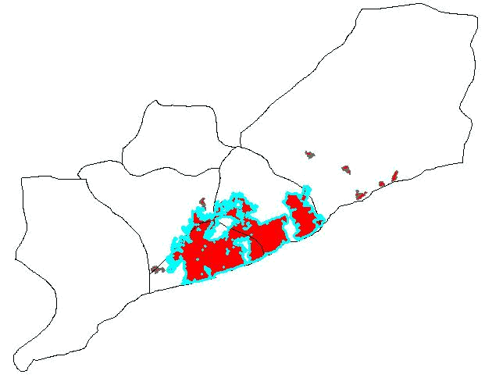 | 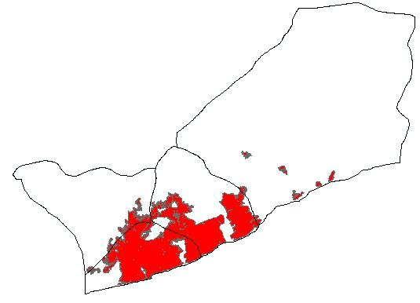
(d) Original set of districts with main built up area highlighted | (e) The set of districts containing the city

4. Estimating the population and built areas for cut-off districts
The extent of the Landsat image for some cities⎯typically covering a 100km-by-100km area⎯was insufficient to cover the set of districts containing the city. Parts of some districts were cut off. Since census population data were only available for entire districts, the research team decided to calculate the built-up area that corresponded to this population, hence to calculate the built-up area of the entire set of districts containing the city. The built-up area of cut-off districts therefore had to be extrapolated.
Each cut-off district was manually split into an ‘in’ portion, covered by the Landsat image, and an ‘out’ portion, that was not covered by the image (see figure IV-2 below). The areas of the ‘in’ portion, A_{i}, and the area of the ‘out’ portion, A_{o}, were calculated. The distance, from the center of the largest built-up area in the image to the center of the ‘in’ portion of the district, d_{i}, was measured. The distance, from the center of the largest built-up area to the center of the ‘out’ portion of the district, d_{o}, was also measured. The following distance-decay function was then used for calculating the built-up area for the entire district, B, given the built-up area for the ‘in’ portion of the district, B_{i}:

B = B_{i} x [(A₀ / A_{i}) x (d_{i}² / d_{o}²) +1]. (4)
For the purposes of modeling urban expansion, it was also desirable to estimate the population contained within the ‘in’ portion of a cut-off district. The following distance decay function was used for estimating population in the ‘in’ portion of cut-off districts:
P_{i} = A_{i} x P / [A_{o} x (d_{i}² / d_{o}²) + A_{i}]. (5)
where P_{i} is the population of ‘in’ portion of district and P is the population of the entire district.
Figure IV-2. A cut-off district in Accra, Ghana
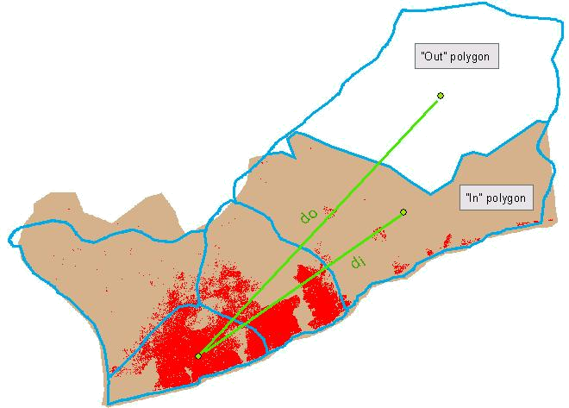

5. Estimating basic measures of urban extent and expansion in regions, income groups and city size categories
The procedures described above allowed us to calculate the total built-up area within the administrative districts that comprise the metropolitan area of each one of the cities in the sample. At present, these calculations are available only for 90 out of the 120 cities in the global sample, although the classification of all 120 images into built-up and non-built-up areas is already complete. For each city in the 90-city sample, we have calculated population and built-up area estimates for 1990 and 2000. Given that the sample was stratified, and given the weights assigned to each of the 90 cities in the sample (see Chapter II, section 9), we can now obtain preliminary estimates of several key measures of urban extent and expansion for regions, income groups and city size categories.
Table IV-1 below provides preliminary estimates of the total population and built-up areas in 1990 and in 2000⎯as well as their annual rate of change⎯for each region, income category and city size class.

Table IV-1: Preliminary estimates of population and built-up area totals for regions, income groups and city size groups, 1990 – 2000
 | Urban Population>100,000 |  |  | Built-up Area
Category |  |  | Annual |  |  | Annual
 | 1990 | 2000 | % Change | 1990 | 2000 | % Change
Developing Countries | 1,394,533,000 | 1,665,035,000 | 1.8% | 145,800 | 206,900 | 3.6%
Industrialized Countries | 540,701,000 | 572,893,000 | 0.6% | 152,500 | 202,100 | 2.9%
Region |  |  |  | ,
East Asia & the Pacific | 336,214,000 | 410,903,000 | 2.0% | 21,900 | 43,900 | 7.2%
Europe | 350,776,000 | 353,722,000 | 0.1% | 66,600 | 81,400 | 2.0%
Latin America & the Caribbean | 234,459,000 | 288,937,000 | 2.1% | 33,700 | 42,600 | 2.4%
Northern Africa | 44,997,000 | 54,765,000 | 2.0% | 4,500 | 5,900 | 2.8%
Other Developed Countries | 337,202,000 | 367,041,000 | 0.9% | 120,800 | 159,600 | 2.8%
South & Central Asia | 278,205,000 | 332,207,000 | 1.8% | 15,500 | 24,200 | 4.6%
Southeast Asia | 91,019,000 | 110,279,000 | 1.9% | 3,600 | 6,700 | 6.4%
Sub-Saharan Africa | 180,735,000 | 227,930,000 | 2.3% | 19,100 | 28,800 | 6.1%
Western Asia | 81,627,000 | 92,142,000 | 1.2% | 12,700 | 15,800 | 2.2%
Income Category
Low Income | 446,475,000 | 537,037,000 | 1.9% | 29,100 | 45,300 | 4.5%
Lower-Middle Income | 426,640,000 | 521,470,000 | 2.0% | 34,800 | 59,100 | 5.4%
Upper-Middle Income | 514,394,000 | 597,692,000 | 1.5% | 80,700 | 100,800 | 2.2%
High Income | 547,724,000 | 581,729,000 | 0.6% | 153,600 | 203,800 | 2.9%
City Population Size
100,000 - 528,000 | 585,330,000 | 655,294,000 | 1.1% | 98,300 | 136,300 | 3.3%
528,000 - 1,490,000 | 482,319,000 | 539,682,000 | 1.1% | 63,300 | 90,400 | 3.6%
1,490,000 - 4,180,000 | 449,160,000 | 547,268,000 | 2.0% | 65,400 | 90,600 | 3.3%
More than 4,180,000 | 418,423,000 | 495,685,000 | 1.7% | 71,400 | 91,700 | 2.5%
Total | 1,935,233,000 | 2,237,928,000 | 1.5% | 298,300 | 409,000 | 3.2%
Note: Based on weighted averages of the 90-city sample.
Table IV-1 introduces information never available before on the built-up areas of cities and their change over time. It estimates that the total built-up area of cities with population in excess of 100,000 in 1990 was of the order of 300,000 km² and that it grew by one-third to 410,000 km² in 2000, at twice the rate of population growth in these cities. This area is now divided approximately equally between developing countries and industrialized countries, although the population in developing countries is three times the population of industrialized countries.
The built-up area of cities grew the fastest in the East Asia and Pacific region, at the annual rate of 7.2%, more than triple the urban population growth rate in that region. At that rate, the built-up area of cities in that region will double in 10 years. Average built-up area growth rates of more than 6% per annum were observed in both Southeast Asia and Sub-Saharan Africa, again more than triple the urban population growth rate in these regions. The lowest rate of expansion of the built-up area of cities was observed in Europe⎯2.0 percent per annum⎯but that rate was 20 times larger than Europe’s population growth rate during the decade⎯0.1% per annum.
Cities in the high-income categories consumed considerably more land than cities in lower income categories, but their total area did not expand as rapidly, in relative terms, as did the total area of cities in low-income countries. The area of cities in high-income countries expanded at 2.9% per annum, compared to 4.5% per annum in low-income countries, but 2.9% was almost 5 times the rate of population growth in high-income countries, while 4.5% was only twice the rate of population growth in low-income countries.
Surprisingly, cities of different size expanded at approximately the same average rates, these rates varying between 2.5% per annum for the largest city size category to 3.6% in cities with population of 0.5 to 1.5 million. However, the populations in cities in the two smaller-size categories grew at slower rates than cities in the two larger size categories, with the result that the rate of expansion of the built-up area in the smaller cities was triple their rate of population growth, while that rate was only 50% higher than the rate of population growth in the largest-size cities.
We must conclude these observations with a note of caution. The area of cities used in these calculations is their net built-up area as determined by counting individual pixels in Landsat images that were classified as built-up. This area does not include much of the open space that is largely contained within the built-up areas of the city (such as parks, or golf courses, or simply green space), as well as areas held off from the market with the intent of building on them later. In this sense it may be a conservative estimate of what people perceive to be the urban or urbanized area of the city. Indeed, measures of the area of cities that are available from disparate sources appear to be consistently higher than our own estimates. The average area of 34 cities for which data are available at www.demographia.com, for example, is some 50 percent higher than our average built-up area estimates for these cities.
Given the data on the population and built-up area for each city in table IV-1, we can calculate two important dimensions of urban extent and expansion⎯the average population density of the built-up area and the average amount of built-up area taken up by each resident of the city. These estimates are shown in table IV-2 below. As can` be seen from the table, the average density in developing-country cities was almost triple that of industrialized-country cities, averaging 8,000 persons per square kilometer in the former and 2,800 in the latter in 2000. The average built-up area per person, defined simply as the reciprocal of the average density and measured in square meters per person, was 125m² in developing-country cities and 355m² in industrialized-country cities.
Average built-up area densities were highest in Southeast Asia (25,000 persons per km²) and in South Asia (18,000 per km²) in 1990, and lowest in other developed countries (2,300 people per km²) in 2000. In all regions, densities decreased between 1990 and 2000, in East Asia by as much as 4.9% per annum and in Southeast Asia by 4.2% per annum. The lowest decrease in densities was registered in Western Asia, 1% per annum.
Table IV-2: Preliminary estimates of average density and built-up area per person for regions, income groups and city size groups, 1990 – 2000
 | Average Built-up Area Density |  |  | Average Built-up Area per Person
Category |  |  | Annual |  |  | Annual
 | 1990 | 2000 | % Change | 1990 | 2000 | % Change
Developing Countries | 9,560 | 8,050 | -1.7% | 105 | 125 | 1.7%
Industrialized Countries | 3,545 | 2,835 | -2.2% | 280 | 355 | 2.3%
Region
East Asia & the Pacific | 15,380 | 9,350 | -4.9% | 65 | 105 | 5.1%
Europe | 5,270 | 4,345 | -1.9% | 190 | 230 | 1.9%
Latin America & the Caribbean | 6,955 | 6,785 | -0.3% | 145 | 145 | 0.3%
Northern Africa | 10,010 | 9,250 | -0.8% | 100 | 110 | 0.8%
Other Developed Countries | 2,790 | 2,300 | -1.9% | 360 | 435 | 2.0%
South & Central Asia | 17,980 | 13,720 | -2.7% | 55 | 75 | 2.7%
Southeast Asia | 25,360 | 16,495 | -4.2% | 40 | 60 | 4.4%
Sub-Saharan Africa | 9,470 | 6,630 | -3.5% | 105 | 150 | 3.6%
Western Asia | 6,410 | 5,820 | -1.0% | 155 | 170 | 1.0%
Income Category
Low Income | 15,340 | 11,850 | -2.5% | 65 | 85 | 2.6%
Lower-Middle Income | 12,245 | 8,820 | -3.2% | 80 | 115 | 3.3%
Upper-Middle Income | 6,370 | 5,930 | -0.7% | 155 | 170 | 0.7%
High Income | 3,565 | 2,855 | -2.2% | 280 | 350 | 2.2%
City Population Size
100,000 - 528,000 | 5,955 | 4,810 | -2.1% | 170 | 210 | 2.2%
528,000 - 1,490,000 | 7,620 | 5,970 | -2.4% | 130 | 165 | 2.5%
1,490,000 - 4,180,000 | 6,870 | 6,040 | -1.3% | 145 | 165 | 1.3%
More than 4,180,000 | 5,860 | 5,405 | -0.8% | 170 | 185 | 0.8%
Global Average | 6,485 | 5,470 | -1.7% | 155 | 185 | 1.7%
Note: Based on weighted averages of the 90-city sample.
On average, densities increased by 1.7% per annum in the cities of developing countries and by 2.2% in the cities in industrialized countries. This contradicts the findings of Richardson et al, given their limited sample of cities, that cities in developing countries “are not becoming significantly less compact in spite of decelerating population growth and the beginnings of decentralization”. It contradicts the findings of Acioly and Davidson that “there was evidence that a general process of change was leading to more compact cities” in developing countries. While “the belief in the blessings of the compact city policy is now widespread”, these findings do not bode well for those pursuing policies of urban intensification and compact city development policies, in both developing and industrialized countries, as the way of the future. For the time being, cities in the world over are becoming less, rather than more, compact.
Table IV-2 clearly shows that average built-up area densities are strongly affected by income⎯densities decrease steadily as income increases, from an average of 15,340 in low-income countries to an average of 3,550 in high-income countries in 1990. Surprisingly, average built-up area densities did not vary significantly among cities in the four different size categories, they were all within the range of 5,000-6,000 persons per km². This finding suggests that cities do not necessary become either denser or less dense as they grow in size.

6. Acquiring elevation and deriving slope
To calculate one measure of the compactness of the city, defined as ‘the share of the buildable area in a circle of minimal radius containing the city that is actually built-up, it was necessary to identify the buildable area in the city and its vicinity. The buildable area was defined as ‘the sum of all the areas within the circle that had slopes less than the maximum slope found within the built-up area.’ The maximum slope was defined in such a way that ‘99 percent of the built-up area had a slope less steep than the maximum slope’. To derive this measure of compactness, it was necessary to obtain slope measures for the set of districts containing the city.
Slope is usually defined as “the incline, or steepness, of a surface” and “can be measured in degrees from horizontal (0–90), or percent slope (which is the rise divided by the run, multiplied by 100). A slope of 45 degrees equals 100 percent slope”. Topographic slope is perceived as both a constraint and an opportunity for urban growth. Flat to gentle slopes are conducive to development, whereas moderate and especially steep slopes present a relative⎯and perhaps even an absolute⎯barrier to development.
A topographic map typically portrays elevation as a set of contours of equal elevation (isolines). Given these contours, the slope at any location, measured in degrees (from 0 to 90) or in percentages (i.e., rise over run) can be determined. Elevation can also be portrayed digitally either as contours (arcs), TINs (Triangulated Irregular Networks), or as grids of cells each of which has a z-value of elevation. This latter format for portraying topography for use with a geographic information system (GIS) is one commonly used and is often referred to as a digital elevation model (DEM). Slope can be calculated from a DEM using a roving window in which the elevation value of a cell is compared with those of its eight neighbors in a 3-by-3 array of grid cells. Conceptually, a least-squares plane is fit to this 3-by-3 neighborhood, this plane possessing the properties of orientation (aspect) and degree of tilt (slope).
There are several sources of digital elevation data, including the National Elevation Dataset (NED) for the United States, for which the horizontal resolution is generally approximately 30 meters, and the GTOPO30, a global digital elevation model (DEM) with a horizontal grid spacing of 30 arc seconds (approximately 1 kilometer). While GTOPO30 is global, its spatial resolution was deemed insufficient for this project; and while the USGS NED has a relatively high resolution, those data are only available for the United States. Given the uniform nature of the urban land cover classifications derived in this project (see Chapter III), it was deemed desirable to employ similarly- consistent elevation data for the characterization of topographic slope.
The Shuttle Radar Topography Mission (SRTM) obtained elevation data on a near-global scale to generate the most complete high-resolution digital topographic database to-date. SRTM consisted of a specially modified radar system that flew onboard the Space Shuttle Endeavour during an 11-day mission in February of 2000. The SRTM project is jointly administered by the US National Aeronautics and Space Administration (NASA) and the US National Geospatial-Intelligence Agency (NGA). NASA and NGA have released 3 arc-sec (~90 m) resolution data for the entire coverage of the SRTM and full resolution 1 arc-sec (~30 m) for the United States. These data are publicly available in tiles of 1-degree of latitude by 1-degree of longitude from NASA’s Jet Propulsion Laboratory.
SRTM elevation data covering each city of interest were downloaded and projected from geographic coordinates (latitude and longitude) into UTM, or Universal Transverse Mercator, a planar coordinate system of 60 global zones each 6-degrees in longitude wide. The data were resampled to 85.5 meters, which is three times the resolution of the Landsat data used, and comparable to the native 90-meter resolution of the original SRTM data. These data were further restricted to the set of district comprising each city in the sample.
Given the natures of the source data (both C-band and X-band interferometric synthetic aperture radars, or IFSAR), there are data failures at extremely high elevations as well as from various smooth surfaces⎯most notably water⎯which act as specular reflectors. Using the analytical functionality of ArcGIS⎯a comprehensive GIS software suite from ESRI⎯a percent slope layer was calculated from each DEM mosaic. The missing data were omitted from the calculation of slope (i.e., received a ‘NoData’ designation in ArcGIS). An “analysis mask” containing only the built pixels was then used to extract the percent slope for those built pixels. Using Microsoft Excel, both the average slope and the maximum slope of built pixels in T₁ and T₂ were calculated for each city in the sample. The maximum slope⎯99th slope percentile⎯was the upper bound containing 99 percent of the built-up area of the city. Slopes higher than these slopes were deemed to be excessive slopes. The buildable area was defined as the area where slopes were not excessive. Average slope and maximum slope data for 90 cities in the global sample are reported on the City Data Sheets in Chapter VII. Figure IV-3 illustrates the process of progressing from the original SRTM elevation data, through the calculation of slope, and finally to the portrayal of the 99th percentile slope in Malatya, Turkey.
Figure IV-3. Extraction of percent slope information for the city of Malatya, Turkey
  SRTM Elevation | 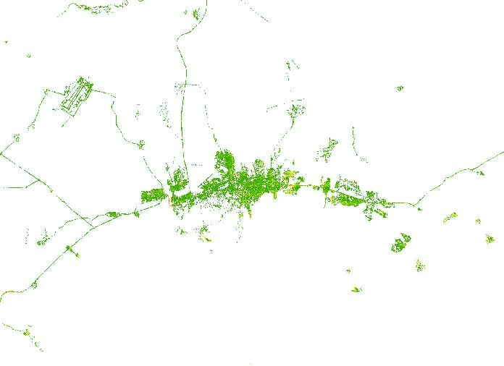  Percent Slope |   99th Percentile Slope

7. The incorporation of slope and water data into the land use classifications
Slope and water are the two constraints used for determining the buildable area, an important intermediate step in calculating the Buildable Perimeter and the Compactness Index of a city (described in subsequent sections). As before, the slope was derived from the SRTM elevation data. This time, however, the slope was computed for all pixels in the set of districts containing the city, rather than only for the built-up ones. The resulting slope grid was reclassified so that pixels with slopes less than or equal to the maximum slope were assigned a value of 1, and pixels with slopes exceeding the maximum slope were given a value of 0. This procedure is illustrated in figure IV-3. To incorporate the water constraint, a new landcover image was created, containing three classes of pixels: water, urban, and non-urban. The image was then reclassified to create a grid in which pixels containing water had a value of 0 and pixels that did not contain water had a value of 1. This procedure is illustrated in figure IV-4.
Figure IV-4. The slope constraint for the city of Chinju, China
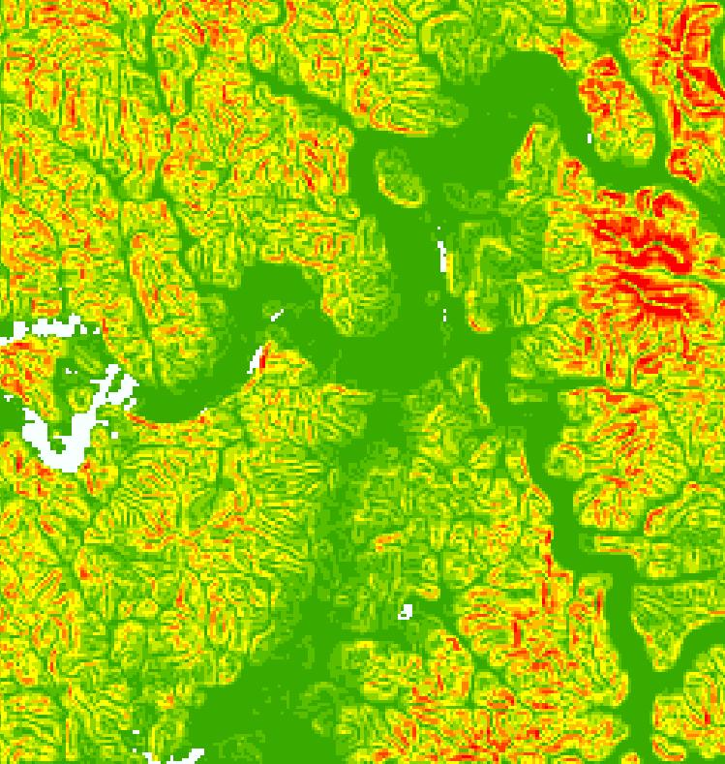 | 
Slope distribution | 99th percentile slope grid
Figure IIC-5. The water constraint for the city of Chinju, China
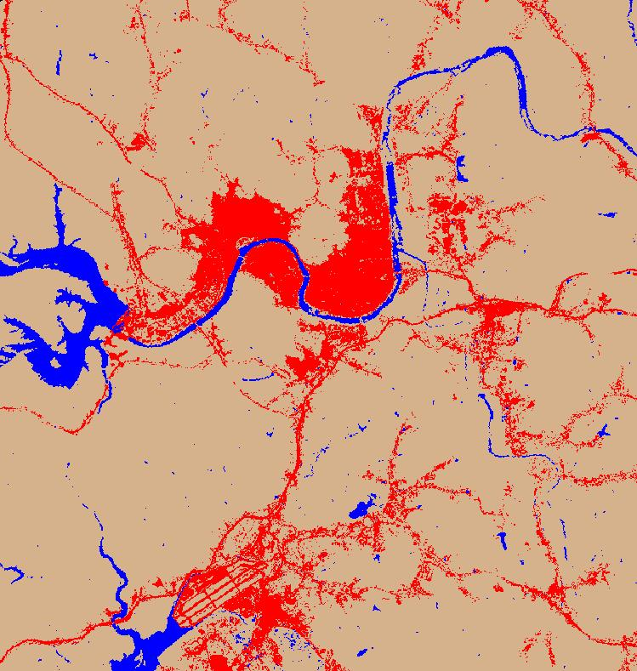 | 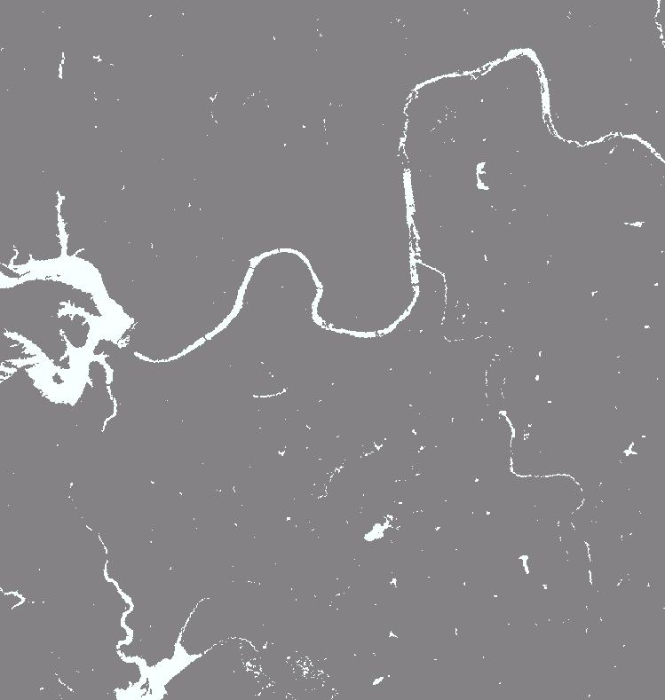
Urban/non-urban/water classification | Water/non-water grid

8. The Consolidated Built-up Area and the Buildable Perimeter
The urban pixels for each city were consolidated in order to derive the final measurements of contiguity, compactness, and the buildable perimeter. For T₁ and T₂, a smoothing algorithm was applied to the urban grids that were within the boundaries of the city districts containing the city. Contiguous pixels, in the smoothed grids, were then grouped. Contiguous clusters of pixels that were larger than 25 hectares (308 pixels, corresponding to 25 typical city blocks) were selected. These selected clusters we defined as constituting the consolidated built-up area of the city. The consolidated built-up area was then given a polygonal representation as a shapefile.
Figure IV-6. Deriving the consolidated built-up area for the city of Cincinnati
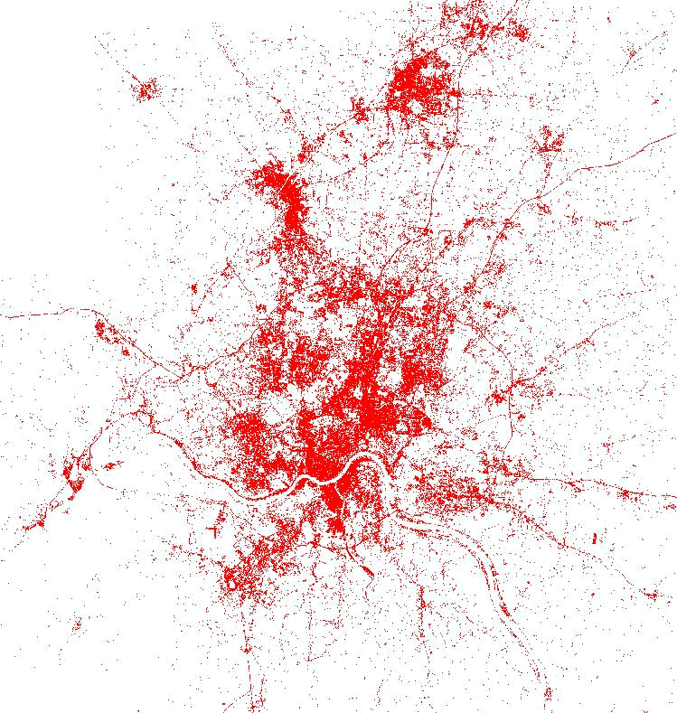  Urban grid | 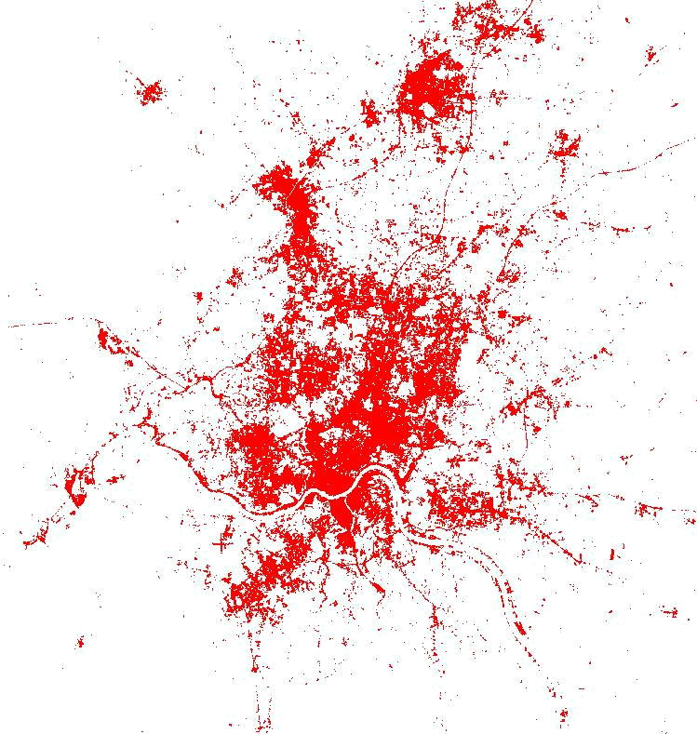  Smoothed urban grid | 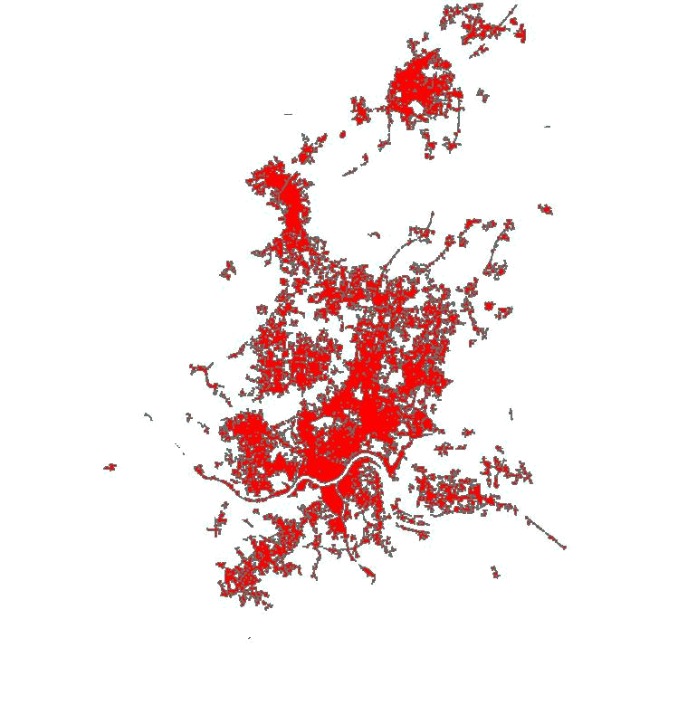  25 ha urban areas (the consolidated built-up area)

The buildable perimeter of a city was defined as the share, in percentage terms, of all the undeveloped area, within 1 km of the consolidated built-up area, that was buildable, i.e. having no areas of excessive slope or bodies of water. To calculate this statistic, 1 km belts around the consolidated built-up areas had to be defined for T₁ and T₂. Using an ArcGIS built-in algorithm, linear distances of 1,000 m were laid out from the edges of the polygons of the consolidated built-up area shapefiles. Each pixel within this radius was assigned a value of 1, while the rest of the pixels were assigned a value of 0. The set product of the resulting map and the previously calculated slope and water maps (see above) was evaluated using the Spatial Analyst Raster Calculator. The derivation of the buildable perimeter for the city of Fukuoka is illustrated in figure IV-7.
Figure IV-7. Deriving the buildable perimeter for the city of Fukuoka
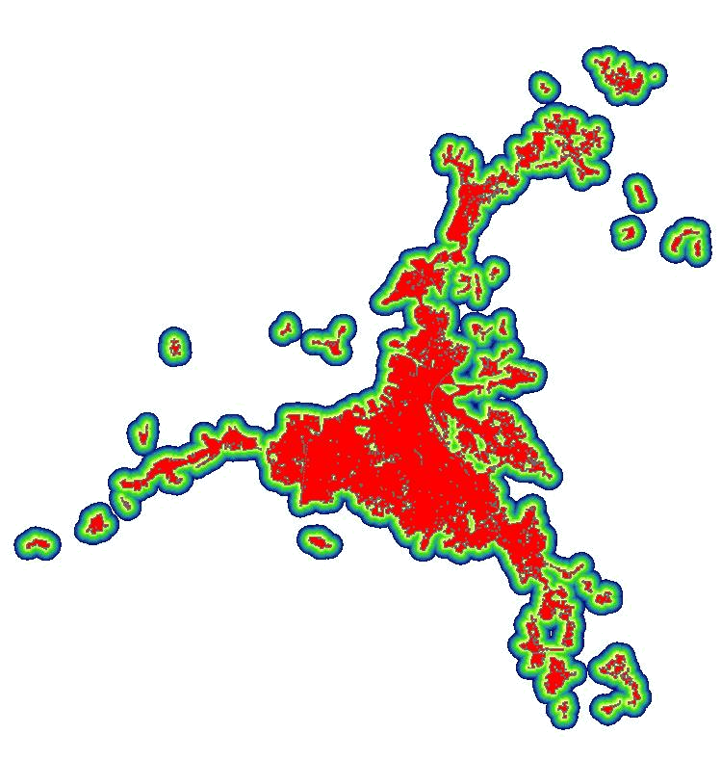 | 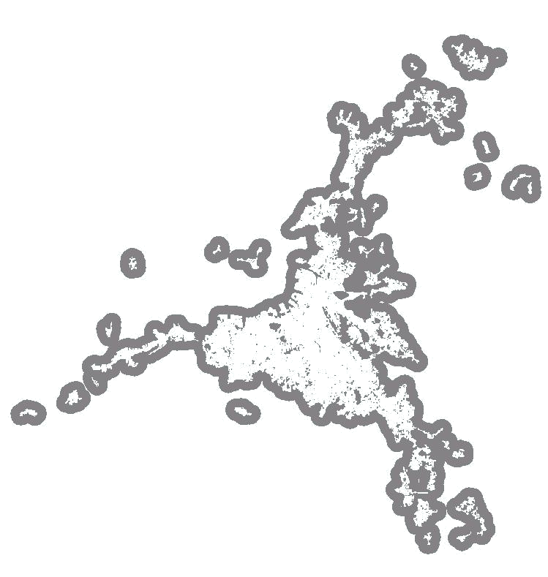 | 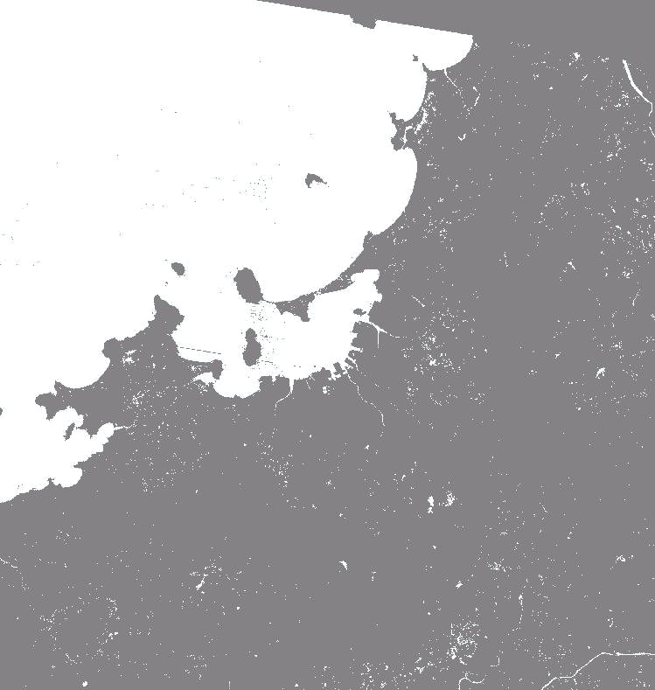
1000-m boundary layer | 1-km belt | Water-constrained area
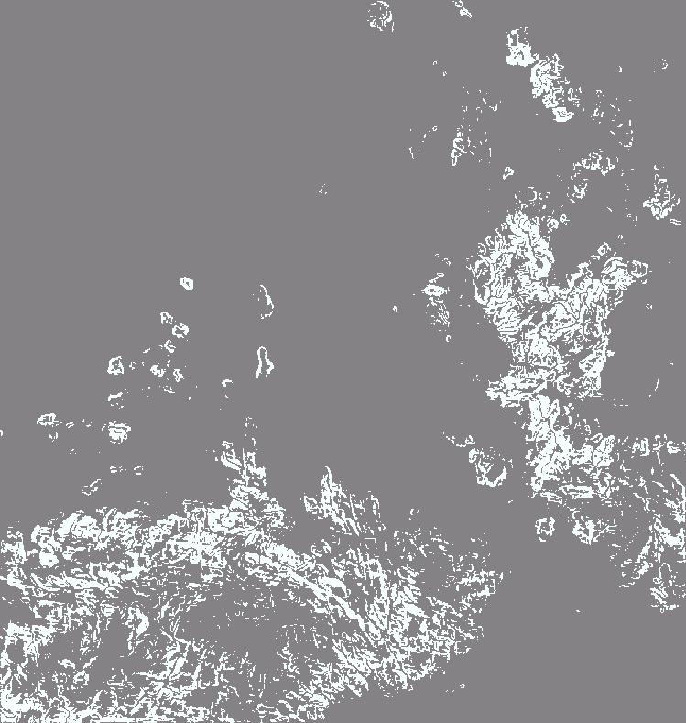 | 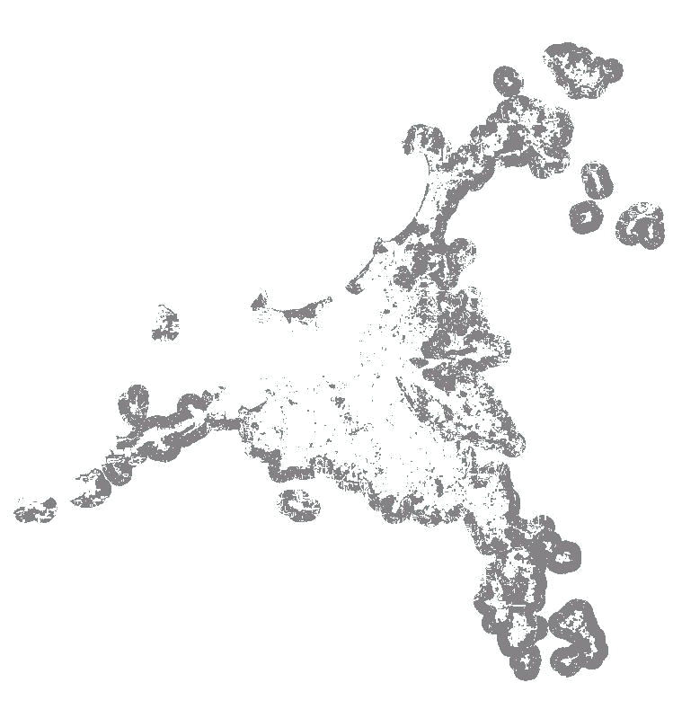
Slope-constrained area | Buildable perimeter

9. The Contiguity Index as a measure of urban spatial structure
It may be possible to look at the images of the cities in our sample with a view to obtaining a better understanding of their urban spatial structure, trying to determine, for example, whether some cities are more monocentric or more polycentric than others, and whether cities are becoming more monocentric or more polycentric over time. Some authors⎯ William Shore, for example, as well as those advocating New Urbanism⎯may not object to the overall low-density of the metropolitan area, but to the fact that it has no structure⎯ the fact that there are no centers and sub-centers in the metropolitan area. For Shore,
[s]prawl is the scatter of activities that people do together…. Its antidote, centers and communities, is the clustering of activities people do together, creating a magnetism…. The larger the cluster of activities (the magnet), the higher the density and the larger the residential community forming around it. The principle applies to monster centers like Manhattan down to centers of rural or suburban villages or city neighborhoods, as well as to downtowns in between, of middle-sized cities.
We can use the classifications of built-up pixels in the city to measure Urban Spatial Structure: to obtain a first approximation of the extent to which the city is monocentric or to the extent to which there are other centers and sub-centers in the metropolitan area. If there were no centers at all, we should expect to find no contiguous clusters of built-up pixels that are larger than, say, a 10-block area, estimated to be approximately 10 hectares in size. The percentage of built-up clusters that are smaller than 10 hectares, for example, may be an important measure of the lack of spatial structure in the city. The distribution of clusters of different areas would also be a measure of the spatial structure of the city.
We can examine a city’s distribution of clusters of connected built-up pixels of different size areas as one way of describing the city’s urban spatial structure. Shown below in figure IV-8 are the built-up areas of Valledupar, Bandung and Guangzhou. Table IV-3 and in figure IV-9 show the distributions of cluster sizes of different orders of magnitude in these three cities.
Table IV-8: The Distribution of the Built-Up Area Among Clusters of Different Size in Valledupar, Bandung and Guangzhou
Cluster Size Class (Hectares) |  |  | Percentage of Area in Each Class
Class | From | To | Valledupar | Bandung | Guangzhou
1 | 0 | 10 | 13 | 12 | 19
2 | 10 | 100 | 7 | 6 | 10
3 | 100 | 1,000 | 0 | 2 | 13
4 | 1,000 | 10,000 | 80 | 0 | 12
5 | 10,000 | 100,000 | 0 | 81 | 46

Figure IV-8: The built up areas in Valledupar, Bandung and Guangzhou in T2
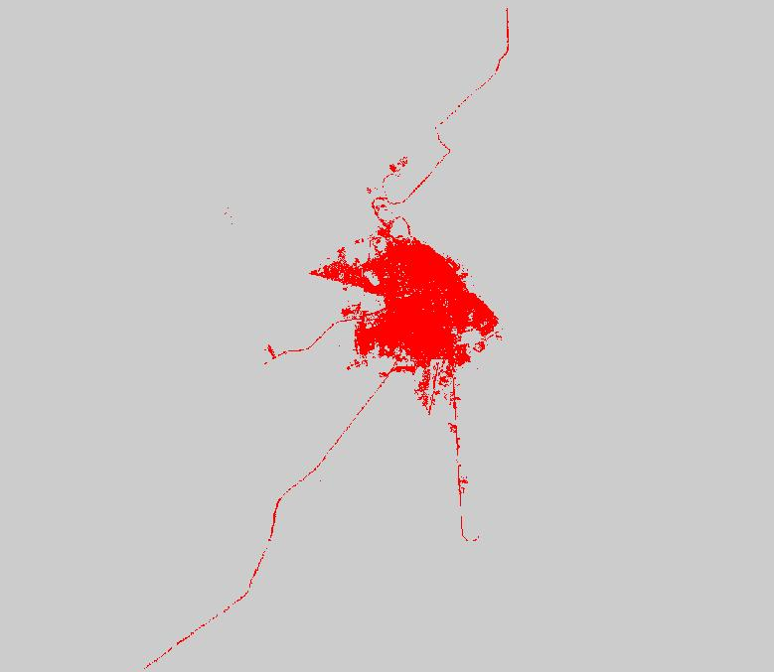 | 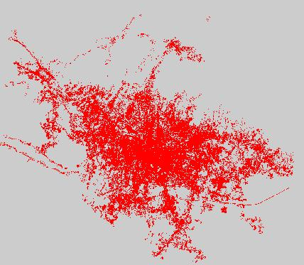
Valledupar 2001 | Bandung 2001
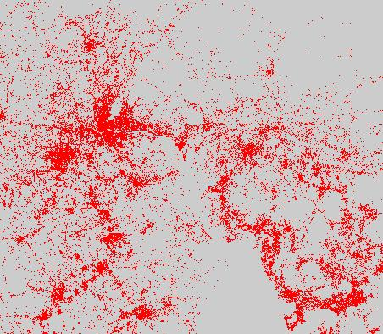
Guangzhou 2000

Figure IV-9: Urban spatial structure in Valledupar,
Bandung and Guangzhou
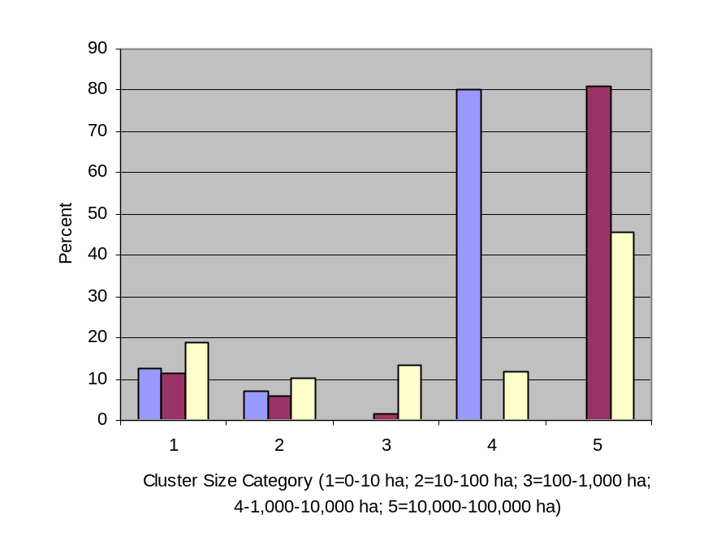
We can make several observations regarding the differences in the urban spatial structure of these three cities. First, Guangzhou has a larger percentage of its area that is not clustered at all⎯19 percent, as against 13 and 12 percent in Valledupar and Bandung respectively. Second, in Valledupar and Bandung, 80 and 81 percent of the built-up area is in one large cluster, while in Guangzhou, less than half the built-up area (46%) is in one cluster. Both Valledupar and Bandung have no second-order clusters and very few⎯seven in Valledupar and eight in Bandung⎯smaller urban clusters. In contrast, in Guangzhou there are 12 second-order clusters, 13 third-order clusters, and 10 fourth-order clusters. In other words, Guangzhou is much more of a polycentric city than either Valledupar or Bandung.
The construction of the Contiguity Index is an attempt to provide a summary measure of this aspect of the spatial structure of cities. The main built-up area of a city was defined to be ‘the largest polygon (or several contiguous polygons separated only by rivers) of the consolidated built-up area’ (see Section 8 in this Chapter). The size of each polygon in the consolidated built-up area was calculated, and this allowed for the computation of B_{m}, the area of the polygon comprising the main built-up area, as well as B_{s}, the sum of the areas of all polygons. The Contiguity Index of the city, for each of the T₁ and T₂ dates, was then calculated as the ratio of the two⎯i.e. Contiguity Index = B_{m}/B_{s.} The Contiguity Indices for Valledupar, Bandung and Guangzhou are 0.95, 0.95, and 0.45 respectively, showing an even more pronounced difference between Valledupar and Bandung on the one hand and Guangzhou on the other. The Contiguity Index is thus one possible summary measure of the extent to which the city is monocentric rather than polycentric.

10. The Compactness Index as a measure of the extent to which a city is fully-built
The discussion of the compactness of geometrical forms owes much to the attempts to fight the common practice of the gerrymandering of political districts, a practice that results in contorted district shapes that are far from being compact, compactness being an intuitive sense that the shape is as much like a disk as possible, the disk being the shape with the maximum area for a given perimeter. To what extent are cities indeed compact, that is, fully built and resembling a circular disk?
In the case of cities, as distinct from election districts, compactness should be restricted to buildable areas, in the sense that a city located on a coast, on a mesa cut up by steep gorges, or in a valley surrounded by steep cliffs can be very compact even if it does not resemble a full disk. We have the compactness of a city as a measure of how concentrated the built-up area is, accounting for the limitations imposed by steep slopes and bodies of water. More precisely, given the circle of minimum radius encompassing the consolidated built-up area of the city⎯called the outer circle⎯the Compactness Index was defined as ‘the ratio of the consolidated built-up area within the circle and buildable area within the circle’.
In practice, this consolidated-area-based circle turned out to be too large so as to compromise the intuitive meaningfulness of the index, since it had to include very distant built-up parts of the city. Consequently, the calculation of the index was restricted to the main built-up area of the city, rather than containing all its consolidated built-up areas. This is illustrated in figures IV-10 and IV-11 below, showing the initial selection of an outer circle for the built-up area of Tel-Aviv-Jaffa, and the final selection of an outer circle for the main built-up area of the city.
Figure IV-10. The selection of an outer circle of minimum radius
for the city of Tel Aviv-Jaffa
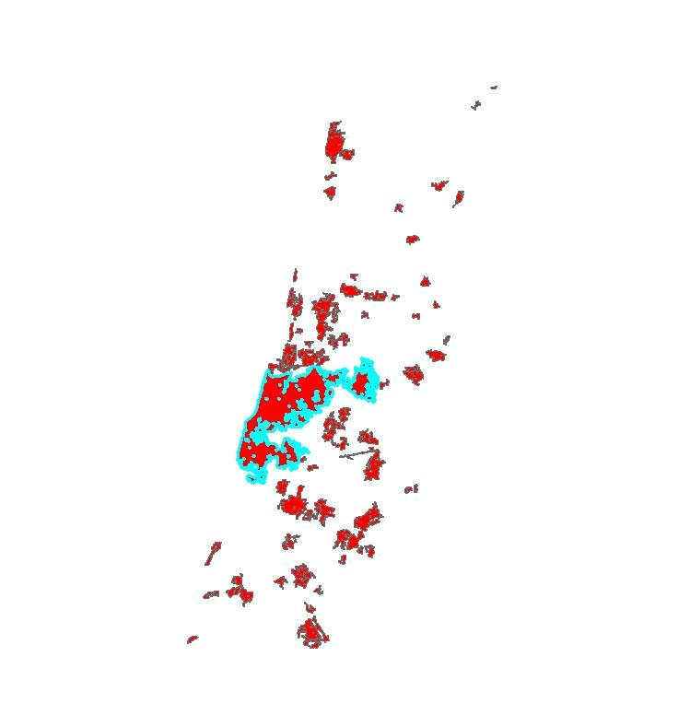 | 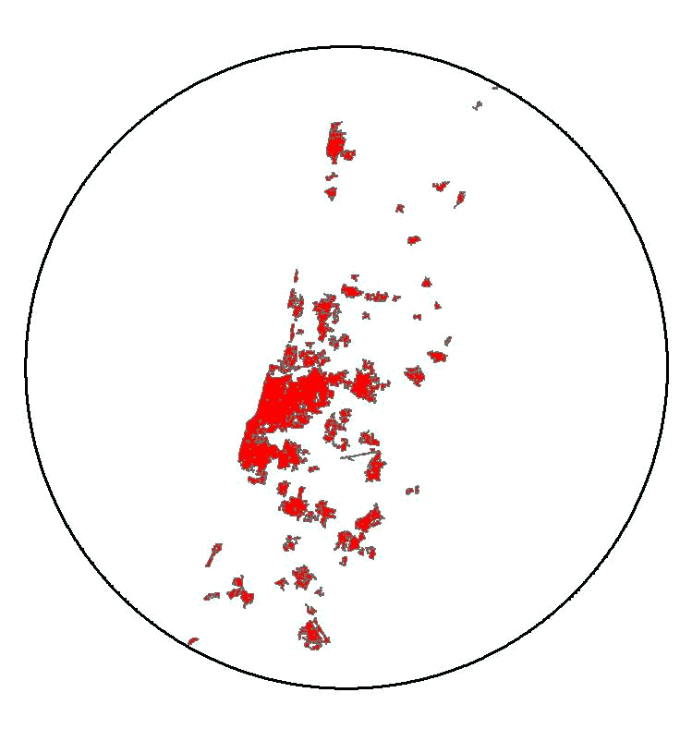 | 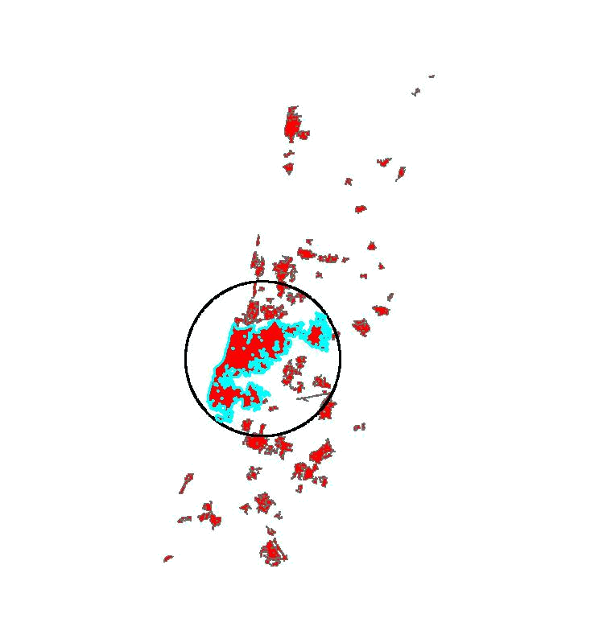
Consolidated built-up area with the main built-up area highlighted | Outer circle based on the consolidated built-up area | Outer circle based on the main built-up area

Figure IV-11. The final selection of an outer circle for the calculation of the compactness index for the city of Tel Aviv-Jaffa
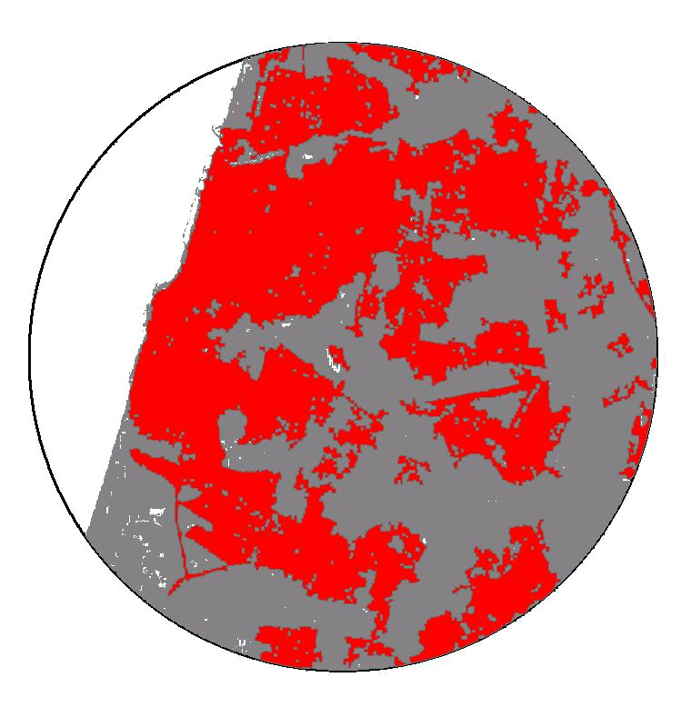
consolidated main built-up area
buildable area
non-buildable area (sea)

The Compactness Index for Tel-Aviv Jaffa in 2000 was 0.5, namely one-half of the buildable area in the circle of minimum radius surrounding the main built-up area of the city was, in fact, built-up. The corresponding measures for Valledupar, Bandung and Guangzhou were 0.47, 0.29, and 0.34 respectively. This measure is largely a measure of the circularity of the main built-up area. It is not a measure of the degree of openness of the city, which will be discussed further below. When the main built-up area of the city is only a small part of the built-up area of the city as a whole, this measure may be misleading as is the case with Guangzhou which has a higher Index value than that of Bandung.
In short, these two measures⎯the Contiguity Index and the Compactness Index are, in and of themselves, insufficient for giving a full description of the essential dimensions of urban form. More measures need to be developed. Some of the questions associated with this challenge are discussed further below.
Table IV-9: Preliminary estimates of the Compactness Index and the Contiguity Index for regions, income groups and city size groups, 1990 – 2000
 | Compactness Index |  |  | Contiguity Index
Category |  |  | Annual |  |  | Annual
 | 1990 | 2000 | % Change | 1990 | 2000 | % Change
Developing Countries | 0.35 | 0.36 | 0.2% | 0.69 | 0.68 | -0.2%
Industrialized Countries | 0.33 | 0.31 | -0.7% | 0.67 | 0.76 | 1.3%
Region
East Asia & the Pacific | 0.35 | 0.32 | -0.8% | 0.55 | 0.47 | -1.7%
Europe | 0.31 | 0.29 | -0.6% | 0.65 | 0.67 | 0.2%
Latin America & the Caribbean | 0.40 | 0.41 | 0.3% | 0.82 | 0.82 | 0.0%
Northern Africa | 0.34 | 0.36 | 0.5% | 0.58 | 0.56 | -0.4%
Other Developed Countries | 0.33 | 0.31 | -0.7% | 0.69 | 0.82 | 1.8%
South & Central Asia | 0.31 | 0.35 | 1.5% | 0.69 | 0.69 | 0.0%
Southeast Asia | 0.37 | 0.36 | -0.1% | 0.85 | 0.90 | 0.6%
Sub-Saharan Africa | 0.42 | 0.42 | 0.2% | 0.75 | 0.81 | 0.7%
Western Asia | 0.26 | 0.30 | 1.4% | 0.63 | 0.62 | -0.1%
Income Category
Low Income | 0.35 | 0.38 | 0.9% | 0.73 | 0.76 | 0.3%
Lower-Middle Income | 0.35 | 0.34 | -0.4% | 0.57 | 0.51 | -1.0%
Upper-Middle Income | 0.35 | 0.35 | 0.1% | 0.76 | 0.76 | -0.1%
High Income | 0.34 | 0.31 | -0.7% | 0.68 | 0.77 | 1.3%
City Population Size
100,000 - 528,000 | 0.33 | 0.35 | 0.6% | 0.67 | 0.65 | -0.3%
528,000 - 1,490,000 | 0.32 | 0.33 | 0.1% | 0.70 | 0.65 | -0.8%
1,490,000 - 4,180,000 | 0.38 | 0.36 | -0.6% | 0.67 | 0.73 | 0.8%
More than 4,180,000 | 0.35 | 0.34 | -0.2% | 0.69 | 0.78 | 1.2%
Global Average | 0.34 | 0.33 | -0.2% | 0.68 | 0.72 | 0.6%
Note: Based on weighted averages of the 90-city sample.
Table IV-9 provides estimates for the Compactness Index and the Contiguity Index for regions, income groups and city size` categories for the years 1990 and 2000. No consistent patterns appear to be observable in this table. There are no significant variations between developing countries and industrialized countries in either of the indices, and neither index appears to increase or decrease systematically over time. The Compactness Index hovers around the value of 0.33, suggesting that cities are far from being fully-built and that there is ample room for densification and infill development in most cities without significantly increasing the distance of their outer limits from their centers. Variations in the Contiguity Index among regions suggest that cities in East Asia may be more polycentric than cities in other regions, and that cities in Southeast Asia, Latin America and Sub-Saharan Africa may be more monocentric in structure.
In addition to the measures discussed in the previous sections, which have now been calculated for 90 cities in our global sample, work is under way to explore, generate and calculate other measures of interest. Several new measures can now be derived from the classification of Landsat images of metropolitan areas into built-up and non-built-up pixels and the combination of these classifications with available data on the population of administrative districts. One of these measures⎯the Openness Index⎯and the work done so far on defining and exploring it will be discussed in the following section.

11. The Openness Index
One metric that has caught our attention is the Sprawl Index used by Burchfield et al intended to capture the “differences in the extent to which development is scattered or compact”. Their measure of sprawl is expressed as “the amount of undeveloped land surrounding an average urban dwelling.” Stated differently, it is “the percentage of undeveloped land in the square kilometer surrounding an average residential development”. In our case, since we make no distinction among urban land use types, the metric would apply to built-up pixels of any kind. We have further amended the Burchfield et al algorithm to derive an openness index, defined as the average share of non-built-up pixels within a half-kilometer radius (i.e., a circle, as opposed to a square) of each and every built-up pixel in the districts comprising the city.
It is worth noting here that the Openness Index measures something that is entirely distinct from our measure of density or from our measure of continuity and compactness. Two cities with the same population and the same built-up area will have the same density, but in one city all of the built-up area can be located in one fully built cluster, while in the other it may be scattered into a very large number of small clusters. Also, a city can be built in a single fully built cluster, but that cluster can be shaped as a disk or as a star, with development along transport corridors. In both cases, both the openness index, the average density, and the contiguity index can be the same, but the compactness index will be quite different⎯it will approach one in the disk-shaped city and it will be quite low in the star-shaped city. In this sense, it is important to develop a set of measures of urban extent and expansion that will be both comprehensive and discrete, each measuring one phenomenon or interest and all together providing a complete assessment of the phenomena of interest.
Theoretically, the neighborhood summation of pixels to calculate the Openness Index can range from 0 to 901, in which case an urban grid cell with a value of 0 is completely surrounded by urban pixels within the entire ½ kilometer radius, and a value of 901 represents an individual built-up pixel surrounded by a homogeneous open space (non-built) neighborhood. Note also that we adjust the denominator of the equation (i.e., the area of the circle) to account for the edge effect near the boundaries of the study area which have a portion of the 1 kilometer diameter circle partially within the area and a portion partially outside. We further standardized the range of this value over the range {0,100}.
Let us now examine the images of Cincinnati in 1988 (T₁) and 1999 (T₂) in figure IV-12. The Openness Index for Cincinnati in 1988 is found to be 55.02 and in 1999 it was 53.80. This suggests that in the intervening period Cincinnati has become more compact, and, on the whole, access to open space decreased. Thus the Openness Index measures the degree to which built-up areas have access to open space, or, for those who define sprawl as ‘discontinuous development’ or ‘leapfrogging development’ the Openness Index is, in fact, a measure of sprawl.
Figure IV-12: The metropolitan area of Cincinnati in T₁ and T₂
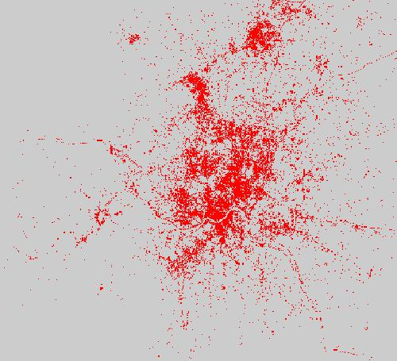 | 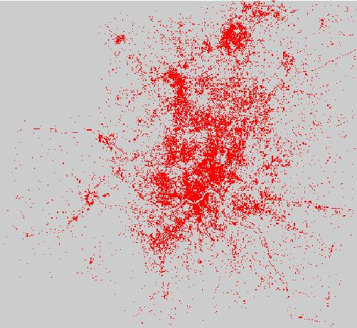
1988 | 1999

The Openness Index can also provide a useful measure of the loss of openness for the residents of Cincinnati that lived there in 1988, typically a cause of concern of sitting residents. We can calculate a new Openness Index value, for the built-up pixels in 1988, given the built-up pixels of both 1988 and 1999. Such calculation has not yet been attempted. Indirectly (and this needs to be investigated further as well), the loss of openness should correspond to the degree to which new development between 1988 and 1999 was infill development rather than new greenfield development on the urban fringe. In fact, there may be a high correlation between loss of openness for sitting residents and infill development. However, while the former relates to existing built-up areas, the latter refers to new development. There may indeed be a more direct indicator of infill development that will measure the percentage of new development that was infill directly. We have not yet been able to construct a useful measure of infill development, and this remains an important task for further research.
Let us look again at the images for the cities of Valledupar, Bandung and Guangzhou shown in figure IV-8 above. Valledupar has relatively solid boundaries between the urban and the rural areas; in Bandung, there are several relatively compact centers but then the urban gradually blends into the rural; and in Guangzhou there is almost no compact center at all, and large areas of very low-density development. The Openness Indices for these three cities were found to be 34.8, 37.2 and 52.5 respectively. The Openness Index does appear to provide an intuitively clear measure of access to open space, or alternatively of what people mean when they speak about sprawl as “discontinuous” or “leapfrogging” development. Measures of the Openness Index will be derived in the near future for all the cities in the sample.
We have now begun to investigate the possible use of the openness index to define better the urbanized area of the city⎯an area which may include the open space which is largely a part of the city, in addition to the built-up area of the city, while excluding rural built-up areas on the urban periphery; to define better a boundary or a fuzzy boundary for the city; and to refine our tentative measures of urban spatial structure. These and other venues of investigation will be pursued further in the second phase of this research project.
* * *

V MODELING URBAN EXTENT AND EXPANSION

- The role for analytic models of urban extent and expansion
The preceding chapter provided preliminary estimates of the global dimensions of urban areas in different world regions, income classes and city size classes and of the rate at which these areas are now expanding. While these numbers are no longer a mystery, they certainly pose great challenges, especially to the local, provincial and national public officials in developing countries and to international developing agencies that need to assist them. It is of the utmost importance to all stakeholders⎯be they ordinary citizens or planners and decision makers in the public, private or civic sector⎯to ensure that adequate quantities of public goods are put in place in a timely fashion, before it is too late: that there are adequate lands for absorbing the expected population growth; that there is an adequate capacity of trunk urban roads than can carry public transport; that there are adequate supplies of drinking water and effective means of sewerage disposal; that sensitive lands are protected from development; and that there is effective protection of open space. None of these are likely to be provided at adequate levels without concerted public action.
One possible reaction to the results presented so far might be to conclude that the magnitude of the problem has now been made manifest, and that the policy problems have been clearly delineated. If human societies are to accommodate the magnitude of urban growth that has been forecast, we must plan for and build adequate urban infrastructure for absorbing more than 1 million persons every week into cities for the next four decades. One might be forgiven for asserting that the time for analysis has passed, and the time for action is now upon us.
Still, some reflection and examination of existing trends and policies suggests that a deeper understanding of the forces that shape urban expansion in world cities is in order. In other words, there is still some serious thinking to be done before effective action can take place, because the phenomenon of urban expansion and the forces driving it are still not properly understood. An astonishing variety of factors have been put forward as contributing to urban expansion. In addition to the growing population of urban areas, these include the repulsion from central city problems and the attraction of urban residents to rural amenities; policy failures related to land use regulation, housing finance, taxation and local public finance or transportation; increasing household incomes; foreign direct investment and industrial structure; access to drinking water through wells rather than through piped water; and the increasing availability of automobiles and other alternatives means of transportation.
Even if each of these factors had some role to play in determining urban expansion, it is critical for policy makers to have some understanding of the relative contributions of different factors to urban expansion. This is particularly critical in the context of developing countries, where the sheer variety of economic circumstances, histories, levels of infrastructure, and modes of governance may pose situations far outside the sample of industrialized-country experiences that typically provide the setting for almost all of the empirical research on urban expansion.
It is towards this need that the present chapter is directed. We provide some initial analysis and modeling of the data that were described and presented in Chapters II through IV above. Our goal is to use the data collected so far to begin to address some basic questions concerning the relative importance of the factors that contribute to urban expansion. This provides an opportunity for developing a quantitative model of the urban extent and expansion that has been observed in our sample of cities⎯a model that will prove useful in planning and preparing for future urban growth. It also allows us to test our theoretical understanding of urban expansion by comparing our model outcomes with those predicted by the most accepted and widely used theories of urban spatial structure.

- Theory and hypotheses explaining urban expansion
The expansion of urban areas is determined by the interaction of three broad types of phenomena: the physical constraints of geography and environment, the demand for land by the households and firms who inhabit the city, and the policy constraints that govern land use and spatial interactions in the city. The most useful models for informing public action on the management of urban expansion will be those models that incorporate each of these factors in some way, and that evaluate the relative contribution of each factor to urban expansion.
Unfortunately, we do not have the same level of theoretical understanding of the effects of the physical, economic, and policy environments on urban expansion. Very little work has been done on the effect of climate, ecological biomes or topography on the form of cities. And while some models of expected policy effects do exist, for the most part such analyses have been limited to an ex post evaluation of the extent to which a particular type of policy appears to have been effective, ceteris paribus, in influencing urban structure. This type of analysis remains a potentially useful exercise because it does provide important information to policy makers about where successes and failures have occurred. A serious constraint on its usefulness, however, has been the relatively limited variety of contexts within which such policy analysis has taken place. Those analyses that have been undertaken have usually focused on individual cities, and almost entirely on cities located in industrialized countries. Under what conditions can these limited results be extended to developing countries or to transition economies? An important long run goal of the present research is to investigate this question.
The economic model of urban spatial structure is, by contrast, relatively well developed, though not necessarily more accurate in predicting actual outcomes. Several authors provide clear expositions of the by-now familiar theory, which proceed briefly as follows: We consider an urban area with exogenously given population of L households having income y and preferences that are represented by a common quasi-concave utility function 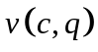that depends on consumption of a composite good c and housing q. Each household has a worker who is employed in the city center and must commute to the center to earn income. The household’s annual transportation costs for this commute are t x x if it resides in a house x units of distance from the center.
Equilibrium requires that a common utility level u be achieved by a household at any location within the built-up area of the city, so that the price per square meter of housing will vary with distance x. Households will allocate their income to select the most preferred combination of the composite good and housing, so that in equilibrium we must have:
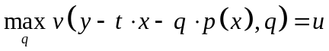 (1)
for all households.
Housing producers combine inputs of capital N and land l using a concave constant- returns production function H(N, l) to produce square meters of housing. Housing production therefore exhibits diminishing marginal productivity of both capital and land. Constant returns to scale and free entry of housing producers is sufficient to determine an equilibrium land rent function r(x) and a capital-land ratio (building density) S(x) that depend upon distance x from the city center and satisfy:
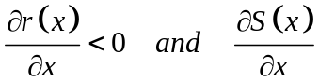, (2)
so that both land value and building density decline with distance from the city center. Combining the solution for building density S(x) with the housing q(x) demanded by a household at distance x provides a solution for the population density D(x,t,y,u) at distance x, given the exogenous levels of transport costs and income and the achieved utility level u.
The maximum extent of the urban area depends on the ability of housing producers to bid land away from its alternative uses. Let r_{A} represent the alternative use value of land (often explained heuristically as the market rent of land in agricultural use). The maximum extent of the urban area is then given implicitly by:
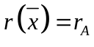 (3)
Finally, equilibrium requires that all households be accommodated in the urban area. If θ represents the share of land available for development at each distance, this is ensured by the following equilibrium condition:
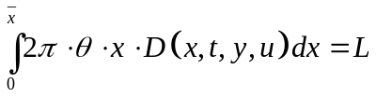. (4)
This basic theory provides an endogenous solution for the maximum extent of urban land use, and relates this solution to several observable characteristics of the urban area. In particular, we can derive a number of comparative static results from this model that provide clear, testable hypotheses for our analysis.
The model discussed above has housing producers (and agricultural producers outside of the urban area whose demand for land generates the rents r_{A}) as the only direct consumers of land. It is easy to generalize this model so that firms who trade in the city center are included as well, combining inputs of capital and land according to f(N,l) to produce an export good for external markets sold at price w. These firms provide a separate commercial demand for land. Assuming that the cost (in terms of reduced profitability) of moving production away from the urban center is greater than the aggregate commuting cost of the households who would occupy an equal amount of land, the firms will be more centrally located than the households. In this case we can derive two additional hypotheses concerning the impact of changes in the productivity of land in export-good production, and the impact of an increase in the world demand for the export good. All of the hypotheses derived from this model of urban spatial structure are summarized and described in table V-1 below.

Table V-1: Hypotheses concerning urban spatial structure
derived from the standard economic model
No. | Comparative Static Result | Description of prediction and hypothesis
1. | 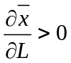 | An increase in population will increase urban extent and urban expansion.
2. | 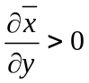 | An increase in household income will increase urban extent and urban expansion.
3. | 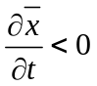 | An increase in transportation costs will reduce urban extent and limit urban expansion.
4. | 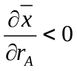 | An increase in the opportunity cost of non-urban land will reduce urban extent and limit urban expansion.
5. | 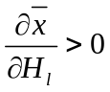 | An increase in the marginal productivity of land in housing production will increase urban extent and urban expansion.
6. | 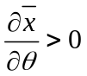 | An increase in the share of land available for housing development will increase urban extent and urban expansion.
7. | 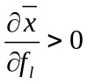 | An increase in marginal productivity of land in production of the export good will increase urban extent and urban expansion.
8. | 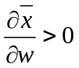 | An increase in the world price of the export good will increase urban extent and urban expansion.

One of the primary objectives of this study was to test these hypotheses with the data from our sample of cities, so as to provide some confirmation of the traditional economic theory of urban extent and urban land use. While successful predictions derived from our empirical data cannot establish the ‘truth’ of the theory, they can surely help increase our confidence in applying this theory, especially in anticipating the impacts on urban expansion that might result from alternative policies or from exogenous changes in the economic environment.
In a full test of this model of urban spatial structure, we would account not only for the factors explicitly identified in the theory as important, but also for those external factors such as policy, environmental, and geographic constraints. A more complete test awaits the completion of ongoing data collection in the second phase of this study, but we are already able to provide some initial results to examine the predictive value of this model at the present time. The following section discusses the data we have collected for analysis so far. Following that is a section that presents our estimates of models of urban land use. We then proceed to engage in a very preliminary exploration of the predictive value of economic variables in explaining some measures of the structure of urban areas, such as their compactness and contiguity (as defined in Chapter IV). We conclude this chapter with an evaluation of the predictive value of the models and an outline of the future directions of our ongoing econometric research into the causes and consequences of urban expansion.

- The collection of data for the analysis of urban expansion
The data used for our analysis begins with the measures of urban land use in the sample of 90 cities discussed extensively in Chapters II through IV above. These provide key measures⎯for each city in the sample⎯of both population and urban land cover (in square kilometers) at two points in time. We can use these data as either 180 observations of urban population and land use, collected at various points in time, or, alternatively, as 90 observations of change in urban land use.
Measures of the built-up area and the maximum slope in the built-up area for each city were derived by the research team as described in Chapter IV above (see also the individual city images and their associated measures presented in Chapter VII). The total population of the cities in the sample was derived from small area population estimates provided by CIESIN. These were collected by CIESIN from national census offices in each country, as part of its project for providing population estimates for the entire world at a 1km-grid resolution. The CIESIN population estimates for the administrative districts that contained each of the cities in the sample were extrapolated to match the dates T₁ and T₂ of each city’s satellite images.
To test the hypotheses listed in Section 2 above, we combined the data generated by our study with available information on population, income, and other relevant variables. These additional data were gathered from a variety of sources. The following three tables, V-2, V-3 and V-4, list the data used in estimating the three groups of econometric models that will be presented below. The final line of each table provides descriptive statistics for the sampling weights based on urban populations. These were used in calculating the descriptive statistics and in estimation of all models discussed below.
Descriptive statistics for variables used in estimating models 1−3 (discussed in Section 4 below) are presented in Table V-2. The final three variables in table V-2 are dichotomous variables indicating location within one of three biomes that turned out to be significant determinants of the level of urban land cover. These three biome indicators and the Ground Water indicator were used in all models.
TableV-2: Variables Used in Models 1-3
Variable | Mean | σ | Min | Max
Urban Land Use (km²) | 400.6871 | 533.7343 | 8.91769 | 2328.87
Total Population | 3,287,357 | 4,179,050 | 105,468 | 1.70E+07
Per Capita GDP (PPP 1995 $) | 9,550.217 | 9,916.317 | 562.982 | 32,636.5
National share of IP addresses | 0.085741 | 0.193696 | 3.50E-06 | 0.593672
Air Linkages | 88.78808 | 117.6716 | 0 | 659
Maximum Slope (percent) | 25.34515 | 14.55289 | 4.16 | 72.78
Agricultural Rent ($/Hectare) | 1,641.608 | 3,140.596 | 68.8372 | 19,442.1
Cost of fuel ($/liter) | 0.581498 | 0.328673 | 0.02 | 1.56
Cars per 1000 persons | 144.7495 | 191.4476 | 0.39 | 558.5
Ground Water (1=shallow aquifer) | 0.281518 | 0.451022 | 0 | 1
Temperate Humid Climate | 0.077395 | 0.267979 | 0 | 1
Mediterranean Warm Climate | 0.005109 | 0.071499 | 0 | 1
Mediterranean Cold Climate | 0.017234 | 0.130515 | 0 | 1
Sampling Weight | 0.011168 | 0.010542 | 0.000834 | 0.068174

Descriptive statistics for additional variables used in estimating models 4−6 (also discussed in Section 4) are presented in Table V-3 below.

Table V-3: Additional Variables Used in Models 4-6
Variable | Mean | σ | Min | Max
Change in Built-Up Area | 125.8202 | 163.3169 | -322.559 | 527.368
Change in Total Population | 751827.3 | 1474634 | -470586 | 5.40E+06
Change in Per Capita GDP | 1566.28 | 2156.812 | -4552.33 | 6722.88
Air Links in 1990 | 88.03663 | 124.1801 | 0 | 659
Maximum Slope in 1990 | 25.03812 | 14.3309 | 4.16 | 70.63
Agricultural Rent in 1990 | 1589.797 | 3396.454 | 84.9003 | 19442.1
Fuel Cost in 1990 | 0.436883 | 0.247924 | 0.02 | 1.18
Cars per 1000 in 1990 | 130.7622 | 182.7599 | 0.39 | 489.2
Sampling Weight | 0.011168 | 0.010573 | 0.000834 | 0.068174

The cost of fuel at the pump, the numbers of cars per 1,000 persons, and per capita GDP (in constant 1995 US dollars converted as PPP exchange rates)⎯all available only at the national level⎯were obtained from the World Development Indicators (WDI) website of the World Bank. The ‘Agricultural Rent’ variable was also available only at the national level. It was computed from WDI data by calculating the total value-added in agriculture (in constant US dollars) per hectare of arable land. The Share of IP Addresses was calculated from data available from MaxMind. It provided, for each country, the share of Internet Protocol (IP) addresses assigned to that country relative to the total of all IP addresses assigned throughout the world. The available data is current as of 2005, but we used it as a general indicator of available business infrastructure in the country, and hence of the marginal productivity of land for business production.
Table V-3 above provides descriptive statistics for those variables used in the models of change in urban land cover (rather than absolute levels of urban land cover). Several of the variables shown in the table were available at the city level. The Air Links variable provided the number of airports connected via incoming flights (both non-stop and connecting) to the cities in our sample from mid-March through mid-June for 1990 (T₁) and 2000 (T₂). This measure and similar measures have been shown to be highly correlated with general global connectedness and the volume of international trade. We used this measure, therefore, as an indicator of global connectedness and the price that domestically produced export goods are likely to receive in global markets. The dichotomous variable ‘Ground Water’ indicates that the city is located in an area with localized and shallow aquifers, so that while drilling a well to obtain water may not be possible at all locations, it is possible at many locations and the required depth is not great.
Descriptive statistics for variables used in estimating models 7−10 (discussed in Section 4) are presented in Table V-4 below.

Table V-4: Variables Used in Models 7-10
Variable | Mean | σ | Min | Max
Ln(Urban Area) | 5.217764 | 1.302409 | 2.18804 | 7.75314
Ln(Total Population) | 14.26064 | 1.243901 | 11.5662 | 16.6682
Ln(Per Capita GDP) | 8.596582 | 1.099758 | 6.33325 | 10.3932
Ln(Share IP Addresses) | -5.249607 | 3.012159 | -12.5592 | -0.52143
Ln(Air Links+1) | 2.923513 | 2.21341 | 0 | 6.49224
Ln(Maximum Slope) | 3.065746 | 0.595572 | 1.42552 | 4.28744
Ln(Agricultural Rent) | 6.757474 | 0.980555 | 4.23174 | 9.8752
Ln(Fuel Cost) | -0.71369 | 0.640135 | -3.91202 | 0.444686
Ln(Cars Per 1,000) | 3.399618 | 2.1609 | -0.941609 | 6.32525
Sampling Weight | 0.011168 | 0.010542 | 0.000834 | 0.068174
Table V-4 provides the information for the data used in the final four models that relate the natural logarithm of urban land cover to the natural logarithm of non-dichotomous variables.

- Models of urban extent and urban expansion
The economic model of urban extent and urban land use outlined in section 2 above does not specify a particular functional relationship between urban extent (the built-up area of the city) or urban expansion (change in total built-up area) and the variables discussed in the hypotheses listed in table V-1. The functional form would depend on the exact functional forms of the utility and production functions in the model.
We tested these hypotheses by estimating three general types of models. We first examined linear models of urban extent, estimating three slightly different relationships between the total built-up area of the city and the variety of explanatory variables discussed and described in the preceding section. These three models⎯labeled Models 1, 2 and 3⎯are presented in table V-5. Each model has the total built-up area of the city (measured in square kilometers) as the dependent variable.
In this table (and in all subsequent tables presenting model estimates), the estimated model is presented in a column, with a blank spot indicating that the variable associated with that row is not included as part of the specification of that model. Each parameter estimate is presented in larger type, with the standard error of the estimate presented in italics below the estimated parameter. Those parameters whose estimates are statistically significant at the 10 percent level or better are printed in bold face. Robust standard errors σ are used and reported for all estimates. All model estimates were obtained using the STATA 9 Special Edition statistics software.
The primary difference between models 1, 2 and 3 is the inclusion of a variable to measure the impact of transportation costs t, so as to provide a test of hypothesis 3 presented in Section 2 above. The data available to us are of limited use, since they are available only at the national level (rather than the individual city), and since they are often highly correlated with income. While it can be argued that the use of national level data provides an exogenous measure of transport costs whose variation is not simultaneously determined by the level of urban land cover, this measure is certainly noisier than a direct observation of local fuel costs and transport mode choices at the city level.
The available measure of automobile use⎯cars per 1,000 persons⎯is difficult for two additional reasons. First, it is not clear whether increasing the number of automobiles per capita decreases transport costs (since automobiles are faster than public transportation) or increases it (due to increased congestion costs). Furthermore, the numbers of cars per 1,000 persons are very highly correlated with national income, so that problems of colinearity arise when both are included in the model. This is clear from examination of table V-6, which provides the Variance Inflation Factors for variables in Model 3 in table V-5. The table clearly demonstrates that the inclusion of both income and cars per 1,000 people in the model has a considerable impact on the variance of parameter estimates.

Table V-5: Linear Models of Total Urban Land Cover
 | Model 1 | Model 2 | Model 3
Total Population | 0.000046 | 0.000046 | 0.000045
σ | 0.000012 | 0.000012 | 0.000012
Income | 0.007656 | 0.007204 | 0.012503
σ | 0.0030 | 0.0028 | 0.0116
Share of IP Addresses | 1035.0870 | 1059.1800 | 1003.3360
σ | 279.5773 | 297.3413 | 282.5092
Air Links | 1.6540 | 1.6467 | 1.6908
σ | 0.2803 | 0.2953 | 0.2880
Maximum Slope | -1.3593 | -1.3574 | -1.3620
σ | 1.7102 | 1.7061 | 1.7285
Agricultural Rent | -0.0111 | -0.0114 | -0.0122
σ | 0.0043 | 0.0048 | 0.0054
Fuel Cost |  | 17.2982
σ |  | 70.4921
Cars/1000 |  |  | -0.2458
σ |  |  | 0.4976
Shallow Ground Water | 97.2364 | 98.1368 | 95.3943
σ | 51.6306 | 52.9738 | 52.8588
Temperate Humid | -225.0211 | -224.1264 | -217.8070
σ | 106.3447 | 107.1763 | 105.1351
Mediterranean Warm | 275.4711 | 274.0859 | 271.0372
σ | 42.4932 | 40.5861 | 44.2845
Mediterranean Cold | 63.9141 | 61.7096 | 66.0667
σ | 36.8820 | 34.0951 | 36.9881
Constant | -19.2077 | -26.3652 | -26.4953
σ | 44.8569 | 62.1321 | 50.1161
Number of observations | 176 | 176 | 176
R-squared | 0.7858 | 0.7858 | 0.7862
Root MSE | 254.43 | 255.16 | 254.91

The parameter estimates for fuel costs and cars per 1,000 are also disconcerting. While neither is statistically significant (owing to the large standard errors with which the parameters are estimated) they also have the wrong sign, with higher fuel costs apparently leading to increased urban land use and higher cars per 1,000 persons leading to reduced urban land use.
Despite the difficulties in obtaining accurate estimates of the impacts of changes in transport costs, the models reported in table V-5 seem to perform surprisingly well. Each model explains nearly 79 percent of the total sample variation in urban land cover.
Population, income, and agricultural rent are statistically significant in each model, and the signs of each parameter estimate are consistent with hypotheses 1, 2 and 3 respectively.
Table V-6: Variance Inflation Factors for Full Linear Model
Variable | VIF
Income | 20.35
Cars per 1,000 | 15.85
Share of IP Addresses | 3.31
Air Links | 2.35
Total Population | 1.90
Agricultural Rent | 1.47
Maximum Slope | 1.23
Temperate Humid | 1.21
Ground Water | 1.17
Mediterranean Cold | 1.03
Mediterranean Warm | 1.02
Mean | 4.63
Taking the Share of IP Share as a measure of the marginal productivity of land in export production and Air Links as a measure of the demand for the cities export product, we note that parameter estimates for both are statistically significant and signed in a way to be supportive of hypotheses 7 and 8. The Maximum Slope variable may be taken as indicative of both limitations in the amount of land available for residential development (an index of θ), and as an indicator of the marginal productivity of land in the production of housing. While the parameter estimate is not statistically significant in any of the three models, it is signed in a way that is consistent with hypotheses 5 and 6.
The dichotomous indicator for shallow aquifers provides a more direct test of hypothesis 5, since such aquifers reduce the amount of capital required to provide housing with water (in contrast with the higher capital cost of water that is obtained through deep wells or through the extension of water pipes from municipal sources). Thus land in areas with shallow aquifers has higher marginal productivity in housing production, and should be associated with increased urban land cover. The parameter estimates for this variable are statistically significant and directly support this hypothesis.
Models 4, 5 and 6 reported in table V-7 below take a different approach to estimating these relationships. Rather than use the total built-up area of cities as a measure of urban extent, these models use the change in built-up area as a direct measure of urban expansion.
Estimation of these models poses two types of data problems. First, the time period over which the change in urban land cover takes place is not the same for each city. The time periods depend on the availability of usable cloud-free satellite images and therefore range from periods of approximately 8 years to more than 12. These changes would ideally be matched with changes in the independent variables. For some data (for example, the Share IP Addresses or other measures of business infrastructure) we lack measures of change over this period. In other cases we have measures of change that fail to correspond to the periods of change in our land cover data.
For the two most important determinants⎯population and income⎯we do have relatively complete data and we can interpolate the data to get change in these variables that corresponds exactly to the time period over which our land cover change is measured. For our other variables, we use either the one measure we have for each city, or the measure available at the beginning of the time period, so as to provide an indication of the economic conditions that produced the observed urban expansion.
Again, examining table V-7, we see that all three models perform quite well, explaining roughly 82 percent of the total sample variance in urban expansion. Population change and income change are statistically significant in every model, and their signs are consistent with hypotheses 1 and 2. The Share of IP Addresses and the Shallow Ground Water variables are also statistically significant and supportive of hypotheses 7 and 5 respectively.

Table V-7: Linear Models of Urban Expansion
 | Model 4 | Model 5 | Model 6
Population Change | 0.000083 | 0.000085 | 0.000084
σ | 0.000007 | 0.000007 | 0.000006
Income Change | 0.02169 | 0.01813 | 0.020129
σ | 0.0077 | 0.0075 | 0.0073
IP Share | 237.1614 | 279.7229 | 270.6102
σ | 96.9735 | 101.1712 | 110.2253
T₁ Airlink | 0.1383 | 0.1154 | 0.1301
σ | 0.1003 | 0.1044 | 0.1105
T₁ Maximum Slope | -1.2954 | -1.1688 | -1.2267
σ | 0.7050 | 0.7033 | 0.7111
T₁ Agricultural Rent | -0.0011
σ | 0.0011
T₁ Fuel Cost |  | 21.0234
σ |  | 34.4916
T₁ Cars/1,000 |  |  | -0.0199
σ |  |  | 0.0902
Shallow Ground Water | 36.0570 | 35.8025 | 36.5591
σ | 19.6228 | 19.1266 | 19.1902
Temperate Humid | -54.7146 | -49.8376 | -47.4455
σ | 40.3215 | 40.3067 | 41.9332
Mediterranean Warm | 148.9260 | 143.7444 | 147.4802
σ | 27.0154 | 26.9233 | 26.6382
Mediterranean Cold | 9.9700 | 13.9181 | 12.9924
σ | 15.6299 | 15.5493 | 14.8440
Constant | 24.2468 | 10.6364 | 20.8378
σ | 17.0721 | 21.2756 | 16.3076
Number of observations | 88 | 90 | 90
R-squared | 0.8207 | 0.816 | 0.8154
Root MSE | 73.515 | 74.035 | 74.154

In Models 4, 5 and 6 the Maximum Slope parameter is statistically significant and signed as would be suggested by hypotheses 5 and 6. While neither the Air Links variable nor the Agricultural Rent variable are statistically significant, both are signed as would be expected by hypotheses 8 and 4 respectively. The Fuel Cost and Cars per 1,000 variables continue to be insignificant and incorrectly signed.
Our final set of models returns to examination of the relationship between total urban land cover and the explanatory variables. Models 7 through 10, reported in table V-8 below, relate the logarithm of total urban land cover to the logarithm of all the non-dichotomous variables in table V-4 as well as to the binary variables in table V-2. This logarithmic functional form evaluates a non-linear relationship between the variables, and permits easy interpretation since estimated parameters provide elasticity measures of the dependent variable with respect to the independent variables.

Table V-8: Logarithmic Models of Urban Expansion
 | Model 7 | Model 8 | Model 9 | Model 10
LN Total Population | 0.662338 | 0.664504 | 0.662429 | 0.664468
σ | 0.0502 | 0.0487 | 0.0505 | 0.0488
LN Income | 0.495863 | 0.024581 | 0.498571 | 0.014567
σ | 0.0700 | 0.1195 | 0.0704 | 0.1296
LN Share of IP Addresses | 0.0513 | 0.0901 | 0.0500 | 0.0917
σ | 0.0237 | 0.0228 | 0.0240 | 0.0241
LN Air Links | 0.1222 | 0.1057 | 0.1210 | 0.1065
σ | 0.0256 | 0.0246 | 0.0258 | 0.0245
LN Maximum Slope |  |  | 0.0300 | -0.0238
σ |  |  | 0.0791 | 0.0788
LN Agricultural Rent | -0.2601 | -0.2142 | -0.2675 | -0.2076
σ | 0.0350 | 0.0358 | 0.0361 | 0.0376
LN Fuel Cost | -0.0870 | -0.1168 | -0.0843 | -0.1194
σ | 0.0743 | 0.0793 | 0.0741 | 0.0779
LN Cars/1000 |  | 0.2228 |  | 0.2265
σ |  | 0.0508 |  | 0.0539
Shallow Ground Water | 0.2665 | 0.2057 | 0.2530 | 0.2154
σ | 0.0913 | 0.0917 | 0.0853 | 0.0835
Temperate Humid | -0.3141 | -0.3456 | -0.3267 | -0.3362
σ | 0.1301 | 0.1274 | 0.1347 | 0.1303
Mediterranean Warm | 1.1353 | 1.8896 | 1.1080 | 1.9238
σ | 0.1642 | 0.2079 | 0.1757 | 0.2418
Mediterranean Cold | 0.6808 | 0.5289 | 0.6883 | 0.5204
σ | 0.2375 | 0.2699 | 0.2455 | 0.2724
Constant | -6.9516 | -3.7494 | -7.0141 | -3.6463
σ | 1.2198 | 1.3542 | 1.2575 | 1.4917
Number of observations | 176 | 176 | 176 | 176
R-squared | 0.8858 | 0.8967 | 0.8859 | 0.8968
Root MSE | 0.45327 | 0.43237 | 0.45439 | 0.43353

Again, the models appear to perform very well, explaining between 88 and 90 percent of the total variation in the log of total urban land cover. The parameters associated with variables measuring Total Population, the Share of IP Addresses, Air Links, Agricultural Rent and Shallow Ground Water are statistically significant in every model and signed correctly, providing support for hypotheses 1, 4, 5, 7, and 8.
Table V-9: Variance Inflation Factors for Full Logarithmic Model
Variable | VIF
Income | 18.71
Cars / 1,000 | 12.99
Share of IP Addresses | 3.84
Population | 3.26
Air Links | 3.11
Agricultural Rent | 1.54
Maximum Slope | 1.5
Shallow Ground Water | 1.25
Mediterranean Warm | 1.23
Fuel Cost | 1.17
Temp Humid | 1.16
Mediterranean Cold | 1.09
Mean | 4.24
The income variable is correctly signed in all models and statistically significant in Models 7 and 9, providing general support for hypothesis 2. The estimation in Models 8 and 10 is again plagued by colinearity problems that increase the variance of parameter estimates, as suggested by the Variance Inflation Factors presented in table V-9.
Models 7 through 10 provide the first support for hypothesis 3, with the impact of higher fuel costs being to reduce urban extent, although the estimated parameters remain statistically insignificant. The estimated parameter associated with Cars per 1,000 Persons is statistically significant in the two models where it appears. Assuming that increasing this value indicates lower transportation costs, this result also provides support for hypothesis 3.

- Models of urban compactness and contiguity
Other characteristics of urban structure besides urban extent and urban expansion have drawn attention of some policy makers, urban planners and scholars. In Chapter IV above we introduced and provided estimates for two of these measures of urban form⎯ compactness and contiguity⎯for regions, income groups and city size classes. The Compactness Index was defined as ‘the share of the buildable area (area with no bodies of water or excessive slope) in a circle of minimum radius containing the main built-up area of the city that is actually built-up’. The Contiguity Index was defined as ‘the share of the main, contiguously built-up area in the total built-up area of the city’. Other measures of urban form⎯such as the Openness Index⎯are presently being explored and will be reported on in later publications of the present study. Not much has been written concerning the determinants of these aspects of urban form. The considerable interest in these variables, however, leads us to undertake an initial exploration of the extent to which our economic variables can explain the variations in these indices.
Table V-10 reports the results of our analysis of Contiguity and Compactness. We have estimated linear and logarithmic versions of models for both the Contiguity Index and the Compactness Index. These models are not derived from a theoretical model as was done for the models presented in the section above, so we must view these results as very preliminary.

Table V-10: Linear and Logarithmic Models of Contiguity and Compactness
 | Contiguity | Compactness | Ln (Contiguity) | Ln(Compactness)
Total Population | -3.4400000E-09 | 3.5300000E-09 | 0.0611118 | 0.0129526
σ | 7.4400000E-09 | 3.2300000E-09 | 0.0335 | 0.0358
Income | -0.0000016 | -0.0000008 | 0.1737462 | -0.015874
σ | 0.0000033 | 0.0000017 | 0.0692 | 0.0685
Share of IP Addresses | 0.0657763 | -0.0864179 | -0.0683419 | -0.0241164
σ | 0.1462 | 0.0706 | 0.0233 | 0.0225
Air Links | 0.0004387 | 0.0000154 | 0.0080391 | 0.0284618
σ | 0.0002 | 0.0000971 | 0.0200 | 0.0191
Maximum Slope | -0.0033939 | -0.0006475
σ | 0.0013 | 0.0007
Agricultural Rent | 0.0000115 | -0.0000008 | -0.0193364 | 0.0009924
σ | 0.0000048 | 0.0000024 | 0.0252 | 0.0257
Fuel Cost |  |  | 0.0118521 | 0.0426241
σ |  |  | 0.0390 | 0.0469
Shallow Ground Water | 0.0646657 | -0.0120385 | 0.0238876 | -0.0410067
σ | 0.0458 | 0.0252 | 0.0821 | 0.0691
Temperate Humid | 0.1717063 | 0.0067534 | 0.1288521 | -0.0075718
σ | 0.0556 | 0.0290 | 0.0907 | 0.0887
Mediterranean Warm | -0.267969 | 0.0423031 | -0.948665 | -0.0052976
σ | 0.0449 | 0.0249 | 0.0717 | 0.0829
Mediterranean Cold | 0.0861863 | -0.0573825 | 0.2809879 | -0.1641055
σ | 0.0727 | 0.0295 | 0.0879 | 0.1454
Constant | 0.7036003 | 0.365947 | -3.059962 | -1.338613
σ | 0.0444 | 0.0233 | 0.9433 | 0.9990
Number of observations | 176 | 176 | 176 | 176
R-squared | 0.1485 | 0.0827 | 0.238 | 0.1275
Root MSE | 0.19683 | 0.10494 | 0.33187 | 0.30761

Overall the models explain far less of the variance in the Contiguity Index or the Compactness Index than the models of urban extent or urban expansion managed using the same data. In only one of the models (for the logarithm of Contiguity) is either population or income a significant determinant of the dependent variable.
The biome within which the city is located and the maximum slope in its built-up area are both more frequently significant than economic variables. This suggests a conclusion that we advance tentatively, with the understanding that it requires further investigation and analysis: it seems as if the contiguity and compactness of urban form are determined, to an important extent, by the physical and climatic constraints that affect the urban area. Were this conclusion supported by subsequent investigation, it would indicate that there is little scope for compact city policies to have significant influence on the contiguity or compactness of urban form. Compactness might well be important in determining the welfare of residents or the environmental impacts of urbanization, but there may be little that policy makers⎯in many, if not in most cities⎯can do to influence their overall compactness in any significant way.

- Conclusions and directions for further research
This chapter opened with an observation about the important role for analytic models of urban expansion in policy making. We proceeded to use a standard neoclassical urban economics model to derive eight testable hypotheses about factors that influence urban extent and urban expansion. We then assembled data from a variety of sources and combined it with the measures of urban land cover and changes in urban land cover that have been presented in chapters II through IV above.
These hypotheses were tested using these data through the estimation of ten models. Each of the hypotheses was directly supported in at least two model estimates, and none of the hypotheses were directly contradicted with statistically significant estimates in any model. In general the estimated models performed well, explaining over 80 percent of the total variation in urban extent and urban expansion.
Our logarithmic models provide for easy interpretation and offer a striking and important observation. These models suggest that a doubling of urban population is generally associated with an increase in urban land area of about 66 percent. This means that, holding other factors constant, the process of urbanization should result in denser cities.
The difficulty lies in the fact that other factors are not held constant. Income growth also results in urban expansion, and these models suggest that a doubling of income is associated with a 49 to 50 percent increase in urban land area. Thus if global efforts to encourage economic development are successful, the policy challenges generated by urban expansion naturally follow⎯as urban residents improve their economic circumstances, they consume more land.
We find that globalization and interconnectedness tend to increase the rate of urban expansion. Doubling the linkages via air transport, for example, is associated with an 11 to 12 percent increase in urban land use. On the other hand, increasing agricultural productivity can provide a countervailing force, with a doubling of the value added per hectare resulting in a 26 percent decline in urban land use. This confirms the result reported on by Brueckner and Fansler who found that US cities were less expansive in regions where the surrounding farmland was more valuable.
There are several directions in which we plan to move forward as the research progresses. These relate both to data collection and to econometric analysis. Beyond the measures of total urban land use and slope, the data available for this research was drawn from published or publicly available sources. In many cases these provided only a rough indication of the conditions in the urban area itself. No data whatsoever were available to provide a measure of the level of planning constraints, the type of development policy in the city, or the price of land and housing in the city. Local consultants hired by the project are now in the process of collecting these data in our global sample of 120 cities, and we plan to analyze the returns once data collection is completed.
The second important direction for our analysis is to evaluate the possible endogeneity associated with some of our independent variables. This is most notably relevant in variables that determine the cost of transportation, but may affect other variables used in this first analysis as well. These concerns will surely be relevant for considering the impact of planning policies that are devised in direct response to growth pressures in cities.
In summary, the results presented in this chapter have been encouraging in that they provide support to varying degrees for all of our derived hypotheses. The traditional neoclassical theory of urban spatial structure that is supported by our findings should prove useful in devising policy responses to the problems associated with preparing for urban expansion. There still remain important policy issues for which little analytical support is now available. Future analytical research, using the global data set generated by this study, should shed some light on these issues in the near future.
* * *
VI THE POLICY IMPLICATIONS OF THE CURRENT FINDINGS

- Anticipating the scale of change
The discussion in the preceding chapters has directed attention to the magnitude of change in urban land cover that can be expected in the coming decades, particularly in cities in developing countries where economic forces and the natural process of national development are encouraging rapid urbanization. The current pace of urban growth would require the governments of developing countries to provide the necessary public goods for building, on average, a new city of 1 million people every week for the next 40 years. This may be a striking image, but it is ultimately unhelpful in terms of guiding future planning and policy-making in the context of specific cities and countries.
What is clear from the preceding analysis is that urban growth and expansion is ubiquitous. Cities that experience population and economic growth inevitably experience urban expansion too. This in itself is an important finding, because it is quite common to hear of urban planners and decision makers speaking of their cities as exceptions to the rule, asserting that other cities will grow and expand and their city will not, simply because it is already bursting at the seams, and because they think that further growth is objectionable. Urban population growth is largely outside the purview of policy making, and economic development is unlikely to be resisted by policy makers. This makes urban expansion all but inevitable.
They key issue facing public sector decision makers⎯at the local, national and international levels⎯is not whether or not urban expansion will take place, but rather what is likely to be the scale of urban expansion and what needs to be done now to adequately prepare for it.
The models introduced and discussed in the preceding chapter can be utilized to provide some guidance as to the scale of change likely to result if trends of the past decade continue. We begin by illustrating how this can work, and then proceed to discuss policy options and implications of our analysis.
Consider, as example, two cities⎯Jaipur, India and Bandung, Indonesia. Jaipur had a population of approximately 2.8 million at the end of 2000, and Bandung had a population of approximately 3.6 million. Our analysis indicates that Jaipur covered about 141 square kilometers, and Bandung 182. If present trends in population growth, income growth, and the change in the value of agricultural output per hectare continue for the next 25 years, what levels of urban growth will these two cities have to prepare for?
Table VI-1 presents an analysis of urban expansion in Jaipur and Bandung using the logarithmic and linear models of urban extent presented in the preceding chapter. Calculating the annual rates of change in population that have prevailed over the past decade, Jaipur would be expected to grow to a population of nearly 5.2 million persons, and Bandung would grow to 6.2 million. If present trends continue, national GDP per capita (adjusted for inflation) would increase to $5,413 in India and $6,059 in Indonesia. The value-added per hectare in agriculture would rise to $1,156 in India and $2,030 in Indonesia.

Table VI-1: Expected Urban Expansion in 25 Years in Jaipur and Bandung
 | Logarithmic Model |  |  | Linear Model
 | Jaipur | Bandung |  | Jaipur | Bandung
Change in Population | 86.64% | 70.81% | Change in Population | 2,407,900 | 2,569,148
Change in Income | 140.33% | 109.83% | Change in Income | $3,160.75 | $3,171.55
Change in Agric. Rent | 81.82% | 60.68% | Change in Agric. Rent | $520.19 | $766.68
T₂ Area (km²) | 140.84 | 181.95
T₂ Population | 2,779,119 | 3,628,117
T₂+25 Population | 5,187,019 | 6,197,265
Pct Increase in Area |  |  | Increase in Area
Due to Population Increase | 0.57 | 0.47 | Due to Population increase | 110.76 | 118.18
Due to Income Increase | 0.70 | 0.54 | Due to Income increase | 24.20 | 24.28
Due to Agric. Rent Increase | -0.21 | -0.16 | Due to Agric. Rent Increase | -5.77 | -8.50
Total Pct Increase in Area | 1.06 | 0.86
Estimated Total New Area | 149 | 156 | Estimated Total New Area | 129 | 134

Assuming that other factors remain unchanged, we can combine these expected changes with our model estimates to determine the expected changes in the total built-up area in each city. As shown in Table V-1, the logarithmic model predicts that in 25 years Jaipur will more than double in size, adding 149 square kilometers of urban built-up area. Bandung will nearly double in size, adding 156 square kilometers of built-up area. The linear model predicts similar orders of magnitude of change⎯although the totals are somewhat lower⎯with Jaipur increasing by 129 square kilometers and Bandung increasing by 134.
Both models suggest that population growth, income growth, and change in the productivity of agricultural land are important factors influencing the change in urban land cover. The linear model seems to suggest that the change in population is by far the most important factor, with the impact from extrapolation of current trends in population growth causing about 4 times the urban expansion that results from extrapolation of income trends. The logarithmic model, which fits the data somewhat better than the linear model, indicates that income change might be a much more significant factor. This suggests that the majority of new urbanization in cities is due to income growth. Even if population growth in Jaipur and Bandung were kept to zero for the next 25 years, the logarithmic model suggests that trends in income and agricultural output would add 68 square kilometers to the area of Jaipur and 70 square kilometers to Bandung.
These estimates refer only to the increase in the built-up area of these two cities. They make no reference to how much area needs to be urbanized, given the Openness Indices for these cities. We do not have an estimate of the Openness Index for Jaipur, but the Openness Index for Bandung was found to be 37.2 (see Chapter IV, Section 11). This suggests that the urbanized area of Bandung is at least one-third larger than its built-up area. If the degree of openness were to stay the same, then the urban area of the city would need to be expanded by up to 200km².

2. The anticipated impact of Compact City policies
Proponents of compact cities will recommend policies that aim to restrict urban expansion⎯in one way or another⎯seeking to reduce the amount of land for absorbing urban population and income growth. They will suggest increasing existing densities, encouraging infill, zoning and land subdivision regulations, placing urban growth limits, or land conservation. According to their adherents, which are many, compact city policies foster
[l]ess car dependency, low emissions, reduced energy consumption, better public transport services, increased overall accessibility, the re-use of infrastructure and previously developed land, the rejuvenation of existing urban areas and urban vitality, a high quality of life, the preservation of green space and a milieu for enhanced business and trading activities.
The merits of restricting urban expansion and encouraging infill and intensification of existing urban areas⎯even in the cities in industrialized countries⎯are by no means clear, nor is it self-evident that these are desired by the majority of urban residents. A comprehensive study of urban intensification in the United Kingdom that included a survey of 445 local planning authorities as well as a questionnaire administered to some 4,500 residents in twelve cities, has found that 52 percent of local authorities encouraged urban intensification, 7 percent discouraged it, and 41 percent were neutral. Resident responses to intensification were, on the whole, negative, as can be readily seen from the table VI-1.
The case for densification and intensification in the cities of developing countries⎯where densities are, on average, three times higher than densities in industrialized country cities⎯is even less clear. Burgess, in framing the debate on compact city policies for developing countries offers the following definition of the compact city approach:
[t]o increase built area and residential population densities; to intensify urban economic, social, and cultural activities and to manipulate urban size, form and structure and settlement systems in pursuit of the environmental, social and global sustainability benefits derived from the concentration of urban functions.

Table VI-1: Issues improved or worsened by activity and
built form intensification (percent respondents)
Issue | Better | Worse
Parking | 4 | 66
Traffic | 1 | 85
Air pollution | 1 | 70
Noise | 1 | 70
Road safety | 3 | 71
Public transport | 25 | 17
Education facilities | 7 | 10
Health facilities | 11 | 13
Recreation facilities | 14 | 18
Shops | 25 | 18
Amount of open space | 2 | 47
Quality of open space | 6 | 41
Job opportunities | 11 | 20
Privacy | 3 | 43
Amount of greenery | 5 | 44
Quality of greenery | 6 | 39
Crime | 2 | 54
Local character | 10 | 45
Neighborliness | 8 | 24
Source: Jenks, M., K. Williams and E. Burton, “Urban Consolidation and the Benefits of Intensification”, in M. Jenks, E. Burton and K. Williams, eds., The Compact city: A Sustainable Form? London: E&FN Spon, table 2.2, 25.
Having defined the compact city approach, Burgess proceeds to present the case of those who question its merits in developing country cities:
What is the sense, it is frequently asked, of further densification given that densities are already high and associated with a range of problems including infrastructure overload, overcrowding, congestion, air pollution, severe health hazards, lack of public and green space and environmental degradation? The sustainability gains from further densification will be limited under conditions where densities are already high. Under these circumstances the merits of urban densification postulated for developed country cities seem far less convincing in the context of developing countries.
As mentioned in the previous chapter, there may be little that policy-makers can do⎯or should do⎯to influence current levels of compactness in the cities of developing countries. Even in the best of circumstances, compact city policies may have a marginal effect on the overall level of urban land consumption.
Whether one prefers to believe the predictions of models presented in table VI-1, the more expansive predictions if current levels of openness are retained, or the more conservative predictions if compact city policies are to have some effect, the message is quite clear⎯developing country cities should be making serious plans for urban expansion, including planning for where this expansion would be most easily accommodated, how infrastructure to accommodate and serve the projected expansion is to be provided and paid for, and how this can be done with minimal environmental impact. To be done at scale, such plans should focus on preparing adequate areas for urban expansion. On average, this may entail the preparation of 100−200m² of new urbanized land for every new resident in the cities in developing countries for many years to come.

3. Urban expansion policies:
There are three groups of policy areas that have a bearing on the shape of urban expansion:
- Policies that affect or seek to affect rural−urban (or international) migration, both directly and indirectly;
- Policies that affect or seek to affect the distribution of urban populations among cities; and
- Policies that affect or seek to affect the process of urban development in individual cities and metropolitan areas.
The motivations for pursuing policies of the first type are many⎯from concerns that cities are already too big and bursting at their seams, to the romantic longings for a wholesome village lifestyle, and to the need to focus development on rural areas, where the majority of poor people live and work. Policy prescriptions have ranged from increasing agricultural productivity and improving rural education to restricting the movement to cities by requiring residence permits. All in all, even though many governments have attempted to control rural−urban migration flows, most, if not all, of these have ended in utter failure⎯not only in democratic countries that guarantee freedom of movement, but also in non-democratic countries such as the former USSR. In China, one of the very few places where people are still required to have residence permits (Hukou) to live in cities, a floating population of some 80−120 million resided in cities illegally in 2000.
Davis and Henderson, for example, conclude that alternative policy regimes have little impact on the rate of urbanization. They do find, however, that public sector investment policies and political structures have significant impact on the second set of policies defined above, that is, on the system of cities that develops, and on the extent to which the urban population is concentrated in a smaller or larger number of urban places. They also find that urban concentration or “primacy” can have significant implications for the rate of economic growth. Still, effective population distribution policies of both types defined above are few and far between, and while most governments have attempted to employ them in one form or another in the past, very few of them can claim success. Again, the former USSR may be a case in point: the repeated attempts to limit the size of Moscow to two million and to redirect the urban population to development regions has failed miserably as Moscow has grown to four times its planned size.
For the most part, the growth of population of a typical city is predicated on its own natural birth and death rates and on its attractiveness to those who see opportunity and promise there. Successful cities, where economic growth is robust, employment is plentiful, urban services are adequate, and the quality of life is high attract people. These cities naturally grow faster than other cities in the country where economic opportunities are few and the promise of a better life is less than convincing. It is hard to imagine, therefore, that the residents or the policy-makers of a successful city will agree to curtail its economic growth or to reduce either its level of urban services or its quality of life so as to prevent people or firms from moving in.
The central focus of this report is therefore on the third set of policies mentioned above⎯those that aim at managing the urban development process in individual cities and metropolitan areas in one form or another. These policies are generally of two main types: regulatory and positivist (or activist). The first type assumes that most development decisions and most investments in urban expansion are undertaken by households and private firms, and seeks to guide this process through legislation and enforcement. The second type focuses on the development decisions and investments of the public sector, and seeks to guide the urban development process by public land acquisition and by undertaking key strategic investments in public infrastructure and in public facilities, and⎯in some cases, rarely seen today⎯public housing. Most cities manage their development with different combinations of regulatory and positivist policies.
Further phases of the present study will explore the effects of various policy regimes on different measures of urban expansion. We shall seek to determine whether, other things being equal, urban expansion in cities pursuing diverse policy regimes take different shapes and forms. This cannot be investigated in a systematic fashion without obtaining information on the policy regime guiding urban development in each individual city in our sample. Collecting such information is one of the key objectives of the second stage of this study, supported by a grant from the US National Science foundation (NSF). In this second phase of the study, now already under way, local consultants are collecting data in municipal offices and in real estate agencies on the policy regimes guiding the urban development process. Once the data is obtained and analyzed, key dimensions of the policy regime governing urban expansion will be quantified and entered into the econometric models seeking to explain variations in different measures of urban expansion in our global sample of 120 cities.

4. Regulating urban expansion
The regulatory tools available for managing the urban development process in cities and metropolitan areas are generally of three main types: urban growth controls; zoning and land subdivision regulations; and building codes and standards. Positivist or activist tools are also of three main types: public land acquisition and allocation; investments in public infrastructure and in facilities; and public-private partnerships in urban development projects.
Urban growth controls in industrialized countries now include legislation to protect wetlands and endangered species near urban areas or, more broadly, to protect farmland; greenbelt legislation or urban growth limits to prevent the conversion of rural to urban land at the periphery of the city; land conservancies to keep land from development; quotas for building permits; delays in releasing public lands for urban development; moratoria on further infrastructure investments; increasing the cost of infrastructure for private developers; prohibiting development that will further congest the existing road network or create more pollution; restricting the ability of municipalities to raise the necessary capital to extend infrastructure networks; requiring lengthy and costly studies and permit procedures; and increasing the risk to residential developers of litigation by environmental groups.
Zoning regulations in industrialized countries now include legislation and enforcement that restrict the use of every parcel of land. These regulations clearly identify lands on which no development is allowed for various reasons. They also prescribe the type of urban use that may be allowed, often restricting lands to a single type of use⎯residential, commercial, or industrial⎯seeking to prevent multiple uses or the use of residences for work purposes. Density limitations, allowable floor-area ratios (FARs) and building height restrictions proliferate. Zoning and land subdivision regulations clearly have a direct bearing on the density of urban expansion. In US suburban areas, for example, they typically include “exclusive single-family use; one structure per lot; minimum lot size; maximum lot coverage; minimum floor area of the house; off-street parking; front, side, and rear-yard setbacks; maximum height restrictions… and requirements for the provision of infrastructure at the developer’s expense.”
Building codes and standards have been imposed since antiquity with the primary aim of protecting health and safety and, in many cases, with the secondary aim of ensuring “decent minimum housing.” They seek to ensure that buildings do not collapse, that fire hazards and the spread of fire are minimized, that rooms have enough light and air, and that clean water and sewerage are in adequate supply. In 19th century Great Britain, according to Burnett,
The development of a sanitary house, with adequate standards of construction, water supply and sewerage, was the product of the Public Health acts, and, more especially of the building by-laws from 1875 onwards, which brought about a major, and largely unrecognized, advance in working-class housing standards.
While such standards may have lead to improvement in the living conditions of some, they have also been used in many cities the world over as the rationale for demolishing sub-standard housing in the name of decency, cleanliness, or public health and safety. Le Corbusier, for example, in his Modernist Athens Charter, proclaimed in 1943:
An elementary knowledge of the principal notions of health and sanitation is sufficient to detect a slum building and to discriminate a clearly unsanitary city block. These blocks must be demolished, and this should be an opportunity to replace them with parks.
The reader can clearly see that a large number, if not most, of the regulatory tools available for managing urban development in industrialized countries are not necessarily appropriate in many developing countries where the rule of law leaves a lot to be desired, where property rights are not strictly enforced, where land registration and cadastres are incomplete, where officially-sanctioned city plans are rarely taken seriously, where much land subdivision and construction proceeds without permits, where enforcement is intermittent and often corrupt, and where a large part of the citizenry cannot afford minimum standard shelter. Surely, almost all countries have adopted zoning and land subdivision regulations, as well as building codes and standards, but these have often been copied wholesale from industrialized countries without regard to their enforceability, their affordability, or their unforeseen consequences.
One of the objectives of later phases of the present study is to investigate the effects of regulatory regimes on different aspects of urban expansion, with particular emphasis on the differences in enforcement regimes between cities. This aspect of the study will be investigated in the second phase of the study, now under way, when data on the enforcement regimes will be collected in our global sample of cities. A related objective is to identify those elements of the regulatory regime governing urban expansion in developing-country cities that appear to be more practical. This aspect will be investigated in more detail in a third phase of the study, now beginning, that will focus on examining the available tools for the management of urban expansion in three cities⎯one in China, one in India, and one in Sub-Saharan Africa⎯funded by the Japanese Trust Fund of the World Bank.

5. The active management of urban expansion in developing countries
As noted earlier, positivist or activist tools for the management of urban expansion are of three main types: public land acquisition and allocation; investments in public infrastructure and in public facilities; and public-private partnerships in urban development projects.
Public action to bring land into the public domain⎯be it through confiscation and nationalization or through acquisition by eminent domain with just compensation⎯can either escalate or slow down urban expansion. Some governments may acquire land (or the development rights to land) to keep it away from development, as in the case of the State of New Jersey in the US mentioned earlier. Other governments⎯those of the Republic of Korea and China being prime examples⎯forcefully acquire large swaths of both built-up and raw land, demolish existing structures, subdivide the areas into new parcels, provide them with new infrastructure, and sell them off to private developers, thus escalating the urban development process.
In many countries, governments acquire much more limited amounts of land by eminent domain for road right-of-way, as well as for other infrastructure projects and public facilities. Acquiring rights-of-way for roads in advance of development is an effective way of ensuring that roads⎯especially secondary roads serving urban communities⎯are not under-supplied. There are many cases where the rights-of-way for roads were acquired in advance of development, New York and Philadelphia being well-known historical examples. Toronto, to cite another example, has developed a one-kilometer grid of secondary roads over the years that now carries public transport into many suburban neighborhoods. There is no doubt that advance purchase of rights-of-way is an effective preparation for absorbing new development.
The acquisition of road right-of-way is especially important for urban secondary roads. While tertiary roads within subdivisions can be built by developers and financed from the sale of homes, and while primary inter-city roads can be built by national transportation agencies and often financed from tolls, secondary roads are true public goods. They are likely to be in short supply if there are inadequate financial resources for building them. There may be reluctance to build such roads in advance of urban development, since highway engineers are typically reluctant to invest in roads that may not carry traffic at projected capacities for a long time to come. It may thus be advisable to acquire the road right-of-way for a wide 1-km grid that could open up the required amounts of new lands for future urban development, but to leave the paving, signaling and lighting of such roads until sufficient travel demand requires them. Advance acquisition of road right-of-way may be the most economical investment in urban transport, since it can occur when land prices are still low.
There is also no doubt that public investments in infrastructure enable and guide urban development. These range from dredging canals to dry the swamps that have made possible the development of St. Petersburg in Russia, to paving roads that create access to new development areas, to storing water in reservoirs and distributing water to previously arid zones unable to sustain human settlements, to building retaining walls and drainage canals that make possible construction on steep slopes, or to creating sewerage networks that treat wastewater or carry it out of the city.
Inter-city roads that are constructed with a view to connecting one city to another typically end up enabling development along their routes. So do inter-city or suburban railroads that attract development around stations. In addition, the public construction of a large number of public facilities⎯university campuses, government office campuses, parks and playgrounds, ports and airports, reservoirs and dams, garbage dumps, power stations and power lines⎯both attract and repel development.
In recent years, public activism in the land development process has joined hands with private interests in a variety of public-private partnerships. In some cases, public authorities are responsible for confiscating lands through eminent domain and other laws, with the aim of transferring them to private developers. A recent ruling of the US Supreme Court, for example, legitimizes the use of the power of eminent domain to acquire land for practically any public purpose⎯say increasing the municipal tax base or generating more jobs⎯rather than restricting it to land needed for public use. This allows for the close collaboration between public and private interests in urban development, possibly leading to an intensification of land use through recycling existing low-density uses into more intensive ones.
Another form of public-private partnership in land development is known as Land Readjustment, and has been practiced in Japan, Australia, Germany and Norway. Land Readjustment involves collaboration between municipal authorities and landowners to develop an area on the urban fringe now in non-urban use. Landowners agree to a plan that assigns them smaller plots, leaving adequate land for urban infrastructure, as well as some land that can be sold at market value to pay for the construction of infrastructure and public facilities. Landowners agree to these schemes because the smaller plots they are left with, now in a fully serviced urban neighborhood can fetch much higher prices than the larger plots they previously owned.
One of the objectives of later phases of the present study is to investigate the availability, use and effectiveness of various activist public tools for preparing for and managing urban expansion. This aspect will be investigated in more detail in the third phase of the study mentioned earlier. This third phase, now beginning, will focus on examining the available regulatory and activist tools for the management of urban expansion in three cities⎯one in China, one in India, and one in Sub-Saharan Africa⎯funded by the Japanese Trust Fund of the World Bank.

6. The costs of failure:
Few governments in the developing countries are actively preparing for urban population growth, even though it is now generally accepted that slowing it down or reversing the tide of urbanization—through rural development or population dispersion policies—is unrealistic and unworkable. In many countries, the planning horizons of politicians are too short to engage in longer–term planning and preparation for orderly urban expansion. To make matters worse, most local and national governments still maintain an anti–urban–growth attitude that results in a refusal to plan or prepare for orderly urban expansion, for fear of attracting more people to cities, even though there is no credible evidence that shortages of, say, housing, roads, open spaces, drinking water, or public facilities have any effect on rural–urban migration. International organizations—such as the World Bank, the regional banks and the United Nations—have generally refrained from engaging in critical dialogues on this issue with their member countries and from designing and implementing effective investment programs to meet this challenge.
As a result, the large majority of urban authorities in developing countries do not engage in realistic minimal preparations for growth: securing the necessary public lands and public rights–of–way necessary to serve future urban growth, protecting sensitive lands from building, or investing in the minimal infrastructure⎯transport grids, water supply, or sewerage and drainage networks⎯necessary to accommodate growth. Instead, they sometimes focus on ambitious utopian master–plans that are never meant to guide development on the ground, take many years to complete, and are usually shelved shortly after their publication. At other times, they simply refuse even minimal planning and investment, hoping against hope that their overcrowded cities will stop growing. Similarly, there are very few serious attempts to design and implement regulatory frameworks to guide urban expansion that are appropriate and affordable⎯as well as enforceable⎯in developing-country cities. As a consequence, urban expansion has taken place on sensitive lands that should be left undisturbed or on watersheds needed for supplying water to critical reservoirs, and newly built–up areas now lack adequate roads, water, sufficient land for public facilities, and even rudimentary open spaces.
Bangkok, the capital of Thailand, provides an important lesson for cities the world over. In the mid–1980s, Bangkok was a model of a well–functioning land and housing market with minimal, if any, public regulation. Affordable and minimally–serviced land was brought into the market by the efficient creation of a minimal number of narrow tertiary roads that connected building plots to the existing road system; mortgages became widely available; and private developers went down–market in large numbers, selling land–and–house packages that were affordable for more than half the urban households. But public sector plans, investments and regulations did not keep up with the private sector, with the result that no adequate system of secondary roads was put in place. As a result, Bangkok quickly became one of the most congested (and polluted) cities in the world. The cost of reducing congestion in Bangkok is now higher—by one or two orders of magnitude—from what it would have been had adequate rights-of-way been secured earlier.
Needless to say, it is more expensive to provide trunk urban infrastructure in built–up areas—especially in areas developed by the informal sector—than to provide such services, or at least to protect the right–of–way needed for such services—before building takes place. While there are many reasons for neglecting to prepare for the inevitable future growth of cities, the absence of even minimal preparation for urban expansion⎯on both the activist and the regulatory fronts⎯is, no doubt, an inefficient, inequitable and unsustainable practice, imposing great economic and environmental costs on societies that can ill afford them. But the fact that such practices are now ingrained does not mean that they cannot be changed or moderated. The mistakes of the past stare us all in the face. They need not be repeated. Humanity has indeed been given a second chance: we now need to build new urban areas yet again that are at least equivalent in size to the cities that we have already built, we need to do it better, and we need to do it in a very short time. This report aims to increase our awareness of this challenge, to improve our understanding of its complexity, and to provide us with some of the tools necessary to meet it in an efficient, equitable and sustainable manner in the years to come.
* * *

VII CITY DATA SHEETS

The following pages present city data sheets for 90 cities out of our global sample of 120 cities. While the classification of the images of all 120 cities in two time periods has now been completed, the measures accompanying the images have not yet been calculated. For each of the 90 cities presented here−and arranged in alphabetical order⎯we provide the following:
- Land use classifications of all the administrative districts that comprise the metropolitan area for two time periods, approximately a decade apart. The image is classified into three land uses⎯the built-up area (shown in red), water (shown in blue), and areas of excessive slope (shown in yellow). Areas of excessive slopes are those areas whose slope exceeds the maximum slope observed in the built-up area;
- A scale accompanying the images, which varies from one city to another.
- A set of ten measures corresponding to the images, with three numbers corresponding to each measure: its value in T₁, its value in T₂, and the annual percentage change of the measure between T₁ and T₂. These measures include:
  - The total population contained in the administrative districts that comprise the city;
  - The built-up area in these districts, measured in km²;
  - The average density of the built-up area, measured in persons per km²;
  - The built-up area per person, which is the reciprocal of the average density, measured in m²;
  - The average slope of the built-up area, measures in percent;
  - The maximum slope in the built up area, where 99 percent of the built-up area has slopes less than the maximum slope;
  - The buildable perimeter of the city, which is the percentage of land in a 1-km-wide belt surrounding the main built-up area of the city that has slopes lower than the maximum slope and no bodies of water;
  - The Contiguity Index, which is the share of the main built-up cluster of the city in the total built-up area of the city;
  - The Compactness Index, which is the share of the buildable area in a circle of minimum radius encompassing the main built-up cluster of the city that is actually built-up; and
  - The per capita Gross Domestic Product in the country in which the city is located, measuring in Purchasing Power Parities in 1995.
Future reports will contain data sheets for all 120 cities in our global sample, and will include additional measures, such as the Openness Index, as well as other measures of important characteristics of the urban spatial structure of the cities in the sample.
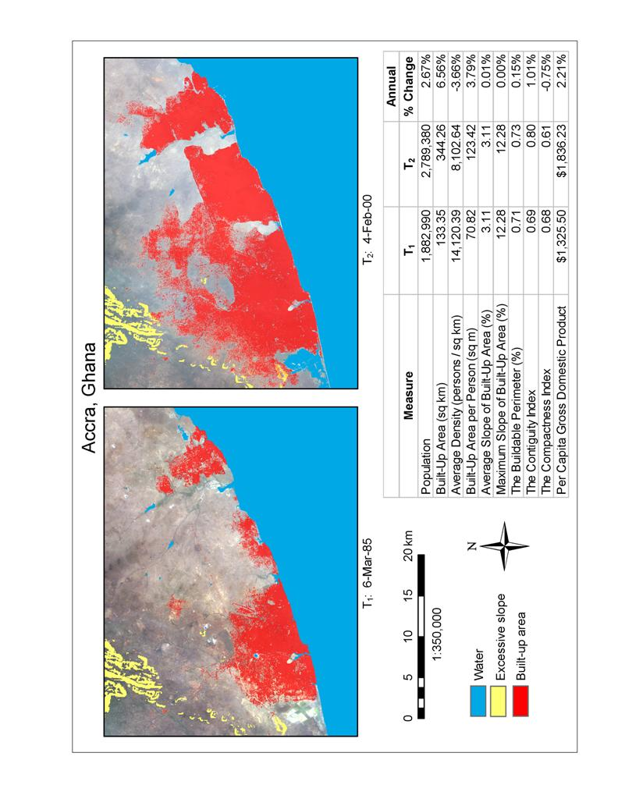
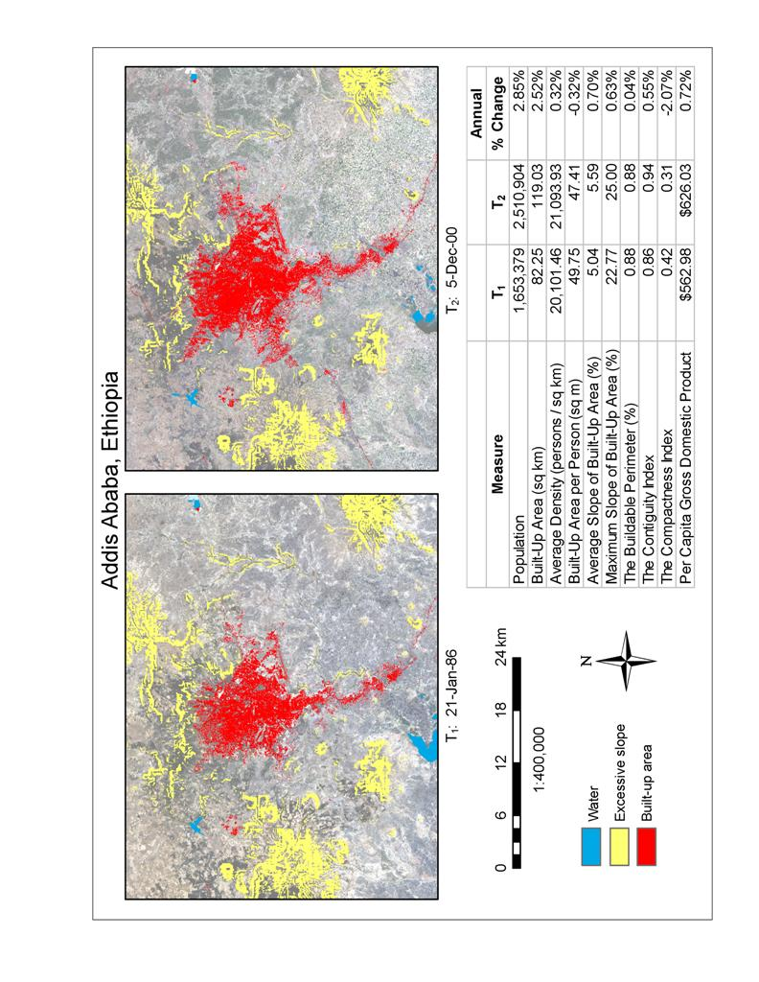
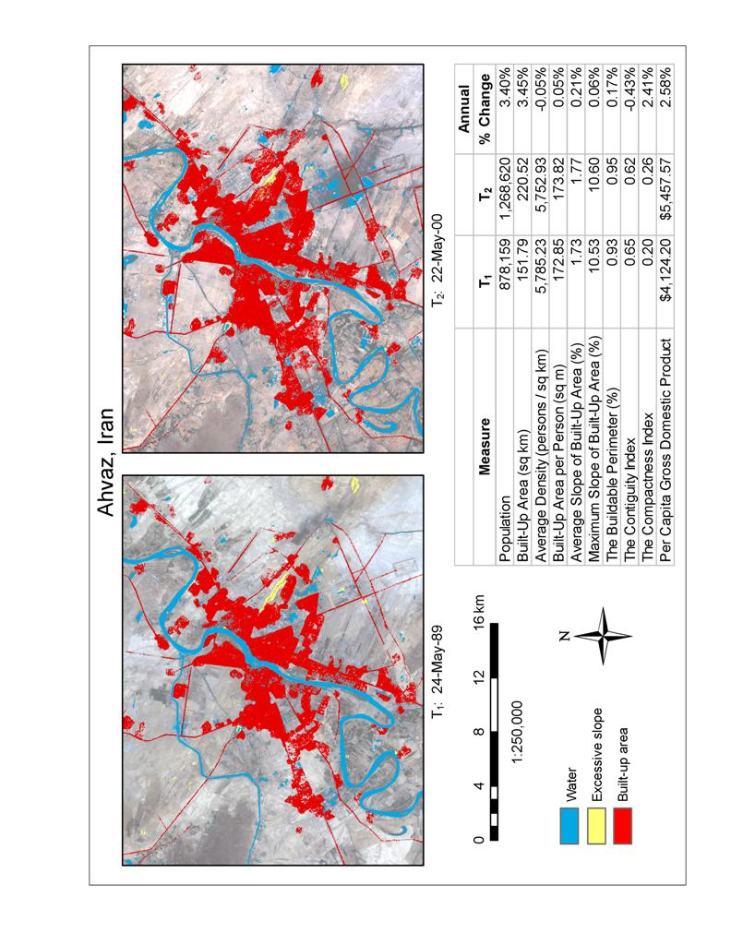
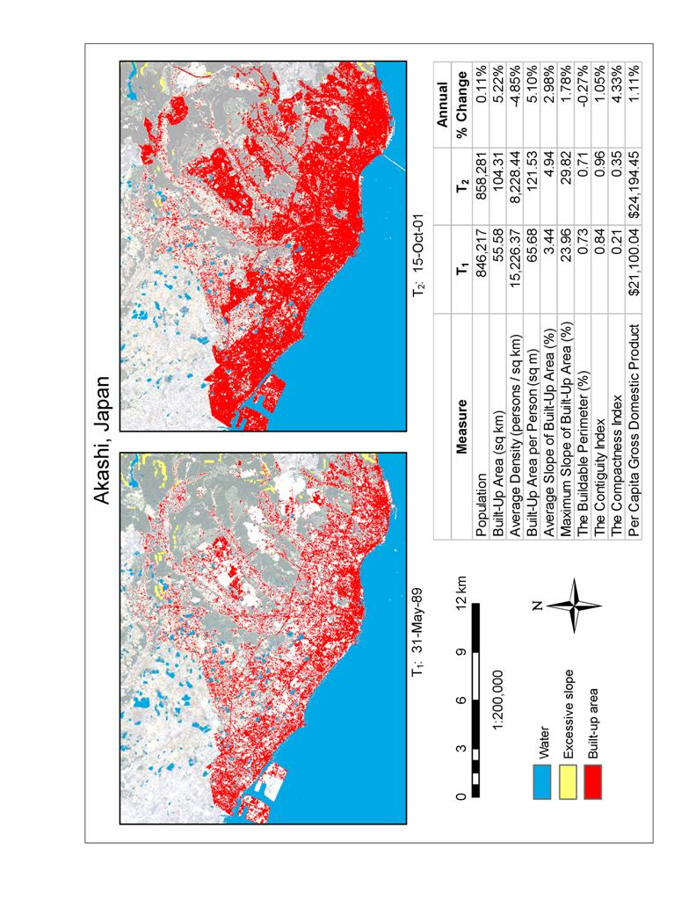
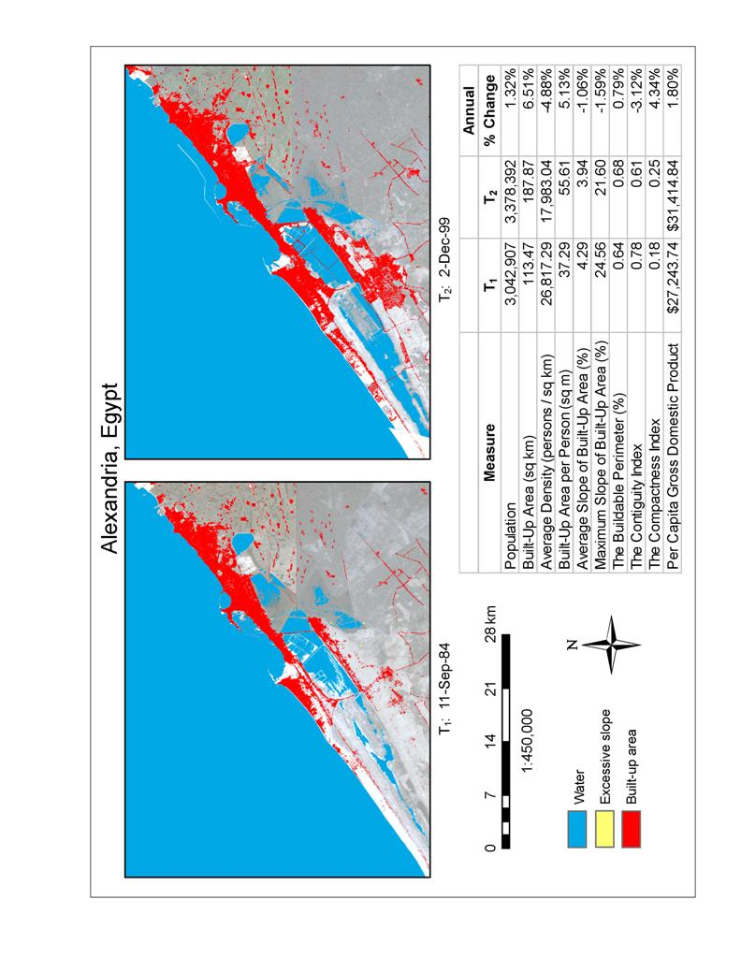
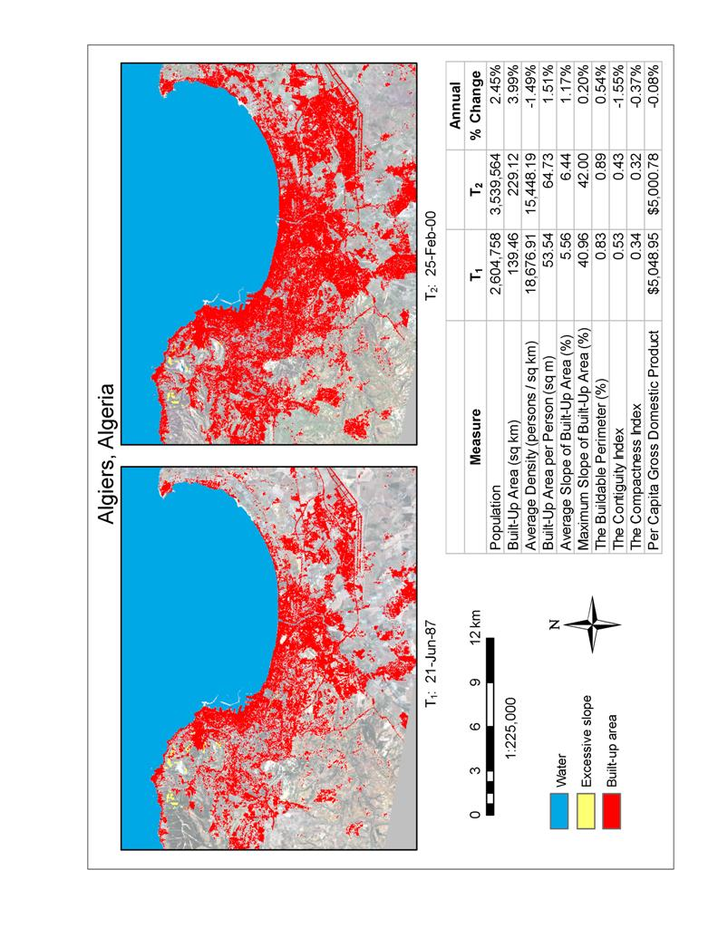
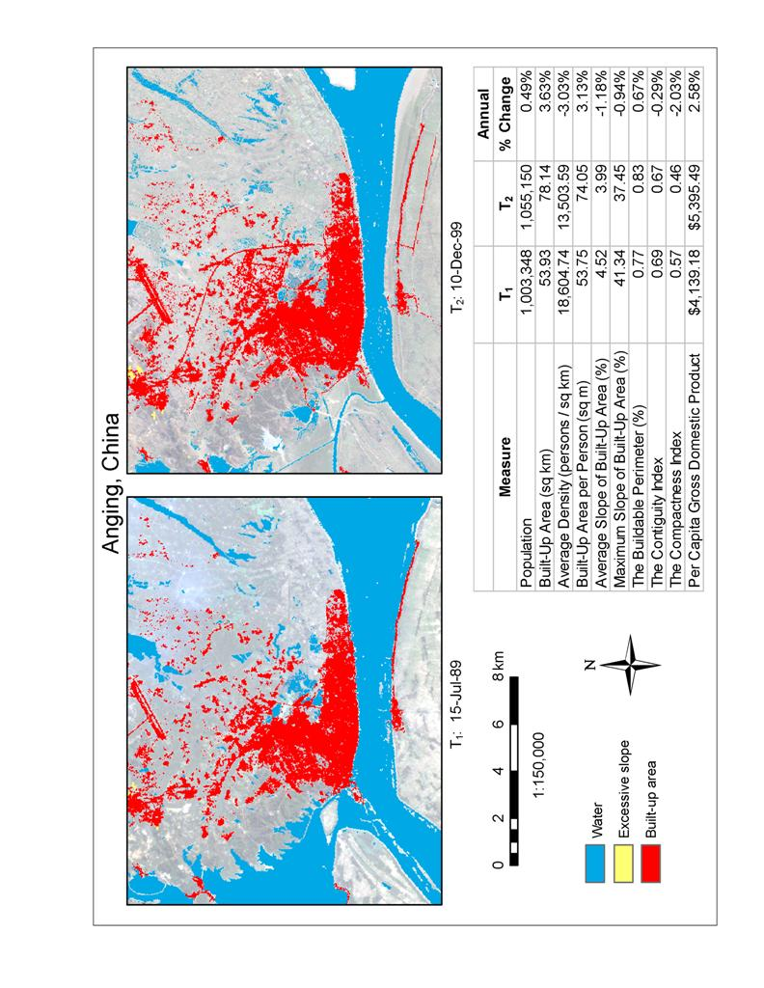
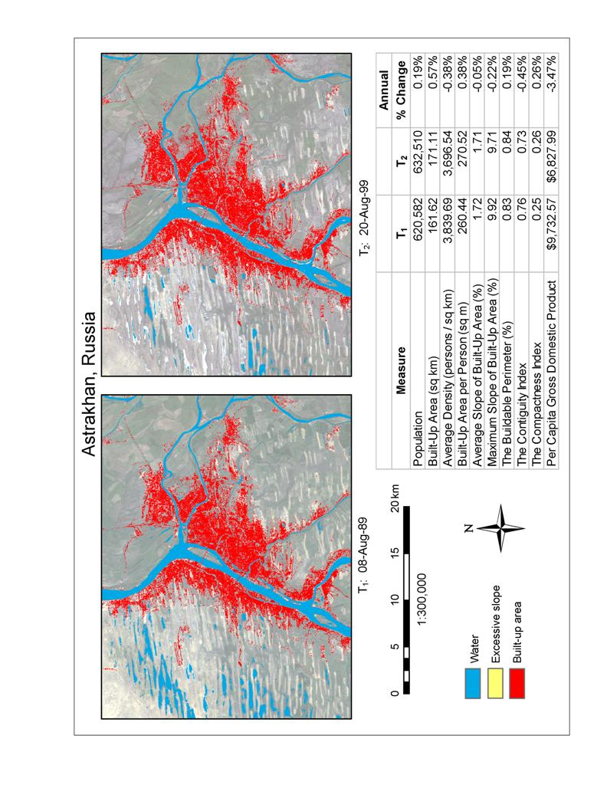
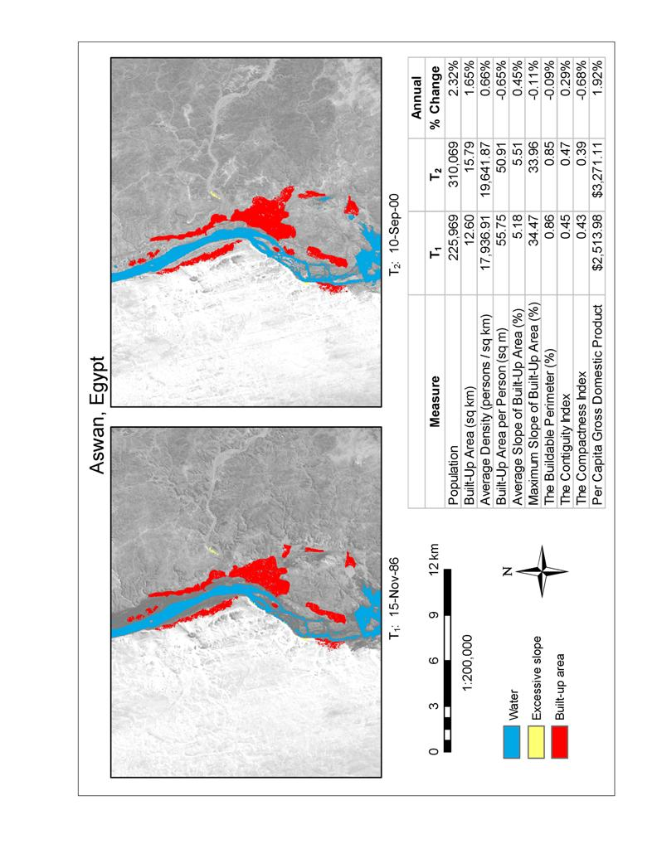
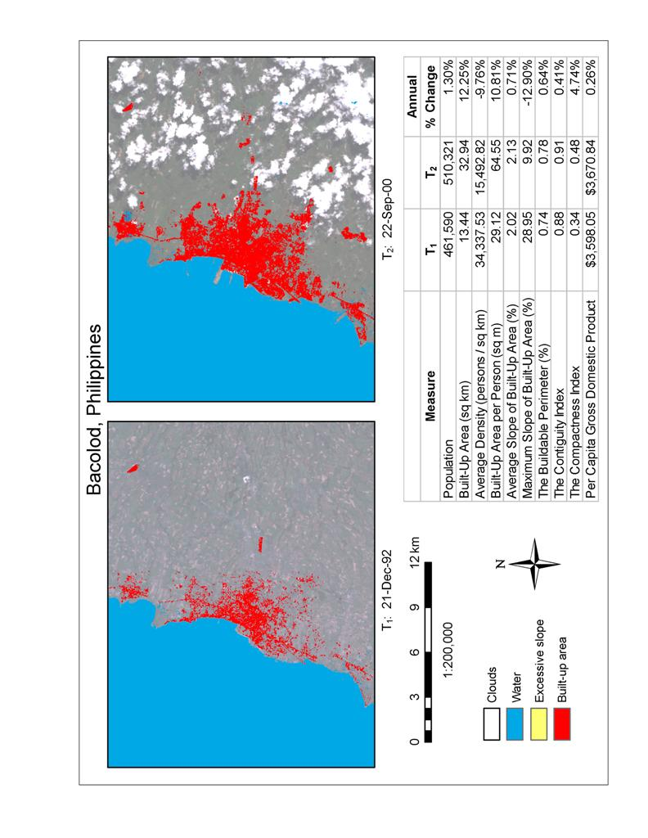
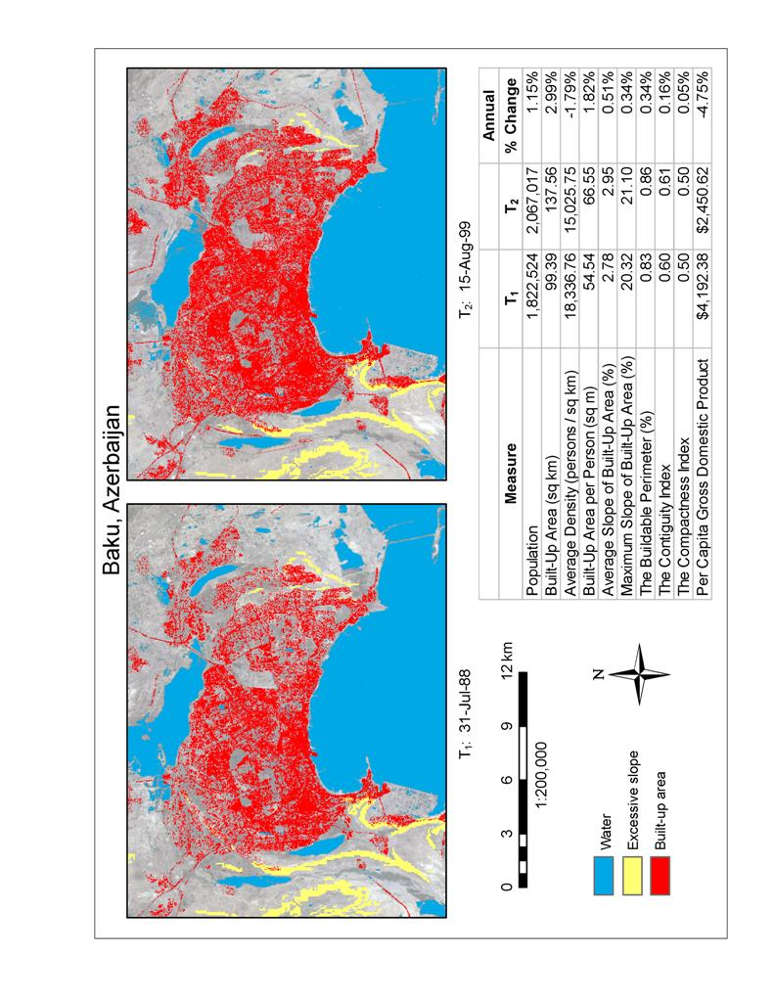
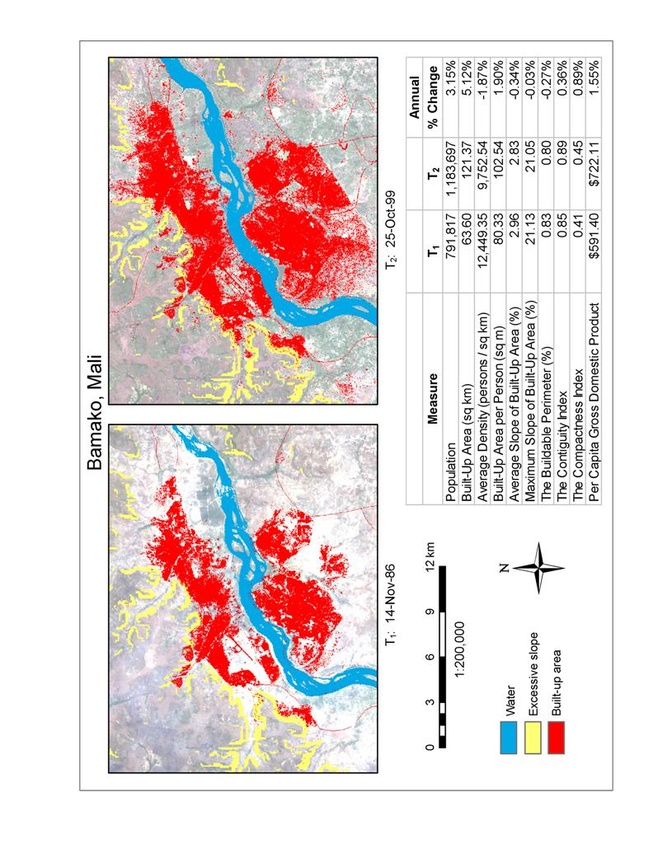
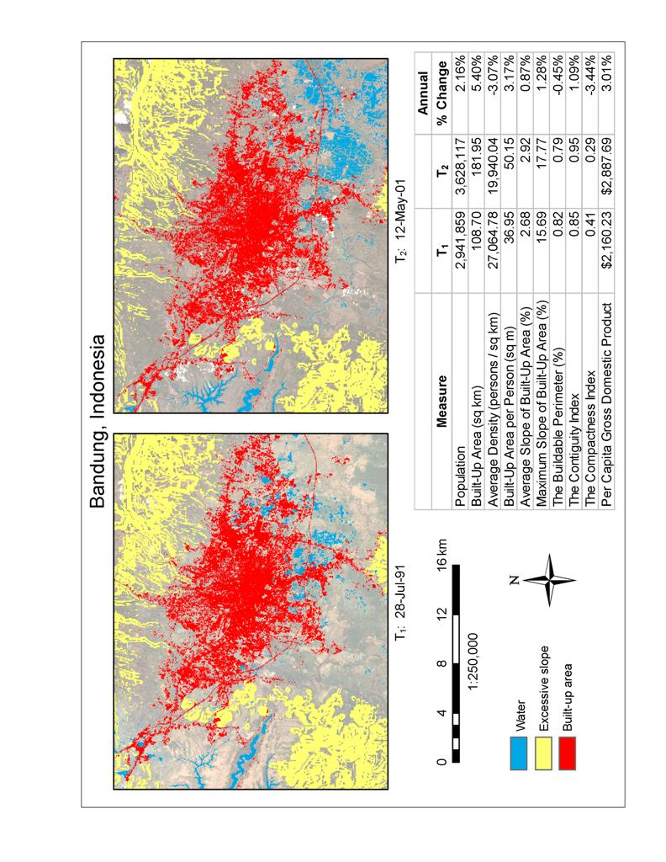
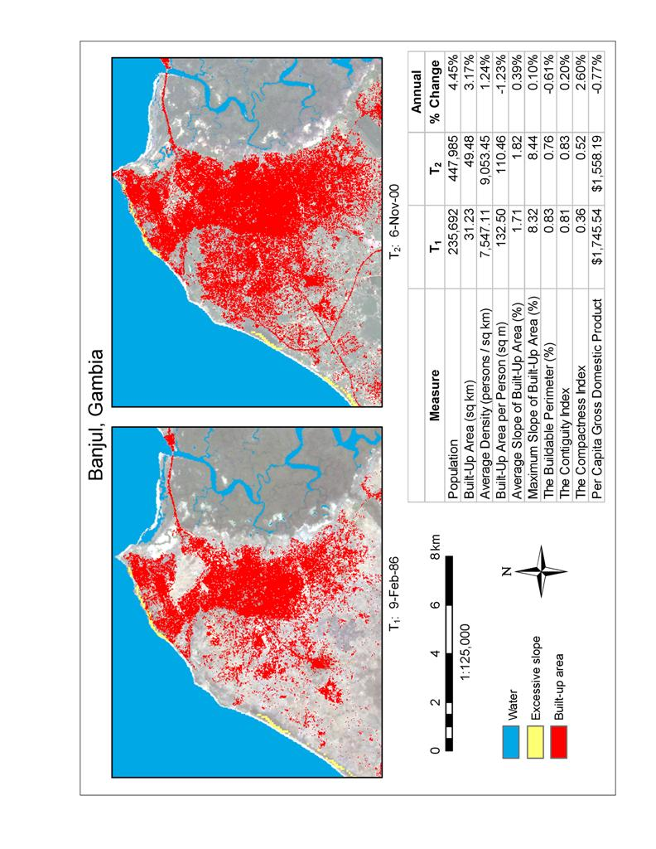
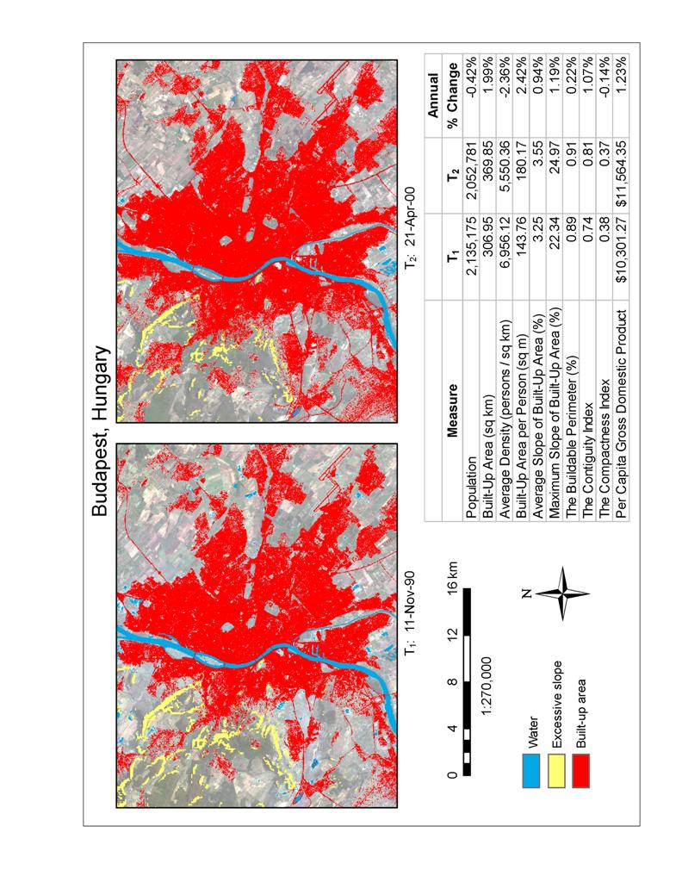
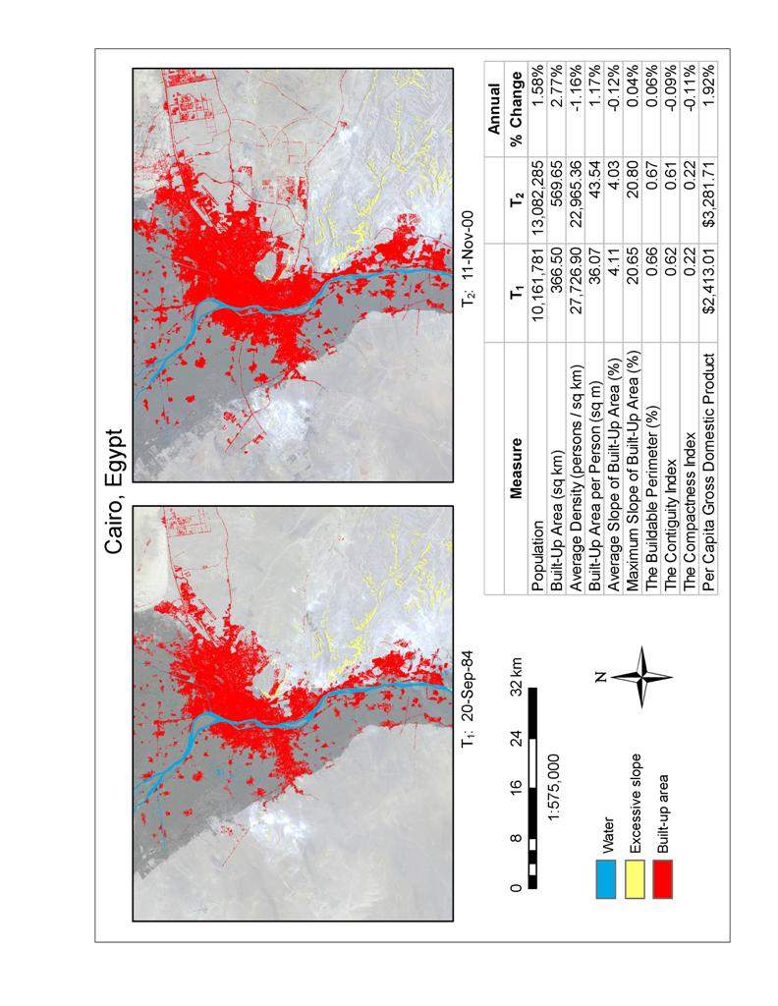
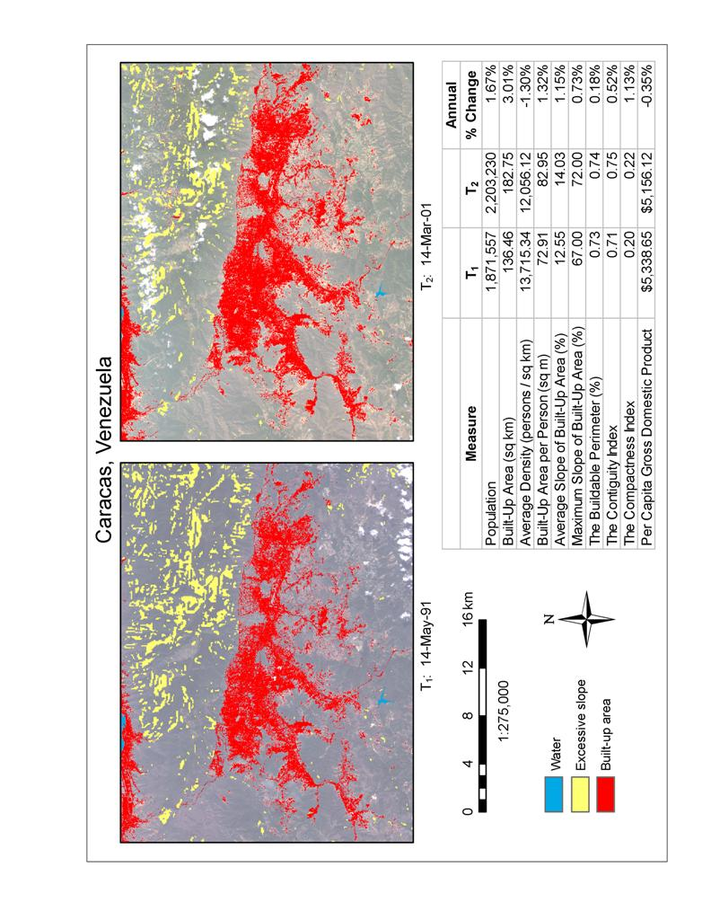
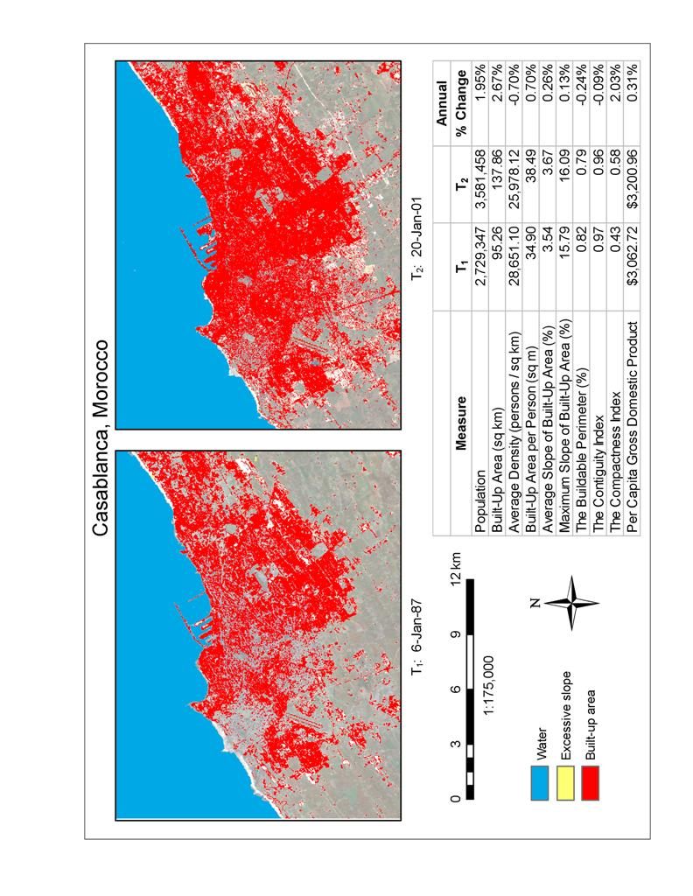
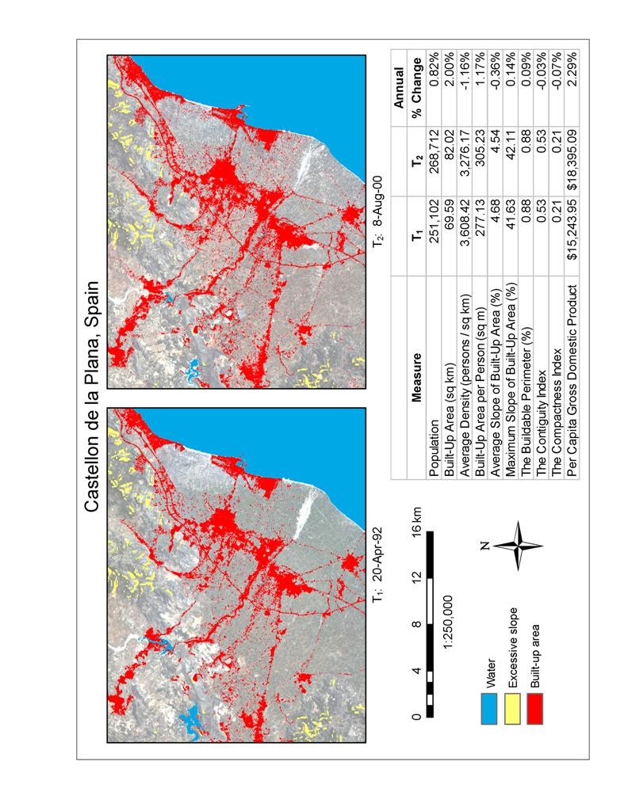
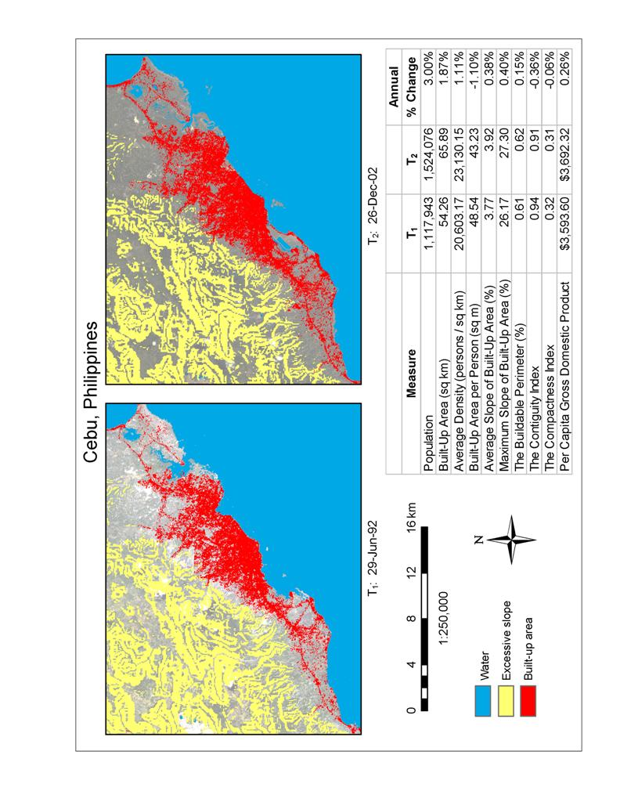
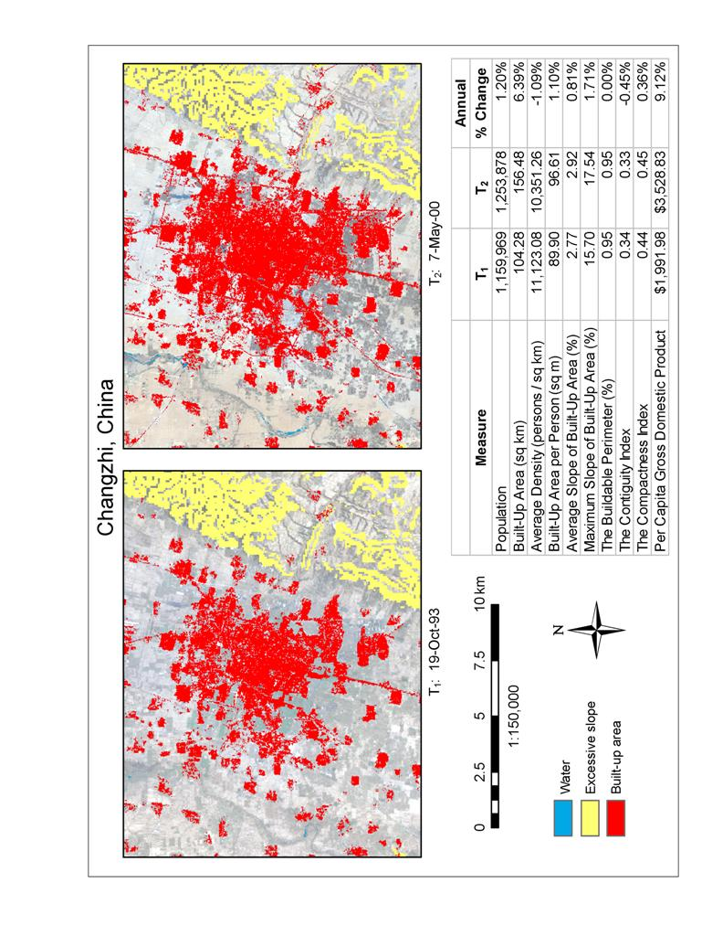
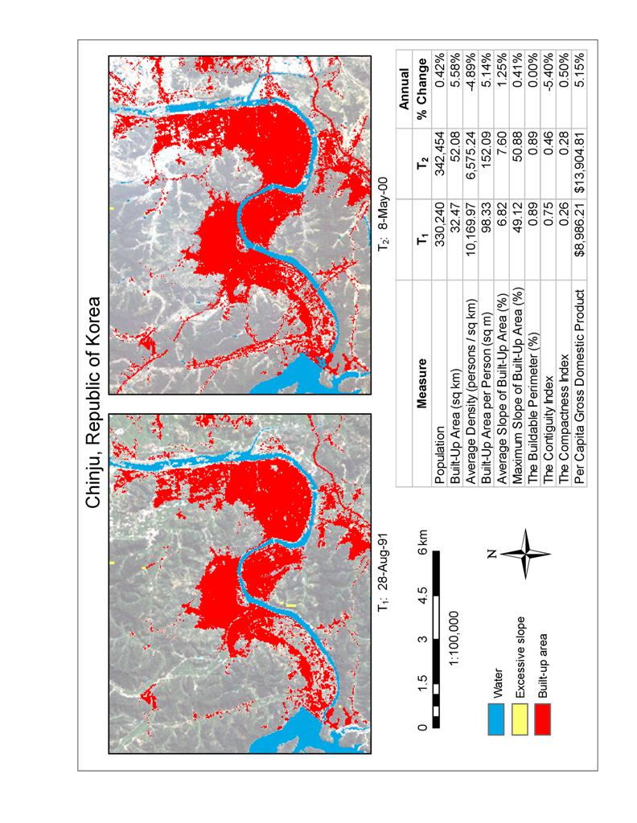
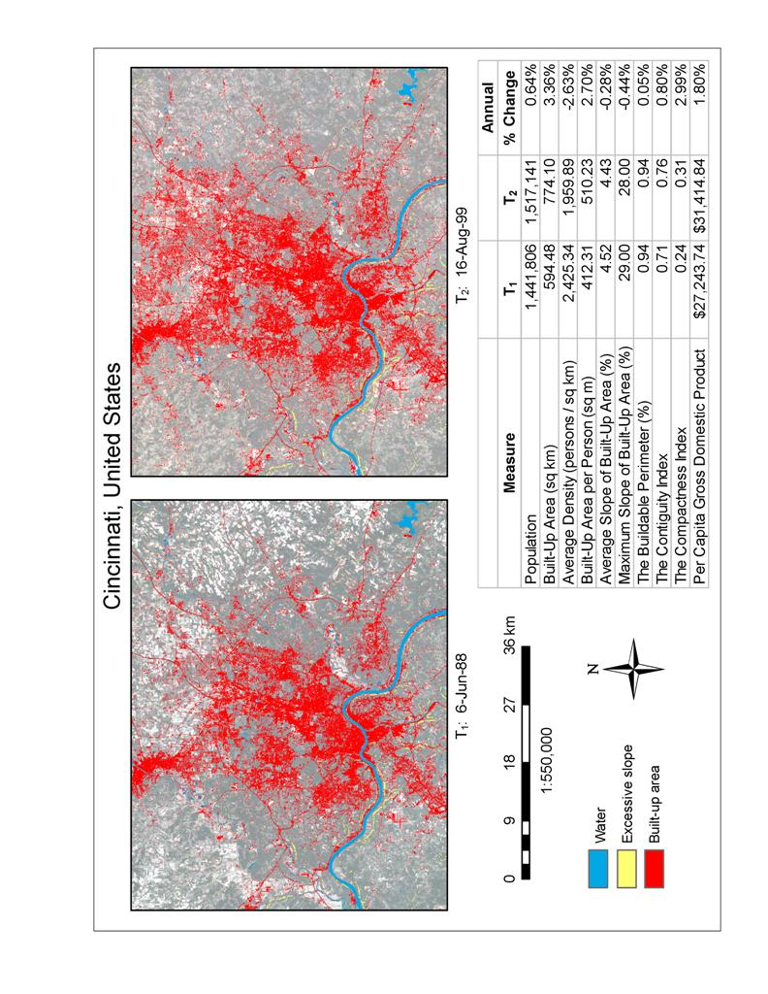
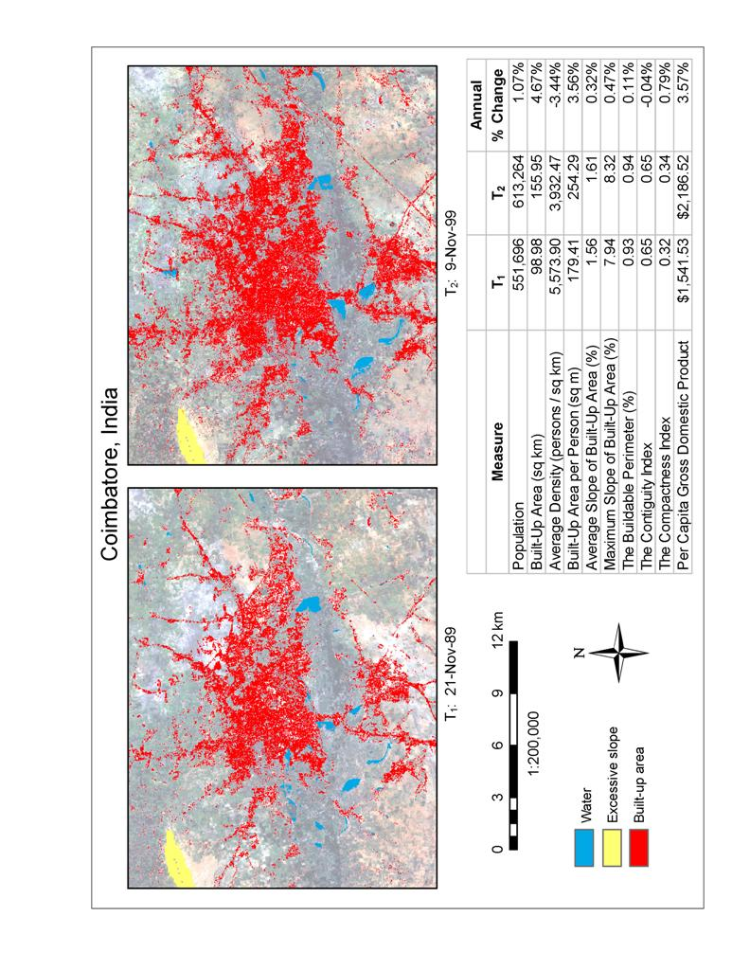
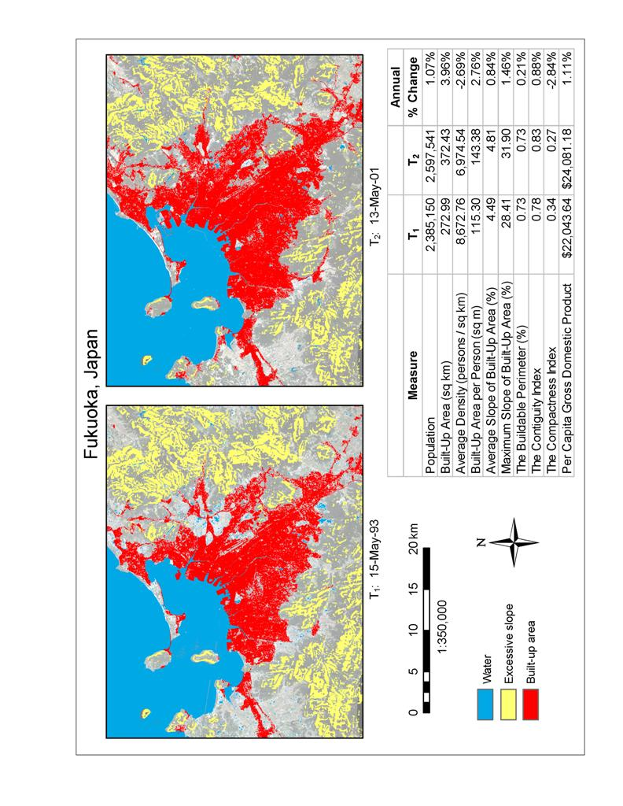
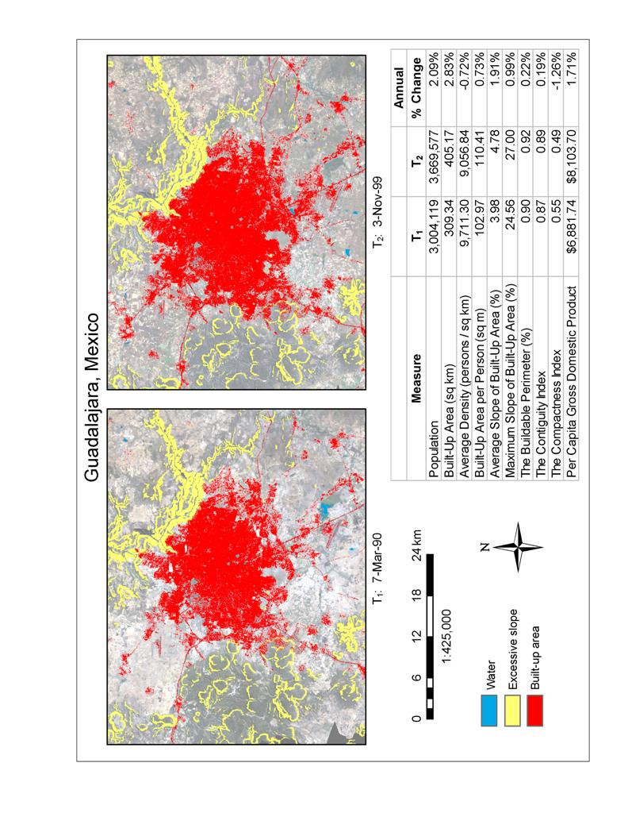
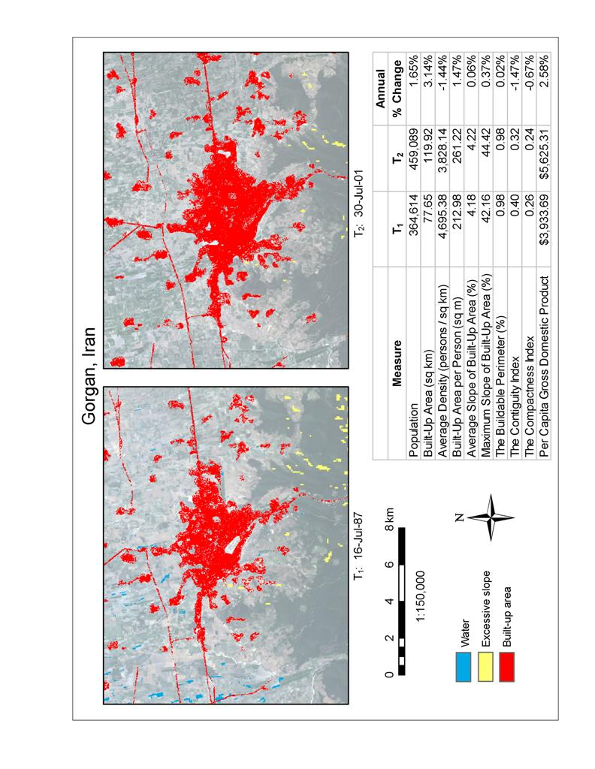
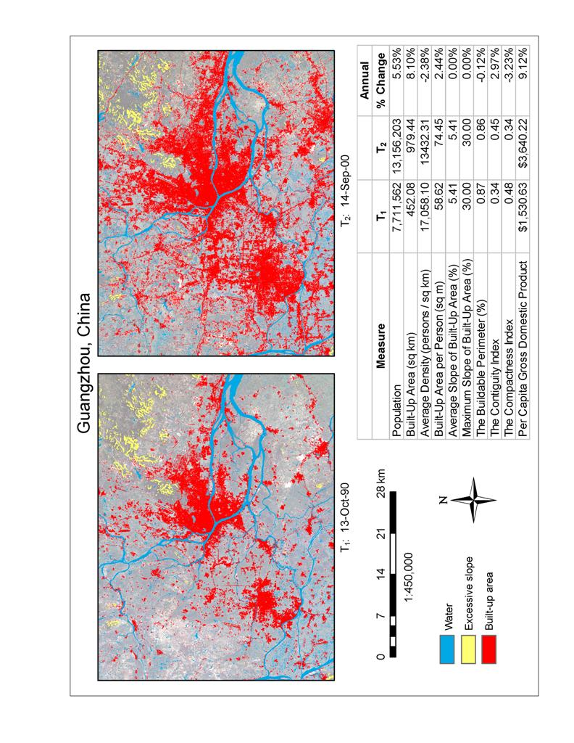
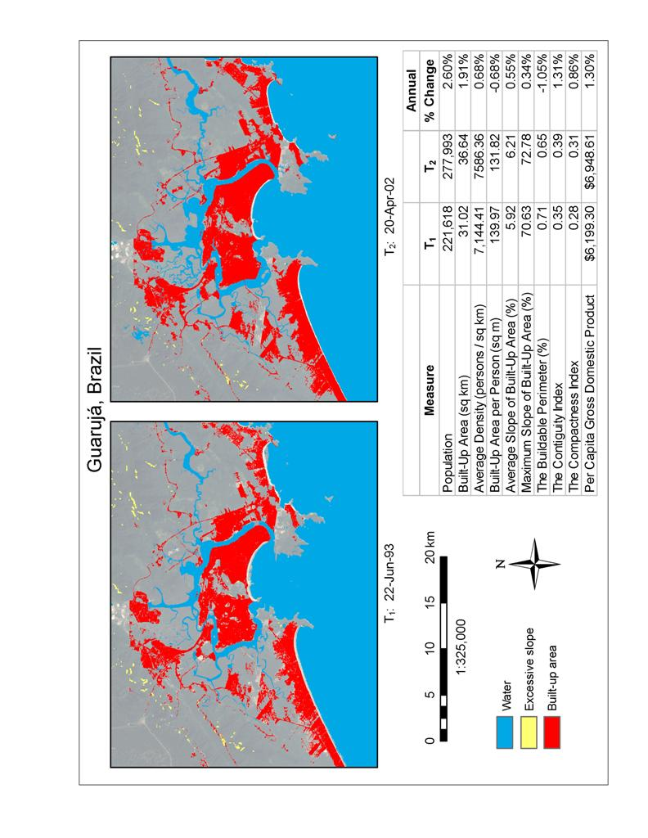
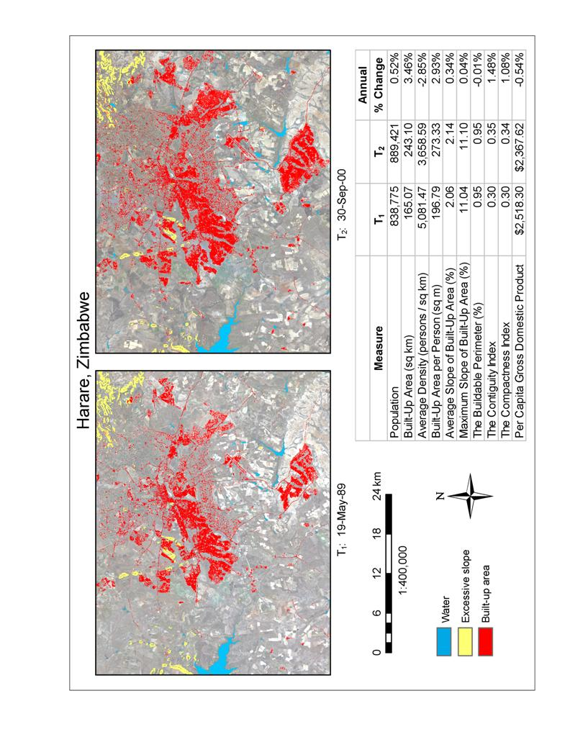
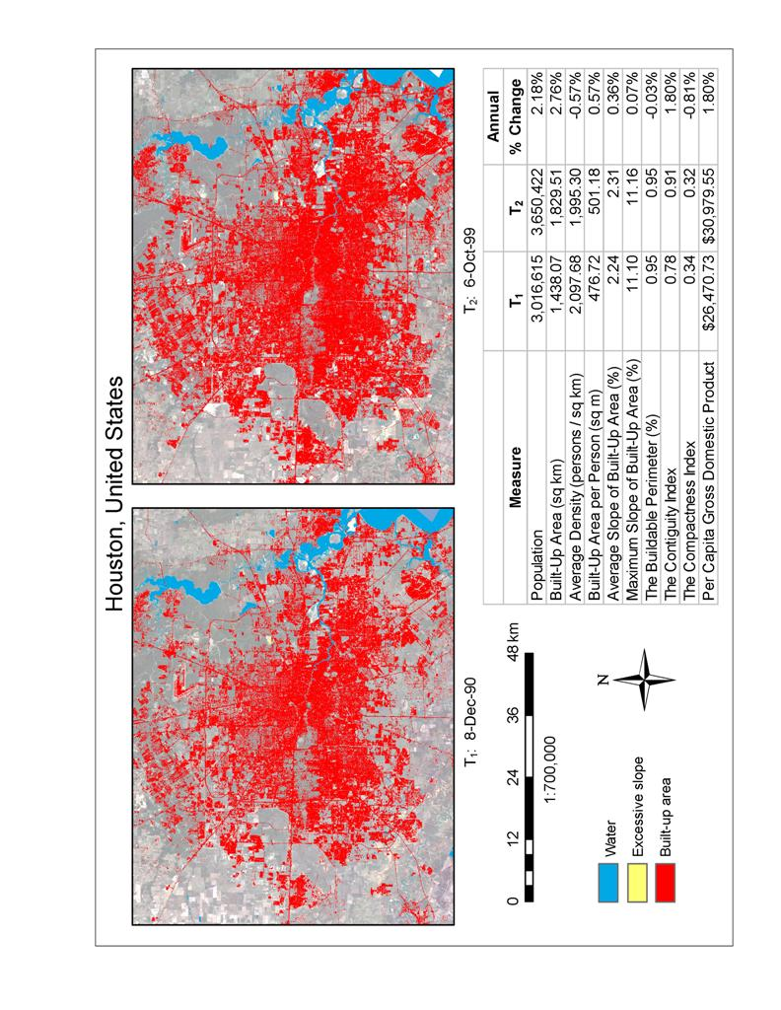
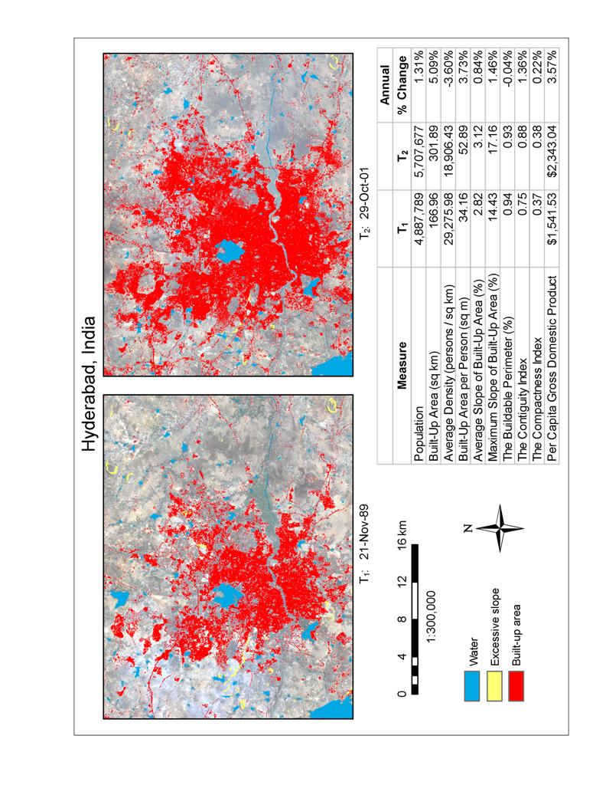
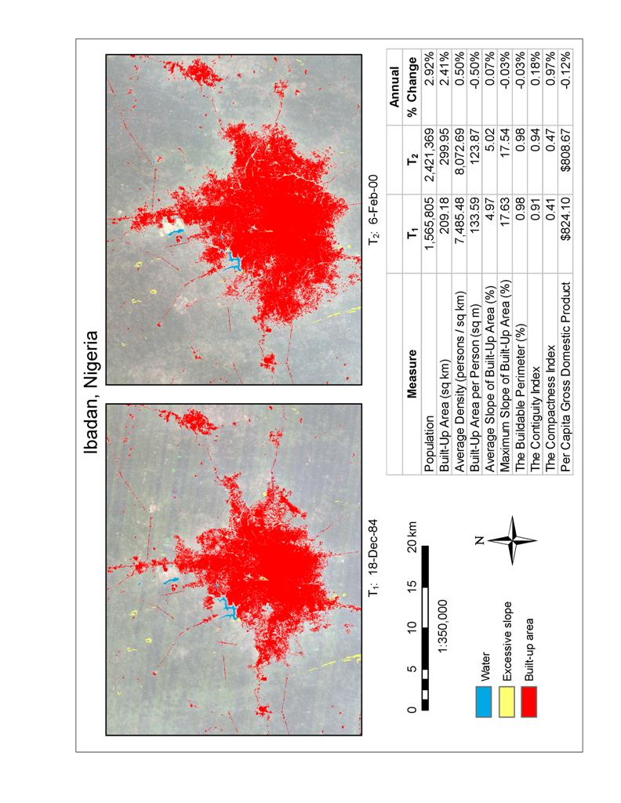
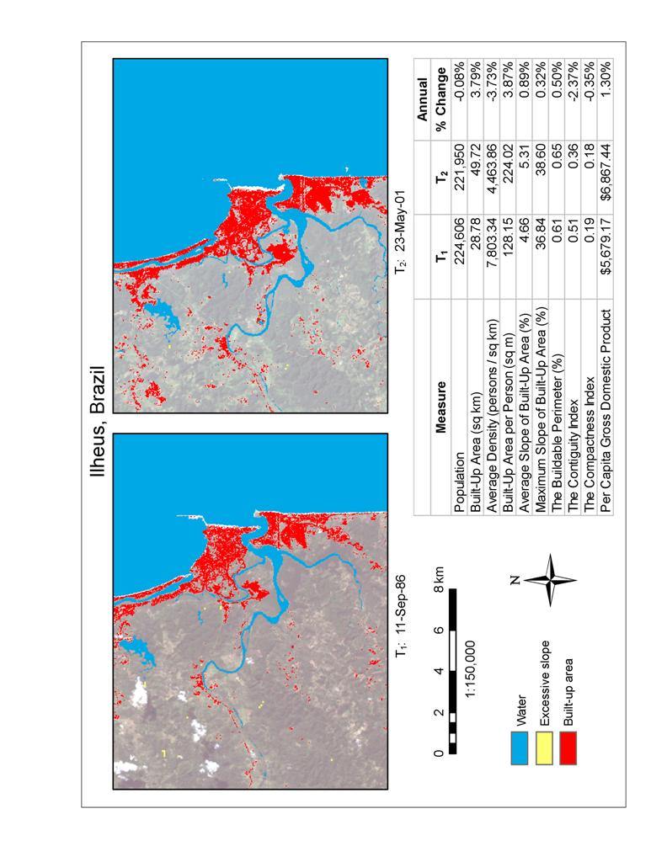
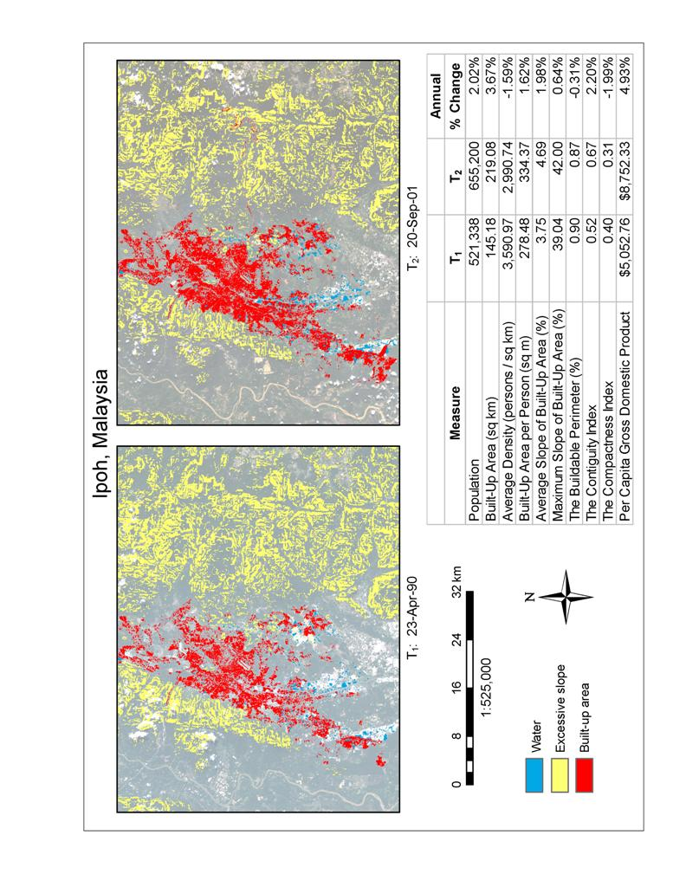
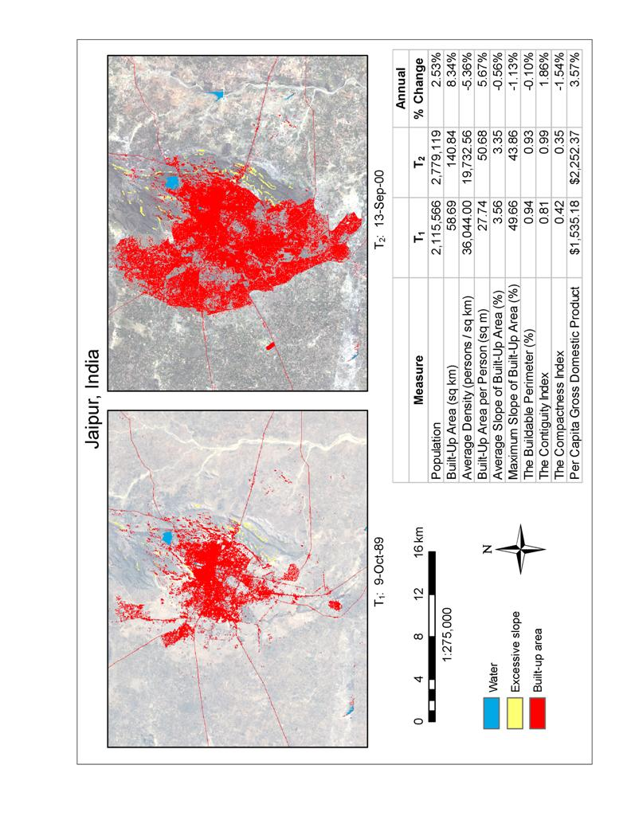
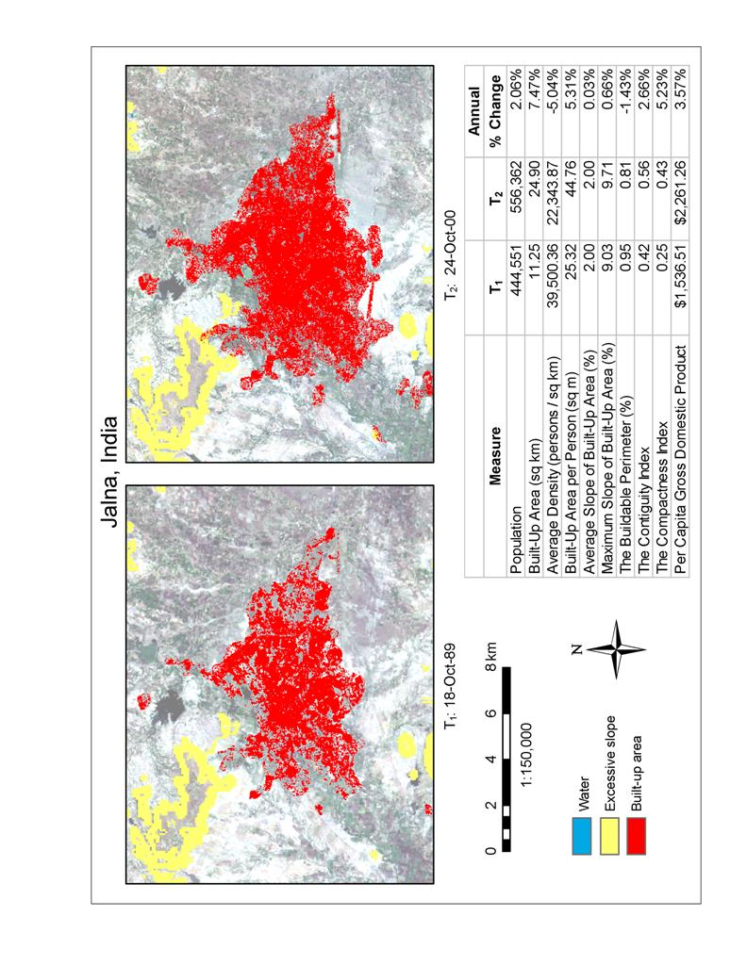
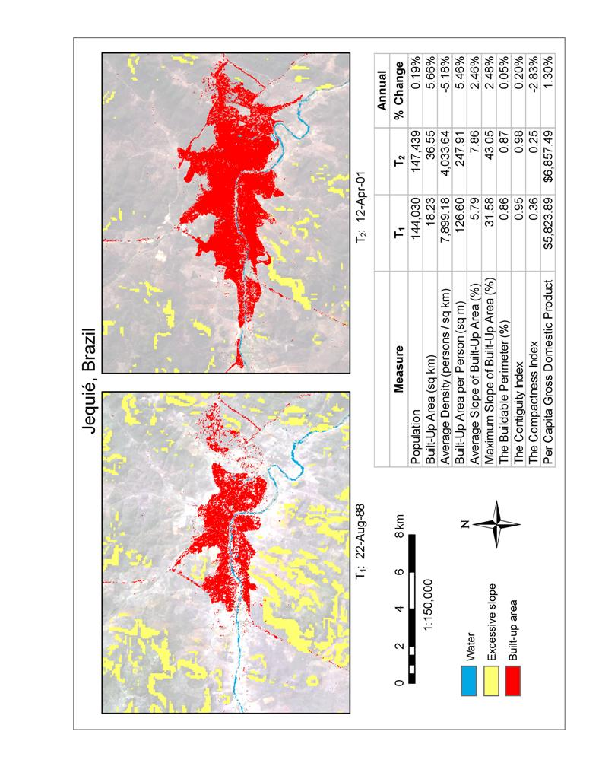
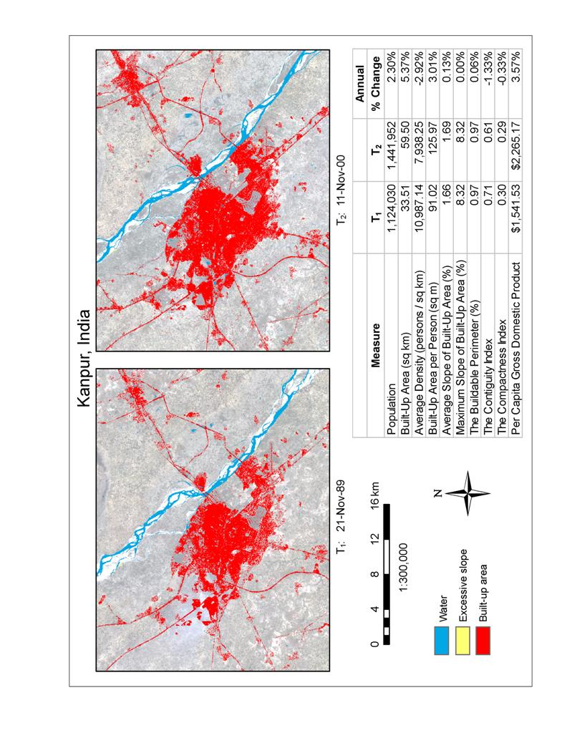
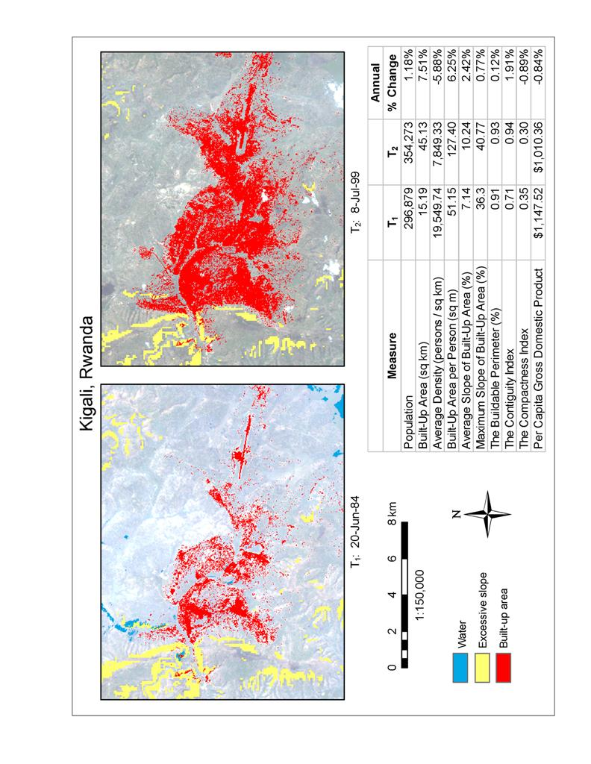
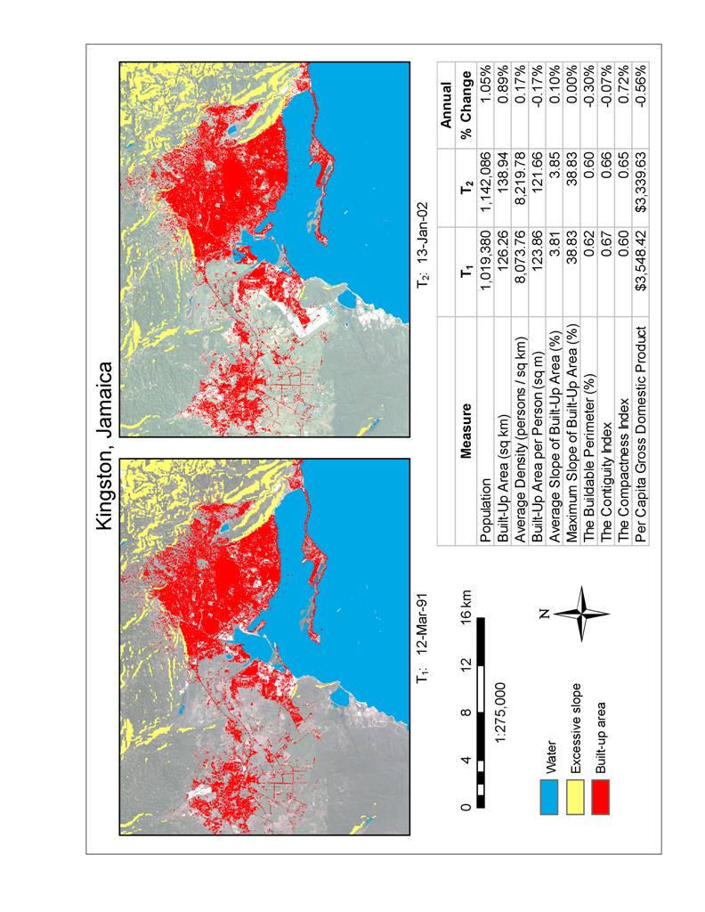
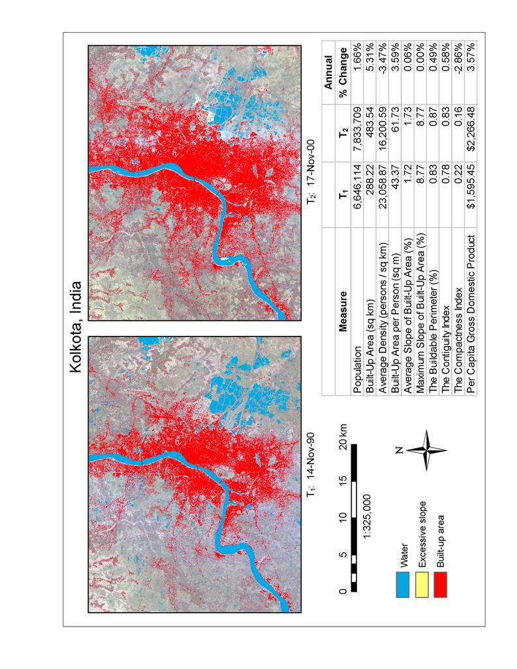
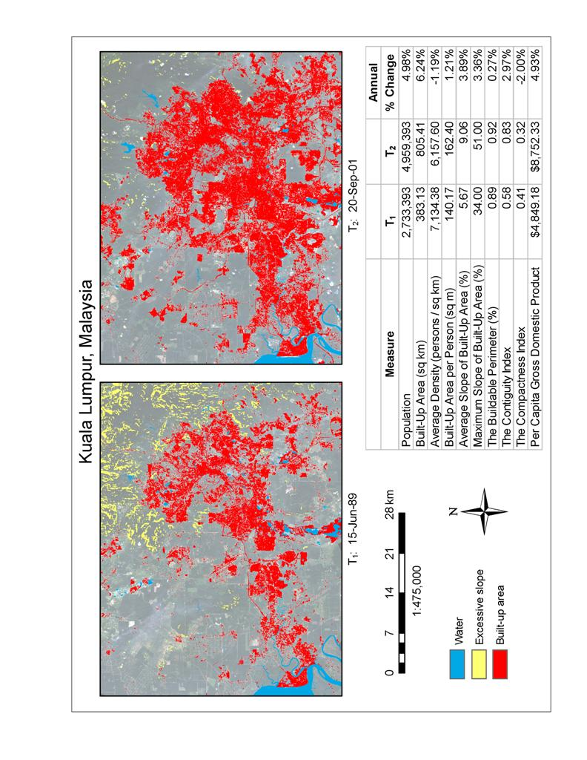
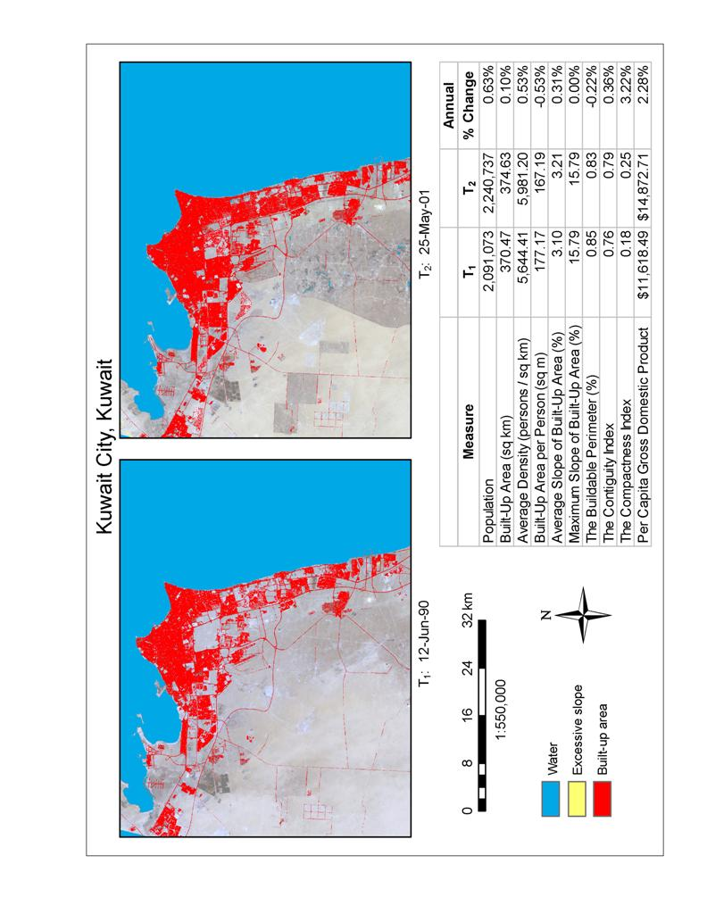
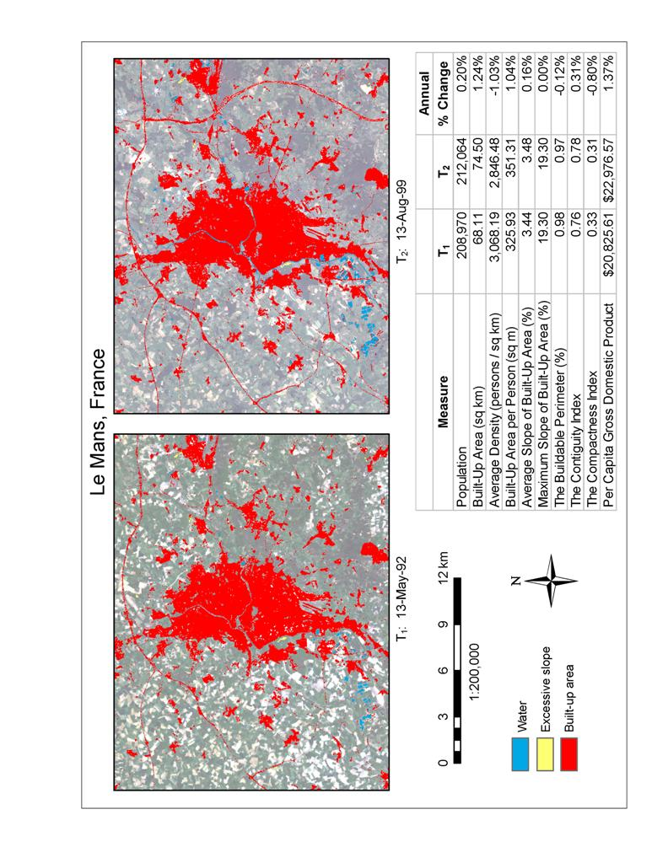
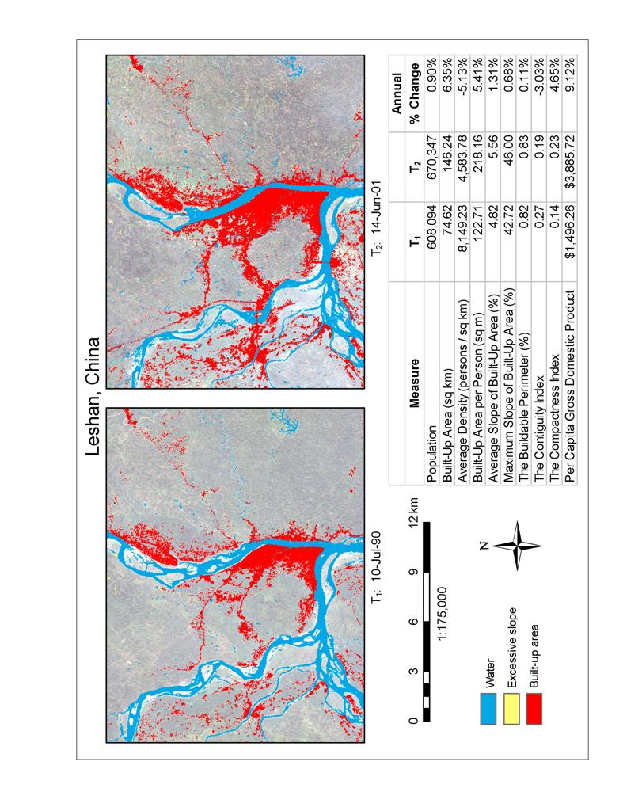
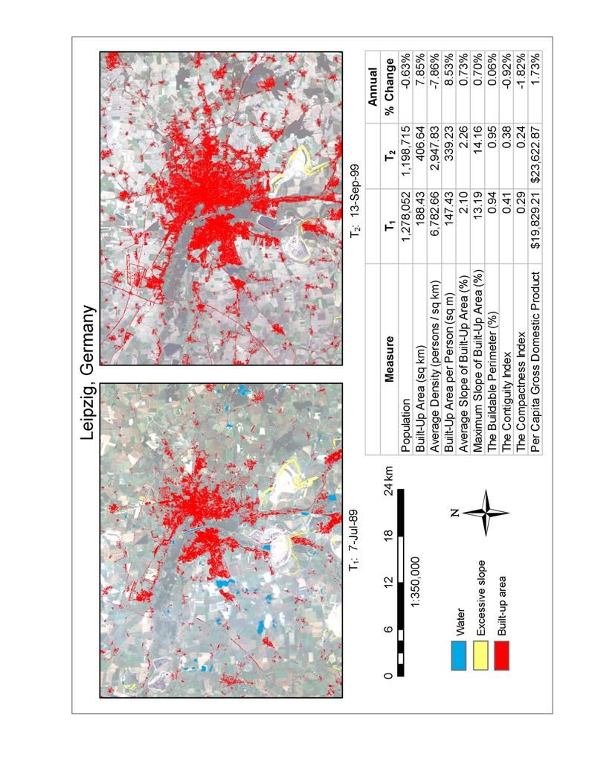
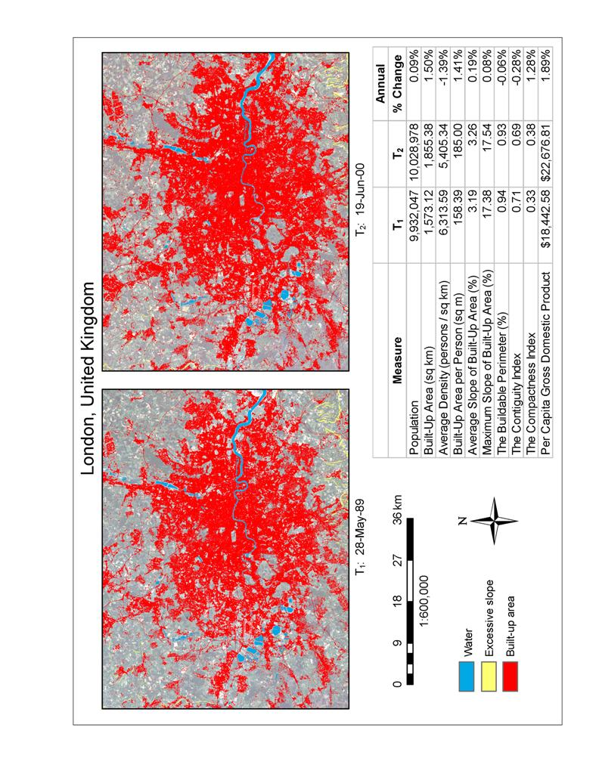
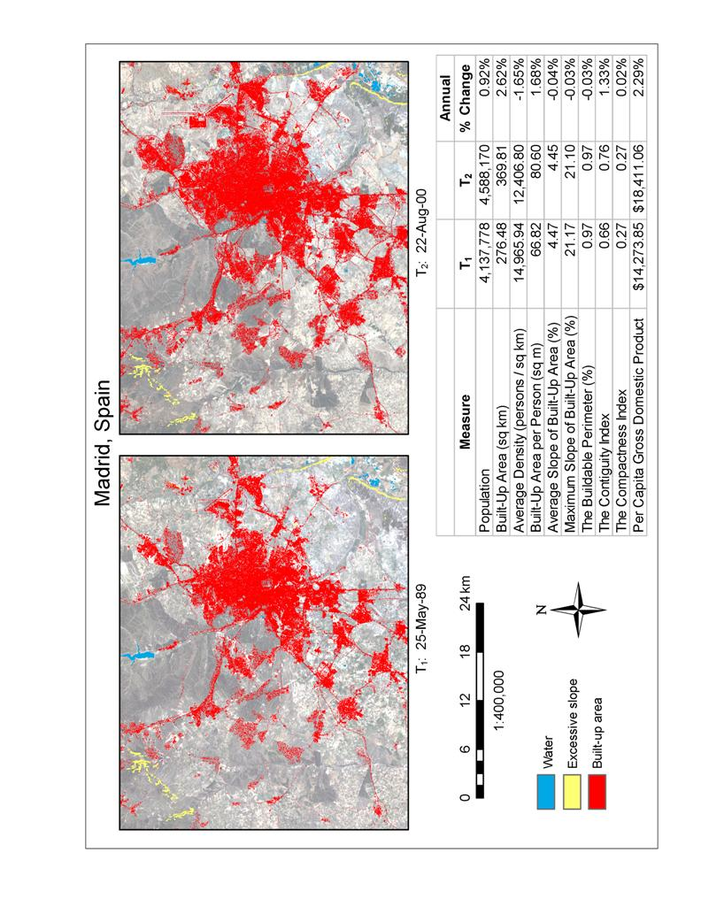
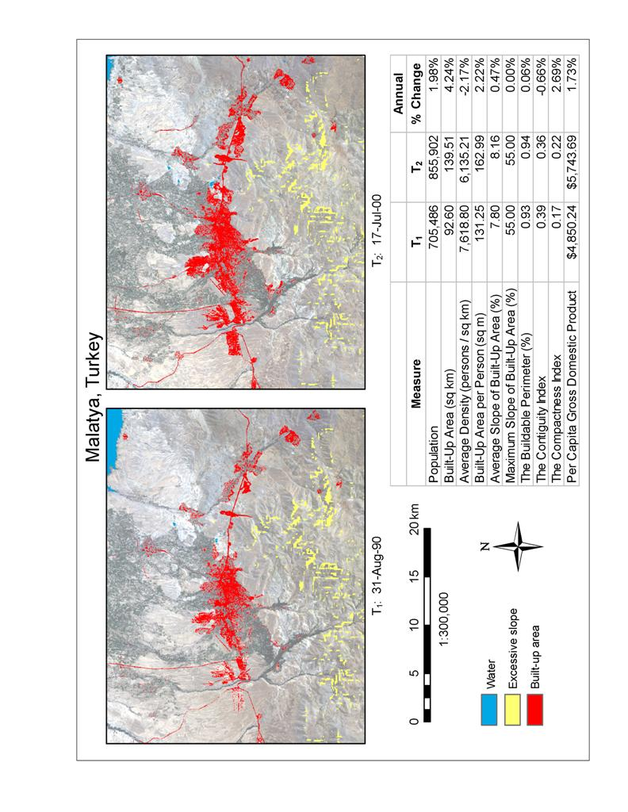
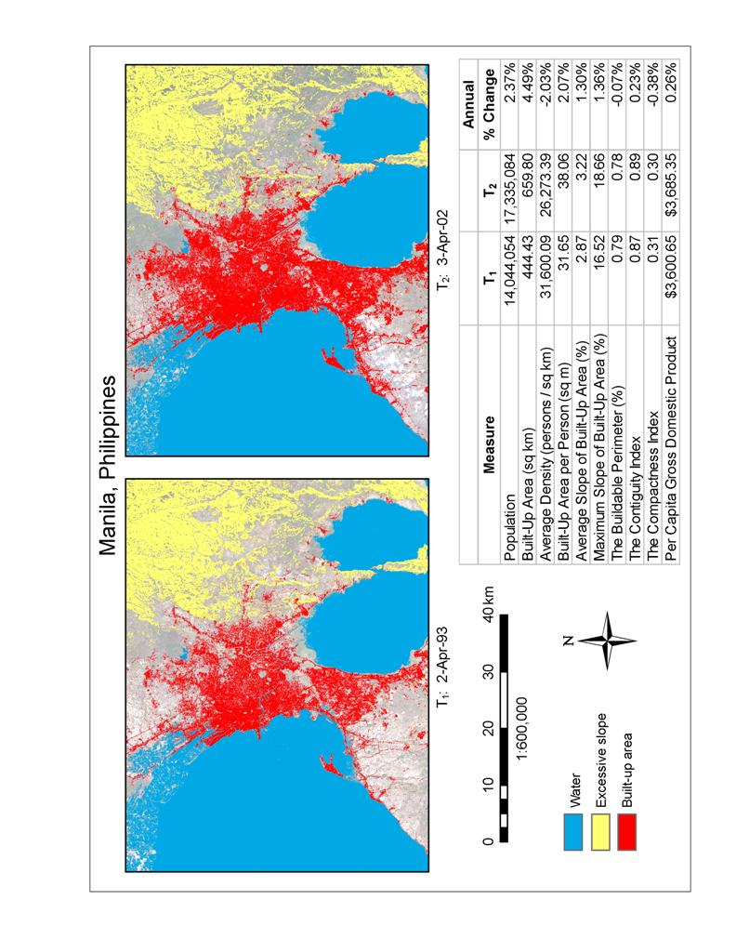
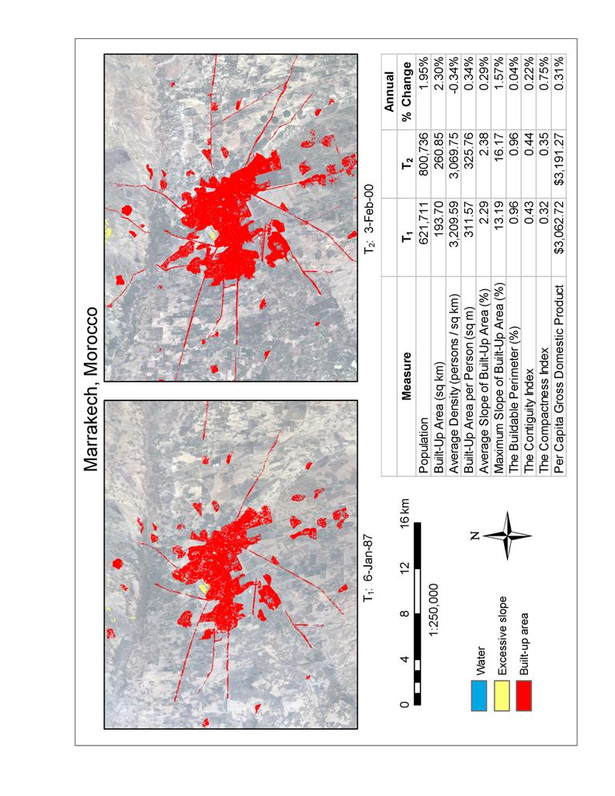
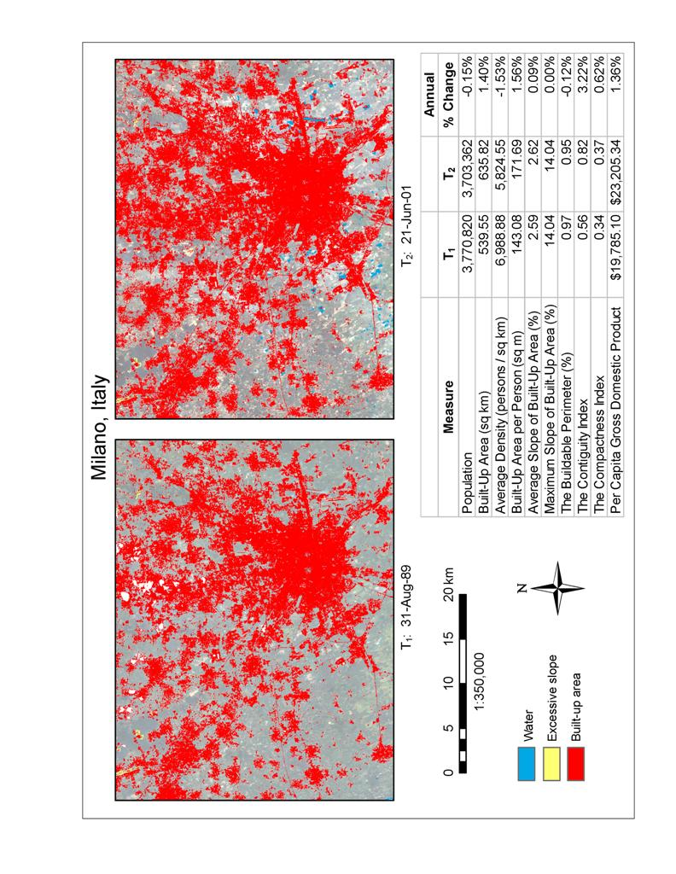
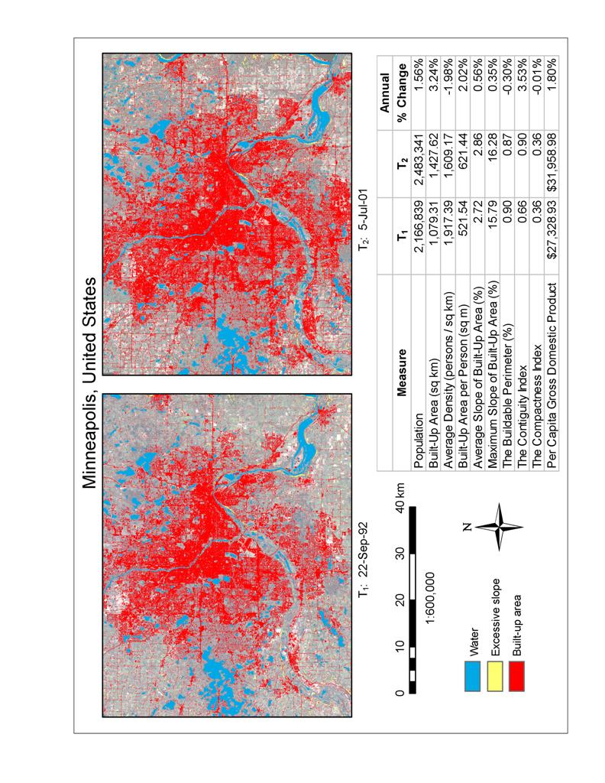
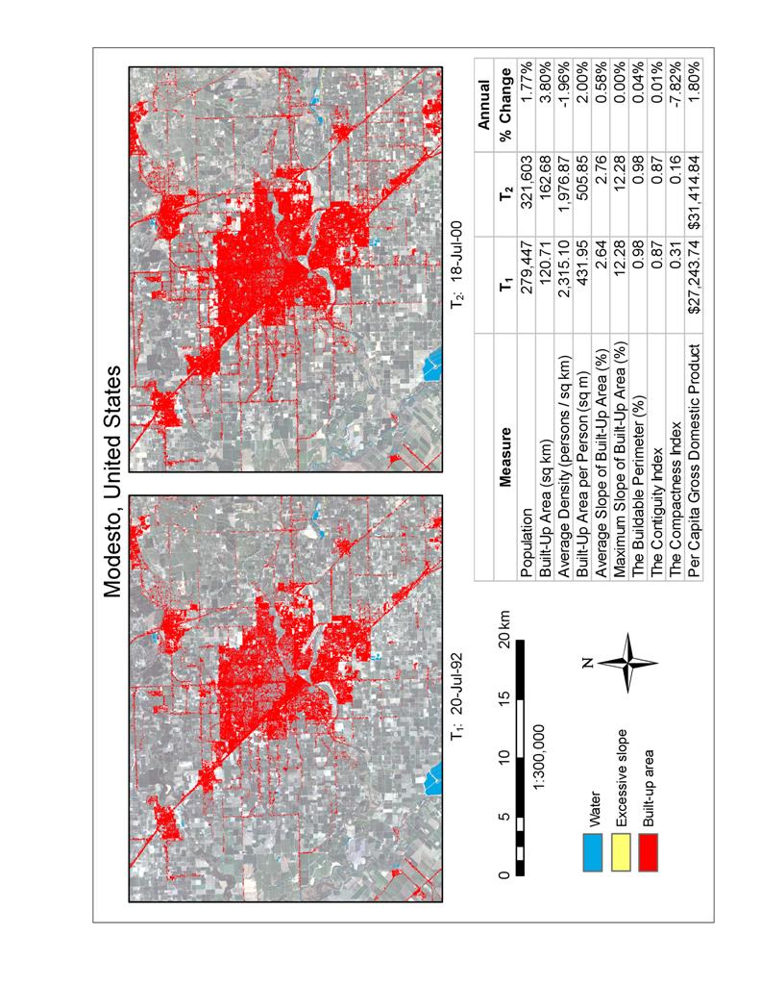
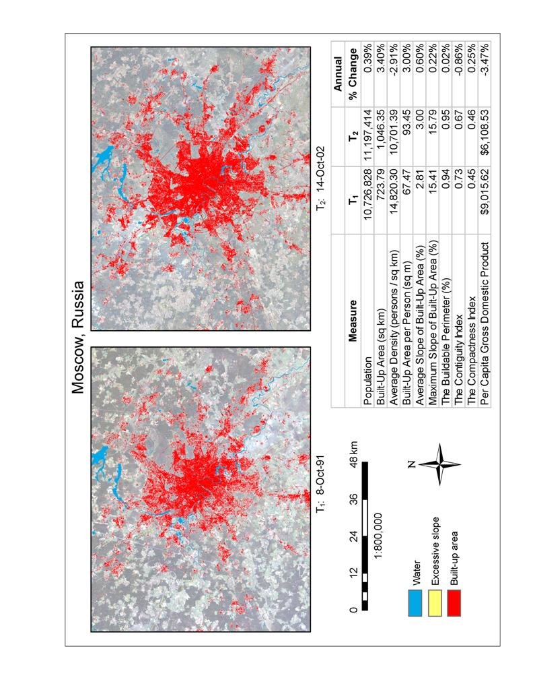
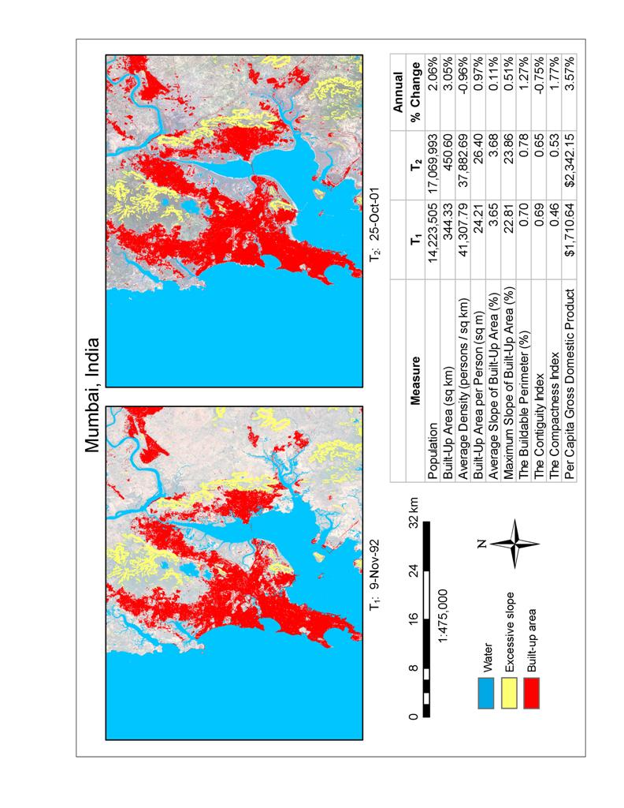
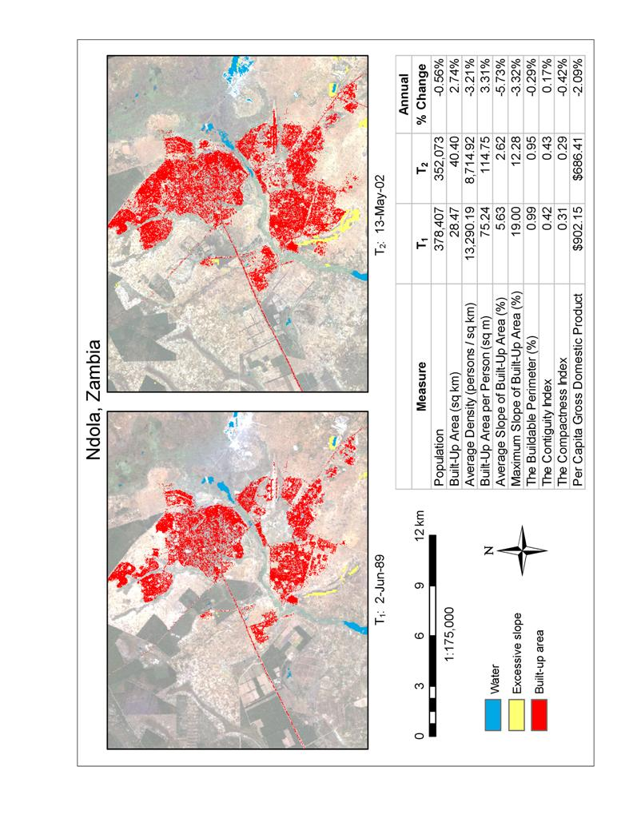
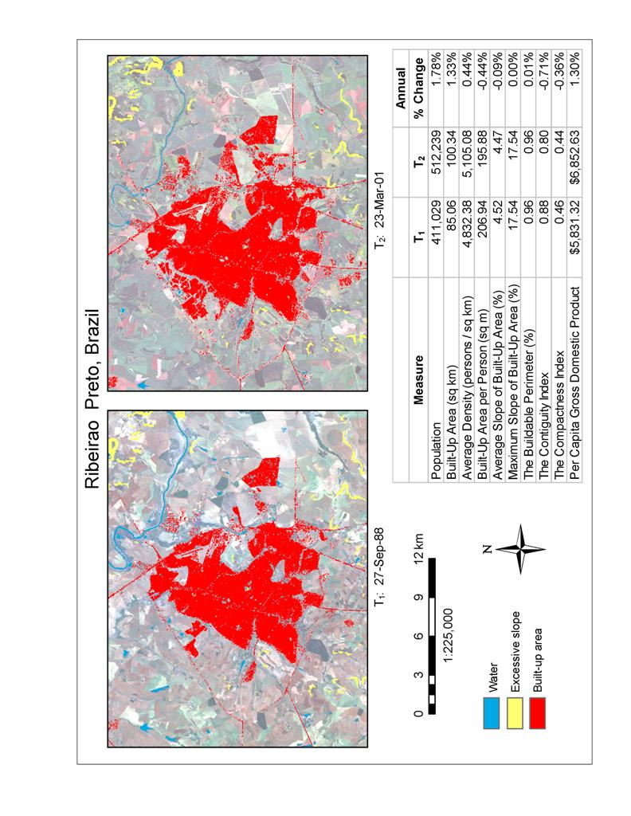
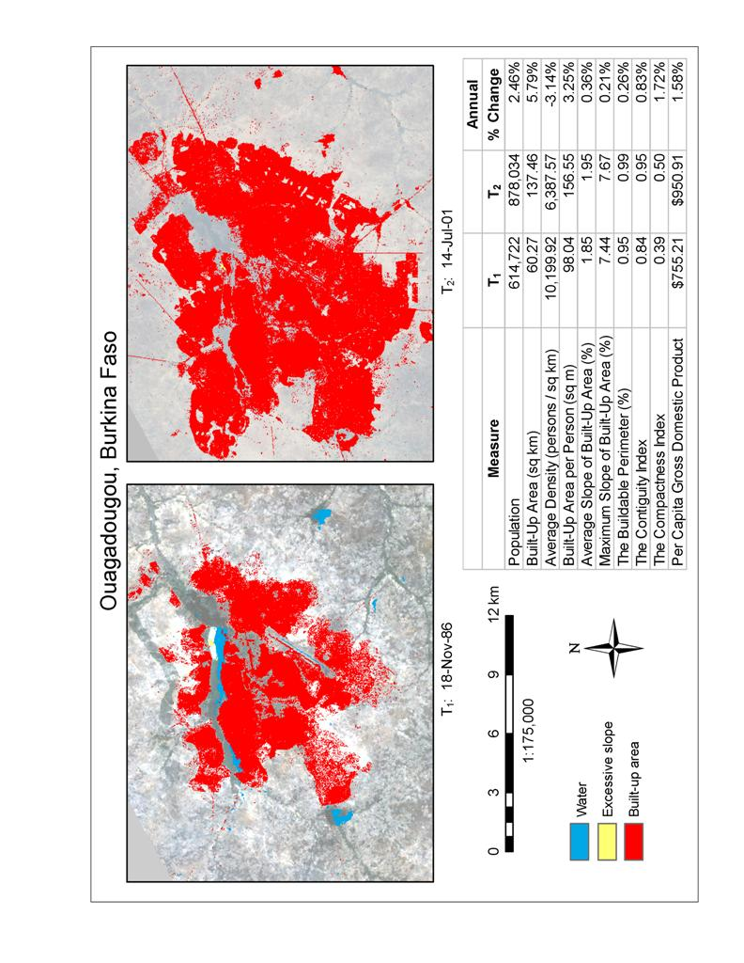
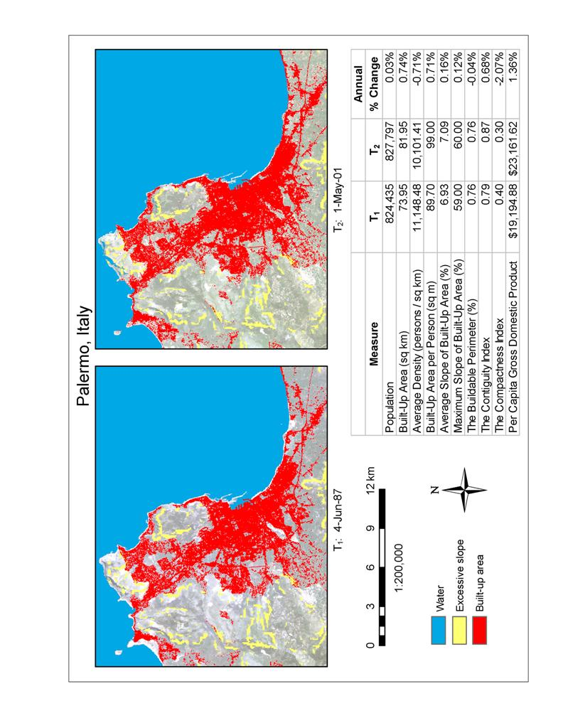
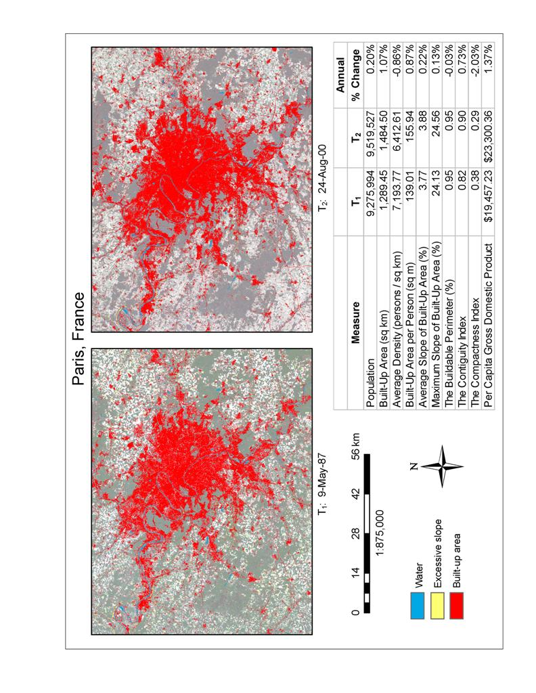
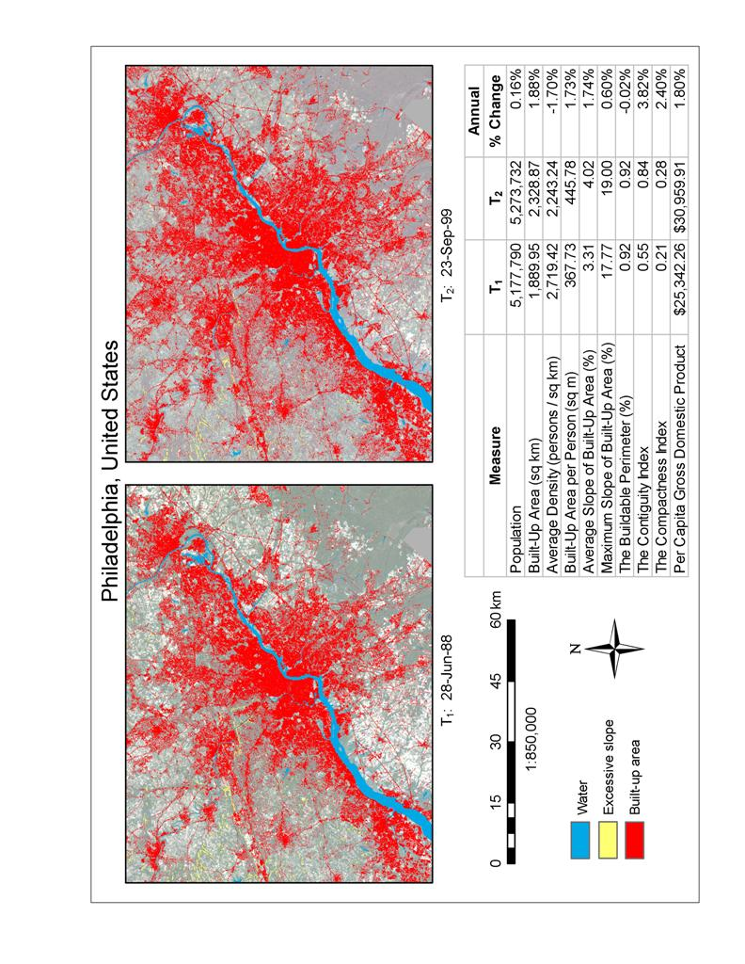
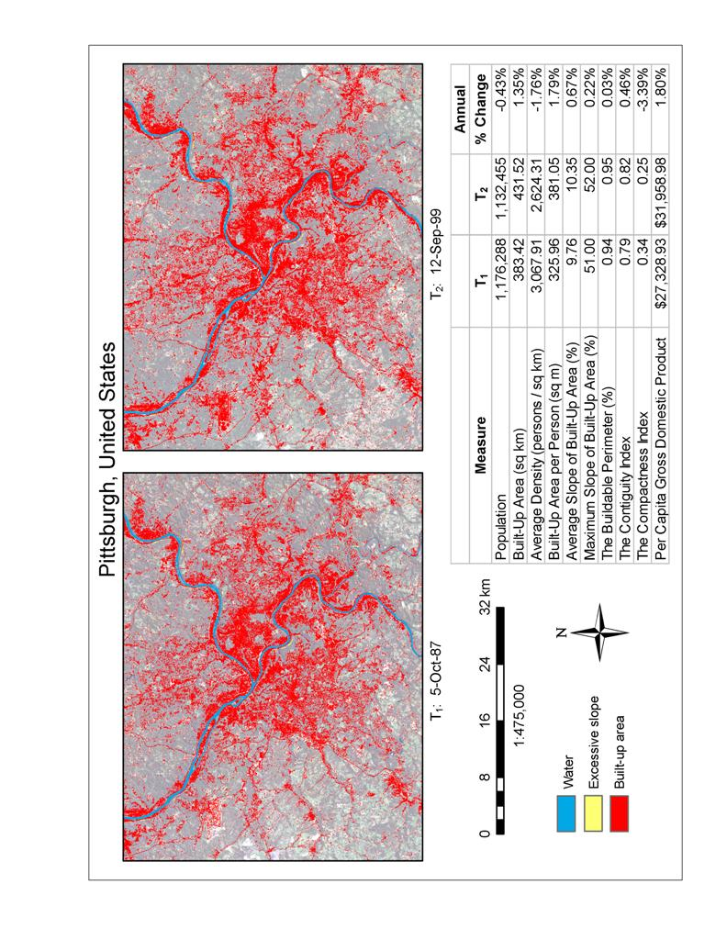
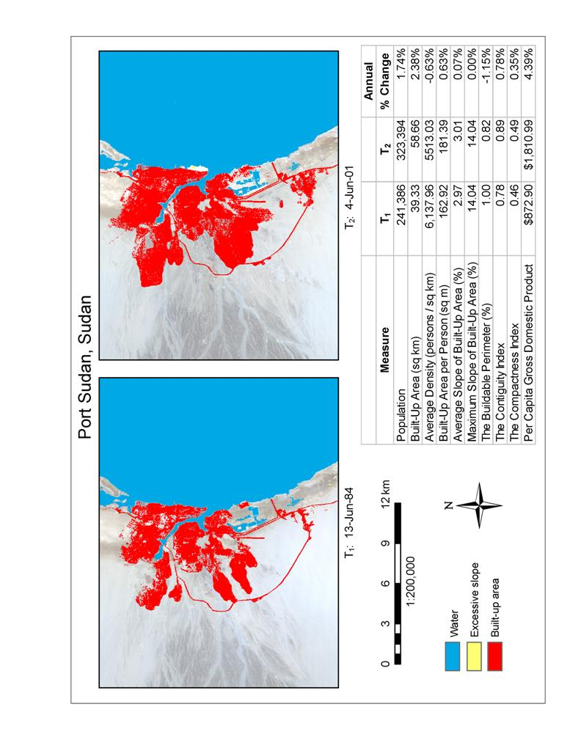
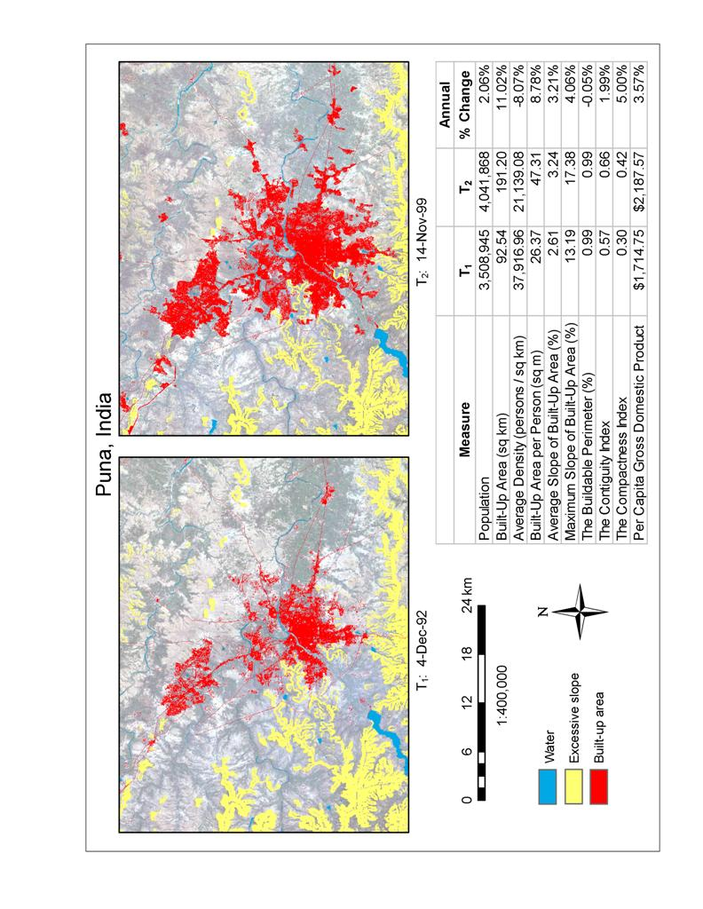
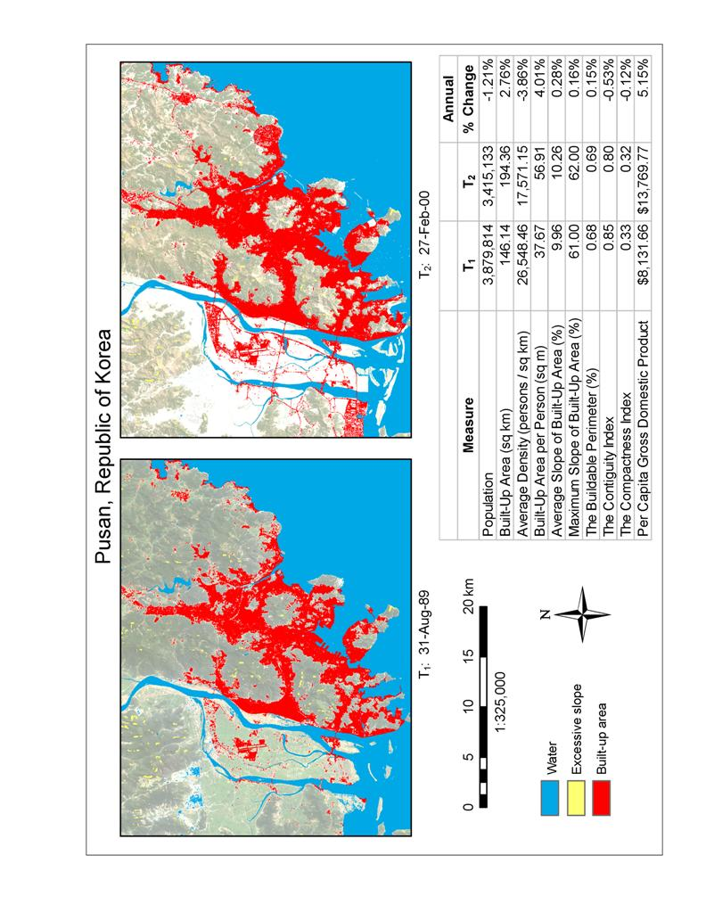
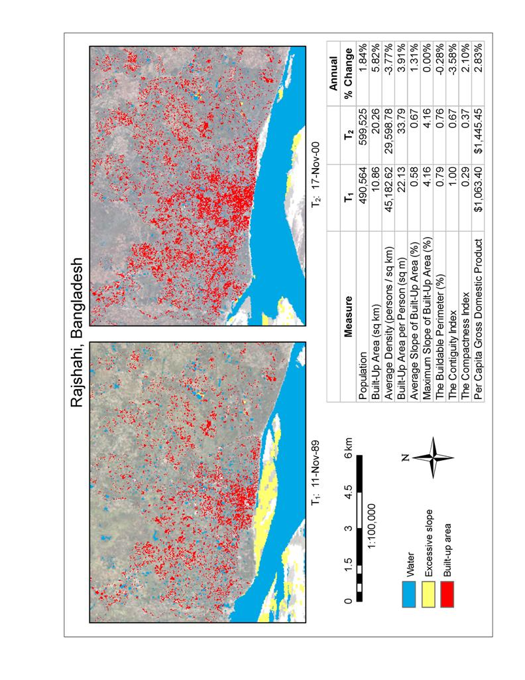
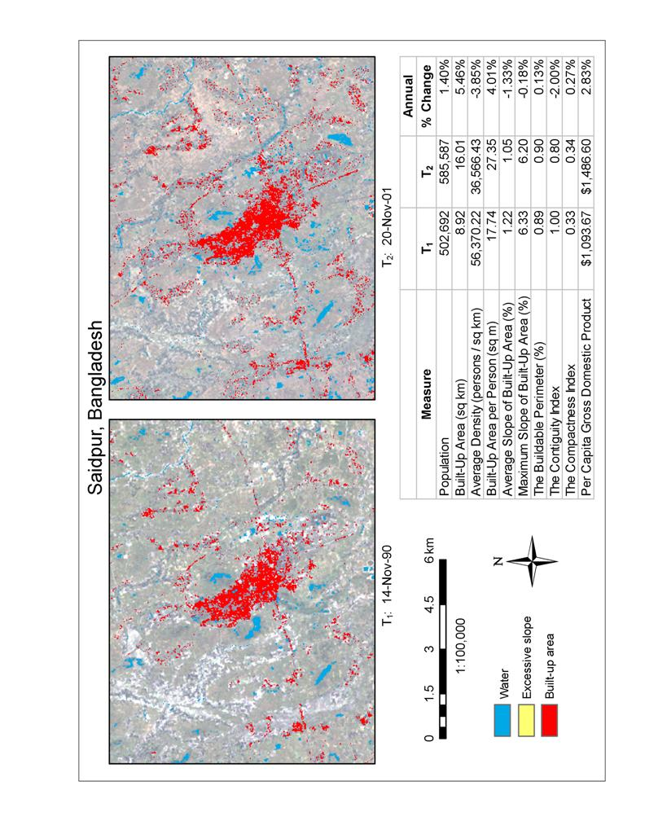
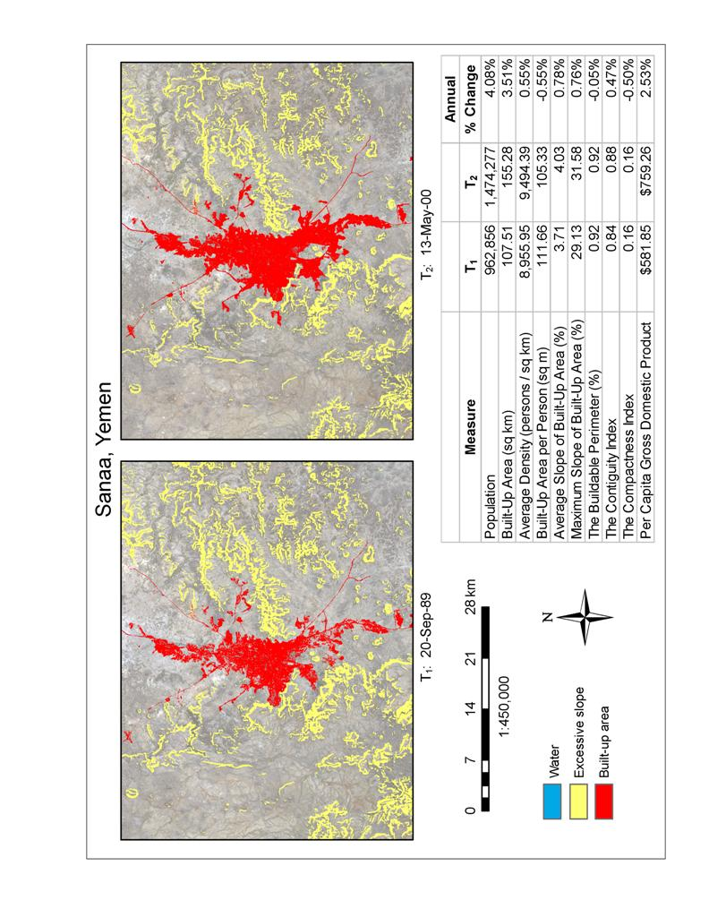
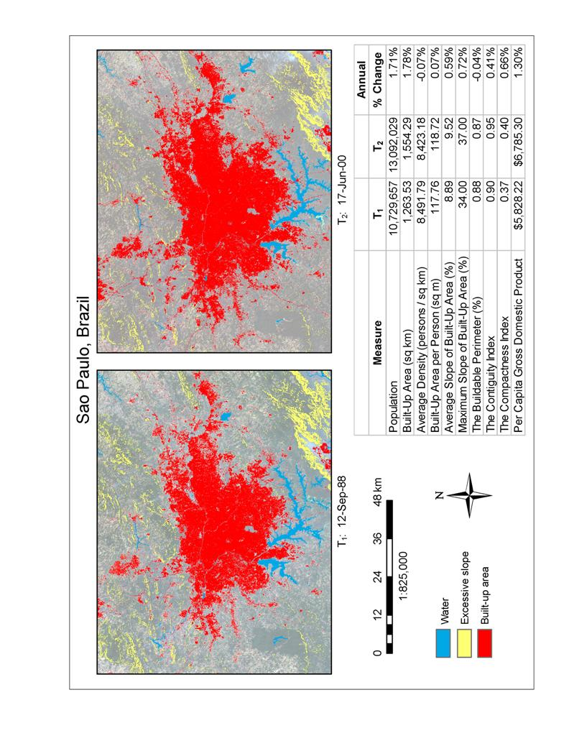
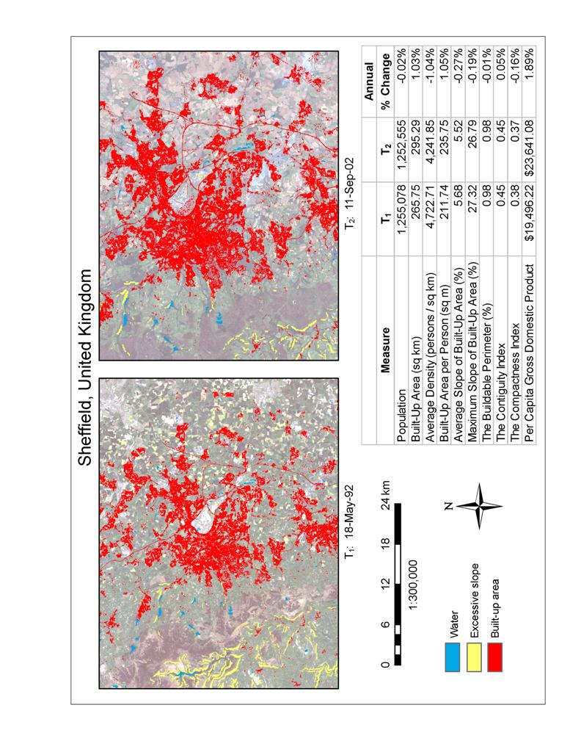
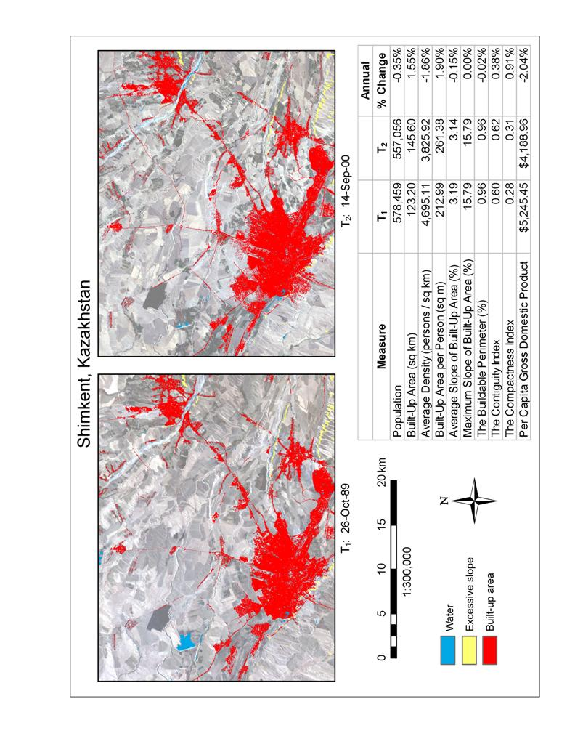
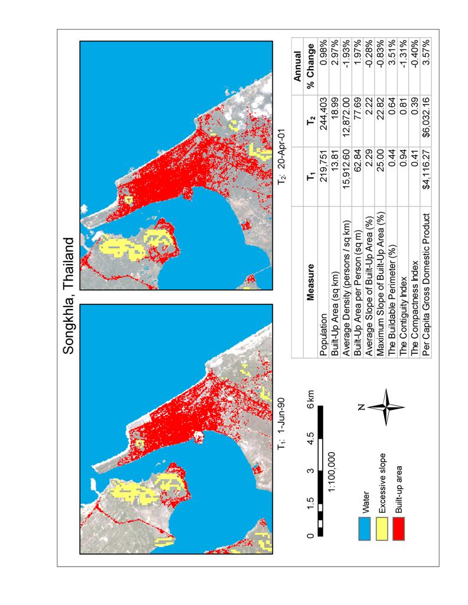
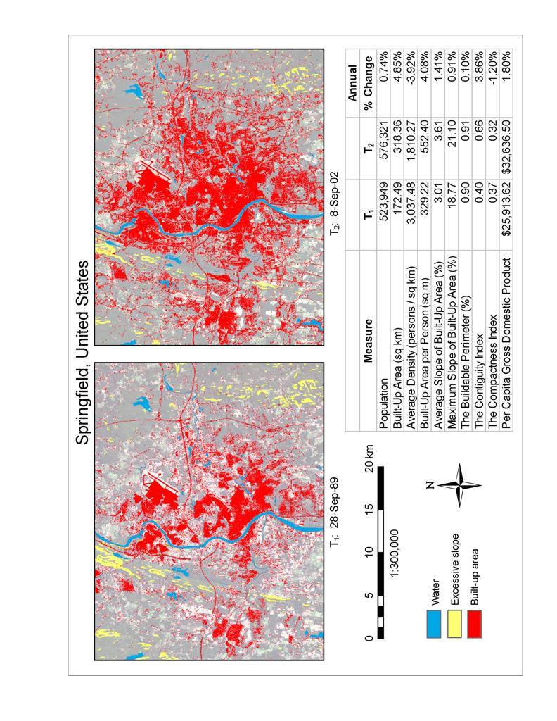
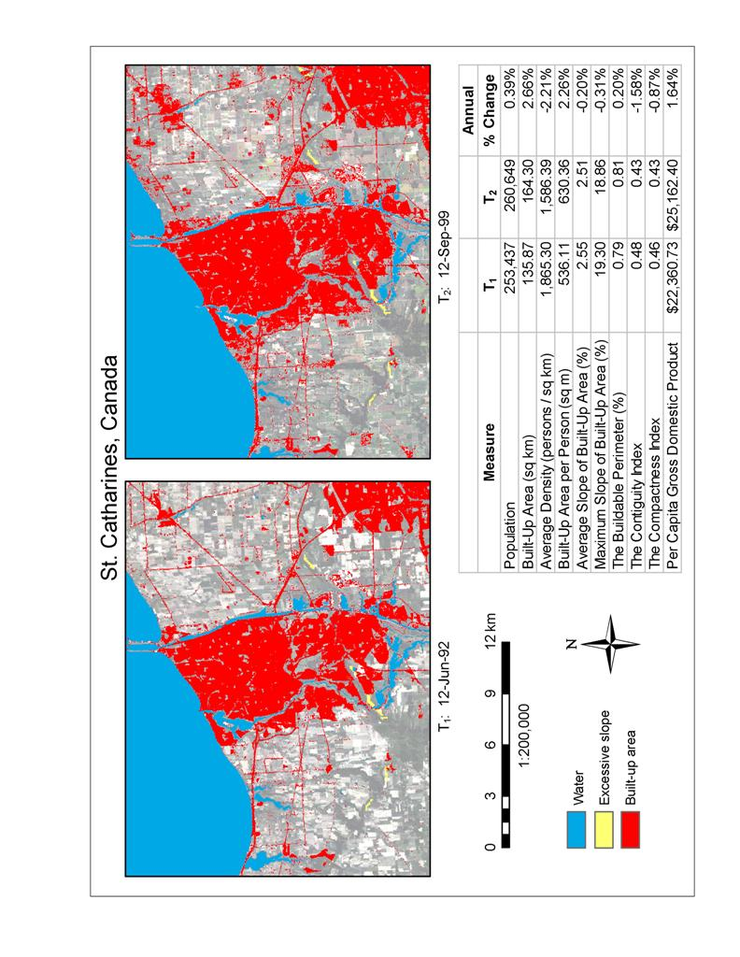
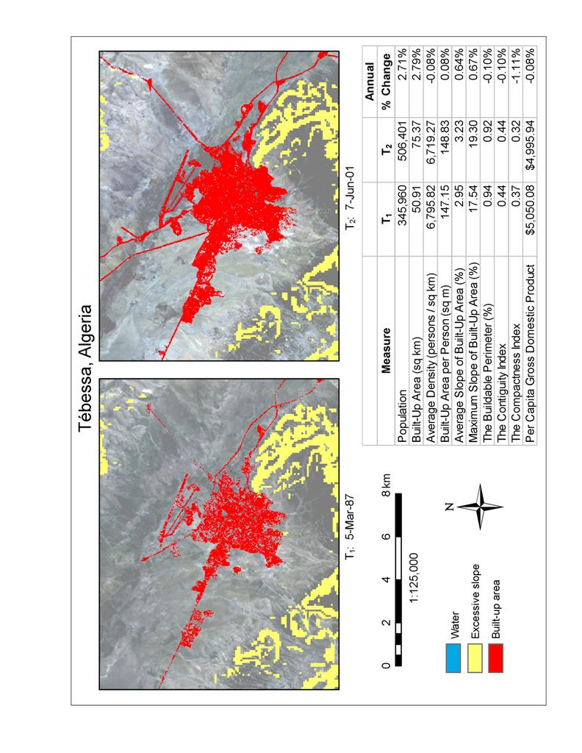
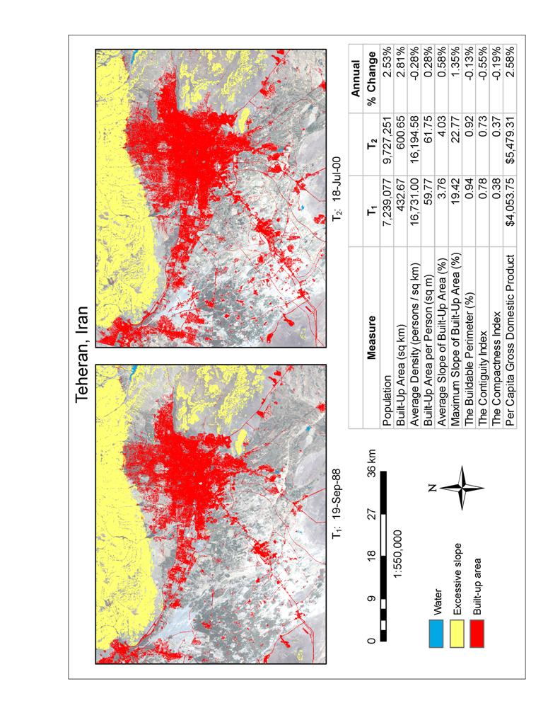
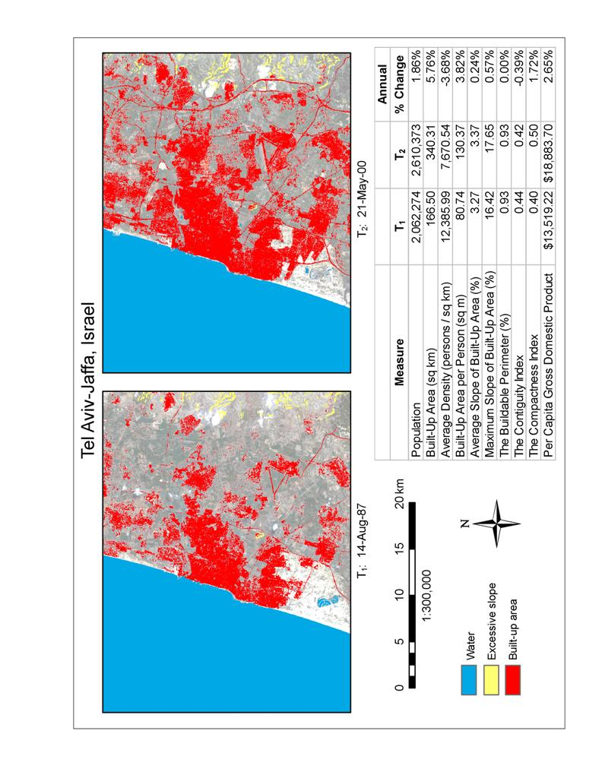
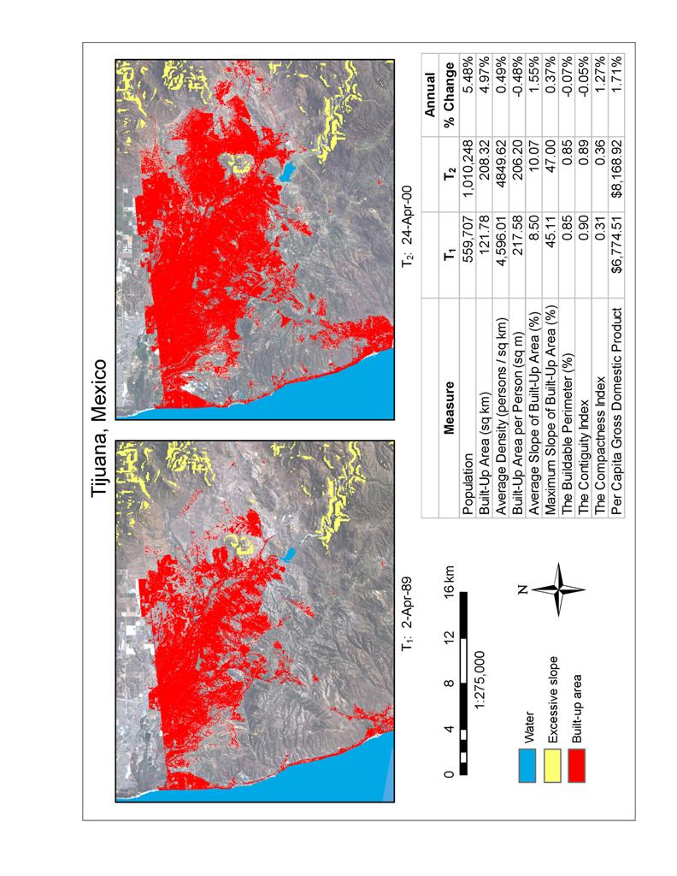
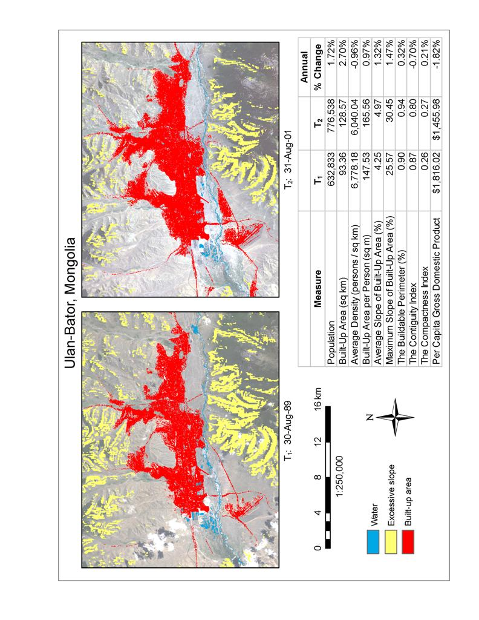
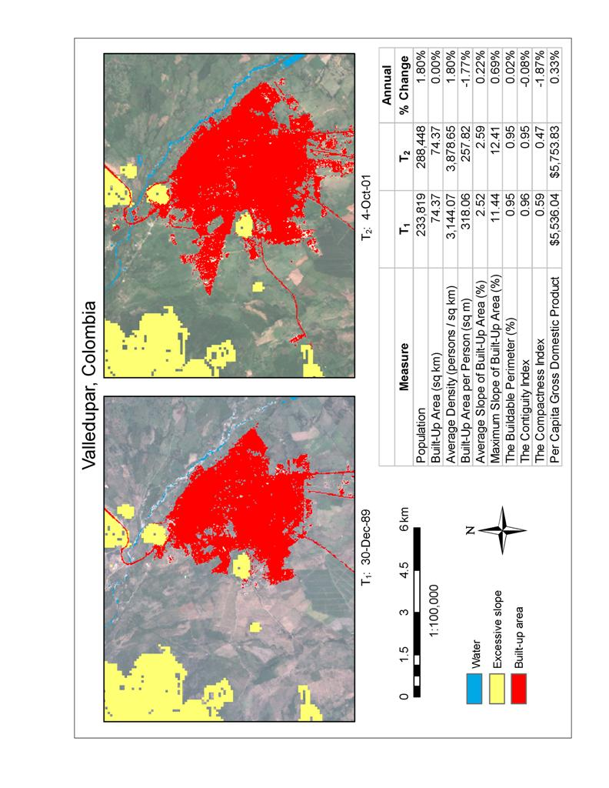
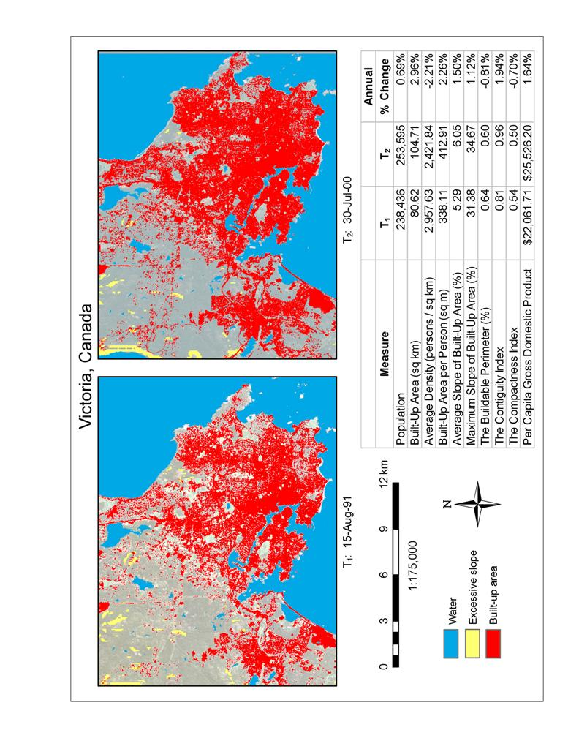
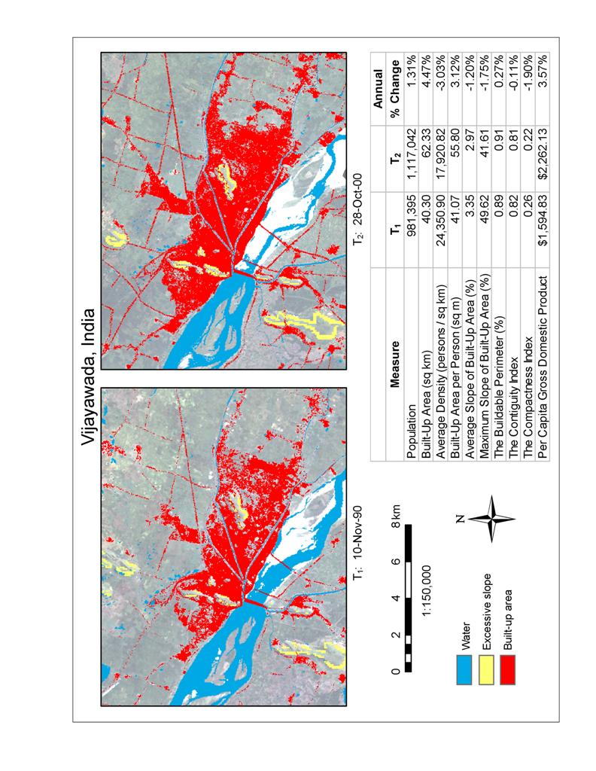
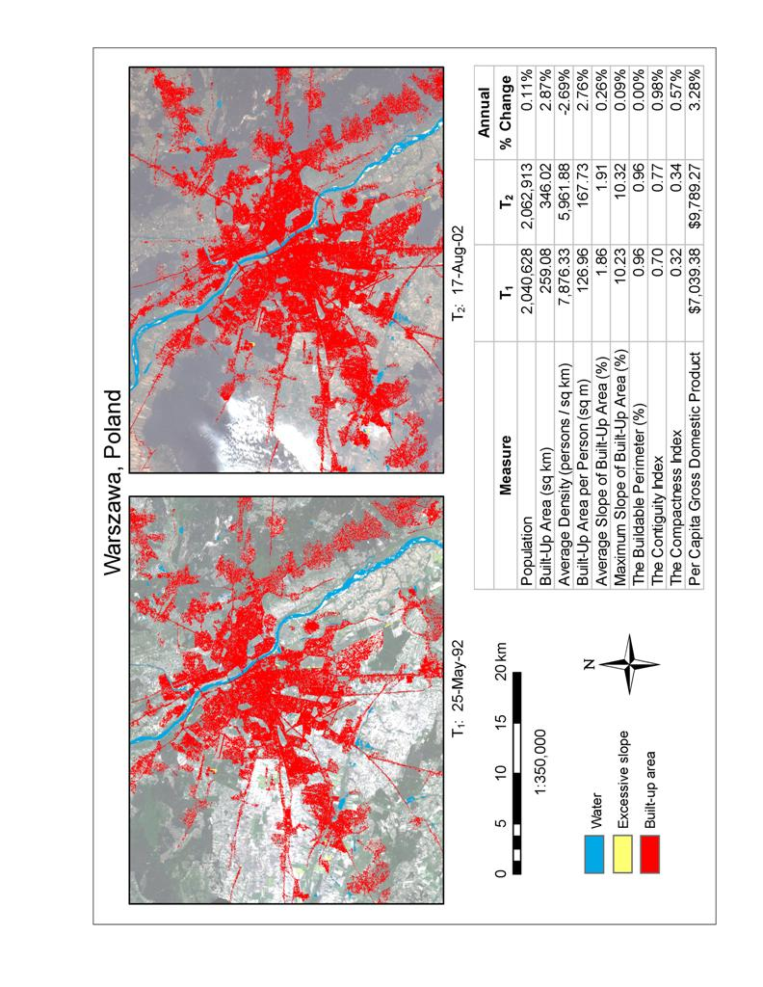
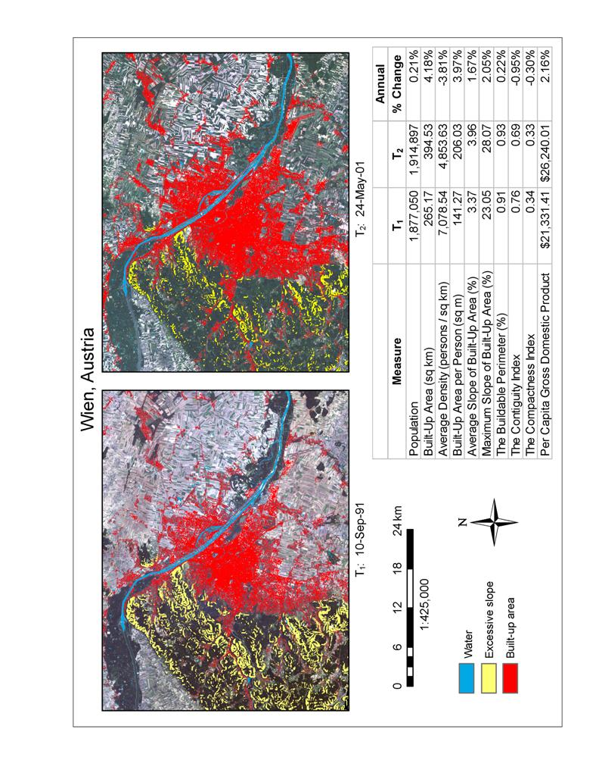
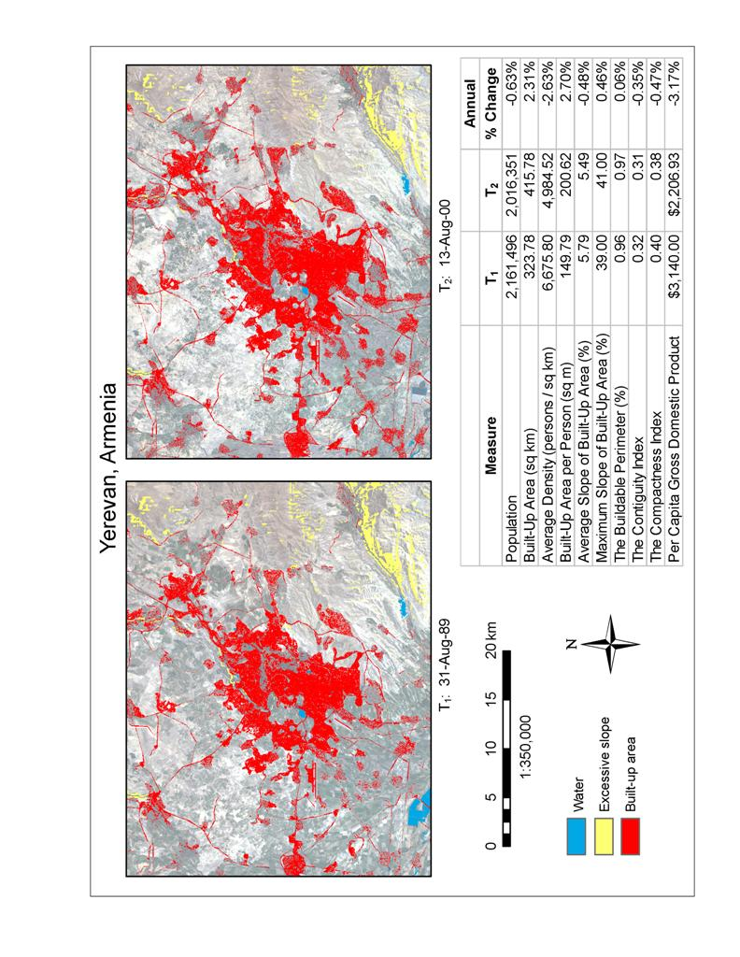
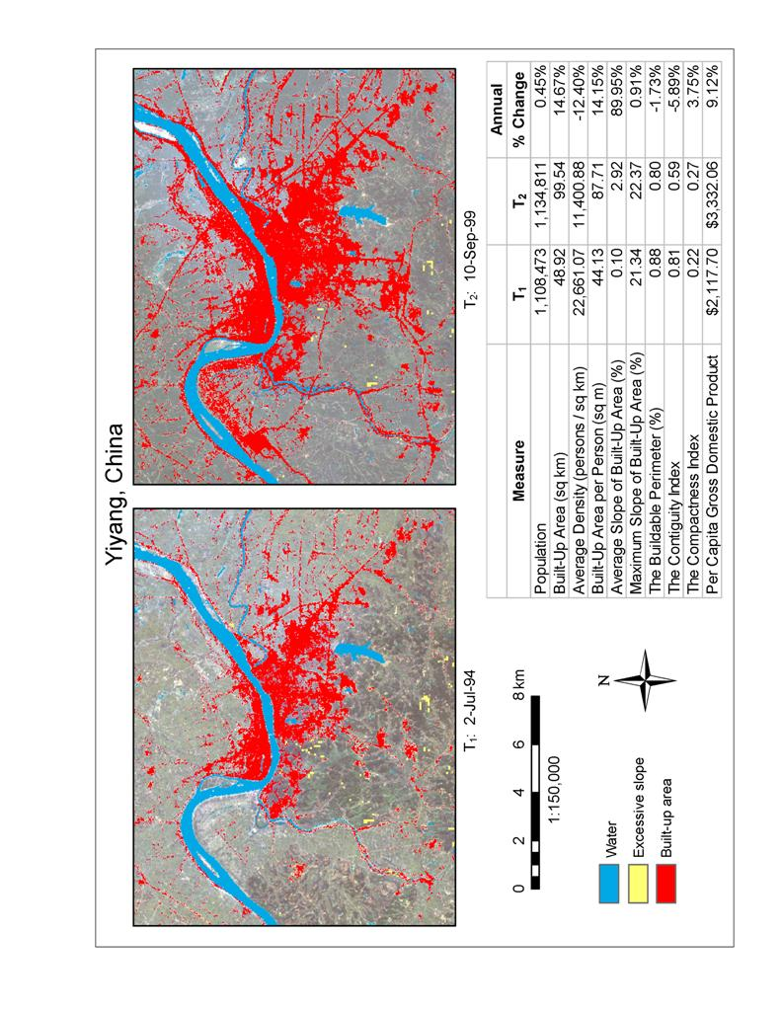
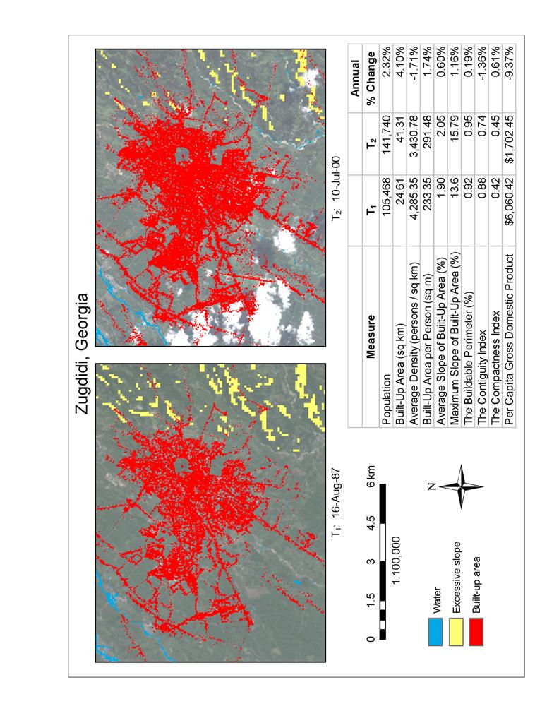
REFERENCES
Acioly, C. C., Jr. and F. Davidson, 1996, “Density in Urban Development”, in Building Issues, 3(8), Lund Centre for Habitat Studies, Lund University, Sweden.
Acioly, C. C., Jr., “Can Urban Management Deliver the sustainable city? Guided Densification in Brazil versus Informal Compactness in Egypt”, in Jenks, Mike and Rod Burgess, eds., Compact Cities: Sustainable Urban Forms for Developing Countries, London and New York: Spon Press.
Angel, Shlomo, 2000, Housing Policy Matters: A Global analysis, New York: Oxford University Press.
Angel, Shlomo, David Dowall et al, 1987, “The Land and Housing Markets of Bangkok: Strategies for Public Sector Participation”, The Bangkok Land Management Study, Bangkok: Planning and Development Collaborative International.
Ball, G. and D. Hall, 1965, “ISODATA: a novel method of data analysis and classification”, Technical Report AD-699616, SRI, Stanford, CA.
Banner, Bonnie B., website manager, Remote Sensing and GIS Laboratory, College of Natural Resources, Utah State University. http://www.nr.usu.edu/~bbanner/intrsgis/rssys.gif
BBC News, 2000, “China Begins Massive Census”, 31 October, online at news.bbc.co.uk /1/hi/world/asia-pacific/1000357.stm
Bertaud, Alain and Jan K. Brueckner, 2004, “Analyzing Building Height Restrictions: Predicted Impacts, Welfare costs, and a Case Study of Bangalore, India”, Policy Research Working Paper 3290, The World Bank, April, Washington: The World Bank.
Brueckner, J. and Hyun-A Kim, 2003, “Urban Sprawl and the Property Tax”, International Tax and Public Finance , 10: 5–23.
Brueckner, J., 1997, “Infrastructure Financing and Urban Development: The Economics of Impact Fees”, Journal of Public Economics, 66, 383-407.
Brueckner, J., and D. Fansler, 1983, “The Economics of Urban Sprawl: Theory and Evidence on the Spatial Sizes of Cities”, Review of Economics and Statistics, 55, 479-82.
Brueckner, J., 1987, “The Structure of Urban Equilibria”, Chapter 20 in Handbook of Regional and Urban Economics, E. Mills, ed., New York: Elsevier.
Brueckner, J., J. Thisse, and Y. Zenou, 1999, “Why is Central Paris Rich and Downtown Detroit Poor? An Amenity Based Theory”, European Economic Review, 43, 91-107.
Brueckner, Jan, 2001, “Urban Sprawl: Lessons From Urban Economics”, Brookings-Wharton Papers on Urban Affairs, 65-97.
Burchfield, Marcy, Henry G. Overman, Diego Puga and Matthew E. Turner, 2004, “The Determinants of urban Sprawl: Portrait from Space”, unpublished manuscript, 7 October.
Burchfield, N., H. Overman, D. Puga, and M. Turner, 2004, “The Determinants of Urban Sprawl: A Portrait from Space”, University of Toronto Working Paper.
Burgess, Rod, 2000, “The Compact city Debate: A Global Perspective”, in Compact cities: Sustainable Urban forms for Developing Countries, Jenks, Mike and Rod Burgess, eds., London and New York: Spon Press.
Burnett, John, 1986, A Social History of Housing 1815−1985, 2nd Edition, London: Methuen.
Burrough, P. A. and McDonell, R.A., 1998, Principles of Geographical Information Systems, New York: Oxford University Press.
Canada Center for Remote Sensing, “Fundamentals of Remote Sensing,” 2004, http://www.ccrs.nrcan.gc.ca/ccrs/learn/tutorials/fundam/chapter1/chapter1_1_e.html
Civco, Daniel J., unpublished note on definition of ‘remote sensing’, undated.
Cohen, J., 1960, “A coefficient of agreement for nominal scales”, Educational and Psychological Measurement 20, 37–46.
Congalton, R.G. and K. Green, 1999, Assessing the Accuracy of Remotely Sensed Data: Principles and Practices, Boca Raton, FL.: Lewis Publishers.
Crumplin, William W., 1992, “Compactness and Electoral Boundary Adjustment: An Assessment of Alternative Measures,” Canadian Geographer 36, 159–171.
Cullen, J. B. and Levitt, S., 1999, “Crime, Urban Flight, and the Consequences for Four Cities”, Review of Economics and Statistics, 81, 159-169.
Davis, J.C. and Henderson, J.V., 2003, “Evidence on the Political Economy of the Urbanization Process”, Journal of Urban Economics 53: 98-125.
De Roo, Gerd and Donald Miller, 2000, “1: Introduction⎯Compact Cities and sustainable Development”, in G. de Roo and D. Miller, eds., Compact cities and sustainable Urban Development: A Critical Assessment of Policies and Plans from an International Perspective, Aldershot: Ashgate.
Durlauf, S. and P. Johnson, [1995], “Multiple Regimes and Cross Country Growth Behavior”, Journal of Applied Econometrics, 10(4): 365-384.
Earth Institute News, 2005. www.earthinstitute.columbia.edu/news/2005/story03-07-05.html
Environmental Systems Research Institute, Inc. (ESRI), 2005, GIS Dictionary. http://support.esri.com/index.cfm?fa=knowledgebase.gisDictionary.search&search= true&searchTerm=slope
Environmental Systems Research Institute, Inc. (ESRI), 2005. http://www.esri.com/library/whitepapers/pdfs/shapefile.pdf
Environmental Systems Research Institute, Inc. (ESRI), ArcGIS. http://www.esri.com/software/arcgis/
ERDAS Imagine 8.7 software, Leica Geosystems, 2003. http://www.gis.leica-geosystems.com/Products/Imagine
ERDAS Imagine Field Guide. 7th Edition. Atlanta, GA: Leica Geosystems GIS & Mapping, LLC.
Felsenstein, D., 2002, “Do High Technology Agglomerations Encourage Urban Sprawl?” The Annals of Regional Science, 36, 663-682.
Fischel, William A., 1995, Regulatory Takings: Law, Economics, and Politics, Cambridge, Mass.: Harvard University Press.
Galster, George, Royce Hanson, Hal Wolman, Jason Freihage, and Steven Coleman, 2000. “Wrestling Sprawl to the Ground: Defining and Measuring an Elusive concept,” unpublished manuscript.
GeoCover Ortho Landsat TM database, http://www.earthsat.com/ip/prodsvc/gcolandsat_prod.html
Glaeser, E. and M. Kahn, 2004, “Sprawl and Urban Growth” Chapter 56 in the Handbook of Regional and Urban Economics, Henderson, J. V., and J. F. Thisse, eds., Elsevier: Amsterdam.
Glaeser, Edward L. and Matthew E. Kahn, 2003, “Sprawl and Urban Growth”, Harvard Institute of Economic research (HIER), Discussion Paper No. 2004, May, Cambridge, Mass.: Harvard University.
Global Land Cover Facility (GLCF), University of Maryland. http://glcf.umiacs.umd.edu/index.shtml
Groundwater Resources of The World, BGR Hannover /UNESCO, Paris 2004.
Gugler, J., 2004, World Cities beyond the West: Globalization, Development and Inequality, Cambridge: Cambridge University Press.
Handy, S., 2005, “Smart Growth and the Transportation–Land Use Connection: What Does the Research Tell Us?” International Regional Science Review, 28, 146-167.
Hansen, M., D. Gillen, and M. Puvathingal, 1998, “Freeway Expansion and Land Development: An empirical Analysis of Transportation Corridors”, Berkeley: Institute for Transportation Studies, University of California, Berkeley.
Hardoy, J., S. Cairncross and D. Satterthwaite, eds., 1990, The Poor Die Young: Housing and Health in Third World Cities, London: Earthscan.
Hart, S. and A. Spivak, 1993, “Elephant in the Bedroom: Automobile Dependence and Denial Impacts on The Economy and Environment.”
Heikkila, Eric J., Ti-yan Shen and Kai-zhong Yang, 2000, “Fuzzy Urban Sets: Theory and Application to Desakota Regions in China”, unpublished paper, forthcoming in Environment and planning B: Planning and Design, 2002, vol. 29.
Henderson, J. V., 1977, Economic Theory and the Cities, New York: Academic Press.
Henderson, J.V., 2003, “The Urbanization Process and Economic Growth: the So-What Question”, Journal of Economic Growth, 8, 47-71.
Horn, David L., Charles R. Hampton, and Anthony J. Vandenberg, 1993, “Practical Application of District Compactness,” Political Geography 12, 103–120.
Hospers, J., 1953, An Introduction to Philosophical Analysis, Englewood Cliffs, NJ: Prentice Hall.
Irwin, E. and N. Bockstael, 2002, “Interacting Agents, Spatial Externalities and the Evolution of Residential Land Use Patterns” Oxford Journal of Economic Geography, 2, 31-54.
Jensen, John R., 2000, Remote Sensing of the Environment: An Earth Resource Perspective, Upper Saddle River, NJ: Prentice Hall.
Lai, Richard Tseng-Yu, 1988, Law in Urban Design and Planning, New York: Von Nostrand.
Lane, Charles, 2005, “Justices Affirm Property Seizures: 5-4 Ruling Backs Forced Sales for Private Development”, The Washington Post, June 24.
Le Corbusier, 1943, The Athens Charter, Paris: La Librarie Pion. Reprinted, New York: Grossman, 1973.
MacEachren, Alan M., 1985, “Compactness of Geographic Shape: Comparison and Evaluation of Measures,” Geografisca Analer 67B, 53–67.
MacHale, Desmond, 1993, Comic Sections: A Book of Mathematical Jokes, Humour, Wit and Wisdom, Dublin: Boole Press.
Malpezzi, Stephen and Alain Bertaud, 2002, “The Spatial Distribution of Population in 48 World Cities: Implications for Economies in Transition,” draft, Center for Urban Land Economics Research, University of Wisconsin, Madison.
Malpezzi, Stephen and Wen–Kai Guo, 2001. “Measuring ‘Sprawl’: Alternative Measures of Urban form in US Metropolitan Areas,” unpublished manuscript, The Center for Urban Land Economics Research, University of Wisconsin, Madison.
Malpezzi, Stephen, 1999, “Estimates of the Measurement and Determinants of Urban Sprawl in U.S. Metropolitan Areas”, unpublished draft, The Center for Urban Land and Economics research, University of Wisconsin, June 7.
Manninen, D.I., 1973, “The Role of Compactness in the Process of Redistricting”, unpublished MA Thesis, Department of Geography, University of Washington.
Margo, R., 1992, “Explaining the Postwar Suburbanization of the Population in the United States: The Role of Income” Journal of Urban Economics, 31, 301-310.
MaxMind, 2005. http://www.maxmind.com/app/geoip_country.
Mayo, S. and S. Sheppard, 2001, “Housing Supply and the Effects of Stochastic Development Control”, Journal of Housing Economics, 10, 109-128.
Mills, E. and L. S. Lubuele, 1997, “Inner Cities”, Journal of Economic Literature, 35, 727-756.
Mills, E., 1972, Studies in the Structure of the Urban Economy, Baltimore: Johns Hopkins University Press.
Morris, de Witt Clinton and Rutherford, quote in Mackay, Donald A., 1987, The Building of Manhattan, New York: Harper and Row.
NASA, Jet Propulsion Laboratory. ftp://e0mss21u.ecs.nasa.gov/srtm/.
National Land Cover Dataset (NLCD), developed by the Multi-Resolution Land Characteristics Consortium (MRLC). http://www.mrlc.gov/index.asp
Newman, P.W.G. and J. Kenworthy, 1989, Cities and Automobile Dependence⎯An International sourcebook, Aldershot, UK: Gower Publishing.
Niemi, R.G., B. Grofman, C. Carlucci and T Hofeller, 1990, “Measuring Compactness and the Role of Compactness in a Test for Partisan and Racial Gerrymandering”, Journal of Politics, 52.
Pew Center for Civic Journalism, 1999, “Straight Talk from Americans: 2000” National Survey.
Plourde, L. and R.G. Congalton, 2003, “Sampling Method and Placement: How Do They Affect the Accuracy of Remotely Sensed Maps?” Photogrammetric Engineering and Remote Sensing 69(3), 289-298.
Richardson, Harry W., Chang-Hee Christine Bae and Murtaza Hatim Baxamusa, 2000, “Compact Cities in Developing Countries: Assessment and Implications”, in Jenks, Mike and Rod Burgess, eds., Compact Cities: Sustainable Urban Forms for Developing Countries, London and New York: Spon Press.
Seto, K. and Kaufmann, R., 2003, “Modeling the Drivers of Urban Land Use Change in the Pearl River Delta, China: Integrating Remote Sensing with Socioeconomic Data”, Land Economics, 79, 106-121.
Shore, William B., 2000, “How to Measure Sprawl and Test Its Impact on Environmental, Economic and Social Phenomena”, unpublished note, New York: Institute of Public Administration, May 1.
Socioeconomic Data and Applications Center (SEDAC), Center for International Earth Science Information Network (CIESIN), Columbia University. http://sedac.ciesin.columbia.edu/
Swain, P. H., 1973, “Pattern Recognition: A Basis for Remote Sensing Data Analysis”, LARS Information Note 111572. The Laboratory for Applications of Remote Sensing, Purdue University, West Lafayette, IN.
Thomas, L. and W. Cousins, 1996, “The Compact City: A Successful, Desirable and Achievable Urban Form?” in M. Jenks, E. Burton and K. Williams, eds., The Compact city: A Sustainable Form? London: E&FN Spon.
U.S. Census, “Census Dates for Countries and Areas of the World: 1945−2014”, available online at www.census.gov/ipc/www/cendates
U.S. Geological Survey, 2004, “Accuracy Assessment of 1992 National Land Cover Data,” http://landcover.usgs.gov/accuracy/pdf/region1-4.pdf
U.S. Geological Survey, 2004, “Earth Observing System Data Gateway.” http://edcimswww.cr.usgs.gov/pub/imswelcome
U.S. Geological Survey, 2004, Global Visualization Viewer (GLOVIS). http://glovis.usgs.gov/
U.S. Geological Survey, 2004, GTOPO30, a global digital elevation model (DEM). http://edcdaac.usgs.gov/gtopo30/gtopo30.asp
U.S. Geological Survey, 2004, National Elevation Dataset (NED). http://ned.usgs.gov/
United Nations, 2004, World Urbanization Prospects⎯The 2003 Revision, New York: United Nations.
Voith, R., 1999, “Does the Federal Tax Treatment of Housing Affect the Pattern of Metropolitan Development?”, Federal Reserve Bank of Philadelphia Review, March, 3-16.
Wilson, E.H., J. D. Hurd, D.L. Civco, S. Prisloe, and C. Arnold, 2003, “Development of a Geospatial Model to Quantify, Describe and Map Urban Growth” Special Issue on Remote Sensing to Urban Planning and Urban Ecology. Remote Sensing of Environment. 86(3): 275-285.
World Bank, World Development Indicators⎯2005, Washington DC: World Bank.
World Bank, World Development Report−2003: Sustainable Development in a Dynamic World, Washington DC: The World Bank.
Wu, J., 2003, “Environmental Amenities and the Spatial Pattern of Sprawl” American Journal of Agricultural Economics, 83, 691-697.
Zadeh, Lofti, 1965, “Fuzzy Sets”, Information and Control, 8, 338-353.

ACKNOWLEDGEMENTS

The study team would like to gratefully acknowledge all the people that have made this study possible. First and foremost, we would like to thank the members of the Research committee of the World Bank for having the confidence in the team and for providing the generous financial support that has made this study possible. Second, we would like to acknowledge Dr. Deborah Balk, Lead SEDAC Project Scientist, Dr. Robert S. Chen, SEDAC Manager, Adam Storeygard, SEDAC Research Associate, and Dr. Christopher Small, all of CIESIN at Columbia University, for proving us with their able assistance and allowing us to share their data on the administrative districts of the cities in our global sample.
Several students at Williams College helped with the classification of images during the summer of 2004⎯Syed Kashif Akhtar, Victoria Wiolff, Tiomoko Harigaya, Wei Wang, and Peng Ou. Jerry Kalarickal helped with the initial collection of census data at the library of the International Programs Center of the U.S. Census Bureau. Timothy Crawley and Scott Beginnati helped with various aspects of satellite data collection. Norma Silvera, Mercedes Aleman, and Maria Eugenia Quintero of the World Bank’s Transport and Urban Development Department helped administer the financial aspects of the research project. And Daniella Gitlin helped with the editing and proofreading of the manuscript and its preparation for publication. The study team most gratefully acknowledges the kind help and assistance of all those people.

See United Nations, 2004, World Urbanization Prospects⎯The 2003 Revision, New York: United Nations, table 1, 14. The urban population in developing countries is expected to grow from 1.93 billion in 2000 to 3.97 billion in 2030.
The weighted average built-up area density for developing-country cities in our provisional sample of 90 in 2000 was found to be 8,049 persons per square kilometer (see table IV-2, Chapter 4).
United Nations, 2004, table 1, 14. The urban population in industrialized countries is expected to grow from 0.88 billion in 2000 to 1.01 billion in 2030.
The weighted average built-up area density for industrialized-country cities in our provisional sample of 90 in 2000 was found to be 2,824 persons per square kilometer (see table IV-2, Chapter 4).
This estimate is considerably lower than previously published estimates. The Earth Institute at Columbia University, for example, recently announced that “GRUMP [Global urban Rural Mapping Project] data indicate that roughly 3% of the Earth’s land surface is occupied by urban areas, an increase of at least 50% over previous estimates that urban areas occupied 1-2% of the Earth’s total land area”; see Earth Institute News, posted on 8 March 2005 at www.earthinstitute.columbia.edu/news/2005/story03-07-05.html. The GRUMP estimates are based mostly on night light data, as against the Landsat data used in our estimates. These and other differences in defining and measuring urban built-up areas will be discussed at length in Chapter IV.
World Bank, World Development Indicators⎯2005, Washington DC: World Bank.
Lai, Richard Tseng-Yu, 1988, Law in Urban Design and Planning, New York: Von Nostrand, 27−33.
Morris, de Witt Clinton and Rutherford, quote in Mackay, Donald A., 1987, The Building of Manhattan, New York: Harper and Row, 20.
Burchfield, Marcy, Henry G. Overman, Diego Puga and Mathhew E. Turner, 2004, “The Determinants of Urban Sprawl: Portrait from Space”, unpublished manuscript, 7 October, 1.
Burchfield et al, 2004, 1. The information in the quote was obtained from Trust for Public Land and Land Trust Alliance, 2002, 2003; and from the Pew Center for Civic Journalism, 2000.
See, for example, Durlauf, S. and P. Johnson, [1995], “Multiple Regimes and Cross Country Growth Behavior”, Journal of Applied Econometrics, 10(4): 365-384. Using a sample of a similar size to that collected for this research, they employ regression trees to identify groups of countries that display similar within-group⎯but different between-group⎯growth behavior.
Most of these arguments are presented forcefully in Glaeser, Edward L. and Matthew E. Kahn, 2003, “Sprawl and Urban Growth, Harvard Institute of Economic research (HIER), Discussion Paper No. 2004, May, Cambridge, Mass.: Harvard University.
See, for example, Malpezzi, Stephen and Alain Bertaud, 2002, “The Spatial Distribution of Population in 48 World Cities: Implications for Economies in Transition,” draft, Center for Urban Land Economics Research, University of Wisconsin, Madison. See also, Galster, George, Royce Hanson, Hal Wolman, Jason Freihage, and Steven Coleman, 2000. “Wrestling Sprawl to the Ground: Defining and Measuring an Elusive concept,” unpublished manuscript; Malpezzi, Stephen and Wen–Kai Guo, 2001. “Measuring ‘Sprawl’: Alternative Measures of Urban form in US Metropolitan Areas, unpublished manuscript, The Center for Urban Land Economics Research, The University of Wisconsin, Madison.
Burchfield et al, 2.
See, for example, Crumplin, William W., 1992, “Compactness and Electoral Boundary Adjustment: An Assessment of Alternative Measures,” Canadian Geographer 36, 159–171; Horn, David L., Charles R. Hampton, and Anthony J. Vandenberg, 1993, “Practical Application of District Compactness,” Political Geography 12, 103–120; MacEachren, Alan M., 1985, “Compactness of Geographic Shape: Comparison and Evaluation of Measures,” Geografisca Analer 67B, 53–67. Many of compactness measures are summarized and thoroughly discussed in Malpezzi, Stephen and Wen-Kai Guo. Measuring “Sprawl: Alternative Measures of Urban Form in US Metropolitan Areas.” Center for Urban Land Economics, University of Wisconsin, Research Working Paper, [2001].
See Brueckner, Jan, 2001, “Urban Sprawl: Lessons From Urban Economics”, Brookings-Wharton Papers on Urban Affairs, 65-97.
BBC News, 2000, “China Begins Massive Census”, 31 October, online at news.bbc.co.uk /1/hi/world/asia-pacific/1000357.stm.
Davis, J.C. and Henderson, J.V., 2003, “Evidence on the Political Economy of the Urbanization Process”, Journal of Urban Economics 53: 98-125.
Reported in Henderson, J.V., 2003, “The Urbanization Process and Economic Growth: the So-What Question”, Journal of Economic Growth, 8, 47-71. Henderson finds that one standard deviation departure from the optimal degree of primacy is associated with reductions in annual growth rates of 1.41 percentage points.
See, for example, Newman, P.W.G. and J. Kenworthy, 1989, Cities and Automobile Dependence⎯An International sourcebook, Aldershot, UK: Gower Publishing; Angel, Shlomo, 2000, Housing Policy Matters: A Global analysis, New York: Oxford University Press; or Malpezzi Bertaud, 2002, op.cit.
Even Burchfield et al, 2004, op.cit., seeking to compare ‘urban sprawl’ in two time periods in the United States⎯where data are plentiful and systematically collected⎯had to use different sources of data for the two time periods that are not strictly comparable.
In the following discussion, however, the terms ‘city’ and ‘metropolitan area’ will be used interchangeably.
In practice, random selection involved selection “with replacement”. Each city selected was returned into the regional sub-universe and could be selected again until 40 cities where selected in each region. In this manner, the bias created by the removal of selected cities from the universe was avoided.
Unfortunately, there is no agreed-upon classification of countries into regions. International organizations, such as the UN and the World Bank, typically classify countries into regions, and these classifications tend to change over time. The UN Habitat sample, as noted earlier, was selected from a 9-region classification. The World Bank currently divides developing countries into six regions: East Asia and the Pacific, Europe and Central Asia, Latin America and the Caribbean, the Middle East and North Africa, Sub-Saharan Africa, and South Asia. The United Nations now divides all countries into 20 world macro-regions, but has five regional commissions in developing countries: Asia and the Pacific, Western Asia, Europe, Africa, and Latin America and the Caribbean.
At the time the sample was drawn, the UN Habitat universe of cities was not available to the study team. Only the UN Habitat sample of 355 cities and the sub-sample of 35 cities were available.
World Bank, World Development Report−2003: Sustainable Development in a Dynamic World, Washington DC: The World Bank, 243.
Data on the national censuses can by found in U.S. Census, “Census Dates for Countries and Areas of the World: 1945−2014”, available on line at www.census.gov/ipc/www/cendates.
Nearest neighbors were identified first by sorting the list of cities by latitude and then by longitude and choosing five nearest cities with greater latitudes and the five with smaller latitudes; and second by sorting the list of cities by longitude and then by latitude and choosing five nearest cities with greater longitudes and the five with smaller longitudes.
A circular city of 30-km radius will have an area of some 2,800 km². Assuming an average density of 7,500 persons per km², such a city will house a population of some 20 million people. Assuming that only half the circle will be built-up, such a city will house some 10 million people. The orbit of a city of 10 million was thus taken to be 30 km. Similar calculations were made for other city sizes.
Burgess, Rod, 2000, “The Compact city Debate: A Global Perspective”, in Compact cities: Sustainable Urban forms for Developing Countries, Jenks, Mike and Rod Burgess, eds., London and New York: Spon Press, 14.
This product is available for purchase at http://www.geocover.com/gc_lc/index.html.
See, for example, http://dmsp.ngdc.noaa.gov/html/download.html
Civco, Daniel J., unpublished note, undated.
Canada Center for Remote Sensing, “Fundamentals of Remote Sensing,” 2004, October 12, http://www.ccrs.nrcan.gc.ca/ccrs/learn/tutorials/fundam/chapter1/chapter1_1_e.html
See Jensen, John R., 2000, Remote Sensing of the Environment: An Earth Resource Perspective, Upper Saddle River, NJ: Prentice Hall.
A term often used for the ground resolution of digital remote sensing data is the picture element, or pixel. This nomenclature will be followed in this report.
Emerging technologies are employing image segmentation and object-oriented classification, enabling the incorporation of spectral and spatial rules.
Derived from this project’s Minneapolis study city, July 2001.
See Ball, G. and D. Hall, 1965, “ISODATA: a novel method of data analysis and classification”, Technical Report AD-699616, SRI, Stanford, CA.
ERDAS Imagine 8.7 software, Leica Geosystems, 2003, http://www.gis.leica-geosystems.com/Products/Imagine
ERDAS Imagine Field Guide. 7th Edition. Atlanta, GA: Leica Geosystems GIS & Mapping, LLC.
See Swain, P. H., 1973, “Pattern Recognition: A Basis for Remote Sensing Data Analysis”, LARS Information Note 111572. The Laboratory for Applications of Remote Sensing, Purdue University, West Lafayette, IN.
http://www.earthsat.com/ip/prodsvc/gcolandsat_prod.html
http://edcimswww.cr.usgs.gov/pub/imswelcome/
http://glovis.usgs.gov/
http://glcf.umiacs.umd.edu/index.shtml
http://sedac.ciesin.columbia.edu/
It should be noted that “urban” is used here as a label for “built up” pixels, and not necessarily indicative of the spatial extent of the urban landscape, which we define in Chapter IIC.
Portrayals of T₁ and T₂ classifications of urban, non-urban, and water are presented in Chapter VI of this report entitled “City Data Sheets”.
See Plourde, L. and R.G. Congalton, 2003, “Sampling Method and Placement: How Do They Affect the Accuracy of Remotely Sensed Maps?” Photogrammetric Engineering and Remote Sensing 69(3), 289-298.
See Congalton, R.G. and K. Green, 1999, Assessing the Accuracy of Remotely Sensed Data: Principles and Practices, Boca Raton, FL.: Lewis Publishers.
In this project’s successor, “Causes and Consequences of Urban Expansion”, sponsored by the National Science Foundation, field data are being collected for each of the 120 cities that will assist in accuracy assessment of the urban land cover classifications.
See Cohen, J., 1960, “A coefficient of agreement for nominal scales”, Educational and Psychological Measurement 20, 37–46.
http://www.mrlc.gov/index.asp
Low Intensity Residential, High Intensity Residential, and Commercial/Industrial/ Transportation.
“Accuracy Assessment of 1992 National Land Cover Data,” U.S. Geological Survey, 2004, August 24, http://landcover.usgs.gov/accuracy/pdf/region1-4.pdf
Quote in MacHale, Desmond, 1993, Comic Sections: A Book of Mathematical Jokes, Humour, Wit and Wisdom, Dublin: Boole Press, 145.
Niemi, R.G., B. Grofman, C. Carlucci and T Hofeller, 1990, “Measuring Compactness and the Role of Compactness in a Test for Partisan and Racial Gerrymandering”, Journal of Politics, 52, 1159.
Manninen, D.I., 1973, “The Role of Compactness in the Process of Redistricting”, unpublished MA Thesis, Department of Geography, University of Washington, 75-6.
Hospers, J., 1953, An Introduction to Philosophical Analysis, Englewood Cliffs, NJ: Prentice Hall, 51-3.
Horn, Daniel L., Charles E. Hampton and Anthony J. Vandenberg, 1993, “Practical Application of district Compactness”, Political Geography, 12(2), March, 103.
Several authors, in an effort to overcome the ambiguity inherent in deciding whether a built-up pixel belongs or does not belong to the city propose treating the city as a fuzzy set, where each built-up pixel is assigned a probability of belonging to the city, but the assignment of such probabilities has its own inherent difficulties. See, for example, Heikkila, Eric J., Ti-yan Shen and Kai-zhong Yang, 2000, “Fuzzy Urban Sets: Theory and Application to Desakota Regions in China”, unpublished paper, forthcoming in Environment and planning B: Planning and Design, 2002, vol. 29. Lofty Zadeh introduced the concept of fuzzy sets in 1965 in “Fuzzy Sets”, Information and Control, 8, 338-353.
See Malpezzi, Stephen, 1999, “Estimates of the Measurement and Determinants of Urban Sprawl in U.S. Metropolitan Areas”, unpublished draft, The Center for Urban Land and Economics research, University of Wisconsin, June 7, 10.
http://www.esri.com/library/whitepapers/pdfs/shapefile.pdf
http://sedac.ciesin.columbia.edu/
In ESRI’s ArcMap, the “Boundary Clean” algorithm, one of the “Generalization” features within “Spatial Analysis Tools” was employed. The Boundary Clean tool is primarily used for cleaning “ragged” edges between zones. It uses an expansion and shrinking method that “cleans” boundaries.
“Region Grouping” is a spatial operator that identifies contiguous patches of like-valued pixels and assigns those patches (groups or regions) a unique identifier. Essentially, this is analogous to enumerating all unique polygons (in a vector-based GIS).
See Richardson, Harry W., Chang-Hee Christine Bae and Murtaza Hatim Baxamusa, 2000, “Compact Cities in Developing Countries: Assessment and Implications”, in Jenks, Mike and Rod Burgess, eds., Compact Cities: Sustainable Urban Forms for Developing Countries, London and New York: Spon Press, 25.
Acioly, C. C., Jr. and F. Davidson, 1996, “Density in Urban Development”, in Building Issues, 3(8), Lund Centre for Habitat Studies, Lund University, Sweden, quoted in Acioly, C. C., Jr., “Can Urban Management Deliver the sustainable city? Guided Densification in Brazil versus Informal Compactness in Egypt”, in Jenks, Mike and Rod Burgess, eds., Compact Cities: Sustainable Urban Forms for Developing Countries, London and New York: Spon Press, 127.
De Roo, Gerd and Donald Miller, 2000, “1: Introduction⎯Compact Cities and sustainable Development”, in G. de Roo and D. Miller, eds., Compact cities and sustainable Urban Development: A Critical Assessment of Policies and Plans from an International Perspective, Aldershot: Ashgate, 1.
At this stage in the analysis, areas where building is not allowed because of planning restrictions were still included in the buildable area.
http://support.esri.com/index.cfm?fa=knowledgebase.gisDictionary.search&search= true&searchTerm=slope.
The mathematics behind the slope algorithm is elaborated upon in Burrough, P. A. and McDonell, R.A., 1998, Principles of Geographical Information Systems, New York: Oxford University Press.
http://ned.usgs.gov/
http://edcdaac.usgs.gov/gtopo30/gtopo30.asp
ftp://e0mss21u.ecs.nasa.gov/srtm/.
ESRI’s ArcGIS was used for most geospatial data processing and analysis in this project. Information about ArcGIS can be found at http://www.esri.com/software/arcgis/.
Normally flagged with a value of –32767.
Shore, William B., 2000, “How to Measure Sprawl and Test Its Impact on Environmental, Economic and Social Phenomena”, unpublished note, New York: Institute of Public Administration, May 1.
Two pixels are connected if they touch each other either along one of their edges or at one of their corners.
This calculation was restricted to polygons larger than 25 hectares. In the calculations for Valledupar, Bandung and Guangzhou, clusters of unconsolidated built-up pixels of any size were formed, and the difference between the two procedures accounts for the difference between the two estimates.
For a review of compactness measures proposed for measuring election districts, see Horn, Daniel L., Charles E. Hampton and Anthony J. Vandenberg, 1993, “Practical Application of District Compactness”, Political Geography, 12(2), March.
See Burchfield, Marcy, Henry G. Overman, Diego Puga and Matthew E. Turner, 2004, “The Determinants of urban Sprawl: Portrait from Space”, unpublished manuscript, 7 October, 1. The information in the quote was obtained from Trust for Public Land and Land Trust Alliance, 2002, 2003; and from the Pew Center for Civic Journalism, 2000.
With a raster data structure consisting of grid cells measuring 28.5 meters, the maximum value is 901, but in the vector domain, the upper limit of this index is 965.94 [(500 meters / 28.5 meters)² ) * π].
Perhaps following on the work reported in Wilson, E.H., J. D. Hurd, D.L. Civco, S. Prisloe, and C. Arnold, 2003, “Development of a Geospatial Model to Quantify, Describe and Map Urban Growth,” Special Issue on Remote Sensing to Urban Planning and Urban Ecology. Remote Sensing of Environment. 86(3): 275-285.
See Mills, E. and Lubuele, L. S., 1997, “Inner Cities”, Journal of Economic Literature, 35, 727-756; Cullen, J. B. and Levitt, S., 1999, “Crime, Urban Flight, and the Consequences for Four Cities”, Review of Economics and Statistics, 81, 159-169; or Brueckner, J., J. Thisse, and Y. Zenou, 1999, “Why is Central Paris Rich and Downtown Detroit Poor? An Amenity Based Theory”, European Economic Review, 43, 91-107.
See Irwin, E. and N. Bockstael, 2002, “Interacting Agents, Spatial Externalities and the Evolution of Residential Land Use Patterns” Oxford Journal of Economic Geography, 2, 31-54, or Wu, J., 2003, “Environmental Amenities and the Spatial Pattern of Sprawl” American Journal of Agricultural Economics, 83, 691-697.
See Voith, R. 1999, “Does the Federal Tax Treatment of Housing Affect the Pattern of Metropolitan Development?”, Federal Reserve Bank of Philadelphia Review, March, 3-16.
See Brueckner, J. K. and Hyun-A Kim, 2003, “Urban Sprawl and the Property Tax”, International Tax and Public Finance, 10: 5–23, or Brueckner, J. K., 1997, “Infrastructure Financing and Urban Development: The Economics of Impact Fees”, Journal of Public Economics, 66, 383-407.
See Hart, S. and A. Spivak, 1993, “Elephant in the Bedroom: Automobile Dependence and Denial Impacts on The Economy and Environment”; or, for a more serious analysis, see Hansen, M., D. Gillen, and M. Puvathingal, 1998, “Freeway Expansion and Land Development: An Empirical Analysis of Transportation Corridors”, Berkeley: Institute for Transportation Studies, University of California, Berkeley.
Margo, R., 1992, “Explaining the Postwar Suburbanization of the Population in the United States: The Role of Income” Journal of Urban Economics, 31, 301-310.
Seto, K. and Kaufmann, R., 2003, “Modeling the Drivers of Urban Land Use Change in the Pearl River Delta, China: Integrating Remote Sensing with Socioeconomic Data”, Land Economics, 79, 106-121, or Felsenstein, D., 2002, “Do High Technology Agglomerations Encourage Urban Sprawl?” The Annals of Regional Science, 36, 663-682.
One of many contributing factors identified in Burchfield, N., H. Overman, D. Puga, and M. Turner, 2004, “The Determinants of Urban Sprawl: A Portrait from Space”, University of Toronto Working Paper.
See Handy, S., 2005, “Smart Growth and the Transportation–Land Use Connection: What Does the Research Tell Us?” International Regional Science Review, 28, 146-167, or Glaeser, E. and M. Kahn, 2004, “Sprawl and Urban Growth” Chapter 56 in the Handbook of Regional and Urban Economics, Henderson, J. V., and J. F. Thisse, eds., Elsevier: Amsterdam.
See, inter alia, Mills, E., 1972, Studies in the Structure of the Urban Economy, Baltimore: Johns Hopkins University Press; Henderson, J. V., 1977, Economic Theory and the Cities, New York: Academic Press; or Brueckner, J., 1987, “The Structure of Urban Equilibria”, Chapter 20 in Handbook of Regional and Urban Economics, E. Mills, ed., New York: Elsevier. We use their notation and basic approach in our discussion.
Documented more fully at http://beta.sedac.ciesin.columbia.edu/gpw/ and http://sedac.ciesin.columbia.edu/plue/gpw/index.html?main.html&2.
Obtained from U.S. Department of Agriculture, Natural Resources Conservation Service, Soil Survey Division, World Soil Resources, Washington, D.C.
Available at http://www.maxmind.com/app/geoip_country.
Measured from the OAG Data database.
See Gugler, J., 2004, World Cities beyond the West: Globalization, Development and Inequality, Cambridge: Cambridge University Press.
The data are obtained from Groundwater Resources of The World (world map at the scale of 1:50 Million meant to provide a global overview), BGR Hannover /UNESCO, Paris 2004.
Although Mayo, S. and S. Sheppard, 2001, “Housing Supply and the Effects of Stochastic Development Control” Journal of Housing Economics, 10, 109-128, present a model that identifies increasing holdings of vacant land by housing producers as a natural response to the risk associated with land use regulations. This analysis would suggest that decreased contiguity is a natural response to increasing regulatory risk.
Brueckner, J. K., and D. Fansler, 1983, “The Economics of Urban Sprawl: Theory and Evidence on the Spatial Sizes of Cities”, Review of Economics and Statistics, 55, 479-82.
Thomas, L. and W. Cousins, 1996, “The Compact City: A Successful, Desirable and Achievable Urban Form?” in M. Jenks, E. Burton and K. Williams, eds., The Compact city: A Sustainable Form? London: E&FN Spon, 56.
Burgess, Rod, 2000, “The Compact city Debate: A Global Perspective”, in Compact cities: Subtainable Urban forms for Developing Countries, Jenks, Mike and Rod Burgess, eds., London and New York: Spon Press, 9.
Paraphrasing Hardoy, J., S. Cairncross and D. Satterthwaite, eds., 1990, The Poor Die Young: Housing and Health in Third World Cities, London: Earthscan.
Burgess, 2000, 15.
BBC News, 2000, “China Begins Massive Census”, 31 October, online at news.bbc.co.uk /1/hi/world/asia-pacific/1000357.stm.
Davis, J.C. and Henderson, J.V., 2003, “Evidence on the Political Economy of the Urbanization Process”, Journal of Urban Economics 53: 98-125.
Reported in Henderson, J.V., 2003, “The Urbanization Process and Economic Growth: the So-What Question”, Journal of Economic Growth, 8, 47-71. Henderson finds that one standard deviation departure from the optimal degree of primacy is associated with reductions in annual growth rates of 1.41 percentage points.
For the impact of building height restrictions on urban expansion in Bangalore, India see Bertaud, Alain and Jan K. Brueckner, 2004, “Analyzing Building Height Restrictions: Predicted Impacts, Welfare costs, and a Case Study of Bangalore, India”, Policy Research Working Paper 3290, The World Bank, April, Washington: The World Bank.
Fischel, William A., 1995, Regulatory Takings: Law, Economics, and Politics, Cambridge, Mass.: Harvard University Press, 221.
Burnett, John, 1986, A Social History of Housing 1815−1985, 2nd Edition, London: Methuen, 335.
Le Corbusier, 1943, The Athens Charter, Paris: La Librarie Pion. Reprinted, New York: Grossman, 1973, 70.
Primary roads connecting one city to another are typically financed by central governments and can often be at least partially financed from tolls. Tertiary roads within subdivisions are typically financed from the sale of plots. Secondary roads that typically carry public transport and other trunk infrastructure are generally financed by municipal funds and are therefore likely to be under-supplied.
See, for example, Lane, Charles, 2005, “Justices Affirm Property Seizures: 5-4 Ruling Backs Forced Sales for Private Development”, The Washington Post, June 24.
See Angel, Shlomo, David Dowall et al, 1987, “The Land and Housing Markets of Bangkok: Strategies for Public Sector Participation”, The Bangkok Land Management Study, Bangkok: Planning and Development Collaborative International.

