General Equilibrium Measures of Agricultural Policy Bias
in Fifteen Developing Countries

Henning Tarp Jensen
University of Copenhagen

Sherman Robinson
International Food Policy Research Institute

Finn Tarp
University of Copenhagen

August 2002

Preliminary draft – please do not quote without permission of the authors.

Abstract

In this paper, we present a comparative analysis of the extent to which indirect taxes, tariffs, and exchange rates affected relative price incentives for agricultural production in a representative sample of 15 developing countries in the 1990s. Empirical studies from the 1980s, using partial equilibrium methodologies, supported the view that policies in many developing countries imparted a major incentive bias against agriculture. Eliminating this bias was one of the goals of policy reform strategies, including structural adjustment programs, supported by the World Bank and others; and many countries undertook such reforms in the 1990s. In our sample, general equilibrium analysis indicates that, in the 1990s, the economywide system of indirect taxes, including tariffs and export taxes, significantly discriminated against agriculture in only one country, was largely neutral in five, provided a moderate subsidy to agriculture in four, and strongly favored agriculture in five. Earlier work assumed that overvaluation of the exchange rate would hurt agriculture, which was assumed to be largely tradable. In a general equilibrium setting, changes in the exchange rate can as demonstrated in this paper lead to anything between strongly increasing and decreasing relative agriculture/non-agriculture incentives, depending on relative trade shares. We conclude that, whatever incentive bias there was in the 1980s, it has mostly disappeared by the 1990s. We also find that it is difficult to generalize—country specific circumstances greatly affect the relative impact of trade policies on agriculture and the rural economy.

1. Introduction

“Getting prices right” was a rallying call when developing countries started re-orienting their economic policies in the early 1980s. Central to this effort was the understanding that trade and macroeconomic policies had negatively affected relative producer price incentives in the agriculture sector. The existence of such an incentive bias against agriculture was affirmed in the late 1980s by a major World Bank research project carried out under the direction of Anne O. Krueger (Krueger, Schiff, and Valdés, 1988; Krueger, 1992; Schiff and Valdés, 1992; and Bautista and Valdés, 1993). The research team analyzed data from the early 1960s to the mid-1980s and concluded that reductions in trade distortions such as import tariffs and export taxes and the removal of overvalued exchange rates should be vigorously pursued in economic reforms, and would improve agricultural price incentives.

It is now clear that structural adjustment did not in general lead to a rapid and dramatic turn-around in the agricultural sector. During the 1980s and 1990s, large capital inflows in the form of foreign aid and loans from bilateral and multilateral sources were coupled with strong adjustment efforts to achieve stabilization and recovery in countries such as Mozambique (Arndt, Jensen, and Tarp, 2000). Nevertheless, the expansion of agricultural production was generally far below expectations. One potential explanation for the weak agricultural response to structural adjustment is that the agricultural incentive bias at the outset may have been smaller than originally thought. If so, reforms—even when pursued whole-heartedly—simply did not have the capacity to generate the results expected with regard to agriculture.

One reason for believing that Krueger and her colleagues overstated the agricultural bias is that they relied on a partial equilibrium modeling methodology that misses intersectoral linkages and feedback effects from changes in incomes and relative prices. Furthermore, their reliance on nominal protection rates (NPRs) ignored potentially important relative price incentive effects due to differences in relative input cost-structures between agricultural and non-agricultural production. Finally, they assumed that domestic agricultural products and world market goods are perfect substitutes, and that essentially all agricultural goods are traded. This may well have led to overstating the agricultural bias, since variation in agricultural tradability is crucial for the transmission from trade policy interventions to relative domestic price incentives.

New data in the form of economy-wide social accounting matrices (SAMs) have recently become available for a large number of countries. They allow us to shed fresh light on past perceptions and help clarify to what extent the agricultural incentive bias continues to exist. We have previously taken a look at the above questions in single-country studies of Tanzania and Mozambique using Computable General Equilibrium (CGE) models (Bautista, Robinson, Tarp, and Wobst, 2001; and Jensen and Tarp, 2002). These studies suggested that the partial-equilibrium measures overstated the policy bias, and—in contrast with established intuition—that trade policies used to protect industrial production sectors might actually have improved relative price incentives for agricultural producers. With this background, we were motivated to go further and pursue the agricultural bias question in a broader, multi-country comparative context.

The main purpose of the present paper is to measure agricultural policy bias in the 1990s for a sample of developing countries. We develop single-country CGE models, based on data that include agricultural detail, for each of the 15 countries in our sample. Subsequently, we go on to measure how indirect taxes, including import tariffs and export taxes, and current account imbalances have affected relative agricultural price incentives during the 1990s. Finally, a series of simulations of agricultural export taxes, non-agricultural import tariffs, and exchange rate appreciation and depreciation is carried out to study the impact of trade policies, traditionally applied to protect industrial production sectors. Further background for the study is presented in Section 2; country models and data sets are summarized in Section 3; results of the various simulations are reviewed in Section 4; and conclusions are offered in Section 5.

2. Historical Background

Until economic reforms were initiated in the early 1980s, many developing countries pursued a development strategy based on import substituting industrialization (ISI). At the root of this strategy was the notion that industrial progress represents a fast track to economic development. The industry sector was generally perceived as a sector with increasing returns to scale, and many developing countries saw achieving industrial development within a controlled political system as the essential role of the state. Infant industry sectors were, nevertheless, seen as highly vulnerable to outside competition due to widespread market failure, and a range of protective measures were implemented against imports of competing manufactured goods.

Most of the protective policy measures can be categorized as either price-related trade interventions or quantitative restrictions, in the form of import tariffs and extensive licensing schemes. While trade interventions were only meant as temporary measures to protect infant industries, the whole system gradually became entrenched. Industries and governments came to rely on the interventions for protection and revenue collection, respectively. In addition, governments typically maintained an overvalued exchange rate to keep import prices low on essential inputs and investment goods, so import-competing food crops had to be subsidized to keep (urban) food prices low. Difficulties in raising revenue domestically due to the subsistence nature of the agricultural sector, which provided livelihood for the majority of the population, also meant that governments felt a need to rely on agricultural export taxes and marketing boards. This combination of measures geared at promoting industrial protection and generating revenue from the agricultural sector clearly seemed to harm agriculture. Rectifying this bias came in focus in the reform efforts initiated in the early 1980s.

With a view to quantifying the impact of trade policies on relative agricultural price incentives Krueger and her colleagues initiated a number of influential studies of a representative group of 18 developing countries. They distinguished between direct and indirect trade policy measures affecting agricultural price incentives. Direct trade policy measures were defined to include all measures, which affected the wedge between agricultural producer and border prices directly. These measures typically included domestic agricultural taxes and subsidies, export taxes on cash crops, and import tariffs on food crops. In contrast, indirect trade policy measures were defined as economy-wide measures, affecting the difference between relative agricultural producer and border prices. Indirect measures came under two main headings, including (i) industrial protection policies, and (ii) overvaluation of the exchange rate. The former group of industrial protection measures typically included industrial import tariffs and quotas, as well as domestic industrial taxes and subsidies. The overvaluation of the exchange rate was measured by the depreciation required to eliminate the non-sustainable part of the current account deficit in addition to the exchange rate impact of other trade policy interventions.

The quantification of direct and indirect effects of domestic tax and trade policies on agricultural price incentives was primarily based on the computation of nominal protection rates (NPRs). The total NPR for a given traded agricultural product was defined as the proportional difference between (i) the ratio of the agricultural producer price and a non-agricultural producer price index, and (ii) the ratio between the agricultural border price and a non-agricultural border price index, both measured at the equilibrium exchange rate. Subsequently, the total NPR was additively decomposed into (i) a direct NPR measuring the impact on relative prices of differences between agricultural producer and border prices measured at the current exchange rate, and (ii) an indirect NPR measuring the impact on relative prices of differences between non-agricultural producer and border prices, and the impact of exchange rate overvaluation.

The study by KSV, which covered the period 1975-84, presented NPRs for one agricultural tradable from each of the 18 countries in their sample. The results indicated that exported agricultural products suffered from both direct and indirect nominal protection. Using simple averages, KSV found that agricultural export goods suffered from a negative direct NPR of -11 percent, while import-competing agricultural goods benefited from a positive direct NPR of around 20 percent. Nevertheless, KSV also found that the direct NPRs were swamped by the economy-wide indirect NPRs, averaging –27 percent. Accordingly, the KSV study concluded that indirect effects dominated direct effects and that total nominal protection was, on average, negative for all types of traded agricultural goods. While KSV used nominal protection as their measure of relative price distortion, they acknowledged that a more appropriate measure would be the so-called Effective Rate of Protection (ERP), which also takes distortions in input prices into account. However, “Due mainly to data inadequacy…” the study by KSV contains no results on ERPs.

The SV study covered the same sample of 18 countries, but extended the period of coverage to 1960-84 and generalized the results by extending the coverage of agricultural goods. Accordingly, SV reported average agricultural NPRs, which were based on “…four to six agricultural commodities, and that coverage typically represented between 40 and 80 percent of net agricultural product”. Their results were qualitatively similar to those of KSV. They confirmed that agricultural exports and imports faced NPRs of respectively –13 percent and 14 percent, on average; and that these direct effects were dominated by indirect NPRs, averaging –22 percent. Moreover, SV reasserted the conclusion arrived at by KSV that total nominal protection was on average negative for all types of traded agricultural goods. The SV study also found that the nominal disprotection of traded agricultural goods increased over time, and that “…industrial protection has penalized agriculture more than overvaluation of the exchange rate in two-thirds of the countries examined”.

Based on the assumption that all agricultural goods are traded, KSV and SV argued that their results (for the chosen set of goods) were representative for the overall agricultural sector. The SV study did recognize that “…traded products have non-tradable components, including some distribution and marketing costs.” Yet, no attempt was made to take account of these non-tradable components of domestic agricultural production, and the same goes for their underlying causes in the form of marketing costs and qualitative differences from world market goods. Perfect substitution between domestic and world market goods was assumed. Moreover, KSV and SV ignored general equilibrium effects.

In contrast, the current study considers imperfect substitution between domestic and world market goods as well as general equilibrium effects. The computable general equilibrium (CGE) framework allows direct computation of value added prices under various policy scenarios, which measure resource pulls in factor markets and provide a theoretically appropriate measure of effective rates of protection.

3. Country Models and Data Sets

The analysis is based on a “standard” trade-focused computable general equilibrium (CGE) model along the lines used in Arndt, Jensen, Robinson, and Tarp (2000) and fully described in Löfgren et al. (2001). The model is applied to each of the sample countries with almost no differences in model specification across the countries. The applications are necessarily somewhat stylized in order to achieve comparability, neglecting country-specific institutional details while capturing the wide differences in country data. References to more detailed case studies of all the countries in the sample are provided in the references section below. The few cases where country-specific behavior has been imposed on the model are duly noted.

The model specifies a two-level nesting structure for the production function, where the bottom nest uses a Constant Elasticity of Substitution (CES) function to aggregate primary factors in the production of value added, while the top nest uses a Leontief function to combine the value added aggregate with inputs of intermediate goods. On the consumption side, the model relies on a Stone-Geary utility function specification, which yields a Linear Expenditure System (LES) with constant marginal propensities to consume, over and above a set of minimum consumption-levels. In terms of trade with the rest of the world, a Constant Elasticity of Transformation (CET) function is used to transform domestic production into respectively exports and domestically marketed production, while an Armington (CES) specification is used to aggregate domestically marketed production and imports into domestic consumer goods.

The model also allows for the modeling of marketing margins and home consumption of own production. Marketing margins are modeled as a sector, which buys marketing services from other production sectors, e.g. transport services, and sells them as a combined commodity. In this way, marketing margins are modeled as intermediate inputs in the production of marketed goods. The model allows for separate marketing margins for imports, exports, and domestically marketed production. Home consumption of own production is modeled by including home-consumed goods in the LES expenditure system. Accordingly, the LES expenditure system specify the allocation of supernumerary income, over and above minimum consumption expenditures, between home consumption, evaluated at producer prices, and marketed consumption, evaluated at market prices.

The data set consists of Social Accounting Matrices (SAM) for the 15 countries listed in Table 1. All SAM data sets are from the 1990s and include significant agricultural detail. The sample includes upper middle-income and high-income countries such as Argentina, Brazil, Korea, and Mexico, and lower middle-income and low-income countries such as Costa Rica, Egypt, Indonesia, Malawi, Morocco, Mozambique, Tanzania, Tunisia, Venezuela, Zambia, and Zimbabwe. The sample countries are geographically dispersed, including five countries from Southern Africa, three from Northern Africa, five from Latin America, and two from Asia. There is an overlap of seven countries (Argentina, Brazil, Costa Rica, Egypt, Korea, Morocco, and Zambia) with the sample used in Krueger, Schiff, and Valdés (1988), and Schiff and Valdés (1992).

[Table 1 around here]

The 15 SAM data sets differ in a couple of important dimensions, including (i) the disaggregation of production sectors, (ii) the disaggregation of primary factors of production, and (iii) the inclusion of marketing costs and home consumption of own production. The disaggregation of production sectors and production factors can be gauged from Table 1. The Tunisian data set is the least disaggregated in our sample with only 19 production sectors and only two agricultural sectors, while the Mexican data set, at the other extreme, accounts for 71 production sectors of which 57 sectors are agriculturally related. The disaggregation of factors also varies among the SAMs. Three country data sets, including Argentina, Korea and Venezuela, specify only three factors of production, while Brazil and Mexico include respectively 39 and 45 different factors. All data sets account separately for value added by labor and capital, but nine data sets, including Brazil, Egypt, Indonesia, Malawi, Mexico, Morocco, Tanzania, Zambia, and Zimbabwe also include land as an agricultural-specific production factor. To make simulations comparable across countries, capital was disaggregated into agricultural and non-agricultural capital so as to create agricultural-specific production factors in all country models. Apart from being a reasonable assumption for the current type of medium-term simulations, it has the added benefit of making our factor market closure comparable to the KSV and SV studies. Accordingly, this closure rule allows us to focus attention on the tradability assumptions underlying the KSV and SV results.

Another difference among the country data sets is whether marketing margins and home consumption are taken into account. Marketing margins are included in the data sets for Indonesia, Mozambique, Tanzania, Tunisia, Venezuela, Zambia, and Zimbabwe, while home consumption is included in the data sets for Mexico, Mozambique, Tanzania, Zambia, and Zimbabwe. Only the four southern African countries include both marketing costs and home consumption of own production.

The economic structure of the 15 country models can be seen in Table 2. The countries differ widely according to the importance of the agricultural sector. Poorer southern African countries like Malawi, Mozambique, Tanzania, and Zambia are very dependent on agricultural production, while countries like Costa Rica and Zimbabwe have smaller and more specialized agricultural sectors. In contrast, more developed middle- and high-income countries like Argentina, Brazil, Korea, Mexico, and Venezuela have much smaller agricultural sectors, whereas northern African countries like Egypt, Morocco, and Tunisia, as well as Indonesia in Asia, have moderately large agricultural sectors.

[Table 2 around here]

In the sample, the degree of dependence on trade in agricultural goods is unrelated to the relative size of the agricultural sector. Among the five countries with relatively high agricultural export shares, Argentina and Mexico are upper middle-income countries with small agricultural sectors; Costa Rica and Zimbabwe are lower-middle income and low-income countries with partly developed and moderately large agricultural sectors; and Malawi is a low-income country with a very large agricultural sector. Nevertheless, each of these countries has agricultural export shares that are significantly larger than their average non-agricultural trade shares. Among the remaining 10 countries in the sample, there are six countries, including the three northern African countries, as well as Korea, Venezuela, and Mozambique, which have relatively high agricultural import shares. Yet, these countries have even higher non-agricultural trade shares. Finally, among the four countries with low agricultural trade shares, Tanzania, Zambia, and Indonesia have high non-agricultural trade shares, while Brazil is a relatively closed economy with low overall trade shares.

Seven of the country data sets include information on marketing margins, as shown in Table 3. Marketing accounts for 15-25 percent of total costs in the agricultural sectors, except Tanzania where it is close to 50 percent. The industrial sectors tend to have higher shares of marketing costs, but, a major part of the marketing costs in industry stem from marketing large quantities of industrial imports. Marketing margins on agricultural and industrial imports are similar, but marketing margins are much higher for industrial commodities sold on the domestic market or exported. The only major exception is Venezuela, which has very high agricultural import marketing margin rates. In general, the structure of marketing margin rates seems to provide another incentive bias against domestic agricultural production. Accordingly, when the price of marketing services increase, this will tend to increase industrial protection afforded by relatively high industrial import margin rates, and decrease relative agricultural price incentives by increasing agricultural marketing costs.

[Table 3 around here]

From the structure of domestic and trade policy taxes and tariffs, presented in Table 4, it follows that export taxes (te) are virtually non-existent. Costa Rica has some dispersion of export tax rates due to high industrial export subsidies, but otherwise (small) export taxes are only observed in Mozambique and Malawi. In contrast, the data indicate that many countries still rely on relatively high protective import tariffs (tm). This partly reflects that governments have relatively easy access to tax revenue from this source. Industrial tariff rates are generally higher than agricultural tariff rates, with a few major exceptions, including Korea, Morocco, and Venezuela, which maintain high protective agricultural tariffs. The dispersion of tariff rates, measured by the standard deviation across sectors, is relatively high for five countries, including the three northern African countries, Egypt, Morocco, and Tunisia, as well as Indonesia and Zimbabwe. The lowest average tariff rates are observed for the relatively open economy of Mexico, while the highest average tariff rates are observed for Morocco and Zimbabwe.

[Table 4 around here]

Domestic indirect taxes are generally much smaller than tariff rates. The biggest dispersion as regards production taxes (ta) is found in the well-developed Korean economy, but dispersion is also high in Brazil, Zambia, and Zimbabwe. Average production tax rates indicate that Brazilian and Zambian agricultural production is taxed significantly less than non-agricultural production, while Korean agricultural production is strongly subsidized. In addition, a number of countries, including Egypt, Mexico, Morocco, and Venezuela have zero tax rates on agricultural production. Looking at consumption tax rates (tq), there are three country data sets, including Brazil, Korea, and Zimbabwe, which exclude this kind of taxes. Consumption tax rates are heavily dispersed in Egypt, and to a lesser degree in Costa Rica and Zambia. Dispersion of consumption taxes is also high in Tanzania where marketed food crops are strongly subsidized. Average consumption tax rates diverge in Morocco and Venezuela, as well as in poorer southern African countries such as Malawi, Mozambique, and Tanzania.

Altogether, judging from the structural characteristics of the countries included in the sample, they represent a heterogeneous group. The sample certainly provides a satisfactory degree of variation in the level of economic development, geographical location, and economic trade and tax structures for a comparative analysis of agricultural bias. We now turn to the results of the various simulations.

4. Simulation Results

This section presents two sets of simulations. Section 4.1 includes simulations to measure the level of agricultural bias in the sample countries. This set includes simulations to measure the impact of tax and tariff structures as well as the impact of eliminating current account deficits and surpluses and the resulting appreciation/depreciation of the exchange rate. Subsequently, Section 4.2 presents two groups of simulations along the lines of the single country-studies in Bautista et al. (2001) and Jensen and Tarp (2002) to assess the possible price incentive effects of a set of stylized ISI-type trade policies. The impact on relative price incentives is measured by the proportional difference between (i) an agricultural value added price index, and (ii) a non-agricultural value added price index. The price of value added (PVA) measures relative price incentives in factor markets, and is therefore equivalent to the Effective Rate of Protection (ERP) discussed in Section 2.

All simulations in Section 4 are carried out using a macro closure in which aggregate investment is specified as a fixed share of total absorption. This simple specification of macro closure assumes no major swings in macro aggregates in response to external shocks, and focuses attention on the tradability assumptions underlying the studies by KSV and SV. To maintain investment as a fixed share of nominal absorption, household savings rates were assumed to vary proportionately. Furthermore, in line with the public finance literature, all simulations were carried out using a revenue-neutral specification of the government budget. In order to fix government revenue, household tax rates, which are treated as lump-sum taxes in the model, were also allowed to vary proportionately. The factor market closure specifies full employment of available factor supplies. Furthermore, all simulations were carried out specifying a flexible real exchange rate and fixed foreign savings, except for the set of exchange rate simulations in Section 4.2, where the impact of pre-set exchange rate appreciation and depreciation are analyzed. Finally, all simulations in Section 4.2 were carried out from a base run where all indirect taxes were reduced to zero and replaced by proportional increases in household income tax rates, providing a distortion-free base.

4.1 Agricultural bias in the 1990s

Tax and tariff simulations

The first set of five tax and tariff simulations includes a base run (Simulation 1) and four alternative scenarios that cumulatively eliminate production taxes/subsidies (Simulation 2), consumption taxes/subsidies (Simulation 3), export taxes/subsidies (Simulation 4), and import tariffs (Simulation 5). The results presented in Table 5 indicate that the empirical tax structure of the 15 countries in our sample show few signs of biasing price incentives against agricultural production. In fact, Malawi stands out as a special case, since the indirect tax structure discriminates significantly against agricultural production. Looking at the Malawian tax structure, it is mainly the structure of consumption taxes that creates this bias. The major share of consumption tax revenue is derived from processed food, which indirectly taxes primary agricultural inputs.

This outcome has to be seen in the context of the particular geographical and political circumstances in Malawi. Malawi is a small, poor, densely populated country where agriculture is organized around large-scale units and where marketing is closely controlled. This structure permits the government to extract rents by indirect taxation of food processing industries. In addition, Malawi is the only country in the sample, where the government is discriminating against agricultural exports, implying that the tax structure discriminates against agricultural production at all levels, with an implicit level of discrimination of eight percent.

[Table 5 around here]

At the other extreme, the tax structure in Morocco implies considerable protection of agricultural production. Table 5 demonstrates that the whole Moroccan tax structure, including production and consumption taxes, but especially import tariffs, contributes to biasing price incentives in favor of agricultural production. The reason is to be found in the highly dispersed tariff structure, where very high tariffs protect domestic agricultural production sectors, including wheat and livestock, while high tariffs on manufactured imports tax domestic manufacturing sectors by increasing their input costs. Moreover, since domestic production and consumption taxes do not apply to agricultural production, the whole indirect tax structure supports the bias against non-agricultural production.

Among the remaining 13 countries, three groups with broadly similar characteristics can be discerned. The first group, including Argentina, Brazil, Costa Rica, and Zimbabwe, has tax structures, which are relatively neutral with respect to relative price incentives. Argentina and Brazil are upper middle-income countries with developed and competitive agricultural sectors, specialized in livestock and cash crops, while the other two, Costa Rica and Zimbabwe, have competitive agricultural export sectors that are large-scale in nature and specialized in the production of cash crops, such as tobacco and cotton in the case of Zimbabwe. Nevertheless, taxation of agricultural production remains relatively moderate in these countries. This implies that it is the structure of non-agricultural indirect taxation that keeps production incentives relatively undistorted. In general, domestic indirect taxes tend to support relative agricultural price incentives, while import tariffs tend to protect non-agricultural production in this group of countries.

The second group, including Egypt, Korea, Tunisia, and Venezuela, has economic structures that are similar to that of Morocco. These countries have relatively small agricultural sectors that are insufficient to feed their populations, so they are dependent on imports of agricultural goods. In order to maintain some level of self-sufficiency, these countries tend to impose tax-structures that favor agricultural production. In spite of their similarities, they differ from Morocco in their approaches to supporting agricultural price incentives. While Morocco relies strongly on agricultural import tariffs (e.g., to protect production of soft wheat), Korea relies more heavily on domestic differences between non-agricultural taxation and agricultural subsidization to generate price incentives in favor of agriculture (e.g., rice). Accordingly, the level of agricultural protection varies from seven percent in Venezuela and 17 percent in Korea, to between 11 and 32 percent in the northern African group of countries, including Egypt, Tunisia, and Morocco.

The third group consists of Indonesia and three poorer southern African countries, including Mozambique, Tanzania, and Zambia. They can be characterized as low-income countries with relatively large but underdeveloped agricultural sectors. Accordingly, trade in agricultural goods is generally small, except in Mozambique, where regional differences in land fertility and agricultural demand, in addition to recurring natural calamities, imply that agricultural imports remain moderately high from time to time. Nevertheless, the relatively large size and underdeveloped nature of the agricultural sector in these countries make taxation of non-agricultural commodities the only viable means of raising tax revenue. Tariff structures, in particular, tend to be skewed towards taxation of non-agricultural imports. Since agricultural production technologies are very rudimentary while non-agricultural production technologies are more input-intensive, this tends to lower non-agricultural price incentives by increasing intermediate input costs. Combined with non-agricultural production and consumption taxes which lower producer prices, the tax structure of these countries discriminates against non-agricultural production on all levels. The implicit level of agricultural protection ranges from three percent in Indonesia, to 6-13 percent in the two southern African countries.

Finally, Mexico stands out as the country where import tariffs have the smallest effect on relative price incentives. While Mexico has one of the most open economies in our sample, it has a relatively uniform and non-distorting structure of import tariffs, as well as a relatively balanced trade account in both agricultural and non-agricultural goods. This structure implies that Mexico maintains a relatively neutral foreign trade regime. In line with Korea, Mexico relies on domestic differences between indirect non-agricultural taxes and (small) agricultural subsidies to yield relative price incentives in favor of agricultural production, resulting in an implicit level of agricultural price support of six percent.

Figure 1 summarizes the results of the empirical tax and tariff simulations. It maps relative value added prices against the relative dispersion of taxes and tariff rates, as measured by the ratio between the coefficients of variation of relative agricultural vs. non-agricultural tax and tariff rates. The figure shows that any structural relationship between relative price incentives and the relative dispersion of tax and tariff rates is dominated by other factors. A comparison of a few selected countries makes this point clear. Low rates of relative dispersion in the order of 0.5-0.7 accompany protection for agricultural production in Indonesia, Mozambique, Tunisia, Venezuela, and Zambia. However, huge import tariffs and production subsidies also benefit agriculture in Morocco and Korea, even though the dispersion of agricultural tax and tariff rates is 1.8-1.9 times the dispersion of non-agricultural tax and tariff rates. Absolute differences in average taxes and tariffs account better for the variation in results. The spread between average levels of agricultural and non-agricultural production and consumption taxes are typically negative, and generally leads to proportional increases in relative agricultural value added prices. Malawi is special since a negative three percent average differential in consumption taxes leads to a seven percent decline in relative agricultural price incentives. This is, however, as argued above, due to strong taxation of food processing industries, which implicitly taxes agricultural production.

[Figure 1 around here]

Figure 2 maps the impact of the tariff rate structures on relative agricultural value added prices against absolute differences in tariff rates. Import tariffs have the twin impact of increasing input costs and protecting producer prices, and the dominating channel determines the sign of the impact on relative price incentives. Among the countries that have maintained a negative differential, there are five where the input cost channel clearly dominated (Egypt, Indonesia, Mozambique, Tunisia, and Zambia), while there are four where the protective channel dominated (Argentina, Brazil, Malawi and Zimbabwe). The former group of countries tends to have underdeveloped agricultural sectors and to rely on import tariffs as a source of government revenue. In contrast, the latter group tends to have relatively developed agricultural sectors and to rely on import tariffs to protect non-agricultural production. Costa Rica is a borderline case where tariffs are flat on average, but where the tariff structure, nevertheless, tends to favor non-agricultural production, since non-agricultural tariffs are relatively dispersed. Finally, a group of countries, including food-importers like Korea, Morocco, and Venezuela, has opted to protect agricultural production by maintaining high tariff rates on strategic agricultural crops.

[Figure 2 around here]

To summarize, in our sample of fifteen countries, the structure of indirect taxes generates a significant policy bias against agriculture in only one country (Malawi). For the others, five have very low biases either way (less than ± 3 percent), four have moderate biases in favor of agriculture (5 – 10 percent), and five subsidize agriculture significantly (11 – 30 percent). The impact of indirect tax structures on relative price incentives is relatively neutral in the countries with developed and internationally competitive agricultural sectors. A moderate bias against non-agricultural production, and hence in favor of agriculture, was found in poorer southern African countries with underdeveloped agricultural sectors where indirect taxes on non-agricultural commodities are the main source of government tax revenue. High levels of agricultural protection characterize the northern African countries and countries like Korea and Venezuela. Korea directly subsidizes agricultural production while Morocco imposes high agricultural import tariffs.

The analyses of tax structures further indicate that some countries, including Costa Rica, have used dispersed tax and tariff structures to favor agricultural or non-agricultural production. Nevertheless, most countries simply maintained relatively high non-agricultural production and consumption taxes to improve relative agricultural price incentives. In addition, most developing countries in our sample tended to maintain a negative differential between agricultural and non-agricultural import tariffs. Around half of these countries used high non-agricultural tariffs to improve agricultural price incentives and raise government revenue, while the other half used the negative differential to protect non-agricultural production and tax agricultural production, implicitly. Finally, a number of food-importing countries opted to maintain high strategic agricultural tariff rates for the sole purpose of protecting agricultural production.

Current account simulations

The second set of six current account simulations include a gradual reduction of foreign savings inflows as a share of aggregate absorption in steps of 20 percent of the initial share. The set-up mirrors that of the World Bank studies by Anne Krueger and her collaborators. They relied on estimates of sustainable current account deficits to derive needed reductions in foreign savings inflows. The reductions in foreign savings inflows are accompanied by changes to the exchange rates. The appreciation or depreciation of the exchange rates proves to be very important for relative price incentives. By reducing foreign savings inflows in 20 percent steps, we sidestep the issue of deciding on the size of a sustainable current account deficit. Nevertheless, differences in the size and direction of impact on relative price incentive indicate that exchange rate appreciation in a general equilibrium setting does not always generate a price incentive bias against agriculture.

Table 6 indicates that the size and sign of the current account differed strongly between the countries in our sample during the 1990s. Among the group of Latin American countries, four countries including Argentina, Brazil, Costa Rica, and Mexico, ran moderate current account deficits, while Venezuela ran a very large current account surplus. Among the group of northern African countries, Morocco and Tunisia ran small current account deficits, while Egypt ran a small surplus. In contrast, the group of southern African countries generally ran very large current account deficits. Indonesia also had a sizable current account deficit, while the Korean data set shows a zero current account balance.

[Table 6 around here]

Table 7 indicates that changes in the current account translate into widely different real exchange rate changes. Comparing Latin American countries to each other, it becomes clear that implicit appreciation of the real exchange rate has been much larger in relatively closed economies with small current account deficits such as Argentina and Brazil than in more open economies with larger current account deficits like Costa Rica and Mexico. A large current account surplus in the moderately open economy of Venezuela has been accompanied by a large induced depreciation of the exchange rate, while a smaller current account surplus in the less open economy of Egypt implied more moderate exchange rate depreciation. Finally, current account deficits in the remaining African and Asian countries have been accompanied by exchange rate appreciation of varying sizes.

[Table 7 around here]

While the elimination of current account deficits indicates induced real exchange rate appreciation in 12 of the 15 countries in our sample, the impact of such appreciation clearly has had differing effects on relative agricultural price incentives depending on specific country circumstances. Elimination of current account deficits and resulting exchange rate depreciation improve agricultural price incentives significantly in five countries: Argentina, Brazil, Costa Rica, Malawi, and Zimbabwe. A common characteristic among four of these five countries is that they have relatively large agricultural trade shares. Exchange rate appreciation therefore had a relatively strong negative impact on domestic agricultural prices. In addition, relative agricultural price incentives have suffered from a strong exchange rate appreciation in the relatively closed economy of Brazil. The appreciation tended to protect non-agricultural production sectors by lowering their relative input costs.

On the other hand, elimination of current account deficits and resulting real exchange rate depreciation worsen relative agricultural price incentives in five other countries with very small agricultural trade shares, including poorer southern African countries with underdeveloped agricultural sectors (Mozambique, Tanzania, and Zambia), as well as Indonesia where agricultural production is virtually non-traded, and Tunisia with a relatively developed non-agricultural trade sector. Finally, country specific circumstances and the small degree of overvaluation in Morocco and Mexico mean that relative agricultural price incentives have been little affected. In the case of Morocco, the seemingly unchanged relative agricultural price incentives result from the fact that the impact of declining non-agricultural terms-of-trade are evened out by the impact of declining non-agricultural input costs.

Turning to Egypt and Venezuela, which both ran current account surpluses, the results indicate that elimination of the current account surpluses and resulting exchange rate appreciation improve relative agricultural price incentives significantly. While each of these countries are traditional food importers with little agricultural exports, both countries have relatively developed non-agricultural export sectors such as oil and gas, and tourism services. The elimination of undervaluation in these countries will therefore have a strong negative impact on non-agricultural terms-of-trade, favoring agriculture.

Figure 3 illustrates how current account deficits and surpluses induce exchange rate appreciation and depreciation, respectively. Current account surpluses induced exchange rate depreciation in Egypt and Venezuela, while current account deficits induced exchange rate appreciation in all other countries. Looking at the group of countries with current account deficits, the induced level of exchange rate appreciation clearly depends on country specific characteristics. On the one hand, current account deficits in Argentina and Brazil, in the order of 2.4-2.7 percent of absorption, induced exchange rate appreciation in the order of 13-19 percent. On the other hand, a current account deficit of 19 percent of absorption in Mozambique was accompanied by a mere 10 percent exchange rate appreciation.

[Figure 3 around here]

The impact of induced exchange rate changes on relative agricultural price incentives is presented in Figure 4. There is a lot of variety of responses. Induced real exchange rate depreciation favored non-agricultural production in Egypt and Venezuela and appreciation favored agriculture in Mozambique, Indonesia, Tanzania, Zambia, and Tunisia. In contrast, induced real exchange rate appreciation mainly worsened agricultural price incentives in Argentina, Brazil, Costa Rica, Malawi, and Zimbabwe. The differing relative impact of elimination of trade deficits (or surpluses) on agriculture versus industry depends on relative trade shares and on relative elasticities of import demand and export supply. To see this relationship, Figure 5 plots the impact of eliminating current account deficits and surpluses on relative price incentives against the ratio of agricultural vs. non-agricultural trade shares.

[Figures 4 and 5 around here]

Exchange rate appreciation generally works to (i) lower terms-of-trade for export goods, (ii) lower protection for import-competing goods, and (iii) lower input costs for production sectors using imported inputs. In most of our sample countries, the combined impact of the terms-of-trade and protection channels dominated the input-cost channel. This implies that exchange rate appreciation generally worsens relative price incentives for the most intensively traded sector, while exchange rate depreciation generally improves relative price incentives for the most intensively traded sector. Abstracting from Egypt and Venezuela, figure 5 shows a clear negative relationship between agricultural trade shares and the impact of induced exchange rate appreciation on relative agricultural price incentives. Accordingly, relative agricultural price incentives have generally improved in countries with low relative agricultural trade shares and worsened in countries with high agricultural trade shares. Relative agricultural price incentives also worsened in Egypt and Venezuela, since induced exchange rate depreciation benefited highly traded non-agricultural sectors. The main exception from the general rule is Brazil where a 19 percent induced exchange rate appreciation lead to a seven percent worsening of relative agricultural price incentives, even though the relative agricultural trade share was only 60 percent. As mentioned above, the exchange rate appreciation mainly served to lower non-agricultural input costs in Brazil.

Overall, the current account simulations indicate that there is bias against agriculture arising from the exchange rate in seven (five appreciated, two depreciated) of our fifteen sample countries: Egypt, Argentina, Brazil, Costa Rica, Malawi, Venezuela, and Zimbabwe. In five, the bias is in favor of agriculture: Indonesia, Mozambique, Tanzania, Tunisia, and Zambia. In the remaining three, the bias is negligible: Korea, Mexico, and Morocco. The assessment of overvalued exchange rates has to be based on some measure of the “sustainability” of the current account. Assuming zero as the proper level of current account sustainability, the combination of both indirect tax and exchange rate policies has induced a significant agricultural bias against agriculture in seven countries, and favored agriculture in eight. If a current account deficit of three percent of absorption is considered to be the proper level of sustainability instead, Table 7 indicates current account deficits only induce a bias against agriculture on the order of 3 – 5 percent for Costa Rica, Malawi, and Zimbabwe. Taken together with the impact of tax-structures in Table 6, this implies that a significant agricultural price incentive bias of 6 – 12 percent would only have been present in two sample countries, Malawi and Zimbabwe. Consistent with earlier work, we find that the exchange rate has a strong effect on relative price incentives facing tradable goods, including tradable agriculture, and exchange rate swings often dominate any changes in indirect taxes.
Section 4.2. Traditional ISI-policies

Traditional Import Substitution Industrialization (ISI) policies were used extensively in developing countries throughout the 1960s, 1970s, and early 1980s. Core elements of this strategy included an overvalued exchange rate as well as tariffs on non-agricultural imports to protect domestic non-agricultural production, and agricultural export taxes to raise revenue from the agricultural sector. In this section, we investigate the impact of each of these ISI-type policies on relative agricultural price incentives, by imposing a set of stylized tax and exchange rate policies on our sample of 15 single-country CGE models.

Agricultural Export Tax and Non-Agricultural Import Tariff Simulations

The first set of stylized policies consists of a uniform 25 percent tax on agricultural exports and a uniform 25 percent tariff on non-agricultural imports. Results are presented in Table 8, including changes in relative value added prices (PVA) and changes in relative value added quantities (QVA). The assumption of agriculture-specific factors in each country model implies that inter-sectoral quantity changes between agricultural and non-agricultural production sectors are in most cases minor. The results indicate that non-agricultural import tariffs can both worsen and improve relative agricultural value added prices depending on the structural characteristics of the economy. The biggest relative price increases occur in Tunisia, Mozambique, and Mexico, where relative agricultural value added prices improve by 10 – 16 percent. In contrast, the strongest relative price declines occur in Argentina, Costa Rica, and Malawi, where relative agricultural value added prices drop by 7 – 17 percent. These results indicate that non-agricultural import tariffs do not necessarily provide relative protection for domestic non-agricultural production sectors.

[Table 8 around here]

The relative impact of these ISI policies depends crucially on relative trade shares. The countries that experience the largest declines in relative agricultural value added prices (Argentina, Costa Rica, and Malawi) are those with the largest agricultural export shares and relative agricultural trade shares. The results indicate that pervasive tariff protection induces appreciation in the real exchange rate of 8 – 11 percent in the three countries. Given high agricultural trade shares, the real appreciation leads to lower relative agricultural prices. Induced changes in input costs further reinforce the impact of the overvalued exchange rates. Production technologies employed in (some of the) agricultural sectors use relatively large quantities of marketed, import-intensive, non-agricultural inputs such as chemicals.

The countries, which experience the largest increases in relative agricultural value added prices include Tunisia, Mozambique, and Mexico. Interestingly, Mexico also has large agricultural trade shares, but non-agricultural import tariffs, nevertheless, raise relative agricultural price incentives. A key reason for this result is that Mexican imports consist mainly of intermediate and capital goods for further processing, where possibilities for import substitution are limited. The high import content of exports leads to a counterintuitive result: general protection of industrial imports hurts exports and leads to a small depreciation of the real exchange rate. The result is a slight improvement in relative agricultural value added prices.

Mozambique and Tunisia also experience large increases in relative agricultural value added prices, but in contrast to Mexico, they have low agricultural export shares. Both countries experience an eight percent tariff-induced appreciation of the real exchange rate. The combination of low agricultural trade shares and exchange rate appreciation works to improve relative agricultural price incentives. Tariff-induced increases in non-agricultural input costs also work to improve relative agricultural price incentives. Finally, prices on marketing services decline in both countries by 8 – 11 percent, due to declining demand for marketed goods, ;which reduces the demand for marketing services.

The combination of non-agricultural import tariffs and induced exchange rate appreciation in the range of 5 – 11 percent have more moderate effects on relative price incentives for the remaining group of countries, including Brazil, Egypt, Indonesia, Korea, Morocco, Tanzania, Venezuela, Zambia, and Zimbabwe. Relative agricultural prices improve in five countries (Egypt, Indonesia, Korea, Tanzania, and Zambia) where agricultural exports are generally small and where agricultural imports typically come in the form of primary crops for which there is little or no domestic production and therefore little possibility for substitution. The relatively small agricultural trade shares mean that agricultural production is shielded from the exchange rate-induced disprotection of import-competing sectors, and declining terms of trade for export sectors. The accompanying reallocation of production factors among non-agricultural production sectors tend to benefit largely non-traded food-processing sectors, and lead to increasing producer prices in the equally non-traded agricultural sectors. Tariff-induced increases in non-agricultural input-costs further add to the increasing relative agricultural price incentives.

In contrast, exchange rate appreciation in Zimbabwe works to lower relative value added prices for both small- and large-scale farmers, given large agricultural exports of cotton from small-scale farmers and of tobacco from large-scale farmers. The case of Brazil is special, since it is the only country where relative agricultural prices decrease in an environment where agricultural trade shares are small. However, tariff-induced real exchange rate appreciation lowers the terms-of-trade for processed food exports, which spills over into the agricultural sector and lowers agricultural producer prices. Moreover, agricultural input costs are relatively sensitive to non-agricultural import tariffs in the relatively developed Brazilian agricultural sector. Increasing input costs therefore tend to lower relative agricultural value added prices even further. The exchange rate appreciation almost neutralizes or slightly dominates the protective impact of the tariffs in the two remaining countries, Morocco and Venezuela, leading to almost unchanged relative agricultural value added prices. While the main neutralizing impact of the overvalued exchange rate in Venezuela is to lower domestic export prices in natural resource sectors such as gas and petroleum, the main impact in Morocco is to lower export prices and hence the scope for import substitution in manufacturing and (tourism) services.

Figures 6 and 7 illustrate the impact of non-agricultural import tariffs on relative agricultural price incentives. Figure 6 presents the price incentive impact as a function of absolute non-agricultural import shares, and supports the argument that the impact of non-agricultural import tariffs on relative agricultural price incentives increases with the non-agricultural import share. This relationship indicates that general non-agricultural import tariffs do not lead to relative non-agricultural protection whenever there is a basis for import substituting policies. Nevertheless, the variation of the results for countries with non-agricultural import shares between 20-40 percent indicates that there are other important determinants.

[Figures 6 and 7 around here]

Figure 7 presents the impact of non-agricultural import tariffs as a function of relative trade shares. It indicates that the impact on relative agricultural price incentives is negatively related to the ratio of agricultural versus non-agricultural trade shares. This relationship points to the importance of accompanying tariff-induced exchange rate appreciation, which tends to worsen relative price incentives for the types of goods traded most intensively. The main outlier in Figure 7 is Mexico, where non-agricultural tariffs actually lead to exchange rate depreciation. Non-agricultural tariffs therefore benefit Mexican agriculture since the agricultural trade share is more than 1.5 times the non-agricultural trade share. Overall, the stylized import tariff simulations indicate that non-agricultural import tariffs are likely to yield relative protection for non-agricultural goods when agricultural trade shares are large. However, the simulations also indicate that agricultural price incentives can improve strongly when relative agricultural trade shares are small.

Turning to the agricultural export tax simulations, Table 8 indicates that relative agricultural value added prices decline in all countries. The decline in relative agricultural price incentives is moderate for countries like Brazil, Egypt, Indonesia, Korea, Mozambique, Tanzania, Tunisia, Venezuela, and Zambia, which are characterized by relatively moderate agricultural export shares. On the other hand, relative agricultural value added prices generally drop by more than 20 percent in countries like Costa Rica, Malawi, Mexico, and Zimbabwe, which are characterized by high agricultural export shares. Relative producer prices are strongly affected by export taxes in Malawi and Zimbabwe. They rely heavily on agricultural exports for foreign exchange earnings, but induced real exchange rate depreciations around 8 – 11 percent serve to dampen the impact. Nevertheless, a relatively strong reallocation of production factors away from production of Malawian export crops and Zimbabwean tobacco implies that relative agricultural value added at factor cost declines by 26 – 29 percent. Costa Rica and Mexico have more diversified trade patterns. Exchange rate changes therefore create less relief for the negative impact on relative agricultural prices. Relative input cost changes exacerbate the effect in the case of Costa Rica, where relative value added prices decline by more than 50 percent, while they moderate the effect in the case of Mexico, leading to a less dramatic 22 percent decline.

The cases of Morocco and Argentina indicate that country-specific circumstances such as input cost structures have to be taken into account. Agricultural export taxes have a much stronger impact on relative agricultural price incentives in Morocco compared to Argentina, in spite of the fact that Argentina has the higher agricultural trade share. Moreover, the cases of Tanzania and Zambia indicate that marketing margins are important. A declining price of marketing services in the case of Tanzania yields important support for relative agricultural value added prices. However, an increasing price of marketing services in Zambia indicates that marketing margins can also magnify the negative direct impact of agricultural export taxes on relative agricultural value added prices.

The remaining group of countries where agricultural export taxes have small effects on relative value added prices includes Brazil, Egypt, Indonesia, Korea, Mozambique, Tunisia, and Venezuela. In these countries, agricultural export taxes have a small negative direct impact on overall agricultural producer prices because of low agricultural trade shares. Since changing input prices have only marginal effects on relative value added prices, this group of six countries only experience 0 – 2 percent decreases in relative agricultural value added prices.

Figure 8 illustrates the impact of agricultural export taxes on relative agricultural price incentives as a function of absolute agricultural export shares. It shows a clear negative relationship between the agricultural export trade share and the impact on relative agricultural price incentives. Agricultural export taxes lower relative agricultural price incentives strongly in the countries with the highest agricultural export shares, i.e. Costa Rica, Malawi, Mexico and Zimbabwe. Nevertheless, the variation in results indicates, as discussed above, that differences related to input cost and marketing margin structures also play a role. Interestingly, relative agricultural price incentives decline in all cases, even when the agricultural trade shares are small. This indicates that the direct impact on agricultural producer prices in every case dominates the indirect impact of tax-induced exchange rate depreciation on relative input costs.

[Figure 8 around here]

Exchange Rate Simulations

The second set of simulations of stylized ISI-policies consists of five real exchange rate simulations, including a 20 percent depreciation (Simulation 1), a 10 percent depreciation (Simulation 2), a base run equilibrium (Simulation 3), a 10 percent appreciation (Simulation 4), and a 20 percent appreciation (Simulation 5).

Table 9 presents the results of the exchange rate simulations. They indicate that changes to the real exchange rate have widely differing effects on relative price incentives for agricultural production across the sample. Appreciation of the exchange rate leads to consistently declining agricultural price incentives in six countries, and consistently improving agricultural price incentives in eight. The first group includes countries with high agricultural export shares (Argentina, Costa Rica, Malawi, Mexico, and Zimbabwe), in addition to Brazil, which has very low overall trade-shares. In contrast, countries where agriculture gains from an overvalued exchange rates include poorer southern African countries with underdeveloped agricultural (export) sectors (Mozambique, Tanzania, and Zambia), as well as Indonesia and traditional net-importers of food like Egypt, Korea, Tunisia, and Venezuela where agricultural production is virtually non-traded. Finally, Morocco show signs of non-linearity in the impact of exchange rate changes on relative agricultural value added prices.

[Table 9 around here]

Countries where an exchange rate appreciation has a negative impact on relative agricultural price incentives tend to have relatively large agricultural trade shares. The Argentinean agricultural sector loses more from an overvalued exchange rate, since declining price incentives for agricultural exports dominate declining incentives for non-agricultural exports and induced disprotection of import-competing non-agricultural production. The same argument goes for Malawi and Zimbabwe, while declining protection of import-competing agricultural products further adds to declining relative agricultural price incentives in Costa Rica and Mexico. In contrast, agricultural trade shares are relatively small in Brazil. Nevertheless, an overvalued exchange rate leads to lower relative agricultural price incentives, since the negative price-impact on traded food processing sectors feeds through to agricultural production sectors.

In countries where an overvalued exchange rate has a positive impact on relative agricultural price incentives, agricultural trade shares are much smaller than non-agricultural trade shares. From Table 2, most countries in this group are net-importers of agricultural goods (e.g., Egypt and Tunisia), and an overvalued exchange rate induces disprotection for import-competing agricultural crops. At the same time, declining terms-of-trade for exports of non-agricultural goods and (tourist) services, and disprotection of import-competing non-agricultural production, feed through to domestic prices because of high non-agricultural trade shares. Agricultural price incentives improve particularly strongly in Tunisia, where non-agricultural trade shares are especially high. Korea and Venezuela are special since they are characterized by relatively large agricultural imports. Nevertheless, an overvalued exchange rate once again works to lower non-agricultural price incentives strongly for export products like manufactured goods in the case of Korea, and oil and gas in the case of Venezuela.

Real appreciation causes relative agricultural price incentives to improve relatively strongly in Indonesia, since agricultural trade shares are very small. Among the group of poorer southern African countries, Mozambique and Tanzania experience moderate improvements in relative agricultural price incentives compared to the strong improvement in the case of Zambia. Part of the reason for this difference is that the price of marketing margins declines in the case of Mozambique and Tanzania, while it increases in the case of Zambia. Finally, exchange rate appreciation tends to have a non-linear impact on relative price incentives in Morocco. Lower import prices leads to increasing imports of intermediate goods. The accompanying decline in non-agricultural input costs, gradually comes to dominate the exchange rate induced disprotection of import-competing non-agricultural production.

Figure 9 illustrates the changes to relative agricultural price incentives as a function of the exchange rate changes. The main lesson is the multiplicity of possible outcomes resulting from deviations of the exchange rate from its equilibrium level. The variation of the results shows that an overvalued exchange can have virtually any kind of impact on relative agricultural price incentives. Accordingly, the impact of a 20 percent exchange rate appreciation on relative agricultural price incentives varies from a 48 percent decline in the case of Costa Rica, over unchanged relative prices in the case of Morocco, to a 30 percent increase in the case of Venezuela. The upshot of these results is that the impact of eliminating exchange rate imbalances is strongly dependent on specific country characteristics.

[Figure 9 around here]

As argued above, one of the key structural characteristics determining the impact of exchange rate changes on relative agricultural price incentives is the size of relative trade shares. Figure 10 illustrates the impact of a 10 percent exchange rate appreciation on relative agricultural price incentives (simulation 4 in Table 9) as a function of relative agricultural trade shares. It clearly shows a negative relationship. The strongest declines in relative agricultural price incentives are observed for Argentina, Costa Rica, Malawi, Mexico, and Zimbabwe, which are also characterized by having relative agricultural trade shares over 100 percent. Similarly, the strongest increases in relative agricultural price incentives are observed for Egypt, Tunisia, Venezuela, and Zambia, where relative agricultural trade shares are significantly below 100 percent. This indicates that the combination of the terms-of-trade channel and the protection channel tend to dominate the input-cost channel for our sample of developing countries. Nevertheless, the importance of other country-specific characteristics such as marketing margins is illustrated by comparing Tanzania and Mozambique to Zambia. While trade shares are relatively similar, an exchange rate appreciation increases relative agricultural price incentives particularly strongly in Zambia, where the price of marketing services declines to the benefit of agriculture.

[Figure 10 around here]

5. Conclusion

Empirical studies from the 1980s, using partial equilibrium methodologies, supported the view that policies in many developing countries imparted a major incentive bias against agriculture. Eliminating this bias was one of the goals of policy reform strategies, including structural adjustment programs, supported by the World Bank and others; and many countries undertook such reforms in the 1990s. This paper uses a general equilibrium framework and provides comparative analysis of the extent to which indirect taxes, tariffs, and exchange rates affected relative price incentives for agricultural production in a representative sample of 15 developing countries in the 1990s.

In contrast to earlier findings, in our sample of fifteen developing countries during the 1990s, general equilibrium analysis indicates that the economywide system of indirect taxes, including tariffs and export taxes, significantly discriminated against agriculture in only one country, was largely neutral in five, provided a moderate subsidy to agriculture in four, and strongly favored agriculture in five. Earlier work found that overvaluation of the exchange rate would generally hurt agriculture, which was assumed to be largely tradable. In a general equilibrium setting, the impact of changes in the exchange rate on relative agriculture/non-agriculture incentives depends crucially on relative trade shares. If a current account deficit of three percent of absorption is considered to be the proper level of sustainability, the combination of exchange rate and tax policy generated a significant agricultural bias in only two sample countries (Malawi and Zimbabwe), while significant agricultural protection was evident in seven. The net effect in the remaining six was small. While the issue of determining a sustainable current account is controversial, our analysis indicates that tax and exchange rate policies had either little impact or improved relative agricultural price incentives during the 1990s.

Our sample includes seven countries that were also included in a comparative World Bank study led by Krueger, Schiff, and Valdés, 1988: Argentina, Brazil, Costa Rica, Egypt, Korea, Morocco, and Zambia. Our results indicate that there are very limited signs of agricultural bias in these countries in the 1990s. While the estimated level of agricultural protection in Korea in the Bank studies resembles our results, findings of strong levels of agricultural bias in Argentina, Brazil, Costa Rica, Egypt, Morocco, and Zambia are not borne out by our general equilibrium analysis. In sum, our results suggest that the partial-equilibrium measures used in earlier studies tended to overstate the bias against agriculture and, in any case, whatever bias there was to begin with, it was largely eliminated during the 1990s.

The second part of our simulations indicates that traditional ISI-type policies, including non-agricultural import tariffs, agricultural export taxes, and overvalued exchange rates, can affect relative price incentives in strongly divergent directions, depending on country-specific characteristics. The impact of agricultural export taxes on relative overall agricultural price incentives depends strongly on agricultural export shares, and rarely exceed two percent for the majority of countries where agricultural export shares are small. In contrast, the impact of non-agricultural import tariffs was found to depend strongly on relative agricultural trade shares and the impact of real exchange rate appreciation induced by the introduction of pervasive tariffs.

Our stylized exchange rate simulations tend to reaffirm the conclusion from the World Bank studies that appreciation of the exchange rate, resulting from a current account deficit, can have a strong impact on relative price incentives for tradable goods, including tradable agriculture. These studies found that overvaluation of the exchange rate would hurt agriculture, which was assumed to be largely tradable. In a general equilibrium setting, the impact of changes in the exchange rate on relative agriculture/non-agriculture incentives depends critically on relative trade shares. In our sample, overvaluation of the real exchange rate hurts agriculture relative to non-agriculture in six countries, while it favors agriculture in nine, with wide variation in the size of the effect. There is no easy generalization—the impact depends on particular country characteristics. Our results therefore point to the essential role of country-specific characteristics and the need to take them into account in a general-equilibrium framework when analyzing how tax and exchange rate policies affect relative price incentives for agricultural production.

References

Arndt, Channing, Henning T. Jensen, Sherman Robinson, and Finn Tarp (2000). ”Marketing Margins and Agricultural Technology in Mozambique.” Journal of Development Studies, Vol. 37(1), pp. 121-37.
Arndt, Channing, Henning T. Jensen, and Finn Tarp (2000). “Structural Characteristics of the Mozambican Economy: A SAM-Based Analysis.” Review of Development Economics, Vol. 4(3), pp. 292-306.
Bautista, Romeo M., Sherman Robinson, Peter Wobst, and Finn Tarp (2001). “Policy Bias and Agriculture: Partial and General Equilibrium Measures.” Review of Development Economics, Vol. 5(1), pp. 89-104.
Bautista, Romeo M. and Alberto Valdés, eds. (1993). The Bias Against Agriculture. San Francisco: ICS Press.
Devarajan, Shantayanan and Chalongphob Sussangkarn (1992). “Effective Rates of Protection When Domestic and Foreign Goods Are Imperfect Substitutes: The Case of Thailand.” The Review of Economics and Statistics, Vol. 74, No. 4, pp.701-711.
Jensen, Henning T. and Finn Tarp (2002). “CGE Modelling and Trade Policy: Reassessing the Agricultural Bias.” Forthcoming in Journal of Agricultural Economics, Vol. 53(2).
Krueger, Anne O. (1992) The Political Economy of Agricultural Pricing Policy Volume 5. A Synthesis of the Economics in Developing Countries. A World Bank Comparative Study. Baltimore and London: Johns Hopkins University Press for the World Bank.
Krueger, Anne O., Maurice Schiff, and Alberto Valdés (1988). “Agricultural Incentives in Developing Countries: Measuring the Effect of Sectoral and Economywide Policies.” World Bank Economic Review, Vol. 2(3), pp. 255-71.
Löfgren, Hans, Rebecca L. Harris, and Sherman Robinson (2001). “A Standard Computable General Equilibrium (CGE) Model in GAMS.” Trade and Macroeconomics Discussion Paper no. 75, International Food Policy Research Institute, Washington, DC, USA.
Melo, Jaime de and Sherman Robinson (1981). “Trade Policy and Resource Allocation in the Presence of Product Differentiation.” The Review of Economics and Statistics, Vol. 63, No. 2 (May), pp. 169-177.
Schiff, Maurice and Alberto Valdés (1992). The Political Economy of Agricultural Pricing Policy Volume 4. A Synthesis of the Economics in Developing Countries. A World Bank Comparative Study. Baltimore and London: Johns Hopkins University Press for the World Bank.

Selected CGE-Based Country Case Studies:

Argentina
Diaz Bonilla, Eugenio, and Valeria Pineiro (1998). “Posibles Escenarios de Integracion para Argentina: usando un modelo CGE estatico.” Final Report, SAGPyA, IFPRI. Buenos Aires and Washington, DC.
Robinson, Sherman, Mary Burfisher, and Karen Thierfelder. (1998). “Agricultura, Comercio y Tasas de Cambio en el Mercosur.” In Agricultura, Medio Ambiente y Pobreza Rural en América Latina. L. Reca and R. Echeverría (eds.), pp. 327-350. Washington, D.C.: Instituto Internacional de Investigaciones Sobre Políticas Alimentarias, Banco Interamericano de Desarrollo (Inter-American Development Bank).

Brazil
Cattaneo, Andrea. (2000). “Deforestation in the Brazilian Amazon: Comparing the Impacts of Macroeconomic Shocks, Land Tenure, and Technological Change.” Land Economics, May 2001.
Cattaneo, Andrea. (2000). Technology, Migration, and the Last Frontier: A General Equilibrium Analysis of Deforestation in the Brazilian Amazon. In Technological Change in Agriculture and Deforestation. A. Angelsen and D. Kaimowitz (eds.), CABI Press.

Costa Rica
Robinson, Sherman, Andrea Cattaneo, and Raúl Hinojosa-Ojeda. (1999). “Costa Rica Trade Liberalization, Fiscal Imbalances, and Macroeconomic Policy: A Computable General Equilibrium Model.” The North American Journal of Economics and Finance 10, pp.39-67.

Egypt
Ahmed, Akhter U., Howarth E. Bouis, Tamar Gutner, and Hans Löfgren. (2001). The Egyptian Food Subsidy System: Structure, Performance, and Options for Reform. IFPRI Research Report 119. Washington, D.C.: IFPRI.
Kherallah, Mylène, Hans Löfgren, Peter Gruhn, and Meyra Reeder. (2000). Wheat Policy Reform in Egypt: Adjustment of Local Markets and Options for Future Reforms. Research Report 115. Washington, D.C.: IFPRI.
Löfgren, Hans, and Moataz El-Said. (2001). “Food Subsidies in Egypt: Reform Options, Distribution and Welfare,” pp. 65-83 in Food Policy, vol. 26.

Indonesia
Robinson, Sherman, Moataz El-Said, and Nu Nu San (1998). “Rice Policy, Trade, and Exchange Rate Changes in Indonesia: A General Equilibrium Analysis.” Journal of Asian Economics, Vol. 9 No.3, Fall.

Korea
Noland, Marcus, Sherman Robinson, and Tao Wang. (2000). “Modeling Korean Unification.” Journal of Comparative Economics 28, pp. 400-421

Malawi
Löfgren, Hans, with Osten Chulu, Osky Sichinga, Franklin Simtowe, hardwick Tchale, Ralph Tseka, and Peter Wobst. (2001). “External Shocks and Domestic Poverty Alleviation: Simulations with a CGE Model of Malawi.” Trade and Macroeconomics Discussion Paper no. 71, International Food Policy Research Institute (IFPRI), Washington, DC, USA.

Mexico
Harris, Rebecca Lee. (2001). “A Computable General Equilibrium Analysis of Mexico’s Agricultural Policy Reforms.” Trade and Macroeconomics Discussion Paper no. 65, International Food Policy Research Institute (IFPRI), Washington, DC, USA.
Burfisher, Mary, Sherman Robinson, and Karen Thierfelder. (1992). “Agricultural Policy in a U.S.-Mexico Free Trade Agreement.” North American Journal of Economics and Finance, Vol. 3, No. 2, pp. 117-140.
Burfisher, Mary, Sherman Robinson, and Karen Thierfelder. (2002). “Developing Countries and the Gains from Regionalism: Links between Trade and Farm Policy Reforms in Mexico.” American Journal of Agricultural Economics, Vol. 84, No. 3 (August), pp 736-748.

Morocco
Löfgren, Hans. (2000). “Trade Reform and the Poor in Morocco: A Rural-Urban General Equilibrium Analysis of Reduced Protection,” pp. 51-77 in eds. Wassim Shahin and Ghassan Dibeh, Earnings Inequality, Unemployment and Poverty in the Middle East and North Africa. Westport, CT: Greenwood Publishing Group.
Löfgren, Hans, Moataz El-Said, and Sherman Robinson. (2002). “Trade Liberalization and the Poor: A Dynamic Rural-Urban General Equilibrium Analysis of Morocco,” pp. 129-146 in eds. Sébastien Dessus, Raed Safadi, and Julia Devlin. Towards Arab and Euro-Med Regional Integration. Paris: OECD.
Löfgren, Hans, Rachid Doukkali, Hassan Serghini, and Sherman Robinson. (1999). “Rural Development in Morocco: Alternative Scenarios to the Year 2000.” pp. 521-597 in Ahmed Al-Kawaz, ed. New Economic Developments and Their Impact on Arab Economies. New York: Elsevier Science, North-Holland.

Mozambique
Tarp, Finn, Channing Arndt, Henning T. Jensen, Sherman Robinson, and Rasmus Heltberg (2002), forthcoming. Facing the Development Challenge in Mozambique: An Economy-wide Perspective. Research Report. Washington, D.C.: International Food Policy Research Institute (IFPRI).

Tanzania
Wobst, Peter. (2001). Structural Adjustment and Intersectoral Shifts in Tanzania: A Computable General Equilibrium Analysis. Research Report 117. Washington, D.C.: International Food Policy Research Institute (IFPRI).

Tunisia
Bousselmi, Nejib, Abdellaziz Houichi, Thouraya Lakoud, Hans Löfgren, and Anne-Sophie Robilliard. (2000). “Impact de l’instauration d’une zone de libre-échange avec l’Union Européenne.” Trade and Macroeconomics Division, International Food Policy Research Institute (IFPRI), mimeo, (March).

Venezuela
Diaz Bonilla, Eugenio, Lucio Reca, and Valeria Pineiro (1999). "Venezuela: Estrategias Agropecuarias Alternativas. Un analisis cuantitativo." Final report, MAyC, IICA, IFPRI. Caracas and Washington, DC: October.

Zambia
Löfgren, Hans, Sherman Robinson, and James Thurlow. (2002). “Macro and Micro Effects of Recent and Potential Shocks to Copper Mining in Zambia.” Trade and Macroeconomics Discussion Paper no. 99, International Food Policy Research Institute (IFPRI), Washington, DC, USA.
Hausner, Ulrich. (2000). “Structural Adjustment, Agricultural Performance, and Income Distribution in Zambia: A Computable General Equilibrium Analysis.” Ph.D. Thesis, University of Minnesota.

Zimbabwe
Bautista, Romeo M., Kay Muir-Leresche, Hans Löfgren, and Marcelle Thomas. (2002), forthcoming. Macroeconomic Policy Reform and Agriculture: Toward Equitable Growth in Zimbabwe. Research Report. Washington, D.C.: International Food Policy Research Institute (IFPRI).

Table 1. Sample Countries
Country | SAM data year | # ag. sectors | # non-ag. sectors | # factors | 1995 GNP per capita
Argentina | 1993 | 13 | 31 | 3 | 8030
Brazil | 1995 | 36 | 6 | 39 | 3640
Costa Rica | 1991 | 5 | 17 | 13 | 2610
Egypt | 1997 | 13 | 14 | 5 | 790
Indonesia | 1995 | 5 | 18 | 23 | 980
Korea | 1990 | 12 | 28 | 3 | 9700
Malawi | 1998 | 7 | 26 | 11 | 170
Mexico | 1996 | 57 | 14 | 45 | 3320
Morocco | 1994 | 31 | 10 | 14 | 1110
Mozambique | 1995 | 12 | 27 | 4 | 80
Tanzania | 1992 | 21 | 34 | 7 | 120
Tunisia | 1996 | 2 | 17 | 4 | 1820
Venezuela | 1995 | 12 | 40 | 3 | 3020
Zambia | 1995 | 14 | 14 | 10 | 400
Zimbabwe | 1991 | 24 | 12 | 9 | 540
Source: Trade and Macroeconomics Division, International Food Policy Research Institute. See references to country case studies. GNP per capita data are from the World Bank, World Development Report, 1998.

Table 2. General characteristics of country models (percent)
 |  | VA | X | E | M | E/X | M/Q
Argentina | Agric | 5.5 | 4.1 | 16.6 | 1.2 | 14.4 | 1.7
 | Indus | 15.3 | 25.3 | 66.8 | 66.7 | 9.4 | 13.4
 | Servi | 79.3 | 70.6 | 16.6 | 32.1 | 0.8 | 2.1
Brazil | Agric | 9.5 | 7.7 | 5.3 | 4.4 | 2.5 | 2.6
 | Indus | 26.4 | 43.6 | 81.9 | 80.7 | 6.9 | 8.8
 | Servi | 64.1 | 48.7 | 12.8 | 14.9 | 1.0 | 1.3
Costa Rica | Agric | 13.2 | 16.3 | 31.8 | 16.1 | 45.9 | 33.7
 | Indus | 18.5 | 32.6 | 37.9 | 65.9 | 27.9 | 44.0
 | Servi | 68.3 | 51.1 | 30.3 | 18.0 | 13.9 | 9.9
Egypt | Agric | 17.7 | 14.1 | 0.5 | 9.5 | 0.5 | 9.6
 | Indus | 24.7 | 36.9 | 37.7 | 77.3 | 12.9 | 28.3
 | Servi | 57.6 | 49.0 | 61.8 | 13.2 | 15.9 | 4.3
Indonesia | Agric | 18.4 | 12.8 | 2.1 | 2.9 | 1.7 | 2.9
 | Indus | 30.1 | 39.9 | 82.9 | 78.4 | 23.2 | 27.2
 | Servi | 51.4 | 47.3 | 15.0 | 18.8 | 4.0 | 5.1
Korea | Agric | 8.8 | 5.0 | 1.6 | 7.0 | 4.1 | 17.7
 | Indus | 30.1 | 50.2 | 79.6 | 85.3 | 20.3 | 23.0
 | Servi | 61.1 | 44.8 | 18.8 | 7.7 | 5.4 | 2.3
Malawi | Agric | 35.9 | 29.6 | 68.8 | 7.8 | 44.1 | 10.7
 | Indus | 16.1 | 31.4 | 13.6 | 65.7 | 8.2 | 38.4
 | Servi | 48.0 | 38.9 | 17.7 | 26.5 | 8.7 | 15.8
Mexico | Agric | 6.4 | 5.3 | 8.5 | 6.9 | 30.3 | 25.7
 | Indus | 22.4 | 38.0 | 91.5 | 93.1 | 45.7 | 44.6
 | Servi | 71.2 | 56.7 | 0.0 | 0.0 | 0.0 | 0.0
Morocco | Agric | 19.2 | 13.1 | 8.1 | 5.6 | 7.0 | 14.3
 | Indus | 24.3 | 38.5 | 51.2 | 75.7 | 15.2 | 29.8
 | Servi | 56.6 | 48.4 | 40.8 | 18.7 | 9.6 | 5.6
Mozambique | Agric | 25.9 | 16.6 | 4.9 | 6.0 | 2.3 | 22.2
 | Indus | 10.4 | 15.6 | 43.0 | 75.7 | 27.6 | 67.3
 | Servi | 63.7 | 67.8 | 52.1 | 18.4 | 9.1 | 8.4
Tanzania | Agric | 38.6 | 27.0 | 25.6 | 1.4 | 4.7 | 1.4
 | Indus | 13.3 | 25.3 | 30.5 | 83.5 | 5.4 | 44.1
 | Servi | 48.1 | 47.8 | 43.9 | 15.1 | 5.3 | 6.1
Tunisia | Agric | 14.8 | 9.8 | 1.2 | 4.4 | 1.9 | 9.6
 | Indus | 22.4 | 43.4 | 67.1 | 88.2 | 35.2 | 45.4
 | Servi | 62.9 | 46.9 | 31.7 | 7.5 | 16.0 | 4.5
Venezuela | Agric | 4.5 | 4.1 | 0.4 | 4.8 | 1.2 | 15.3
 | Indus | 41.4 | 46.3 | 93.2 | 70.1 | 44.3 | 29.5
 | Servi | 54.1 | 49.6 | 6.5 | 25.1 | 3.0 | 6.5
Zambia | Agric | 28.5 | 21.8 | 6.4 | 4.6 | 4.5 | 8.8
 | Indus | 29.2 | 33.6 | 85.7 | 73.7 | 40.3 | 47.1
 | Servi | 42.3 | 44.6 | 7.9 | 21.8 | 2.5 | 10.9
Zimbabwe | Agric | 15.3 | 13.6 | 41.9 | 0.6 | 36.1 | 1.6
 | Indus | 31.7 | 36.8 | 35.5 | 93.8 | 11.8 | 37.3
 | Servi | 53.1 | 49.6 | 22.6 | 5.6 | 6.6 | 2.2
VA – Value Added. E – Exports. X – Production. M – Imports. Q – Demand.
Agric – Agriculture. Indus – Industry. Servi – Services.

Table 3. Marketing margins (percent)
 |  | MRG | DMRG/DC | EMRG/E | MMRG/M
Indonesia | Agric | 19.3 | 13.7 | 15.1 | 11.1
 | Indus | 80.7 | 14.2 | 11.5 | 18.1
Mozambique | Agric | 23.3 | 38.3 | 33.1 | 24.3
 | Indus | 76.7 | 31.6 | 15.4 | 23.9
Tanzania | Agric | 49.9 | 17.6 | 15.3 | 5.7
 | Indus | 50.1 | 6.5 | 23.2 | 10.7
Tunisia | Agric | 15.3 | 9.7 | 35.1 | 2.4
 | Indus | 84.7 | 10.5 | 3.5 | 9.7
Venezuela | Agric | 20.3 | 37.2 | 43.3 | 38.5
 | Indus | 79.7 | 21.4 | 3.8 | 25.6
Zambia | Agric | 16.2 | 17.3 | 22.8 | 15.3
 | Indus | 68.4 | 19.7 | 20.7 | 16.1
 | Servi | 15.4 | 4.9 | 29.5 | 0.0
Zimbabwe | Agric | 20.4 | 15.7 | 19.6 | 13.4
 | Indus | 79.6 | 15.0 | 16.2 | 15.2
MRG – Total Marketing Margins. DMRG – Domestic Marketing Margins. EMRG – Export Marketing Margins. MMRG – Import Marketing Margins. DC – Domestically Marketed Production. E - Exports. M – Imports.
Agric – Agriculture. Indus – Industry. Servi – Services.

Table 4. Tax and tariff rate structure (percent)
 |  | ta | tq | tm | Te
Argentina | Agric | 0.4 | 1.1 | 7.4 | -
 | Indus | 2.4 | 2.6 | 16.0 | -
 | Servi | 0.4 | 3.2 | 2.8 | -
 | Sigma | 0.5 | 0.3 | 1.0 | -
Brazil | Agric | 2.7 | - | 5.9 | -
 | Indus | 6.6 | - | 12.1 | -
 | Servi | 8.4 | - | - | -
 | Sigma | 0.8 | - | 1.6 | -
Costa Rica | Agric | 1.0 | 1.8 | 7.3 | 0.2
 | Indus | 1.0 | 4.4 | 8.1 | -2.2
 | Servi | 1.7 | 2.5 | 3.6 | 0.8
 | Sigma | 0.2 | 0.9 | 0.9 | 0.7
Egypt | Agric | 0.0 | 1.8 | 10.9 | -
 | Indus | 0.7 | 0.7 | 15.6 | -
 | Servi | 0.5 | 2.2 | - | -
 | Sigma | 0.1 | 5.1 | 3.1 | -
Indonesia | Agric | - | 0.7 | 2.6 | -
 | Indus | - | 2.5 | 7.1 | -
 | Servi | - | 2.4 | 0.3 | -
 | Sigma | - | 0.3 | 13.5 | -
Korea | Agric | -4.9 | - | 13.9 | -
 | Indus | 4.2 | - | 9.0 | -
 | Servi | 3.9 | - | 0.3 | -
 | Sigma | 1.9 | - | 2.1 | -
Malawi | Agric | - | 0.9 | 1.4 | 0.5
 | Indus | - | 7.3 | 8.8 | -
 | Servi | - | - | - | -
 | Sigma | - | 0.7 | 1.7 | 0.1
Mexico | Agric | -0.1 | 0.2 | 1.2 | -
 | Indus | 1.8 | 1.3 | 2.1 | -
 | Servi | 2.2 | 0.8 | - | -
 | Sigma | 0.3 | 0.2 | 0.3 | -
ta – Production Taxes/Subsidies, tq – Consumption Taxes/Subsidies.
te – Export Taxes/Subsidies, tm – Import Tariffs.
Agric – Agriculture. Indus – Industry, Servi – Services.
Sigma – Standard Deviation of Tax and Tariff Rates.

Table 4. (cont.) Tax and tariff rate structure (percent)
 |  | ta | tq | tm | Te
Morocco | Agric | - | - | 159.8 | -
 | Indus | 1.1 | 3.7 | 31.6 | -
 | Servi | 2.2 | 0.1 | - | -
 | Sigma | 0.2 | 0.6 | 29.6 | -
Mozambique | Agric | -0.4 | 2.7 | 4.8 | 0.0
 | Indus | -0.1 | 5.3 | 8.9 | 0.0
 | Servi | -0.1 | 1.3 | - | -
 | Sigma | 0.1 | 0.7 | 1.2 | 0.0
Tanzania | Agric | 0.8 | 0.2 | 7.2 | -
 | Indus | 2.0 | 3.2 | 5.0 | -
 | Servi | 0.5 | 0.1 | - | -
 | Sigma | 0.4 | 0.4 | 0.6 | -
Tunisia | Agric | 1.0 | -3.6 | 2.5 | -
 | Indus | 0.8 | 6.5 | 9.3 | -
 | Servi | -0.8 | 1.7 | - | -
 | Sigma | 0.6 | 0.9 | 6.4 | -
Venezuela | Agric | 0.0 | - | 12.0 | -
 | Indus | 0.8 | 3.8 | 9.1 | -
 | Servi | 0.7 | 1.8 | - | -
 | Sigma | 0.6 | 0.4 | 0.9 | -
Zambia | Agric | 0.6 | 0.1 | 7.4 | -
 | Indus | 4.2 | 1.9 | 13.5 | -
 | Servi | 1.0 | 1.2 | 13.1 | -
 | Sigma | 0.9 | 1.1 | 1.8 | -
Zimbabwe | Agric | 3.3 | - | 20.2 | -
 | Indus | 2.9 | - | 23.8 | -
 | Servi | 3.1 | - | 11.4 | -
 | Sigma | 1.9 | - | 3.5 | -
ta – Production Taxes/Subsidies, tq – Consumption Taxes/Subsidies.
te – Export Taxes/Subsidies, tm – Import Tariffs.
Agric – Agriculture. Indus – Industry, Servi – Services.
Sigma – Standard Deviation of Tax and Tariff Rates.

Table 5. Agricultural bias simulations
 |  | Sim.1 | Sim.2 | Sim.3 | Sim.4 | Sim.5
 |  | BASE | ta | tq | te | Tm
Argentina | PVA | 100.0 | 99.6 | 98.8 | 98.8 | 102.4
 | QVA | 100.0 | 99.9 | 99.6 | 99.6 | 101.8
Brazil | PVA | 100.0 | 99.3 | 99.3 | 99.3 | 100.3
 | QVA | 100.0 | 100.0 | 100.0 | 100.0 | 100.0
Costa Rica | PVA | 100.0 | 97.7 | 96.9 | 92.0 | 97.1
 | QVA | 100.0 | 100.0 | 100.0 | 100.0 | 100.0
Egypt | PVA | 100.0 | 99.1 | 94.3 | 94.3 | 89.4
 | QVA | 100.0 | 100.0 | 100.0 | 100.0 | 100.0
Indonesia | PVA | 100.0 | 100.0 | 99.2 | 99.2 | 97.1
 | QVA | 100.0 | 100.0 | 99.9 | 99.9 | 99.8
Korea | PVA | 100.0 | 85.6 | 85.6 | 85.6 | 82.8
 | QVA | 100.0 | 98.0 | 98.0 | 98.0 | 97.5
Malawi | PVA | 100.0 | 100.0 | 106.8 | 107.2 | 108.2
 | QVA | 100.0 | 100.0 | 100.0 | 100.0 | 100.0
Mexico | PVA | 100.0 | 95.2 | 94.2 | 94.2 | 94.0
 | QVA | 100.0 | 99.8 | 99.7 | 99.7 | 99.7
Morocco | PVA | 100.0 | 93.6 | 90.0 | 90.0 | 67.6
 | QVA | 100.0 | 99.9 | 99.9 | 99.9 | 99.6
Mozambique | PVA | 100.0 | 99.6 | 92.4 | 92.4 | 87.4
 | QVA | 100.0 | 100.0 | 100.0 | 100.0 | 100.0
Tanzania | PVA | 100.0 | 97.2 | 94.5 | 94.5 | 92.4
 | QVA | 100.0 | 99.7 | 99.3 | 99.3 | 99.1
Tunisia | PVA | 100.0 | 99.4 | 92.9 | 92.9 | 87.3
 | QVA | 100.0 | 99.9 | 99.0 | 99.0 | 98.3
Venezuela | PVA | 100.0 | 99.3 | 95.3 | 95.3 | 93.0
 | QVA | 100.0 | 99.8 | 98.7 | 98.7 | 98.1
Zambia | PVA | 100.0 | 96.2 | 95.7 | 95.7 | 94.0
 | QVA | 100.0 | 100.0 | 100.0 | 100.0 | 100.0
Zimbabwe | PVA | 100.0 | 98.5 | 98.5 | 98.5 | 102.4
 | QVA | 100.0 | 99.3 | 99.3 | 99.3 | 100.3
NOTE: The elimination of indirect taxes are additive, i.e. Simulation 2 represents the elimination of ta
while Simulation 5 represents the elimination of ta, tq, te, and tm.
ta – Production Taxes/Subsidies, tq – Consumption Taxes/Subsidies,
te – Export Taxes/Subsidies, tm – Import Tariffs,
PVA – Price of Value Added, QVA – Quantity of Value Added.

Table 6. Current account deficit (percent)
Country
Argentina | 2.7
Brazil | 2.4
Costa Rica | 4.9
Egypt | -2.9
Indonesia | 8.5
Korea | 0.0
Malawi | 11.6
Mexico | 3.5
Morocco | 2.3
Mozambique | 18.9
Tanzania | 9.1
Tunisia | 2.5
Venezuela | -18.0
Zambia | 14.4
Zimbabwe | 5.1

Table 7. Current account simulations
 |  | Sim. 1 | Sim. 2 | Sim. 3 | Sim. 4 | Sim. 5 | Sim. 6
 |  | base | -20% | -40% | -60% | -80% | -100%
Argentina | PVA | 100.0 | 104.1 | 108.4 | 112.7 | 117.0 | 121.4
 | QVA | 100.0 | 102.5 | 104.9 | 107.4 | 109.7 | 112.1
 | EXR | 100.0 | 103.7 | 106.8 | 109.5 | 112.1 | 114.4
Brazil | PVA | 100.0 | 101.4 | 102.7 | 104.0 | 105.3 | 106.5
 | QVA | 100.0 | 100.0 | 100.0 | 100.0 | 100.0 | 100.0
 | EXR | 100.0 | 105.2 | 110.0 | 114.5 | 118.8 | 122.9
Costa Rica | PVA | 100.0 | 102.9 | 105.6 | 108.3 | 110.8 | 113.2
 | QVA | 100.0 | 100.0 | 100.0 | 100.0 | 100.0 | 100.0
 | EXR | 100.0 | 101.1 | 102.1 | 103.1 | 104.1 | 105.0
Egypt | PVA | 100.0 | 101.7 | 103.5 | 105.3 | 107.2 | 109.1
 | QVA | 100.0 | 100.0 | 100.0 | 100.0 | 100.0 | 100.0
 | EXR | 100.0 | 98.3 | 96.6 | 94.8 | 93.0 | 91.2
Indonesia | PVA | 100.0 | 94.9 | 90.3 | 86.3 | 82.7 | 79.5
 | QVA | 100.0 | 99.8 | 99.6 | 99.4 | 99.3 | 99.2
 | EXR | 100.0 | 105.6 | 110.3 | 114.2 | 117.5 | 120.3
Korea | PVA | 100.0 | 100.0 | 100.0 | 100.0 | 100.0 | 100.0
 | QVA | 100.0 | 100.0 | 100.0 | 100.0 | 100.0 | 100.0
 | EXR | 100.0 | 100.0 | 100.0 | 100.0 | 100.0 | 100.0
Malawi | PVA | 100.0 | 103.5 | 106.5 | 109.0 | 111.0 | 112.6
 | QVA | 100.0 | 100.0 | 99.9 | 99.7 | 99.6 | 99.4
 | EXR | 100.0 | 103.6 | 106.7 | 109.6 | 112.3 | 114.6
Mexico | PVA | 100.0 | 99.7 | 99.4 | 99.2 | 98.9 | 98.6
 | QVA | 100.0 | 99.9 | 99.9 | 99.8 | 99.7 | 99.6
 | EXR | 100.0 | 100.2 | 100.4 | 100.5 | 100.7 | 100.9
Morocco | PVA | 100.0 | 100.0 | 100.1 | 100.1 | 100.1 | 100.2
 | QVA | 100.0 | 100.0 | 100.0 | 100.0 | 100.0 | 100.0
 | EXR | 100.0 | 101.1 | 102.1 | 103.2 | 104.2 | 105.2
Mozambique | PVA | 100.0 | 90.1 | 82.4 | 76.3 | 71.3 | 67.2
 | QVA | 100.0 | 100.0 | 100.0 | 99.8 | 99.4 | 98.9
 | EXR | 100.0 | 102.4 | 104.7 | 106.8 | 108.8 | 110.7
Tanzania | PVA | 100.0 | 96.5 | 93.2 | 90.2 | 87.5 | 85.2
 | QVA | 100.0 | 99.8 | 99.5 | 99.2 | 98.9 | 98.7
 | EXR | 100.0 | 105.4 | 109.5 | 112.9 | 115.6 | 118.0
Tunisia | PVA | 100.0 | 99.1 | 98.2 | 97.3 | 96.5 | 95.6
 | QVA | 100.0 | 99.9 | 99.9 | 99.8 | 99.8 | 99.7
 | EXR | 100.0 | 100.6 | 101.3 | 101.9 | 102.5 | 103.1
Venezuela | PVA | 100.0 | 107.8 | 116.4 | 126.1 | 137.2 | 150.2
 | QVA | 100.0 | 101.3 | 102.6 | 103.9 | 105.3 | 106.8
 | EXR | 100.0 | 94.7 | 88.6 | 81.7 | 73.6 | 63.7
Zambia | PVA | 100.0 | 94.0 | 92.3 | 91.7 | 91.2 | 90.6
 | QVA | 100.0 | 100.0 | 99.8 | 99.5 | 99.2 | 98.8
 | EXR | 100.0 | 107.3 | 112.2 | 116.0 | 119.3 | 122.0
Zimbabwe | PVA | 100.0 | 102.6 | 105.1 | 107.6 | 110.0 | 112.3
 | QVA | 100.0 | 100.9 | 101.8 | 102.6 | 103.4 | 104.2
 | EXR | 100.0 | 102.4 | 104.7 | 106.8 | 108.8 | 110.7
PVA – Price of Value Added, QVA – Quantity of Value Added, EXR – Exchange Rate.

Table 8. Traditional ISI-simulations
 |  | Sim.1 | Sim.2 | Sim.3
 |  | BASE | tm | te
Argentina | PVA | 100.0 | 92.9 | 96.4
 | QVA | 100.0 | 95.7 | 97.2
Brazil | PVA | 100.0 | 95.3 | 99.2
 | QVA | 100.0 | 100.0 | 100.0
Costa Rica | PVA | 100.0 | 82.8 | 48.1
 | QVA | 100.0 | 100.0 | 100.0
Egypt | PVA | 100.0 | 107.4 | 99.2
 | QVA | 100.0 | 100.0 | 100.0
Indonesia | PVA | 100.0 | 106.1 | 98.2
 | QVA | 100.0 | 100.3 | 99.9
Korea | PVA | 100.0 | 106.0 | 97.6
 | QVA | 100.0 | 100.7 | 99.4
Malawi | PVA | 100.0 | 91.9 | 74.1
 | QVA | 100.0 | 99.9 | 99.1
Mexico | PVA | 100.0 | 110.2 | 78.4
 | QVA | 100.0 | 100.8 | 98.9
Morocco | PVA | 100.0 | 99.4 | 85.2
 | QVA | 100.0 | 100.0 | 99.7
Mozambique | PVA | 100.0 | 114.7 | 97.6
 | QVA | 100.0 | 100.0 | 100.0
Tanzania | PVA | 100.0 | 108.2 | 94.9
 | QVA | 100.0 | 100.7 | 99.4
Tunisia | PVA | 100.0 | 115.8 | 98.0
 | QVA | 100.0 | 101.6 | 99.8
Venezuela | PVA | 100.0 | 104.2 | 98.7
 | QVA | 100.0 | 100.8 | 99.7
Zambia | PVA | 100.0 | 100.0 | 89.3
 | QVA | 100.0 | 100.0 | 100.0
Zimbabwe | PVA | 100.0 | 95.0 | 78.4
 | QVA | 100.0 | 98.6 | 92.3
te – 25 Percent Agricultural Export Taxes.
tm – 25 Percent Non-agricultural Import Tariffs.
PVA – Price of Value Added, QVA – Quantity of Value Added.

Table 9. Exchange rate simulations
 |  | Sim.1 | Sim.2 | Sim.3 | Sim.4 | Sim.5
 |  | +20% | +10% | BASE | -10% | -20%
Argentina | PVA | 133.7 | 114.8 | 100.0 | 91.3 | 86.3
 | QVA | 118.1 | 108.5 | 100.0 | 94.6 | 91.4
Brazil | PVA | 105.4 | 102.6 | 100.0 | 97.6 | 95.6
 | QVA | 100.0 | 100.0 | 100.0 | 100.0 | 100.0
Costa Rica | PVA | 149.1 | 124.9 | 100.0 | 75.4 | 51.9
 | QVA | 100.2 | 100.0 | 100.0 | 100.0 | 100.2
Egypt | PVA | 78.3 | 89.0 | 100.0 | 111.0 | 121.9
 | QVA | 100.0 | 100.0 | 100.0 | 100.0 | 100.0
Indonesia | PVA | 78.8 | 90.1 | 100.0 | 108.7 | 116.4
 | QVA | 99.1 | 99.6 | 100.0 | 100.4 | 100.7
Korea | PVA | 73.8 | 88.5 | 100.0 | 109.2 | 116.7
 | QVA | 96.2 | 98.5 | 100.0 | 101.0 | 101.7
Malawi | PVA | 119.8 | 112.8 | 100.0 | 86.9 | 78.1
 | QVA | 97.8 | 99.4 | 100.0 | 99.0 | 95.1
Mexico | PVA | 113.5 | 106.7 | 100.0 | 92.7 | 85.0
 | QVA | 99.8 | 100.0 | 100.0 | 100.0 | 100.0
Morocco | PVA | 95.4 | 98.2 | 100.0 | 100.7 | 100.4
 | QVA | 99.7 | 99.9 | 100.0 | 100.1 | 100.2
Mozambique | PVA | 81.1 | 92.1 | 100.0 | 105.0 | 107.3
 | QVA | 99.9 | 100.0 | 100.0 | 100.0 | 100.1
Tanzania | PVA | 87.2 | 93.4 | 100.0 | 104.2 | 106.3
 | QVA | 100.9 | 99.9 | 100.0 | 100.1 | 100.1
Tunisia | PVA | 66.8 | 83.8 | 100.0 | 114.5 | 126.5
 | QVA | 97.1 | 98.8 | 100.0 | 101.0 | 101.8
Venezuela | PVA | 7.8 | 71.0 | 100.0 | 115.3 | 129.5
 | QVA | 41.7 | 92.7 | 100.0 | 102.6 | 104.6
Zambia | PVA | 90.2 | 93.5 | 100.0 | 112.6 | 127.6
 | QVA | 98.8 | 99.8 | 100.0 | 100.0 | 100.1
Zimbabwe | PVA | 123.2 | 111.2 | 100.0 | 89.9 | 81.3
 | QVA | 107.6 | 103.8 | 100.0 | 96.3 | 92.9
PVA – Price of Value Added, QVA – Quantity of Value Added.

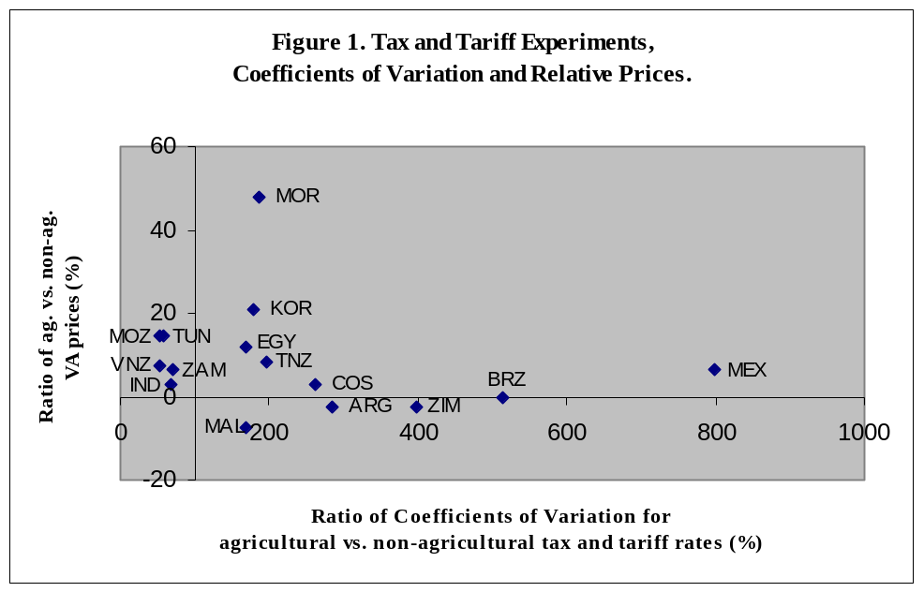

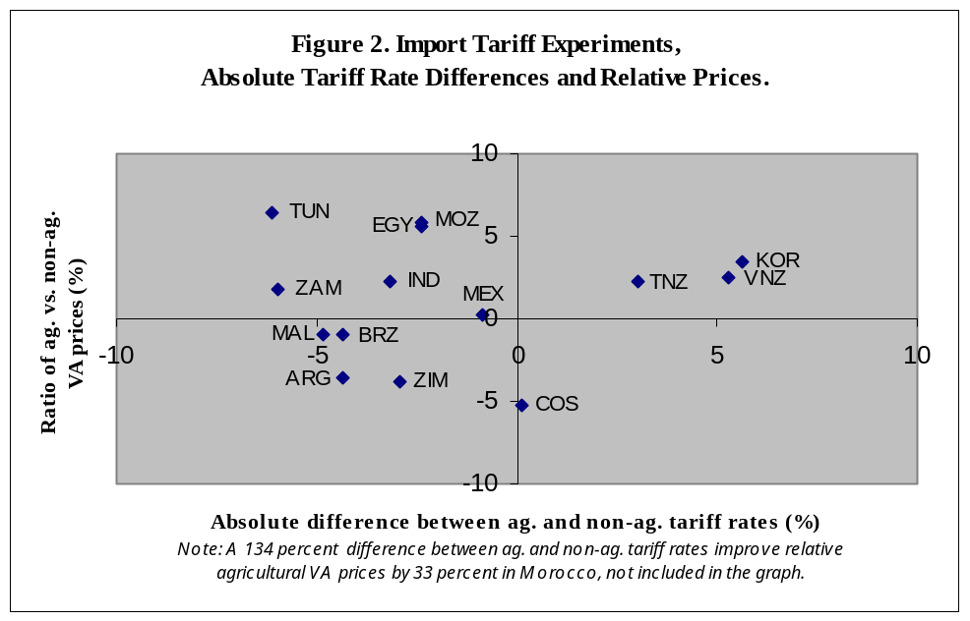

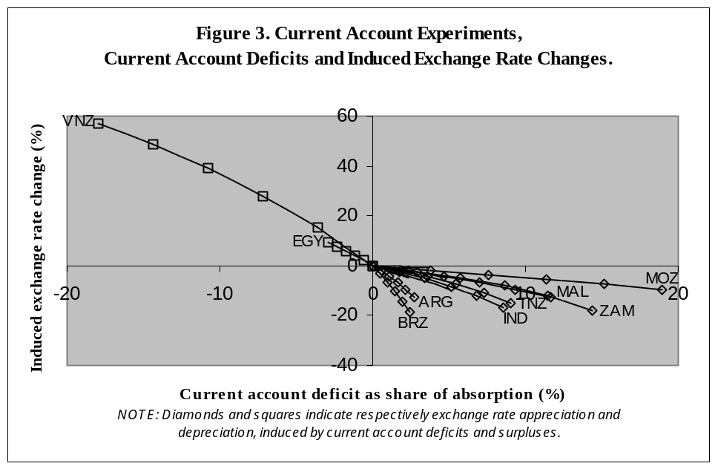

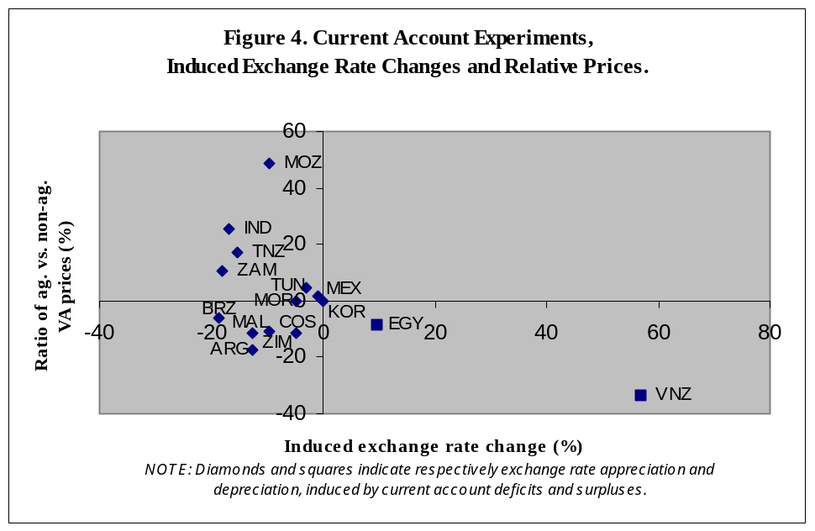

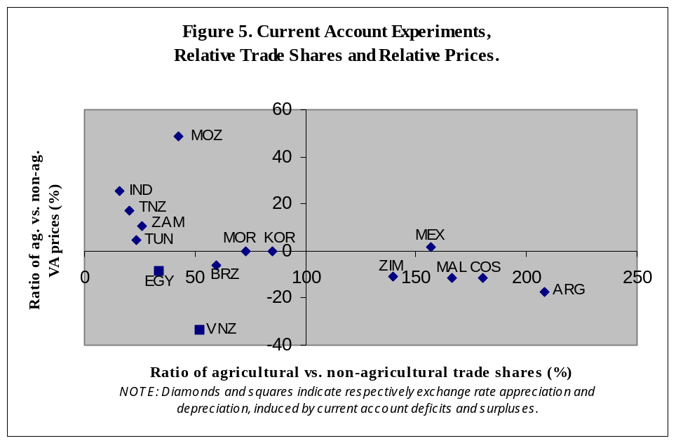

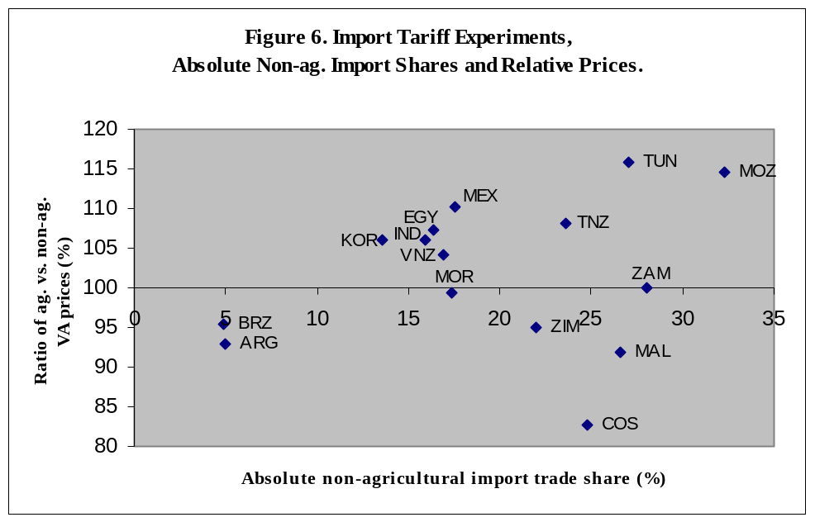

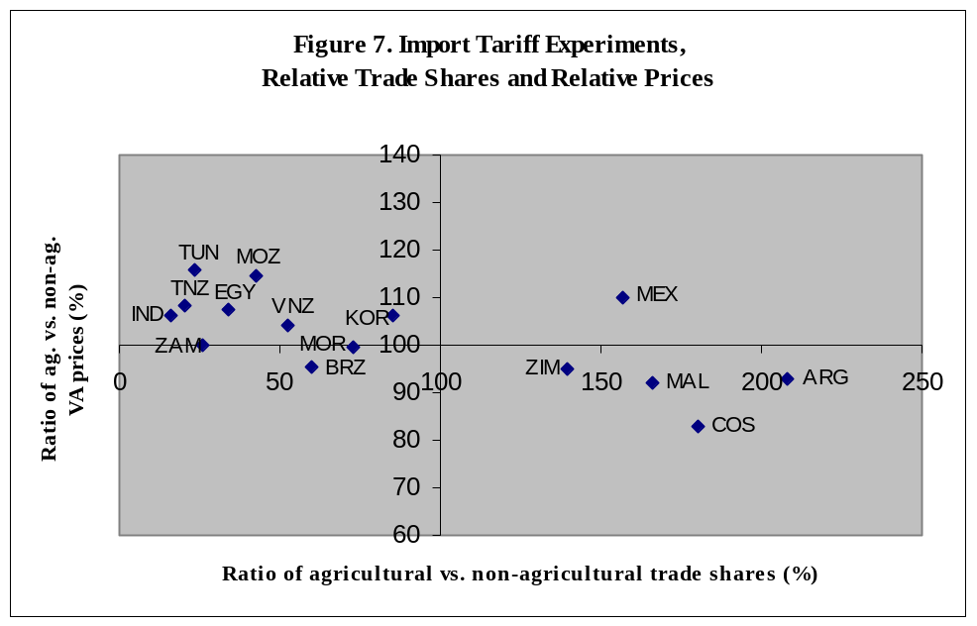

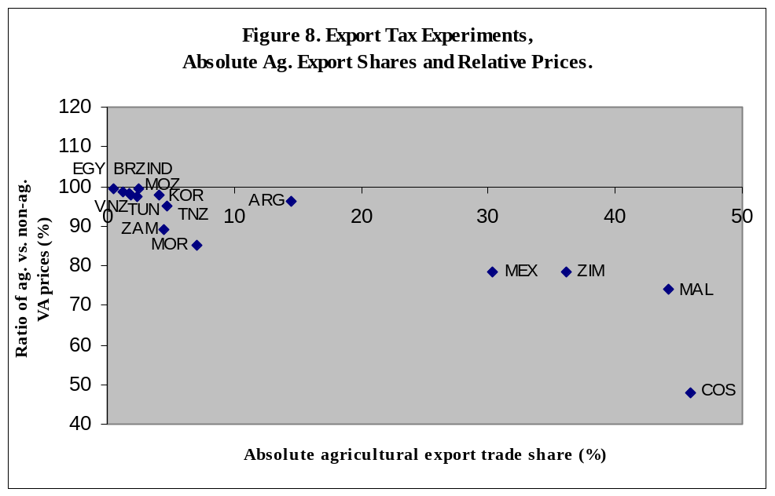

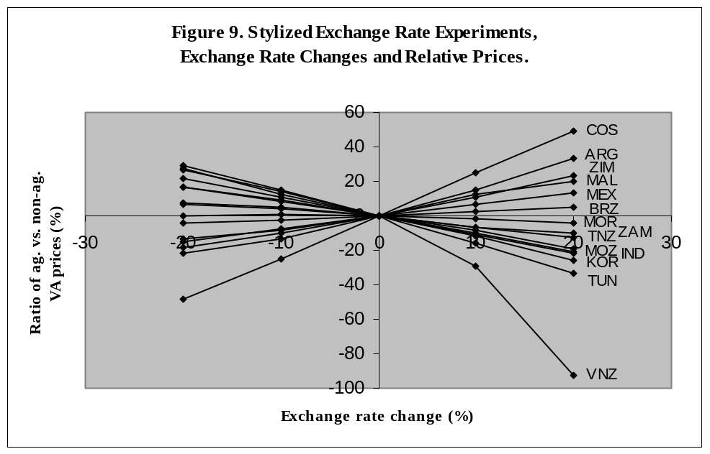

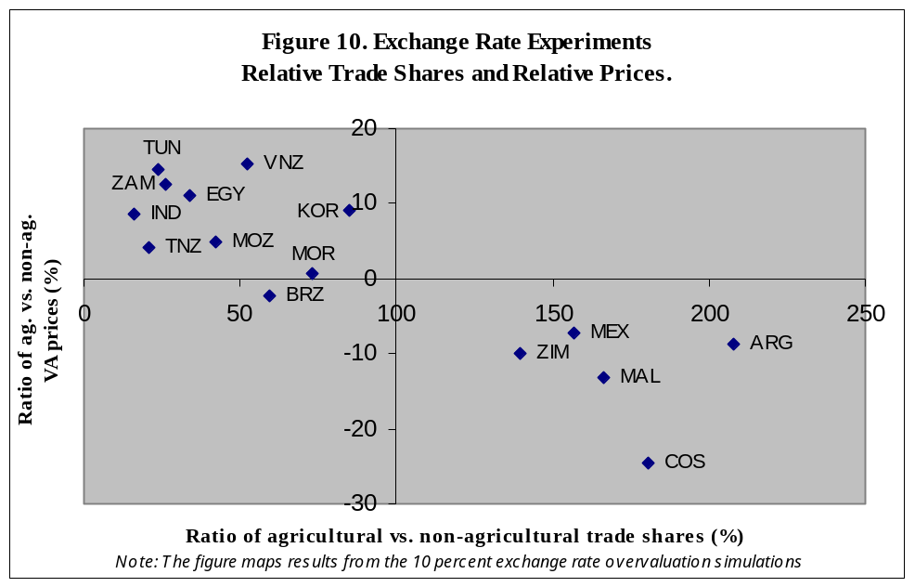

Krueger, Schiff and Valdés (1988), and Schiff and Valdés (1992) will henceforth be referred to as KSV and SV.
The implications of assuming imperfect “tradability” for the use of the ERP measure are explored in Devarajan and Sussangkarn, 1992, and de Melo and Robinson, 1981. Comparison with partial-equilibrium measures is provided in Bautista, Robinson, Wobst, and Tarp, 2001.
The fisheries sector was inconsistently defined among the various SAM data sets. It is defined as an agricultural sector in Indonesia, Malawi, Mexico, Tanzania, and Zambia, and as an industry sector in Mozambique. In the Argentina, Korea, Morocco, Tunisia and Venezuela models, the fisheries sector was defined as an agricultural sector even though it used both agricultural and non-agricultural production factors. Finally, fishery was not defined as a separate production sector in the Brazil, Costa Rica, and Egypt country models.
Large production and export shares of services, which in general do not incur marketing costs, lower average non-agricultural marketing costs and reinforce the agricultural bias implied by the structure of marketing costs. In contrast, moderate import shares for services lower average non-agricultural protection rates and the implied agricultural bias. The Zambian data set is unusual, in the sense that service sectors such as energy and construction incur marketing costs.
Only countries with a current account balance different from zero will be discussed in what follows.
The case of Indonesia is more complicated since it is a major producer and consumer of rice. In this period, Indonesia was largely self-sufficient in rice while government controlled international trade in rice tightly. For an analysis of the case of Indonesia, see Robinson, El Said, and San, 1998.
In the case of Venezuela, the assumption that the existence of a surplus indicates undervaluation ignores the Dutch-disease effect of oil exports on the real exchange over a long period, which has hurt tradable agriculture. Zambia has had a similar Dutch-disease problem, which may explain its low share of tradable agriculture (Löfgren, Robinson, and Thurlow, 2002.
Again note the case of Indonesia where rice is important, but with a small trade share. In Indonesia, appreciation would hurt domestic rice producers, but the government insulated them using direct import controls. See Robinson, El Said, and San, 1998. Our standard model simply treats rice as largely nontraded.
The marketing margin rates presented in Table 3 indicate that services do not incur marketing margins in Mozambique. It follows that average margin rates for marketed agricultural goods are significantly higher than for non-agricultural goods.
Assuming that changes in the world price of rice are only weakly passed through to domestic prices.

