Third Draft

Nutrition Knowledge Versus Schooling in the Demand for

Child Micronutrient Status

Abstract
This study extends the literature on the demand for child height to consider the demand for child micronutrient status. Micronutrient malnutrition is a pervasive and debilitating problem in many developing countries. A central focus concerns the distinct roles of maternal schooling versus maternal nutrition knowledge as determinants of micronutrient status. Applying both parametric and non-parametric techniques to Indonesian household data, the study finds that critical determinants include: child gender and age, the number of children in the household, household expenditure levels, access to water, and maternal nutrition knowledge. Maternal schooling contributes to child micronutrient status primarily through its effect on nutrition knowledge (for which schooling is not the primary source), and possibly through its effect on household expenditures.

JEL: I12, I31, I21, O15
Keywords: micronutrient status, health, education, human resources

Steven Block

Fletcher School

Tufts University

Medford, MA 02155

steven.block@tufts.edu

17 July 2002

Introduction

In the extensive literature on the demand for child health, “health” is almost exclusively defined as height-for-age. While height conditional on age is widely regarded as a valuable indicator of long-term nutritional status in children (Martorell and Habicht, 1986), it is far from a complete description of child health. Indeed, since the 1980s, the importance of micronutrient malnutrition has received increasing attention from nutritionists; yet, economists have rarely addressed analysis of micronutrient demand and the determinants of micronutrient status.
Micronutrients such as vitamin A, iron, iodine, and various minerals and trace elements are not produced by the body and are required in only small quantities. Yet, micronutrient deficiencies can cause learning disabilities, impair work capacity, and have been associated with heightened morbidity and mortality – particularly among pre-school children and pregnant women (World Bank, 1994). A World Bank publication illustrates the scope of micronutrient malnutrition with a stylized scenario: in a country of 50 million with South Asian levels of micronutrient deficiencies, annual losses due entirely to inadequate vitamin A, iron, and iodine would include 20,000 deaths, 11,000 children born cretins or blinded as preschoolers, 1.3 million person-years of work lost to lethargy or more severe disability, and 360,000 student-years wasted. Indeed, in that same publication, the World Bank asserts of the control of micronutrient deficiencies that, “Probably no other technology available today offers as large an opportunity to improve lives and accelerate development at such low cost in such a short time.” (World Bank, 1994, p. 1)
Iron deficiency anemia remains the world’s most widespread micronutrient deficiency-related disease, estimated by the WHO in 1991 to affect 2.15 billion people, nearly all of them in developing countries (WHO, 1992). In rural central Java (Indonesia), the focus of the present study, the prevalence of child anemia during 1999-2000 was 50 percent. In infants, iron deficiency has a permanent impact on mental development; iron deficiency at any age is associated with impaired cognitive performance, and has been shown to reduce resistance to infection and to adversely affect child development and growth (Bloem and Darnton-Hill, 2001). Severe anemia kills 30 percent of children who enter the hospital with it and do not receive an immediate blood transfusion (World Bank, 1995). Despite recent progress in combating other forms of “hidden hunger,” such as vitamin A and iodine deficiency, progress in reducing the prevalence of iron deficiency anemia has lagged (Darnton-Hill, 1999).
While the humanitarian dimensions of this problem, themselves, justify increased analysis, those health effects also have important economic implications. Childhood anemia is associated with a reduction of one-half of one standard deviation on cognitive tests, which in turn has been found to reduce adult wages by 4% (Ross and Horton, 1998; Horton, 2001). The combination of cognitive loss and reduced productivity of physical labor resulting from iron deficiency has been estimated to be on the order of 1% of GDP (and higher in the poorest countries). In South Asia, such a loss represents $5 billion annually (Horton, 2001).
The extent to which micronutrient malnutrition is automatically ameliorated by income growth is unclear. Several studies have asserted that expenditure elasticities for nutrients may be close to zero, despite significantly higher expenditure elasticities for food as a result of consumer preferences for higher quality calories as income rises (Behrman and Deolalikar, 1987; Behrman and Wolfe, 1984; Pitt and Rosenzweig, 1985; Bouis and Haddad,1992; Subramanian and Deaton, 1996). The implications of such substitution, particularly substitution towards red meat, are potentially positive with respect to iron deficiency anemia. Yet, substitution to meat typically occurs at relatively high levels of income, and may thus be too remote a solution for those at the lower end of the expenditure distribution. Non-parametric evidence (presented below) from rural central Java suggests a non-linear relationship between child blood hemoglobin concentration and per capita expenditure such that hemoglobin concentration increases with expenditure across the expenditure distribution, but at a greater rate in the top decile than in the bottom decile of the distribution.
The “hidden” quality of micronutrient content in food suggests that improved intake of micronutrient-rich foods may depend importantly on consumers’ nutrition knowledge and/or education level, in addition to their income level. Maternal education, in particular, has played a central role in empirical studies of the demand for child health (read, height). Behrman and Wolfe (1984, 1987), Barrera (1990), Alderman and Garcia (1994), Lavy, et.al. (1996), and others consistently find a strong positive association between maternal education and child. Far fewer studies (Glewwe, 1999; Thomas, Strauss, and Henriques, 1990; Desai and Alva, 1998; and Christiaensen and Alderman, 2001) have extended the analysis to consider the mechanisms through which maternal education contributes to child height.
Thomas, Strauss, and Henriques (1990), find in a Brazilian sample that nearly all the impact of maternal schooling on child height could be explained by access to media, and that schooling and community health services are substitutes. Glewwe (1999) addresses this question with Moroccan data, considering three possible mechanisms: 1) the direct teaching of nutrition knowledge in school, 2) the facilitation of gaining nutrition knowledge that comes from the literacy and numeracy learned in school, and 3) exposure to modern society through school. He finds that maternal health knowledge stands alone among these possible mechanisms in contributing to child height (his proxy for health), and that such knowledge is gained largely outside the classroom. Such findings have direct and important policy implications. As formal schooling is often limited among the poor, the potential benefits of specific nutrition training may be substantial. The findings of the present study reinforce the centrality of maternal nutrition knowledge (as distinct from schooling) in improving children’s micronutrient status. By extending that lesson to micronutrient status, this study adds a new and critical dimension. Indeed, no studies of the demand for child health have examined the determinants of demand for child micronutrient status, nor have any previous studies explored the role of nutrition knowledge per se in the demand for child micronutrient status. This paper begins to fill that gap by presenting evidence on the determinants of demand for child micronutrient status, emphasizing the functional distinctions between formal schooling and specific nutrition knowledge.
Drawing on recently collected household data from rural central Java, the present study employs both parametric and non-parametric techniques to identify individual, household, and community determinants of the demand for child micronutrient status as proxied by hemoglobin concentration (CHb). A central finding is that to the extent that maternal education contributes to child micronutrient status, its effects are largely meditated through maternal nutrition knowledge. Maternal years of schooling have little if any direct effect on child micronutrient status (though may contribute indirectly through an impact on earnings), and nutrition knowledge derives from several sources among which schooling is not the most important.
The study is organized as follows. Section I presents non-parametric evidence of the effects of nutrition knowledge, maternal education, and per capita expenditures on CHb. Section II supports this analysis with a model of the conditional demand for micronutrient status, addressing the specific question of the sources of nutrition knowledge. Section III describes the household survey data and knowledge proxy. Section IV presents parametric results, and Section V concludes.
I. Maternal Nutrition Knowledge vs. Schooling: Non-Parametric Evidence
Figure 1 provides a first look at the relationship between child micronutrient status (CHb) and per capita expenditure (per adult equivalent). This non-parametric relationship suggests that CHb is approximately a quadratic function of the logarithm of real per capita expenditure with both first and second derivatives positive. As indicated above, in this two-dimensional relationship CHb is a positive function of expenditures, but at a higher rate of increase at the top decile of the expenditure distribution than in the bottom decile. Note that the cutoff for iron deficiency anemia in children under 5 (and in pregnant women) is 11 g/dL (Yip, 2001). Figure 1 thus suggests a relationship in which children below the median expenditure level in the sample are at greater risk of being anemic.
Figure 2 provides a first cut at observing the effect of maternal nutrition knowledge (defined below) on child micronutrient status. Figure 2 splits the sample between children of mothers with and without nutrition knowledge. The results suggest that at every level of per capita expenditure, mothers with nutrition knowledge demand greater micronutrient status in their children than do mothers without nutrition knowledge. At the sample median, the margin is approximately 0.4 g/dL – an increase sufficient to raise nearly 25% of anemic children in the sample to the 11.0 g/dL cutoff for anemia. The difference between outcomes for those with and without nutrition knowledge is not a function of expenditure levels, and the confidence intervals do not over lap for the middle eight deciles of the expenditure distribution. Yet, Figure 2 fails to identify of the effects of nutrition knowledge, as it provides no information on the potentially confounding effect of maternal schooling on the demand for child micronutrient status.
Figure 3 demonstrates these confounding effects by splitting the sample between children of mothers with and without a complete secondary education. While Figure 3 indicates that mothers with secondary education also demand greater micronutrient status in their children than do mothers with lesser schooling, the margin in this case is quite small and the confidence intervals overlap over nearly the entire relevant range of the expenditure distribution. Thus, the suggestive evidence points to maternal nutrition knowledge as a more powerful determinant of the demand for child micronutrient status than maternal schooling. More complete identification, however, comes only with the imposition of further sample restrictions.
Figure 4 re-creates the relationships presented in Figure 2, but now with the sample restricted to children of mothers with complete secondary educations. Conditional on both maternal schooling and per capita expenditure, the point estimates still indicate that in the top 90% of the expenditure distribution, mothers with nutrition knowledge demand greater micronutrient status in their children. Yet, compared with the case that does not condition on maternal education, the margin attributable to nutrition knowledge is now smaller. The statistical distinction between the paths is also less clear, as the non-nutrition knowledge path lies within the lower confidence interval of the nutrition knowledge path (though the nutrition knowledge path lies above the upper confidence interval for the non-nutrition knowledge path for nearly all but the top and bottom deciles of the expenditure distribution). The relationships depicted in Figure 4, however, are much more strongly suggestive than those that emerge from applying an analogous sample restriction to the relationships in Figure 3.
Figure 5 re-creates the analysis in Figure 3, comparing the CHb-expenditure paths for children of mothers with and without secondary education, but now with the sample restricted to mothers with nutrition knowledge. Conditional now on both maternal nutrition knowledge and per capita expenditure, the effect of maternal education on the demand for child micronutrient status disappears. The two paths lie entirely within each other’s confidence intervals; indeed, the point estimates for the non-secondary education group lie exclusively above those for the secondary education group.
Using sample restrictions, Figures 4 and 5 together provide the identification lacking in Figures 2 and 3. The result is strongly suggestive evidence that maternal nutrition knowledge plays a more important role in the demand for child micronutrient status than does maternal schooling. These results are sharpened and reinforced by the parametric analysis presented in Section IV. Yet, before turning to the theoretical model underlying the parametric analysis, two additional sets of non-parametric relationships further illustrate the distinction between maternal nutrition knowledge and schooling.
Figure 6 directly compares the effect of nutrition knowledge on CHb for children of mothers with and without secondary education. For both groups of children, micronutrient status is a positive function of maternal nutrition knowledge. Yet, conditional on nutrition knowledge, the marginal contribution of maternal education is essentially zero. The two paths are nearly coincident and lie entirely within each other’s confidence intervals. In contrast, Figure 7 compares the effect of maternal years of schooling on CHb for children of mothers with and without nutrition knowledge. These results contrast sharply with those of Figure 6. Conditional on maternal years of schooling, nutrition knowledge makes a substantial contribution to the demand for child micronutrient status. The point estimates suggest that the marginal contribution of nutrition knowledge is a slowly declining function of years of schooling. While a truly negative slope for CHb as a function of maternal schooling would be puzzling, note that a flat relationship for the nutrition knowledge group lies well within its confidence intervals, suggesting the possibility that micronutrient status in the nutrition knowledge group may not be a function of maternal schooling. Yet, even a flat function would lie statistically above the non-nutrition knowledge group until approximately the 85th percentile of schooling attainment. Figure 7 thus suggests that nutrition knowledge can substitute favorably for formal schooling in determining the demand for child micronutrient status, particularly at the lowest levels of schooling attainment. Splitting the sample at median per capita expenditures does not change the relations presented in Figure 7.
While these non-parametric results point strongly to the importance of maternal nutrition knowledge relative to schooling, these two explanatory variables are undoubtedly related to one another. Sorting out this relationship is part of the task of the model described in the following section.
II. Conceptual Model of the Demand for Child Micronutrient Status
The conceptual model employed in this study is based on the standard model of household decision making widely used in the literature on demand for child health, and given its most detailed exposition by Behrman and Deolalikar (1988). In this model, the demand for child micronutrient status will be a function of household characteristics (including maternal human capital) X_{h}, child characteristics (including gender, and age) X_{i}, community characteristics (including water and sanitation infrastructure, and food prices) X_{c}, and total family income y.
Assume the household maximizes its utility over health status H, leisure L, and consumption of goods G, given household and community characteristics:
(1)

where ψ represents unobserved heterogeneity of preferences. The household maximizes this utility function subject to two constraints: a budget constraint and a biological health production function for micronutrient status. This production function takes the form:

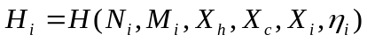(2)

where N_{i} are nutrients consumed by member i, M_{i} are non-food health inputs (such as medical care), and η_{i} are unobserved individual health endowments. CHb is taken here to represent H_{i}.
This maximization problem leads to a reduced-form demand function for child micronutrient status:
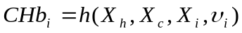(3)
where υ_{i} represents unobserved heterogeneity in iron stores and health status.
The distinction between maternal nutrition knowledge and years of schooling requires further explanation of X_{h}. Household characteristics in this model include: resources, number of children under six years old, maternal schooling, and maternal nutrition knowledge. Yet, the specific form through which the latter two terms enter the demand function for child micronutrient status depends on several considerations, including assumptions about endogeneity and associated issues of the relationship between education and nutrition knowledge.
This study shares the assumption made by Glewwe (1999), Thomas, Strauss, and Henriques (1990), among others, that maternal education is exogenous. This assumption is empirically plausible in the setting of rural central Java, where nearly 55% of mothers have precisely 6 years schooling. Nonetheless, it is possible that estimated effects of maternal education in the demand function could reflect its contribution to child micronutrient status through either education’s effect on per capita expenditures or through its effect on nutrition knowledge. Maternal nutrition knowledge, in contrast, is presumed to be endogenous and a Davidson and MacKinnon test of endogeneity confirms this presumption. The search for valid instruments for nutrition knowledge begins with the question of where nutrition knowledge comes from.
Fortunately, in the present case of rural central Java, we need not guess at the answer to that question. The mothers surveyed were asked specifically where they had heard of vitamin A-rich foods. Approximately 4% of mothers had acquired their information through TV or radio; 11.5% said friends and neighbors; 23.5% had heard about vitamin A-rich foods in school; and, 43.5% had gained such knowledge from health workers. Yet, despite the predominance of health workers in imparting this dimension of nutrition knowledge to mothers, it is unlikely that the decision to visit a health center is endogenous to the demand for child micronutrient status: less than 12% of mothers surveyed responded that the function of a health center was to convey nutrition and health information (as compared with nearly 75% who believed the purpose of health centers was to weigh their children, and 6.3% who did not know its purpose).
The respondents’ direct indication of their sources of nutrition knowledge provides a basis for specifying a reduced form equation for nutrition knowledge (NK) for mother i in community j:

(4)

where SNK_{j} is a vector of sources of nutrition knowledge (measured by the village proportion of mothers whose source of nutrition knowledge was the health worker and the village proportion whose source of nutrition knowledge was school), CNK_{j} is community nutrition knowledge (defined as the non-self village proportion of mothers who had heard of vitamin A-rich foods), CS_{j} is non-self village mean schooling, CHA_{j} is community access to health care (mean distance in minutes to health center), X_{ij} is a vector of other observed maternal characteristics (age, height), and ζ_{ij} are unobserved maternal characteristics. The community averages in these instruments are calculated (as in Christiaensen and Alderman, 2001) as non-self village means (the mean for each village calculated for each household excluding itself), in order to minimize correlation between these instruments and unobserved household heterogeneity. The rationale for including non-self community mean levels of maternal awareness of vitamin A-rich foods and years of schooling draws on Alderman, Hentschel, and Sabates (2002), who demonstrate the explanatory power of knowledge externalities in explaining child height in Peru. If mothers share nutrition knowledge (and nearly 12% of respondents cited friends and neighbors as their source of nutrition knowledge), then the non-self mean level of community knowledge will be correlated with own-maternal knowledge but will not directly explain own-child nutrition. These variables prove, based on tests of overidentifying restrictions, to be valid instruments for addressing the endogeneity of maternal nutrition knowledge in estimating equation (3).
Yet, OLS estimation of equation (3) is also made problematic by the likely endogeneity of household income. One possible source of endogeneity in this case is that child health outcomes are likely related to maternal labor force participation, resulting in the joint determination of total household income and child health status. It is also commonly accepted that the underlying relationship of interest is between permanent income and child health. Yet, permanent income is rarely measurable. The general solution is to use household expenditures, which are a better reflection of permanent income than is current income if households have any opportunity to smooth consumption through capital markets. It is still necessary, however, to instrument for expenditures, which I do with assets and non-wage income, including: the previous year’s remittance income, number of cows owned, number of children sleeping in a single room, and size of house per adult equivalent. These variables also prove to be valid instruments.
Recognition that some household characteristics are endogenous (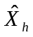) and others exogenous (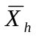) permits revision of equation (3) along lines suggested by Thomas, Strauss, and Henriques (1990) to reflect this distinction:

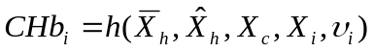(3΄)

Equation (3΄), strictly speaking a conditional demand function (Pollack, 1969), is thus the basic estimating equation used below. The following section describes the survey data with which I test this model, as well as the representation of nutrition knowledge.
- Data and Nutrition Knowledge Proxy
The data employed in this study are from a new, highly detailed, and relatively unexplored household survey implemented by Helen Keller International. This NGO commenced nutrition surveillance activities in Central Java in December 1995 as part of a monitoring and evaluation system for a social marketing campaign focused on Vitamin A. Five rounds of data collection were completed through January 1997. NSS data collection was not reinitiated in Central Java until June 1998, since when data have been collected on a regular basis (approximately every three months). The present analysis uses the 7 rounds of survey data collected between December 1998 and January 2001 (as prior surveys excluded information on household expenditures).
For each new round, a random sample of 7200 households was selected using a multi-stage cluster sampling design. A total of 30 villages were selected from each of Central Java’s six agroecological zones by probability proportional to size sampling techniques. Each village provided a list of households containing at least one child less than 36 months of age (the age eligibility criterion was expanded to 59 months in round 7 (August 1998)). From this list, 40 households were selected by fixed interval systematic sampling using a random start. The total sample size for the 7 rounds of data used in the present study is 53,600. Blood samples were collected from a random sub-sample (approximately 18 percent) of children and mothers by fingerprick to measure hemoglobin concentration. Enumerators also recorded detailed information on household expenditures, sources of income, assets, micronutrient consumption, morbidity, and demographic details. The commodity price data included in the analysis are also reported directly by survey respondents. The prices are thus not deduced unit values, and are free of the quality issues associated with such data. Reported commodity prices are converted into village averages and deflated using rural price deflators for rural Central Java. Table 1 provides descriptive statistics for variables included in the analysis.
As the initial motivation for the survey was to monitor and evaluate a social marketing campaign for vitamin A, the survey instrument includes extensive detail on mothers’ knowledge of vitamin A, its sources and benefits for child health, and the sources of that maternal knowledge. I construct the proxy measure of nutrition knowledge for the present study based on mothers’ knowledge of the child health benefits of consuming vitamin A-rich foods. In particular, mothers were asked to list those benefits of which they were aware. There were nine predetermined correct answers. The survey data include for each respondent whether or not she mentioned each of the nine correct answers. To construct the nutrition knowledge proxy, I count for each respondent the proportion of correct answers given from among the nine possibilities. Thirty percent of the sample correctly identified none of the nine possible benefits of vitamin A, approximately 55% correctly identified one benefit, less than 12% of the sample correctly identified two benefits of vitamin A, 2.3% correctly identified three benefits, and approximately 1.5% correctly identified more than three potential benefits of vitamin A. The fact that this proxy is built around knowledge of vitamin A (as a determinant of biologically unrelated CHb) rather than specific knowledge of iron-rich foods underscores its generality as a proxy for nutrition knowledge.
In the non-parametric analysis presented in Section I, sample splits based on nutrition knowledge divide the sample between mothers who correctly identified more than one benefit of vitamin a-rich foods (16% of the sample) and those who correctly identified one or zero benefits. In Figure 6 and in the parametric estimates presented below, I use the more continuous (e.g., 9-level) version of this nutrition knowledge proxy.
IV. Parametric Results
The parametric results in this section reinforce and sharpen the non-parametric evidence provided in Section I. Table 2 presents both OLS and 2SLS estimates of equation (3΄). Columns 1-3 begin by excluding X_{c}. The dependent variable is CHb. With regard to child-specific characteristics, prior research (Block, et. al., 2002) shows CHb to be a cubic function of child age, and the results in Table 2 consistently support that specification. The point estimates further suggest that CHb is lower for boys than for girls.
The central focus is household characteristics. The number of children under six years of age, while treated as exogenous, appears to yield a quite precise and robust result: each additional child under six reduces CHb by approximately 0.14 g/dL in the other children. A decrease of that magnitude is both plausible and non-trivial (being equal to approximately one-seventh of the sample standard deviation for CHb, and noting the large concentration of children in the sample around the cutoff for iron deficiency anemia). This result is indicative of household resources being stretched more thinly as family size increases.
The point estimates in models 1-3 for log real expenditures per adult equivalent are positive, but are statistically significant only at the .10-level and only in specification 2. It is likely, as noted above, that an OLS estimate for expenditures may suffer from simultaneity bias. The estimate for expenditures is greatly improved (below) by the use of instrumental variables. The primary issue addressed by models 1 – 3 is the distinction between maternal schooling and maternal nutrition knowledge.
Models 1 – 3 proceed by first introducing maternal schooling without nutrition knowledge. This is the typical treatment in studies of the demand for child health. Indeed, the result in column 1 is consistent with that literature in finding a positive and significant contribution of maternal schooling to the demand for child health, though these results extend that finding to micronutrient status instead of the ubiquitous indicator of height-for-age. Conversely, column 2 shows (with no consequence for the other coefficients) that when maternal nutrition knowledge replaces schooling, it too is positive and statistically significant.
The conceptual model presented above, which in equation (4) specifies nutrition knowledge as a function of schooling and other variables, suggests that when those two explanatory variables enter together the point estimate for nutrition knowledge should be reduced to the extent that its impact on CHb reflects the effect of schooling. The model further suggests that if schooling has any additional impact on child micronutrient status, it will be reflected in its coefficient estimate conditional on nutrition knowledge. The result in column 3, in which schooling and nutrition knowledge enter together, confirms both the conceptual model an the implication of the non-parametric results of Section I: the point estimate for nutrition knowledge falls just slightly, from 1.105 to 0.872 (albeit less than a one standard error decline), while the schooling coefficient falls substantially and remains significant with a lower degree of certainty than previously. It is thus reasonable to interpret the impact of maternal schooling on the demand for child micronutrient status as operating to a substantial degree through its effect on maternal nutrition knowledge (consistent with Glewwe’s (1999) finding for the demand for child height); yet, as the mothers themselves described, nutrition knowledge has multiple other sources among which schooling is not the leading one.
Column 4 extends the specifications of columns 1 through 3 to include community characteristics, X_{c}. Among the health infrastructure variables, the non-self village proportions of households with tap water, and households with enclosed waste disposal systems have no statistically discernable effect on CHb outcomes (though the sign of the point estimate for the presence of tap water is as expected). However, the non-self village mean distance from the household to the water source is negatively associated with child micronutrient status (at the .05-level of significance). Noting that diarrhea can be a function of water quality and availability, as well as a cause of anemia, these results are plausible.
Including log village mean prices for several micronutrient-rich foods (eggs, chicken, beef, fish) and for rice (the primary staple, accounting for approximately 20% of total household expenditures) adds relatively little to the model’s explanatory power. The price of chicken alone is statistically significant and it is positively associated with child micronutrient status. This apparently anomalous result, however, is intuitively explained by considering the likelihood that chicken and beef are substitutes and that, per unit of weight, beef contains approximately three times the heme iron content of chicken (food composition tables, Wardlaw and Kessel, 2002). In addition, the point estimates for both eggs and beef prices are consistently negative (as expected), if imprecisely estimated.
Including community characteristics in the OLS estimates of columns 4 strengthens the findings of columns 1 – 3 with respect to the relationship between nutrition knowledge and schooling. In the presence of community characteristics, maternal schooling remains only marginally significant while the estimate for nutrition knowledge remains unchanged and retains its statistical significance at the .01-level. Maternal nutrition knowledge has a clear and positive effect on child micronutrient outcomes. This finding is robust to the use of instrumental variables for both nutrition knowledge and for expenditures, while the following results demonstrate the fragility of the OLS results for maternal schooling.
Columns 5 – 8 employ 2SLS to address the potential endogeneity of both per capita expenditures and nutrition knowledge. In column 5, expenditures alone are treated as endogenous, and instrumented as described above. Thus estimated, real expenditures become statistically significant at the .05-level, and of a magnitude that is consistent with other studies. A test of overidentifying restrictions fails to reject the null hypothesis that the instruments used are valid. Instrumenting for expenditures in column 5 has no impact on the other coefficient estimates relative to the OLS results. In particular, maternal nutrition knowledge retains its prior magnitude and significance while maternal schooling essentially exits the model.
While, as noted above, only 12% of mothers surveyed indicated a belief that the purpose of the health center was to disseminate nutrition knowledge, there remains that small portion of the sample for which a visit to the health center may be endogenous to micronutrient status. Re-estimating the model in column 5 excluding the children of those mothers does not change the finding that nutrition knowledge is statistically significantly associated with child micronutrient status while maternal schooling is not (though the point estimate for nutrition knowledge falls to 0.6 in that case).
Column 6 differs from column 5 in treating nutrition knowledge, rather than expenditures, as endogenous in the fully specified model. In this treatment, the point estimate for nutrition knowledge increases by a factor of five and remains statistically significant at the .10-level, while maternal schooling continues to fall out of the model. This re-specification of the model has no effect on the other coefficient estimates.
The specifications in columns 7 and 8 demonstrate the importance of considering explicitly the distinct impact of nutrition knowledge on child micronutrient status. Column 7 instruments for expenditures and excludes nutrition knowledge while including schooling. In this more traditional specification schooling appears to have a positive and statistically significant effect on micronutrient status. Yet, when nutrition knowledge is included (in column 8) and treated along with expenditures as being endogenous, schooling once again vanishes from the model while nutrition knowledge retains significance (at the .10-level). The parametric results presented in Table 2 are thus fully consistent with the non-parametric evidence presented in Section I in demonstrating the primacy of nutrition knowledge in driving the demand for child micronutrient status.
V. Conclusions
This paper extends the literature on the demand for child health in two dimensions. In contrast to all previous studies, which define health exclusively in terms of height-for-age, the present study considers determinants of the demand for child micronutrient status. The debilitating, potentially fatal, and pervasive consequences of micronutrient malnutrition – or “hidden hunger” – are an increasing priority for public health officials in developing countries. Analytical support for that effort can provide an added basis for designing effective interventions. This study’s secondary contribution thus lies in the finding that specific nutrition knowledge plays a central role in determining child micronutrient status. This is intuitively plausible, given the invisibility of foods’ micronutrient content. Yet, the associated findings that maternal schooling contributes to child micronutrient status essentially through its effect on nutrition knowledge (and potentially through its effect on total family income), and that schooling is not the most important source of nutrition knowledge, have important policy implications.
Specific nutrition education for girls and women should yield high returns in terms of enhanced child micronutrient status. Indeed, the only other determinants of child micronutrient status found to be statistically significant are child gender and age, the number of children under 6 in households, the price of chicken (presumably through its substitution with beef), access to water source, and per capita expenditures of the household. From this set, maternal nutrition education clearly emerges as the most sensible and policy accessible target of opportunity. Future research on the relative cost effectiveness of potential micronutrient interventions should concentrate attention on maternal nutrition education, an intervention category for which relatively little analysis is available (Horton, 2001).
Maternal nutrition education may also have a substantial macroeconomic payoff, given the cognitive and labor productivity losses estimated specifically for iron deficiency. The results presented above provide the basis for crude approximations. Using an accounting approach developed by Ross and Horton (1998), the baseline 50% prevalence of child anemia in rural Central Java (if it is broadly representative of Indonesia) costs $32.52 per capita loss of GDP (in 1999 PPP dollars), or approximately $6.73 billion (1.33% of GDP). Increasing real per adult equivalent household expenditures by one standard deviation would (based on the coefficients estimated in Table 2 column 8) reduce the per capita loss to anemia by $1.95, a savings of nearly $404 million. However, a one standard deviation increase in the proportion of mothers defined in this study as having nutrition knowledge would save $5.85 per capita, or $1.2 billion in lost national income (nearly a quarter of one percent of total GDP in 1999 PPP dollars). More concretely, increasing the proportion of mothers with nutrition knowledge from its baseline of 15% to 50% would save Indonesia approximately $7.80 per capita, or $1.6 billion annually. The prospects for a one standard deviation increase in maternal nutrition knowledge may be low in the short run, but it is surely a more attainable goal than a similar increase in per capita income, and one with three times the benefit in saved GDP. This points strongly towards the importance of public efforts to promote specific nutrition knowledge of mothers.
These figures represent only crude orders of magnitude. Yet, benefits on this order of magnitude are likely to compare favorably with many alternative uses of public investment funds, to say nothing of the resulting improvements in the quality of life and income earning prospects of the poor.

References
Alderman, H and M. Garcia, 1994. “Food Security and Health Security: Explaining the Levels of Nutrition Status in Pakistan,” Economic Development and Cultural Change, 42-3:485-507.
Alderman H., J. Hentschel and R. Sabates, 2002. “With the Help of One’s Neighbors: Externalities in the Production of Nutrition in Peru,” mimeo, The World Bank: Washington, D.C.
Barrera, A. 1990. “The Role of Maternal Schooling and its Interaction with Public Health Programs in Child Health Production,” Journal of Development Economics 32:69-91.
Behrman, J. and A. Deolalikar, 1988. “Health and Nutrition,” in Chenery and Srinivasan, eds., Handbook of Development Economics, Vol. 1. Amsterdam:North-Holland Press.
Behrman, J. and B. Wolfe, 1984. “More Evidence on Nutrition Demand: Income Seems Overrated and Women’s Schooling Underemphasized,” Journal of Development Economics 14(1-2): 105-128.
Behrman, J. and B. Wolfe, 1987. “How Does Mother’s Schooling Affect the Family’s Health, Nutrition, Medical Care Usage, and Household Sanitation?’ Journal of Development Economics 27(1-2): 395-420.
Block, S., et. al., 2002. “Did Indonesia's Crises of 1997/98 Affect Child Nutrition? A Cohort Decomposition Analysis of National Nutrition Surveillance Data,” Working Paper No. 90, Center for International Development, Harvard University: Cambridge, MA.
Bloem, M. and I. Darnton-Hill, 2001. “Micronutrient Deficiencies. First Link in a Chain of Nutritional and Health Events in Economic Crises,” in Bendich and Deckelbaum, eds. Primary and Secondary Preventive Nutrition. Humana Press: Totowa, NJ.
Bouis, H. and Novenario-Reese, “The Demand for Micronutrients in Bangladesh,” mimeo, International Food Policy Research Institute: Washington, D.C., 1997.
Christiaensen, L. and H. Alderman, 2001. “Child Malnutrition in Ethiopia: Can Maternal Knowledge Augment the Role of Income?” mimeo, World Bank, Washington, D.C.
Darnton-Hill, I., 1999. “The challenge to eliminate micronutrient malnutrition,” Aust NZ, J Public Health. 23(3):309-14.
de Pee, S., Bloem MW, Satoto, Yip R, Sukaton A, Tjiong R, Shrimpton R, Muhilal, Kodyat B. 1998. “Impact of social marketing campaign promoting dark-green leafy vegetables and eggs in Central Java, Indonesia,” Int J Vit Nutr Res 68: 389-398.

Desai, S. and S. Alva, 1998. “Maternal Education and Child Health: Is There a Strong Causal Relationship?”, Demography, 35-1:71-81.
Glewwe, P., 1999. “Why Does Mother’s Schooling Raise Child Health in Developing Countries: Evidence from Morocco, Journal of Human Resources. 34-1: 124-159.
Gollin, D. “Getting Income Shares Right,” Journal of Political Economy. Volume 110, Number 2:
Horton, S. 2001 “The Economics of Nutrition Intervention,” in R. Semba and M. Bloem, eds., Nutrition and Health in Developing Countries. Humana Publications: Totowa, NJ.
Lavy, V., J. Strauss, and P. de Vreyer, 1996. “Quality of Health Care, Survival, and Health Outcomes in Ghana,” Journal of Health Economics, 15:333-357.
Martorell, R. and J. Habicht, 1986. “Growth in Early Childhood in Developing Countries,” in F. Falkner and J. Tanner, eds., Human Growth: A Comprehensive Treatise, Vol. 3. Plenum Press: New York.
Pollack, R. 1969, “Conditional Demand Functions and Consumption Theory,” Quarterly Journal of Economics 83:70-78.
Ross, J and S. Horton, 1998. “The Economic Consequences of Iron Deficiency,” The micronutrient Initiative: Ottawa, CA.
Thomas, D., J. Strauss, and M-H. Henriques, 1990. “How Does Mother’s Education Affect Child Height?” Journal of Human Resources. 26-2:183-211.
Wardlaw, G. and M. Kessel, 2002. Perspectives in Nutrition. McGraw-Hill: New York.
WHO, 1992. “National Strategies for Overcoming Micronutrient Malnutrition.” Draft Resolution proposed by Rapporteurs of the Executive Bd., 89th Session. Geneva.
World Bank, 1994. Enriching Lives. Overcoming Vitamin and Mineral Malnutrition in Developing Countries. World Bank: Washington, D.C.
Yip, Ray, 2001. “Iron Deficiency Anemia,” in R. Semba and M. Bloem, eds., Nutrition and Health in Developing Countries. Humana Publications: Totowa, NJ.

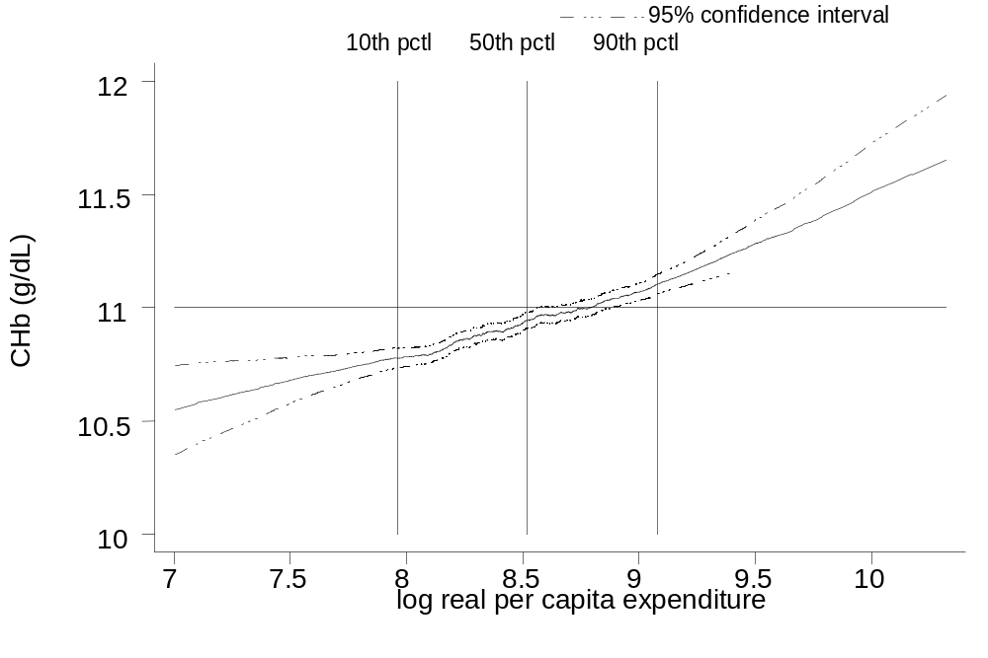
Figure 1
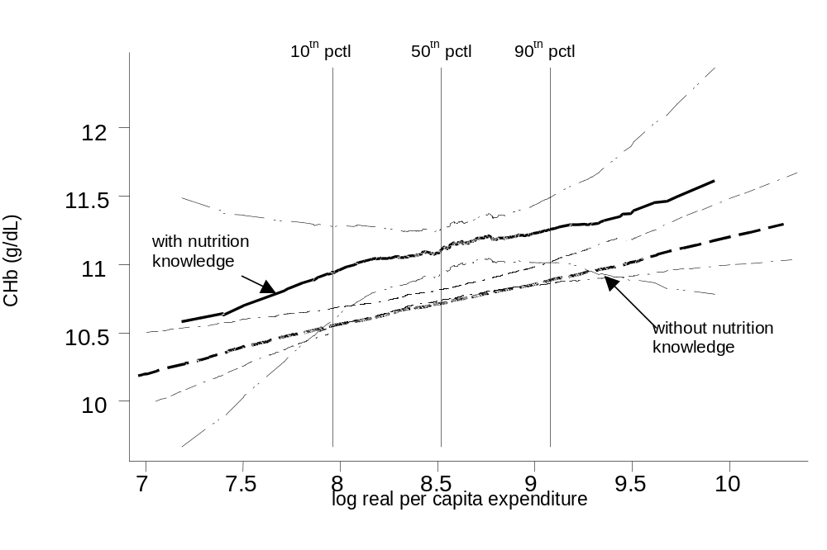
Figure 2

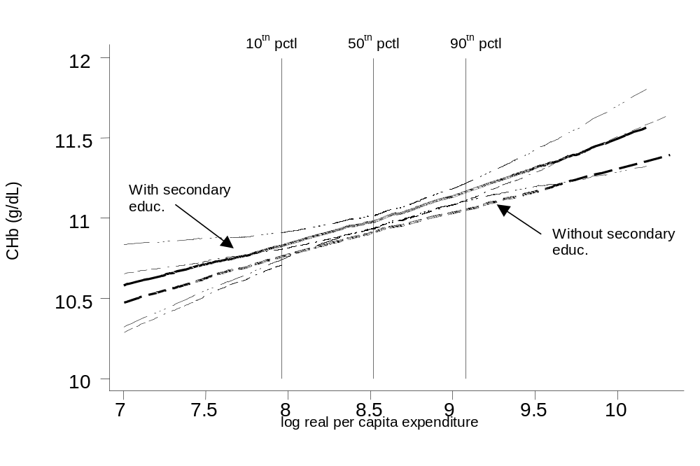
Figure 3

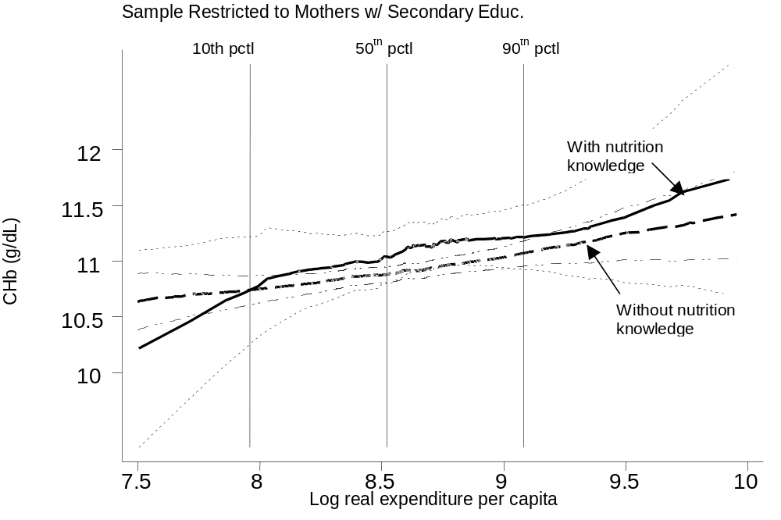
Figure 4

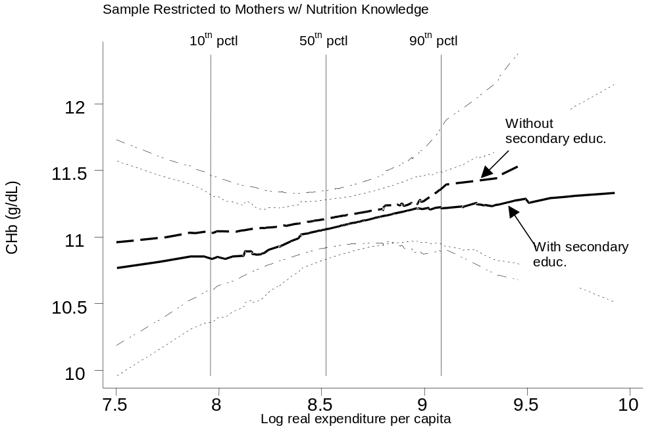
Figure 5

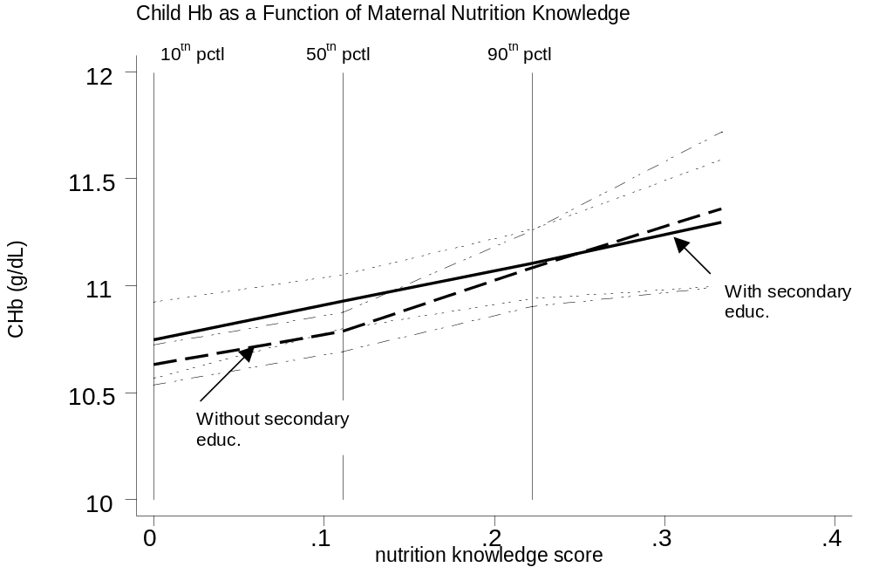
Figure 6
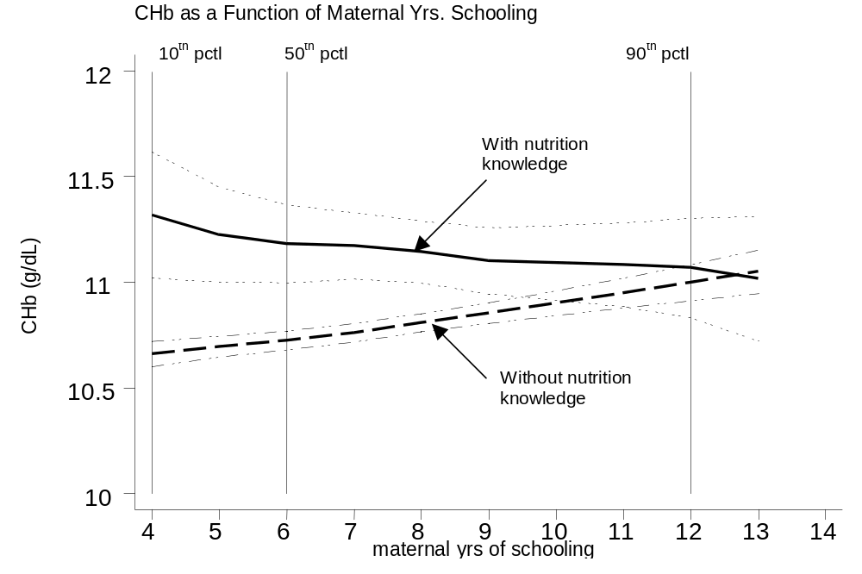
Figure 7

Table 1. Descriptive Statistics

 | Mean | Std. Dev. | Min | Max
CHb | 10.84 | 1.23 | 6.2 | 15.8
Gender (male=1) | 0.53 | 0.50 | 0 | 1
Age (mos.) | 21.84 | 15.25 | 0.5 | 59.9
No. children under 6 | 1.17 | 0.40 | 1 | 4
Log real PCE | 8.51 | 0.42 | 6.65 | 10.32
Nutr. Knw. Score | 0.08 | 0.07 | 0 | .8889
Mtl. Yrs. Schooling | 7.13 | 2.89 | 0 | 18
No. cows owned | 0.11 | 0.45 | 0 | 6.0
Tap water access,vllg mean | 0.05 | 0.13 | 0 | 1
Waste syst. vllg mean | 0.03 | 0.12 | 0 | 0.72
Dist. to water vllg mean | 20.83 | 54.16 | 0 | 450.1
Prpn. NK from hlth wrkr | 0.49 | 0.24 | 0 | 1
Prpn. NK from school | 0.27 | 0.16 | 0 | 0.73
Heard of vt.A vllg mean. | 0.59 | 0.15 | 0.20 | 0.91
Maternal age | 27.7 | 5.75 | 17 | 56
Minutes To Hlth Ctr. (vm) | 7.00 | 2.28 | 3.55 | 19.14
Maternal height | 149.6 | 5.10 | 132.1 | 168.6
Remittance income | 3.77x10⁸ | 4.85x10⁸ | 0 | 1.00x10⁹
No. children sleep/rm | 1.38 | 0.76 | 1 | 19
Size house per adlt eqv | 21.57 | 12.16 | 0.29 | 171.4
Log price eggs | 7.37 | 0.12 | 6.92 | 7.64
Log price chicken | 7.33 | 0.70 | 4.40 | 8.13
Log price rice | 6.31 | 0.09 | 6.08 | 6.51
Log price beef | 6.58 | 0.94 | 2.79 | 8.38
Log price fish | 6.17 | 1.33 | 3.59 | 7.71
n = 3134

Table 2. Parametric Estimation of the Conditional Demand for Child Micronutrient Statusª (Dependent variable: child hemoglobin concentration)
 |  | (1) | (2) | (3) | (4) | (5) | (6) | (7) | (8)
Estimator |  | OLS | OLS | OLS | OLS | 2SLS^{d} | 2SLS^{f} | 2SLS^{d} | 2SLS^{g}

Child Characteristics
Gender (1=male) |  | -0.116***  (0.039)^{c} | -0.116***  (0.039) | -0.115***  (0.039) | -0.113***  (0.039) | -0.119***  (0.040) | -.110***  (0.038) | -0.120***  (0.040) | -0.118***  (0.039)
Age (months) |  | -0.034***  (0.019) | -0.035***  (0.012) | -0.035***  (0.012) | -0.033***  (0.012) | -0.033***  (0.012) | -0.035***  (0.012) | -0.033***  (0.012) | -0.035***  (0.012)
Age squared |  | 0.003***  (0.0005) | 0.003***  (0.0005) | 0.003***  (0.0005) | 0.003***  (0.0005) | 0.003***  (0.0005) | 0.003***  (0.0005) | 0.003***  (0.0005) | 0.003***  (0.0005)
Age cubed |  | -.00003***  (0.000) | -0.00003***  (0.000) | -0.00003***  (0.000) | -0.00003***  (0.000) | -0.00003***  (0.000) | -0.00003***  (0.000) | -0.00003***  (0.000) | -0.00003***  (0.000)

Community Characteristics
Tapwater (nslf)^{b} |  |  |  |  | 0.113  (0.222) | 0.059  (0.229) | 0.014  (0.205) | 0.083  (0.234) | -0.046  (0.217)
Waste System (nslf) |  |  |  |  | -0.067  (0.411) | -0.044  (0.412) | -0.109  (0.439) | -0.036  (0.406) | -0.081  (0.436)
Distance to water (nslf) |  |  |  |  | -0.001**  (0.0004) | -0.001**  (0.0005) | -0.001**  (0.0004) | -0.001**  (0.0005) | -0.001**  (0.0004)
Log price eggs |  |  |  |  | -0.391  (0.386) | -0.415  (0.382) | -0.425  (0.398) | -0.407  (0.382) | -0.453  (0.391)
Log price chicken |  |  |  |  | 0.168**  (0.083) | 0.175**  (0.085) | 0.116  (0.080) | 0.187***  (0.086) | 0.126  (0.081)
Log price rice |  |  |  |  | 0.257  (0.320) | 0.201  (0.323) | 0.440  (0.332) | 0.162  (0.326) | 0.366  (0.330)
Log price beef |  |  |  |  | -0.010  (0.029) | -0.013  (0.030) | -0.017  (0.030) | -0.012  (0.030) | -0.020  (0.030)
Log price fish |  |  |  |  | 0.031  (0.044) | 0.036  (0.046) | 0.049  (0.045) | 0.032  (0.046) | 0.054  (0.047)

Household Characteristics
No. Children Under 6 | -0.152***  (0.049) |  | -0.150***  (0.049) | -0.145***  (0.049) | -0.138***  (0.039) | -0.137***  (0.040) | -0.112**  (0.044) | -0.143***  (0.040) | -0.112**  (0.045)
Maternal Schooling |  | 0.025***  (0.007) |  | 0.018**  (0.007) | 0.015*  (0.008) | 0.009  (0.009) | -0.012  (0.020) | 0.016*  (0.008) | -0.018  (0.021)
Maternal Nutri.Know. |  |  | 1.105***  (0.280) | 0.872***  (0.296) | 0.821***  (0.281) | 0.786***  (0.276) | 4.331*  (2.443) |  | 4.157*  (2.317)
Expenditure per Adult Equivalent |  | 0.066  (0.048) | 0.082*  (0.048) | 0.062  (0.048) | 0.069  (0.048) | 0.294**  (0.126) | 0.054  (0.051) | 0.290**  (0.127) | 0.321**  (0.131)
R² |  | 0.238 | 0.239 | 0.240 | 0.245 | 0.240 | 0.211 | 0.238 | 0.207
Obs |  | 3134 | 3134 | 3134 | 3134 | 3134 | 3134 | 3134 | 3134
Sargan Test |  |  |  |  |  | 0.754 e | 0.264 | 0.707 | 0.509
*** = significant at .01-level, ** = significant at .05-level, * = significant at .10-level.
- All specifications include dummy variables (results omitted) for the six ecological zones included in the sample and for survey round.
- “nslf” indicates village average excluding household i for each i.
- Robust standard errors, corrected for clustering at the village level.
- Endogenous variable: expenditures; Instruments: number of cows owned, previous year’s income from remittances, number of children sleeping in a single room, size of house per adult equivalent (and, for efficiency, all other included exogenous variables).
- P-value from Sargan test of overidentifying restrictions. H₀: instruments are valid.
- Endogenous variable: maternal nutrition knowledge; Instruments: non-self village average of proportion of mothers who had heard of vitamin A-rich foods, non-self village average of maternal years of schooling, non-self village average distance in minutes to health center, village proportion of mothers whose source of nutrition knowledge was health worker, village proportion of mothers whose source of nutrition knowledge was school, maternal age, maternal age squared, maternal height.
- Endogenous variables: expenditures, maternal nutrition knowledge; Instruments: combined list from (d) and (f).

Exceptions include Bouis (1991), Bouis and Novenario-Reese (1997), Pitt and Rosenzweig (1985), Behrman and Deolalikar (1987).
Iron deficiency anemia, while not the only micronutrient deficiency of concern, remains one the most widespread areas of concern globally. Amelioration of other micronutrient deficiencies may not address anemia, nor does amelioration of anemia necessarily address other deficiencies. Yet, as a central and relatively well-measured form of micronutrient deficiency, anemia (hemoglobin concentration) serves as a reasonable proxy for micronutrient status.
The non-parametric relationships presented in this study are smoothed values of the y-variable plotted against the x-variable. Smoothing is performed around each data point in the sample, based on an unweighted mean with a specified proportion of the sample around the given point. Confidence intervals indicate the 95% certainty range around each smoothed point. Estimation if performed using the “running” command in Stata, which approximates the more computationally demanding results of locally weighted kernel regression (for which confidence intervals are not available).
The nutrition knowledge proxy in this case (described in detail in Section II) is a more continuous version of the same proxy used to split the sample in the previous figures.
Secondary education in Indonesia (the criterion applied above to split the sample by schooling) is defined as years of schooling ≥ 7.
Paternal education appeared statistically irrelevant in preliminary specifications, and was dropped.
This test, an alternative to a Hausman test, suggests endogeneity upon finding that the fitted values from a regression of the potentially endogenous variable on its instruments are significant alongside the potentially endogenous variable in the “second stage” regression.
The parametric results presented in Section IV are robust to the exclusion of the 12% of mothers for whom the purpose of the health center is to obtain nutrition knowledge.
This proxy for community nutrition knowledge is related to but distinct from the more specific proxy, described below, by which I score each mothers’ degree of nutrition knowledge.
Estimating equation (4) by OLS shows that these regressors explain 17% of the variation in nutrition knowledge in the full sample. All variables except community distance to the health center are statistically significant at the .01 level.
As the community-level variables are not statistically independent within villages, I adjust the standard errors upward to account for this in the regressions presented below.
Arguably, the number of children under 6 years old in the household may also be endogenous. As no plausible instruments are available, it is treated as exogenous in equation (3΄).
Greater detail on nutritional surveillance methods is available in de Pee, et. al. (2000), and in annual reports of Helen Keller International.
The community nutrition knowledge instrument introduced above is based on a different question, which asked mothers simply whether or not they had heard about vitamin A-rich foods.
At this point, we have not eliminated the possibility that schooling contributes to CHb via an income (expenditure) effect, though the expenditure effect is imprecisely measured in these initial estimates. Elimination of that possibility awaits the 2SLS results.
Christaensen and Alderman (2001), for instance, report an expenditure coefficient of nearly 0.3 in estimating the demand for child height in Ethiopia.
When Glewwe (1999) moves from OLS to 2SLS in estimating the impact of his (different) proxy for maternal nutrition knowledge on the demand for child height, his coefficient estimate increases by over 50-fold.
One exception, based on the same data set used here, is de Pee, et. al. (1998), which concentrates on the social marketing of vitamin A.
These calculations are based on the formula of Ross and Horton (1998), who estimate that cognitive loss from iron deficiency = 4% x wage share of GDP x GDP/capita x Prevalence of child anemia. Four percent is the empirically-derived loss in labor productivity. I make the extremely crude assumptions that the labor share of Indonesia’s GDP is 2/3 (a figure in line with recent estimates (not for Indonesia) by Gollin, 2002) and that the prevalence of child anemia in rural central Java is nationally representative. The change in anemia prevalence among children is calculated by shifting the cumulative distribution function of child hemoglobin concentration by an amount equal to the hypothesized change in the explanatory variable times its point estimate from Table 2 column 8. Calculations are based on a 1999 population of 207 million and a GDP of $505 billion in 1999 PPP dollars.

